Hw-[24SOLIDPrinciplesFixed](https://github.com/elascano/ESPE2405-OOPSW14539/tree/main/hw/chiriboga/u3/hw24SOLIDPrinciplesFixed)  
**1. Single Responsibility Principle (SRP):**

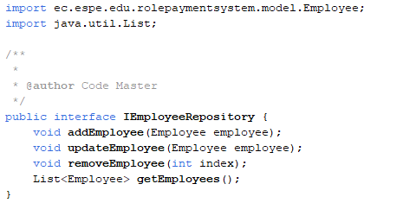

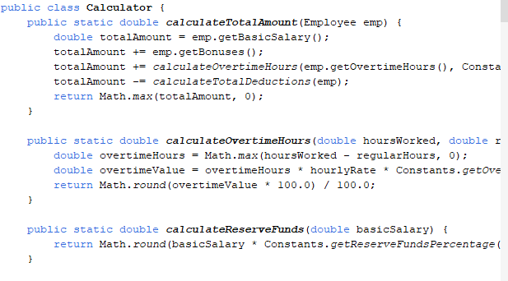**2. Single Responsibility Principle (SRP):**

**:**

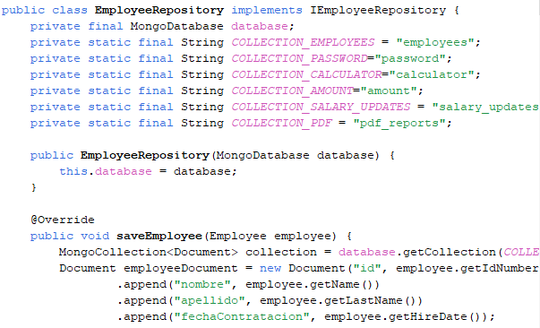**3. Open/Closed Principle (OCP):**

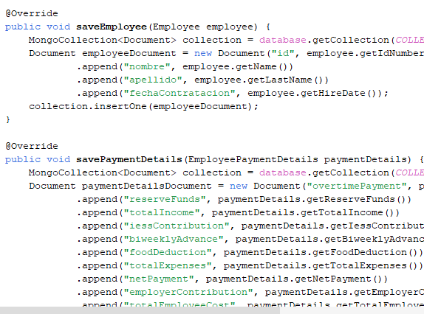

**4. Single Responsibility Principle (SRP):**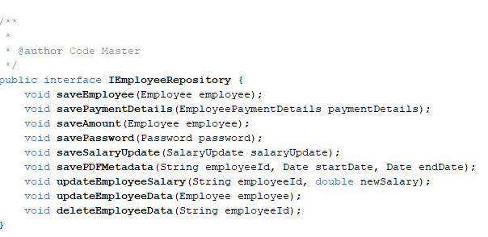

**5. Liskov Substitution Principle**

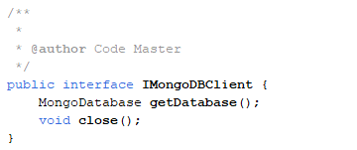

**6.Liskov Substitution Principle**

