

**UNIVERSIDAD DE LAS FUERZAS ARMADAS -ESPE**

**DATE:**

10/05/2024

**CLASS:**

OOP - 14541

**WORKSHOP TOPIC:**

GITHUB REPOSITORY

1. [**CHRISTIAN MARCELO ACUÑA GAMBOA**](https://micampus.espe.edu.ec/user/view.php?id=3274&course=1130)

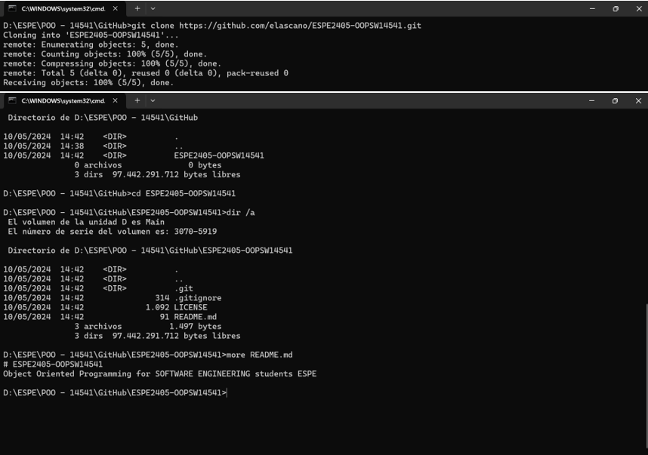

1. [**ABNER DAVID ARBOLEDA ROMAN**](https://micampus.espe.edu.ec/user/view.php?id=3269&course=1130)

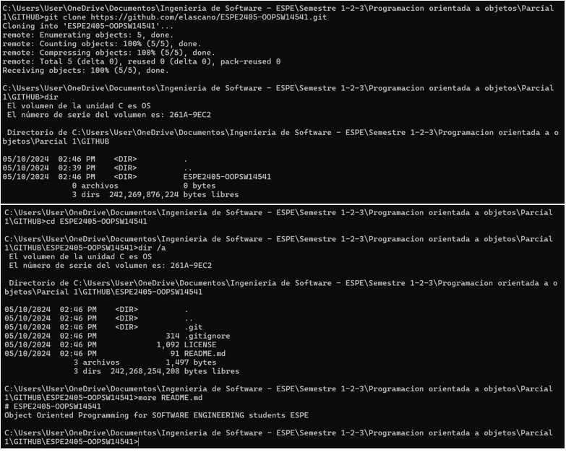

1. [**ENZO ALBERTO ARMIJOS MACAS**](https://micampus.espe.edu.ec/user/view.php?id=11640&course=1130)

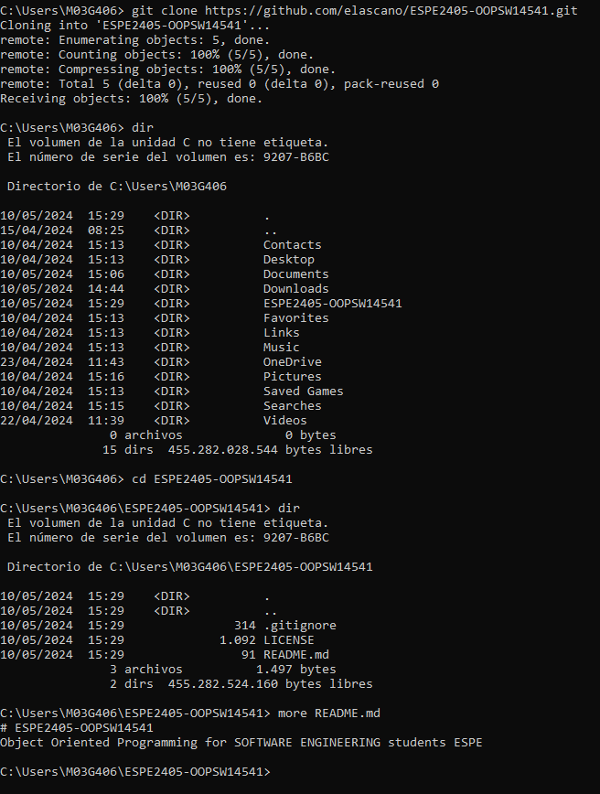

1. [**DANNY MATEO AYUQUINA NAVAS**](https://micampus.espe.edu.ec/user/view.php?id=3321&course=1130)

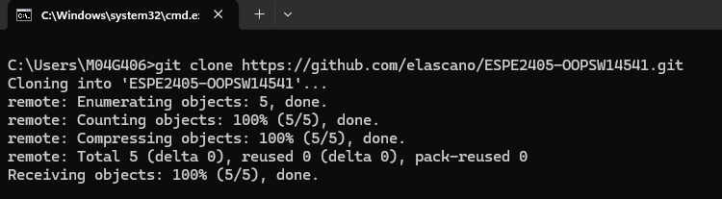

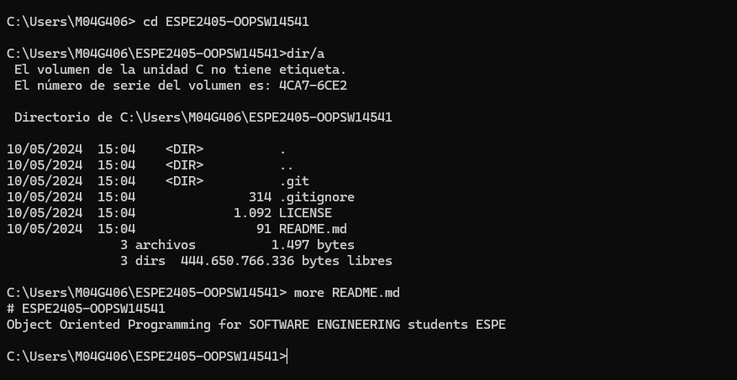

1. [**CHRISTIAN MATEO BONIFAZ VASQUEZ**](https://micampus.espe.edu.ec/user/view.php?id=3271&course=1130)

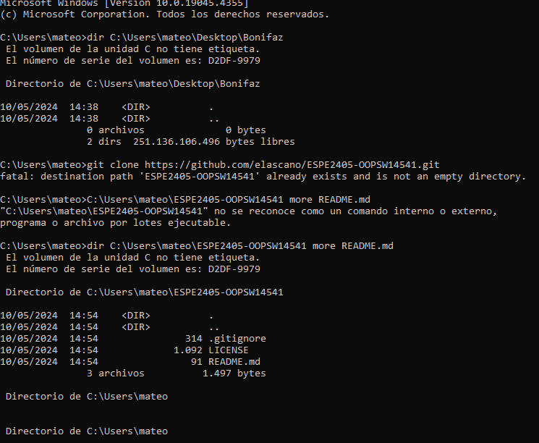

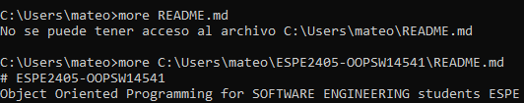

1. [**SARAY ADRIANA CAÑARTE GALARZA**](https://micampus.espe.edu.ec/user/view.php?id=3319&course=1130)

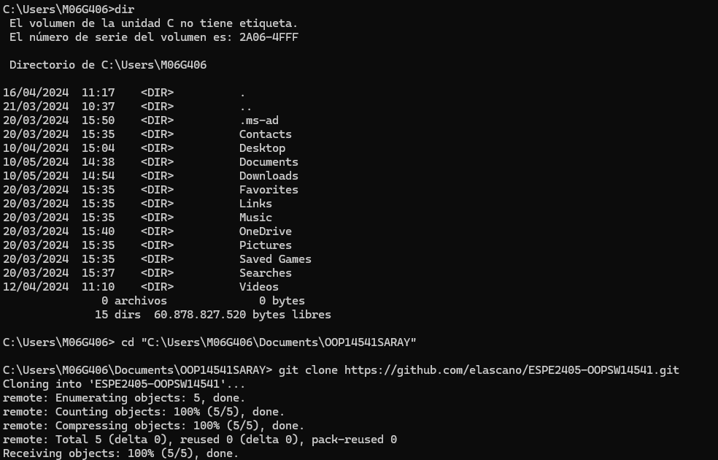

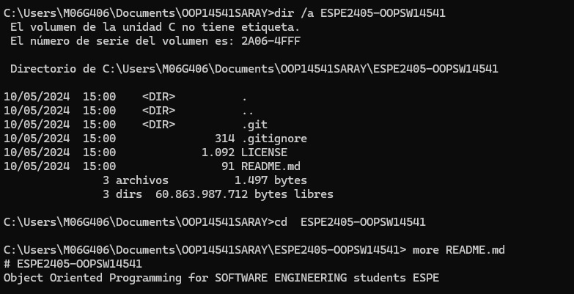

1. [**ANDRES ISAIAS CEDEÑO CUENCA**](https://micampus.espe.edu.ec/user/view.php?id=3315&course=1130)

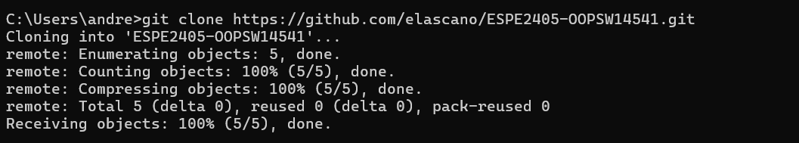

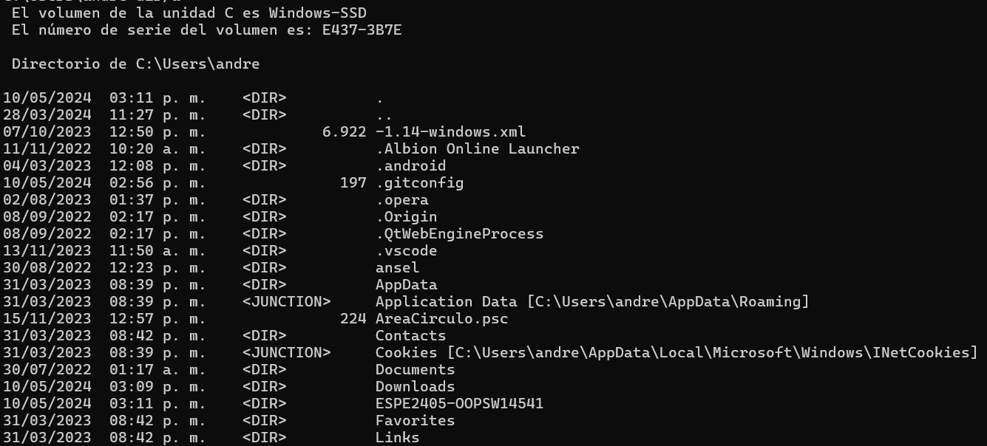

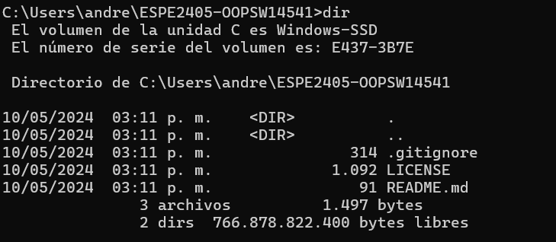

1. [NAHOMI NAYELY CEDEÑO REYES](mailto:nncedeno1@espe.edu.ec)

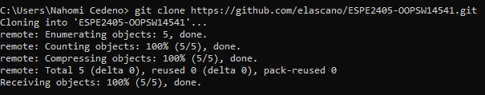

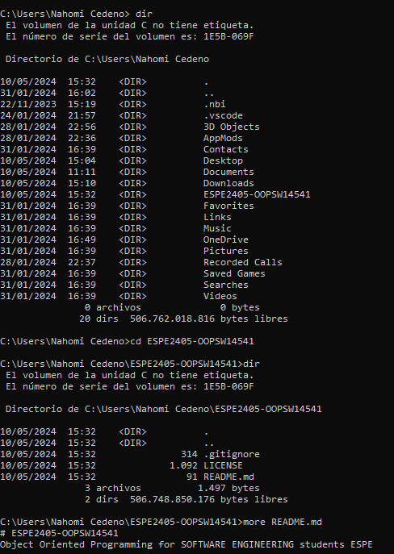

1. [**MARCO VINICIO CHANATAXI QUIMBIAMBA**](https://micampus.espe.edu.ec/user/view.php?id=11261&course=1130)

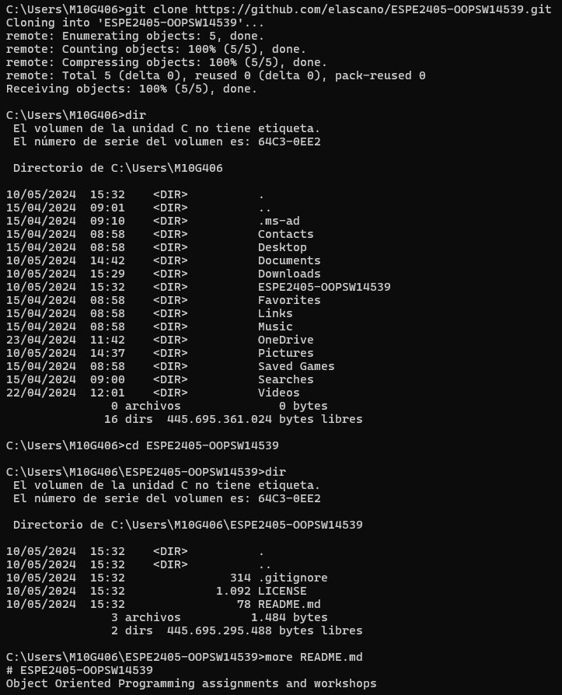

1. [**KENNY JESUS GAVILANEZ OCAMPO**](https://micampus.espe.edu.ec/user/view.php?id=3281&course=1130)

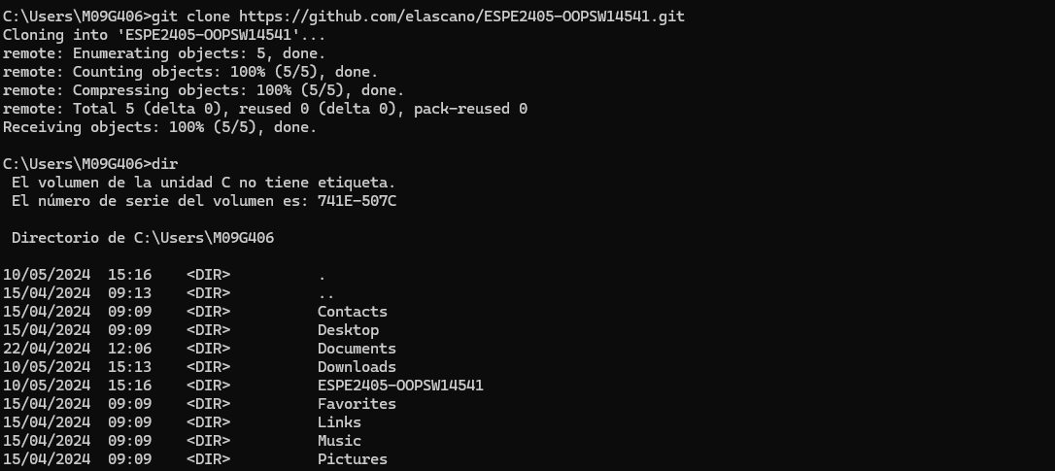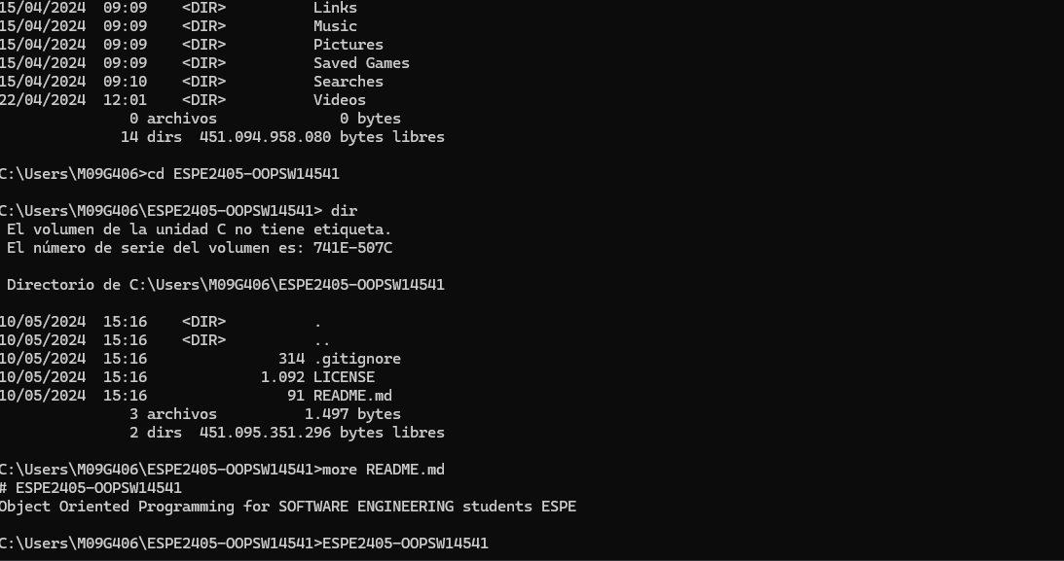

1. [**BRAYAN PATRICIO GUALOTUÑA AMAGUAYA**](https://micampus.espe.edu.ec/user/view.php?id=3311&course=1130)

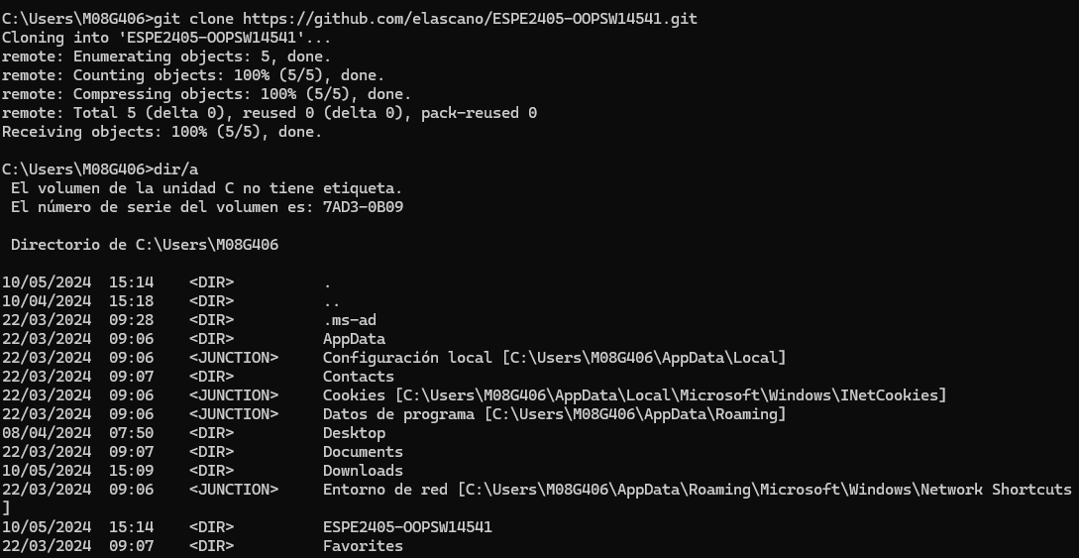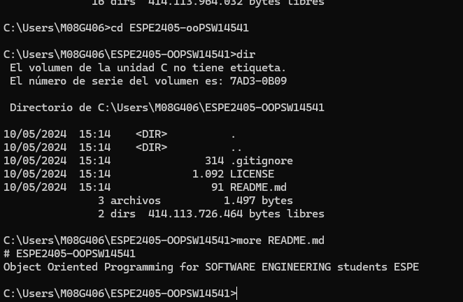

1. [**CRISTIAN MATEO LISINTUÑA CORREA**](https://micampus.espe.edu.ec/user/view.php?id=3316&course=1130)

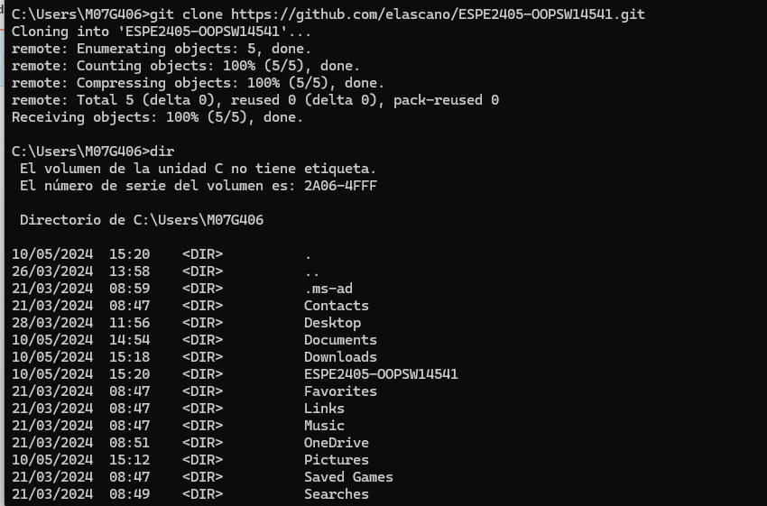

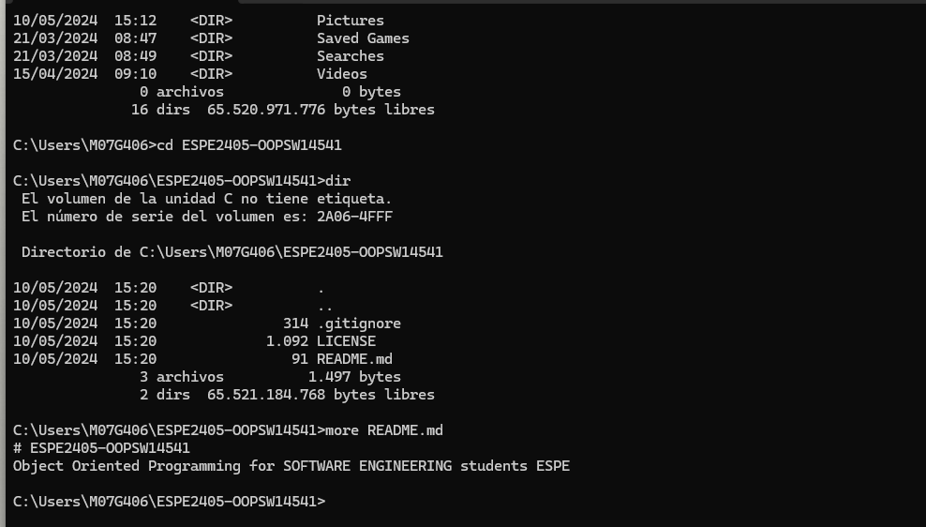

1. [**JENNIFFER PAOLA MARQUEZ QUIROZ**](https://micampus.espe.edu.ec/user/view.php?id=9304&course=1130)

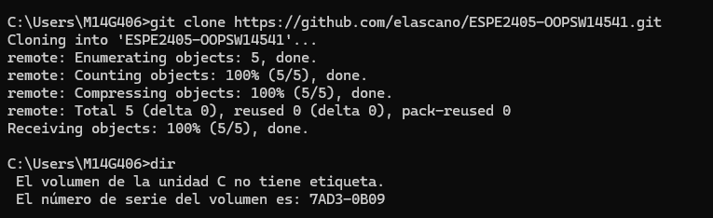

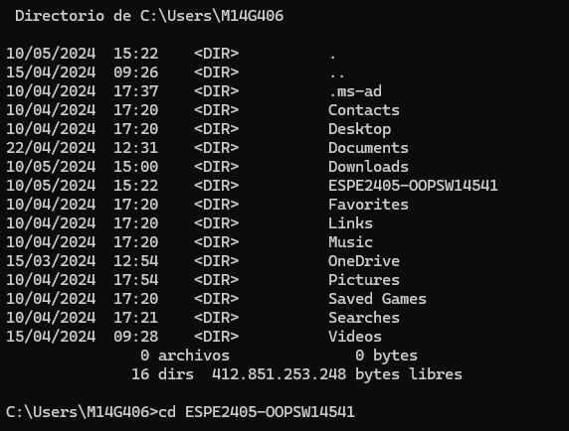

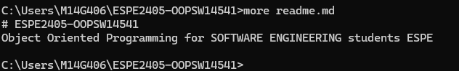

1. [**NATHALY SIMONE MEDINA AUQUILLA**](https://micampus.espe.edu.ec/user/view.php?id=11628&course=1130)
2. [**CARLOS DAVID PANTOJA JIMENEZ**](https://micampus.espe.edu.ec/user/view.php?id=9309&course=1130)

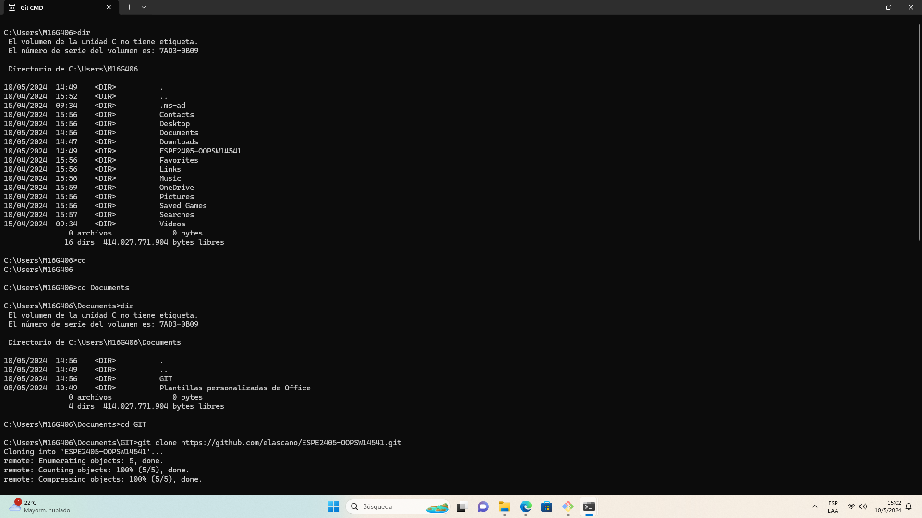

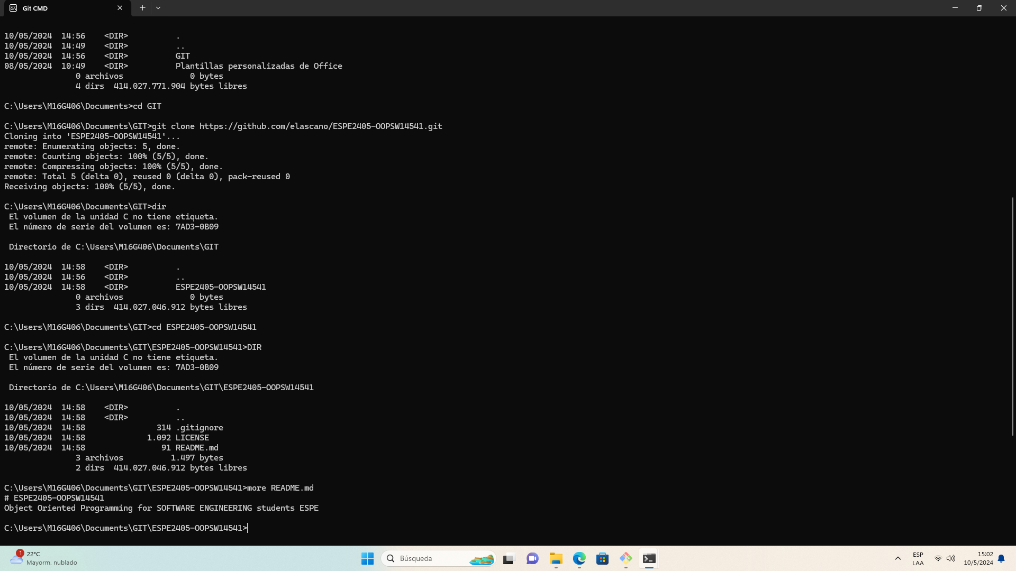

1. [**CARLOS ANDRES PEREZ CONDOR**](https://micampus.espe.edu.ec/user/view.php?id=3314&course=1130)

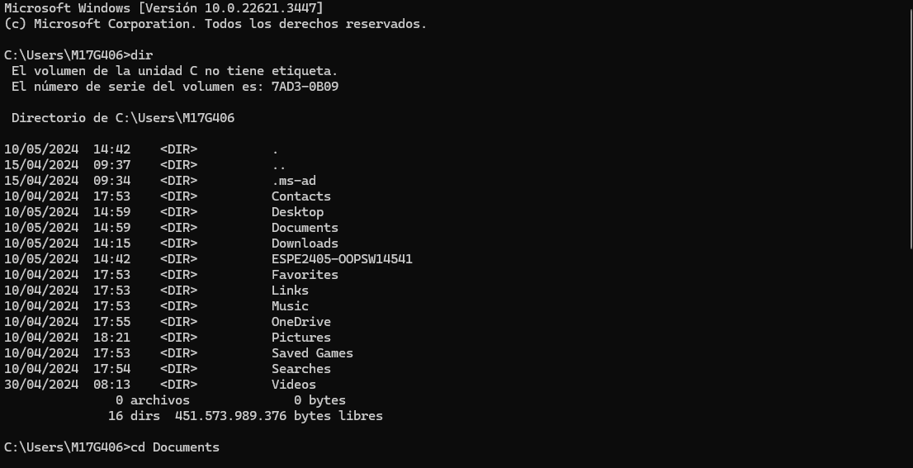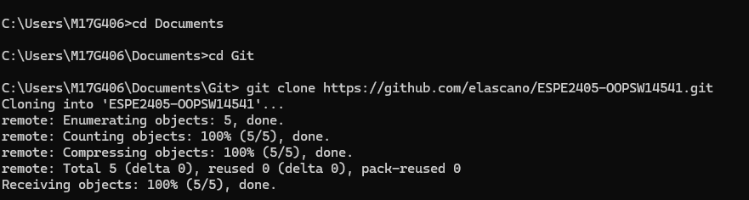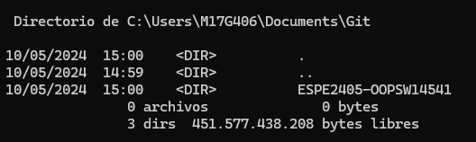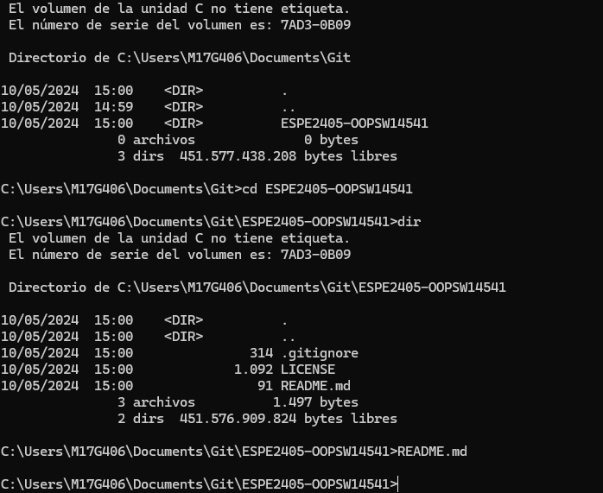

1. [DAVID JOSUE RODRIGUEZ VILLAROEL](mailto:djrodriguez11@espe.edu.ec)

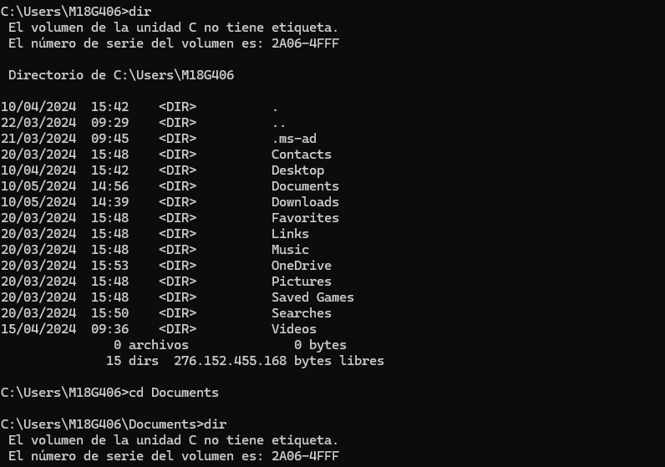

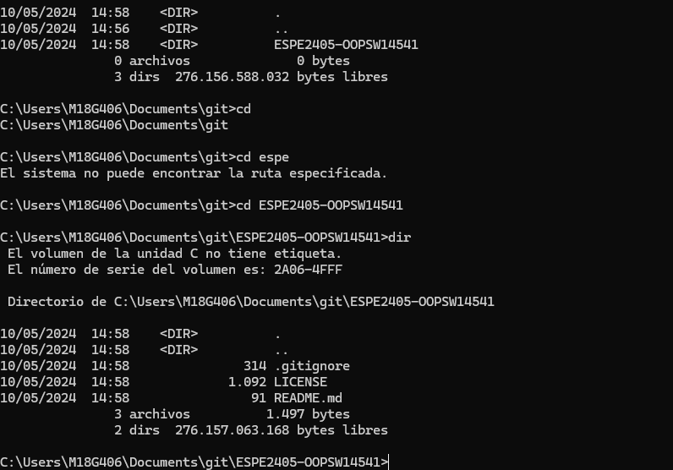

1. [**EDUARDO ANDRES SEGARRA DIAZ**](https://micampus.espe.edu.ec/user/view.php?id=3313&course=1130)

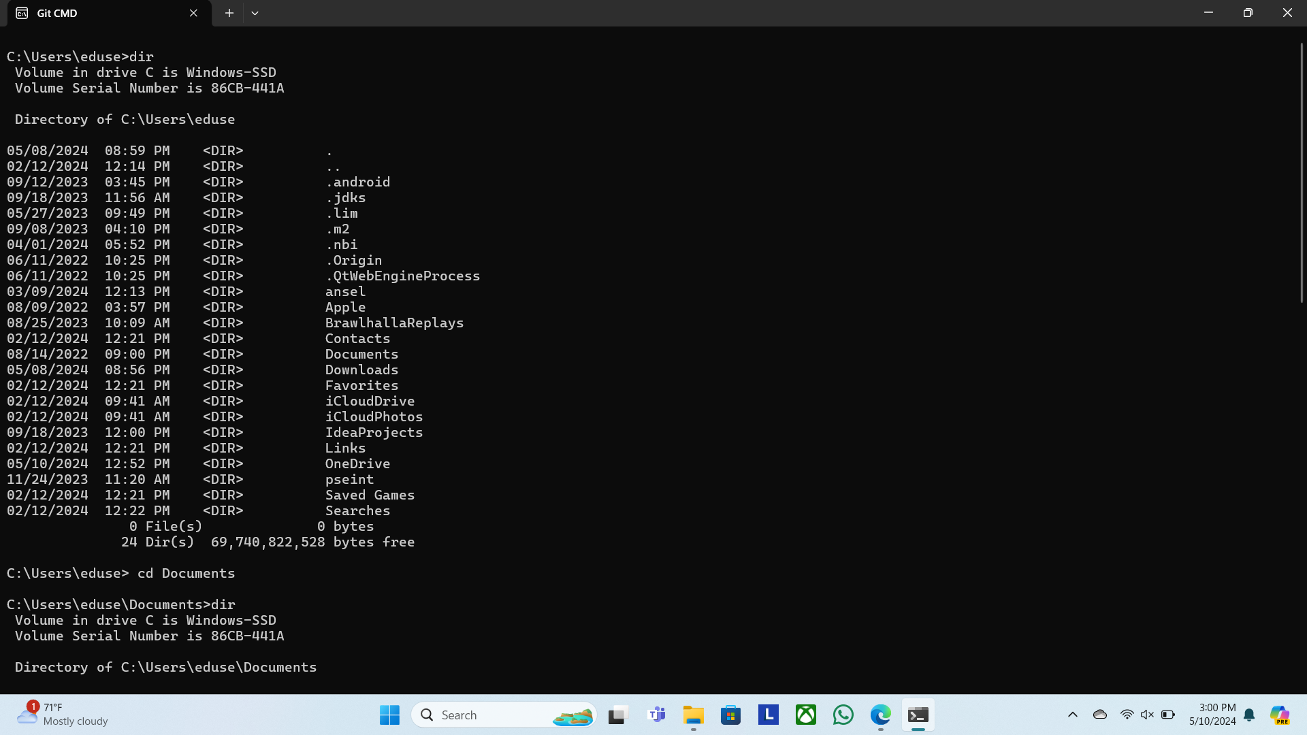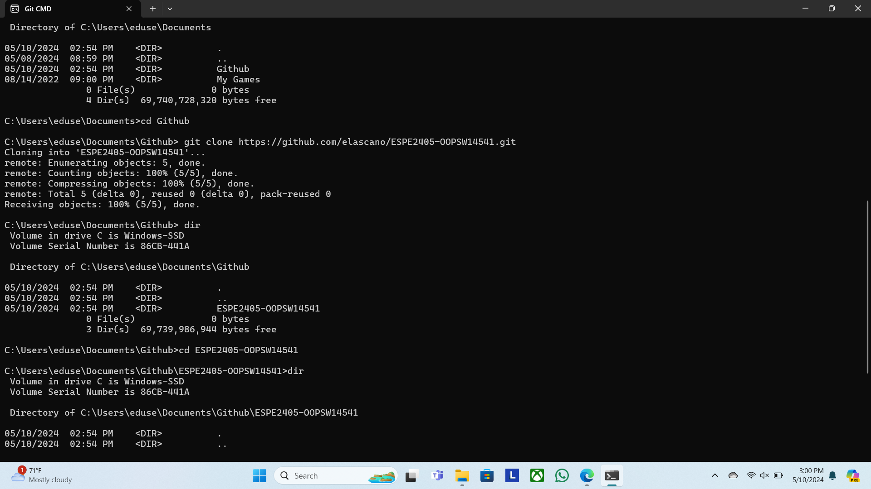

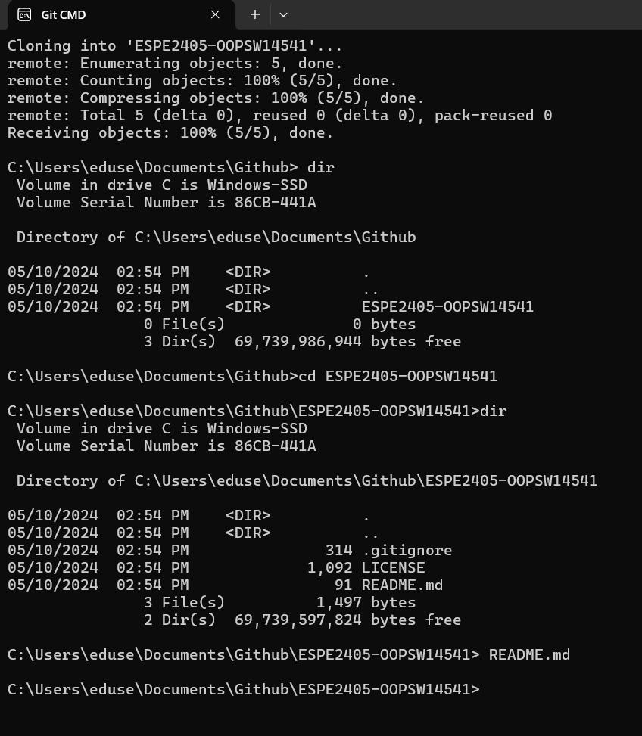

1. **ALEX ISMAEL TRAVEZ CACHAGO**

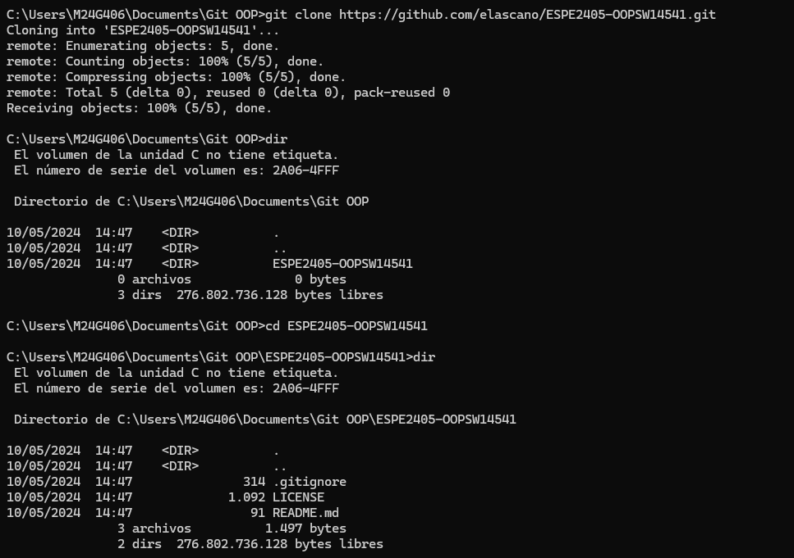

1. [**LUIS EDUARDO VACA ZURITA**](https://micampus.espe.edu.ec/user/view.php?id=3317&course=1130)

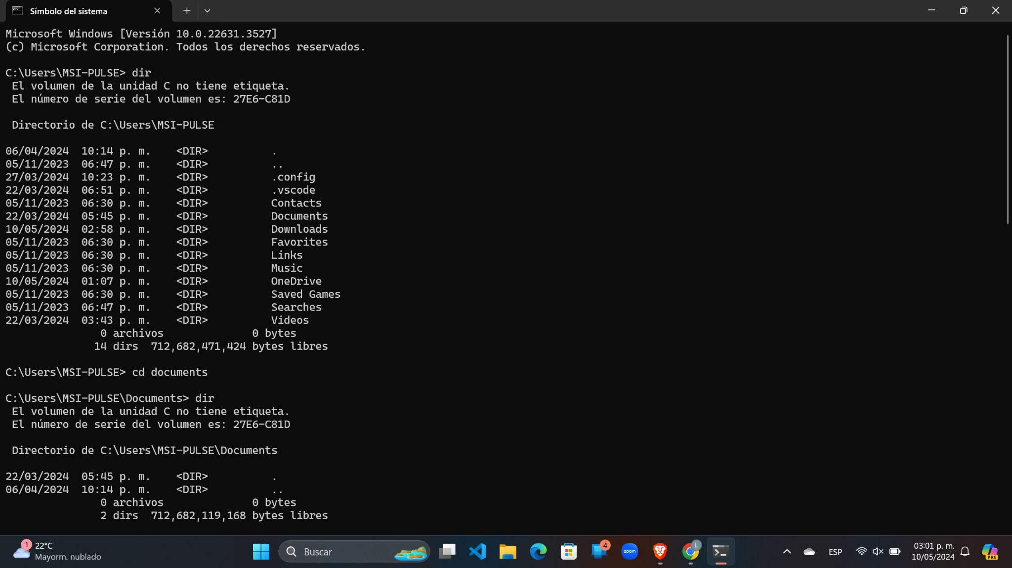

1. [**YULIANA ANAHI VALENCIA BUSTAMANTE**](https://micampus.espe.edu.ec/user/view.php?id=3312&course=1130)





1. [**DOMENICA NICOLE VILLAGOMEZ FREIRE**](https://micampus.espe.edu.ec/user/view.php?id=3318&course=1130)

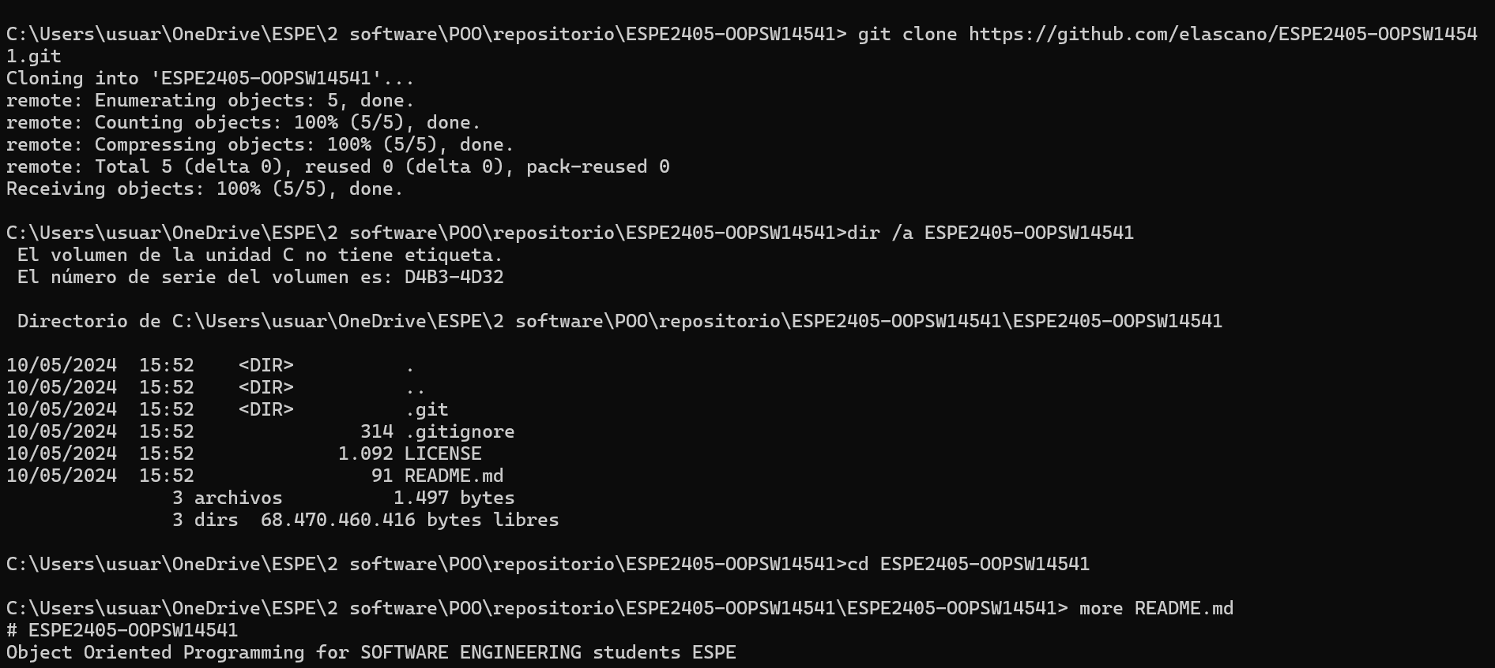

1. [**ALEXIS JHOSUE VITERI AVILA**](https://micampus.espe.edu.ec/user/view.php?id=3320&course=1130)
2. **DAVID ARIEL MORILLO CUEVA**

