UNIVERSIDAD DE LAS FUERZAS ARMADAS-ESPE

**DEPARTAMENTO DE CIENCIAS DE LA COMPUTACIÓN - DCCO**

**CARRERA DE INGENIERÍA DE SOFTWARE**

PERIODO : noviembre 2024 – marzo 2025

ASIGNATURA : Desarrollo web Avanzado.

NOMBRES : Kevin David Asmal Haro

NIVEL-PARALELO : Quinto / 2296.

FECHA DE ENTREGA: 11 de febrero de 2025.

**Artificial Intelligence (AI).**

Artificial intelligence is quickly changing the landscape of web development, and its influence is expected to grow in the future. Several top companies have introduced AI focused tools, like Gird, which allows for the fast development of tailored websites. Furthermore, developers can utilize ADI tools to streamline and personalize the web development process. Technologies such as voice recognition, present in assistants like Siri and Alexa, improve user experience by understanding language patterns. Major firms including Facebook, Microsoft, and Google are pouring resources into AI, suggesting that web developers ought to incorporate these advancements to bring about major transformations in the field.

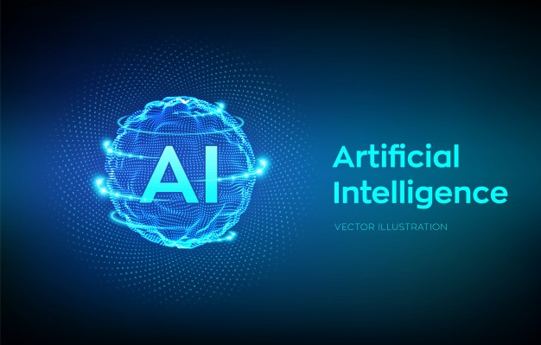

Bibliography:

<https://bsscommerce.com/blog/how-is-the-future-of-web-development/#Motion-User-Interface>

**Motion User Interface.**

Motion User Interface is a software as a service library often employed to make unique CSS animations. When used properly, it can greatly boost a brand's image by visually expressing its message to users. Motion UI also enhances user experience by making navigation easier and improving website performance. As technology progresses, web development is likely to experience major changes, incorporating new features to enhance user interaction. To remain competitive, web developers need to stay updated with the latest trends to better user experience, increase customer satisfaction, and improve overall website functionality.



Bibliography:

<https://bsscommerce.com/blog/how-is-the-future-of-web-development/#Motion-User-Interface>

Javascript.

JavaScript is commonly utilized for creating Android mobile applications and interactive web applications. It was a leading trend in web development in 2020 and is still progressing with new frameworks and rich libraries. The adaptability and user-friendly nature of JavaScript frameworks make them a favored option for developers around the globe. This trend allows for the development of neat, responsive websites, and in the future, JavaScript frameworks and platforms will further improve web development.



Bibliography:

<https://bsscommerce.com/blog/how-is-the-future-of-web-development/#Motion-User-Interface>

Blockchain.

Since 2020, Bitcoin has become more popular, but the tale of blockchain technology is just starting. Blockchain is poised to create major transformations in the online industry by allowing secure transactions and removing the requirement for middlemen. It also offers decentralized data storage, enabling users to keep information in various locations across the globe. Financial institutions and banks take advantage of blockchain’s sophisticated algorithms, which protect customer data and improve security.  
  


Bibliography:

<https://bsscommerce.com/blog/how-is-the-future-of-web-development/#Motion-User-Interface>