WORKSHOP # 28

University of the Armed Forces ESPE

Computer Science Department

Software Engineering



ADVANCE WEB DEVELOP

NRC 2296

06/11/2024

1. Asmal Kevin 0

1. Casignia Diego 0
2. Chavez Kleber 0
3. Chiliquinga Yeshua 0

1. Cuadrado Alejandro 0
2. Escobar Isaac 0
3. Espin Andres 8
4. Gualichico Josue 8
5. Jaya Carlos 0
6. Lugmaña Matias 0
7. Marin Josue 0
8. Orrico Camilo 0
9. Pabon Elkin 0

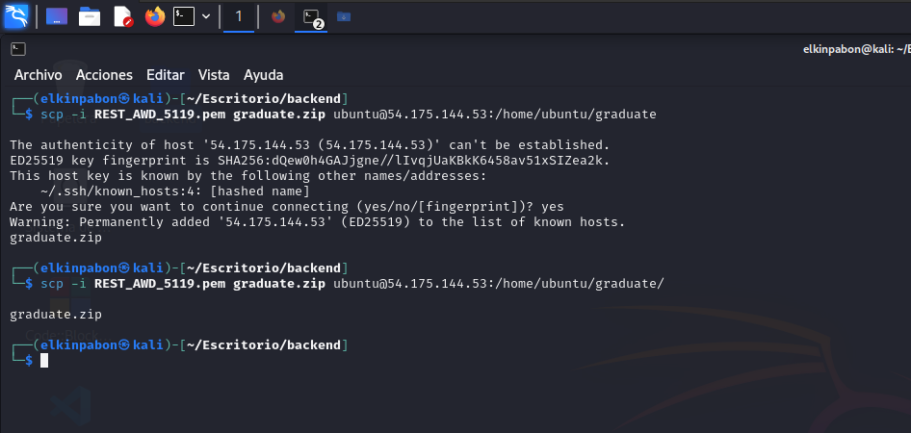

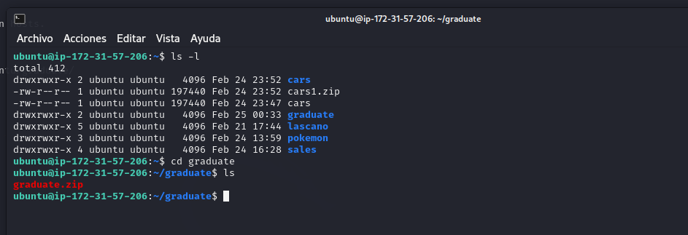

1. Darwin Panchez 0
2. Proaño Jose 8

backend:

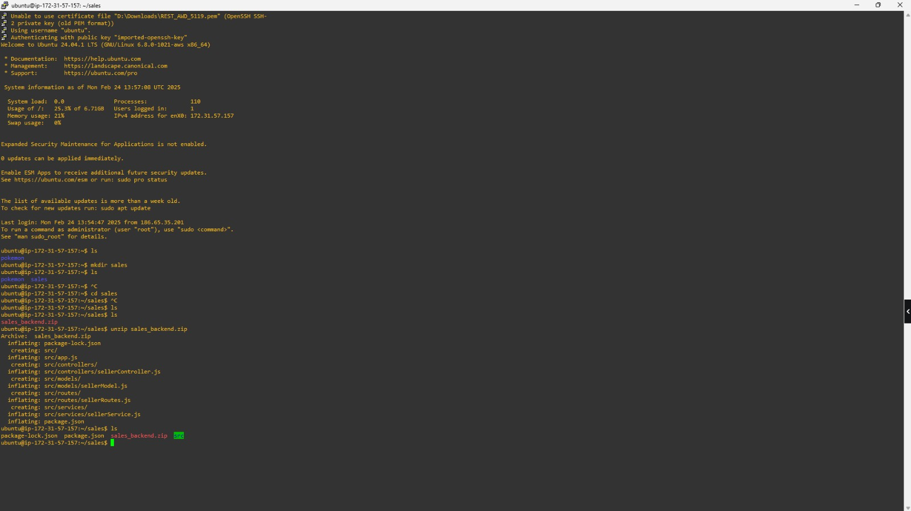

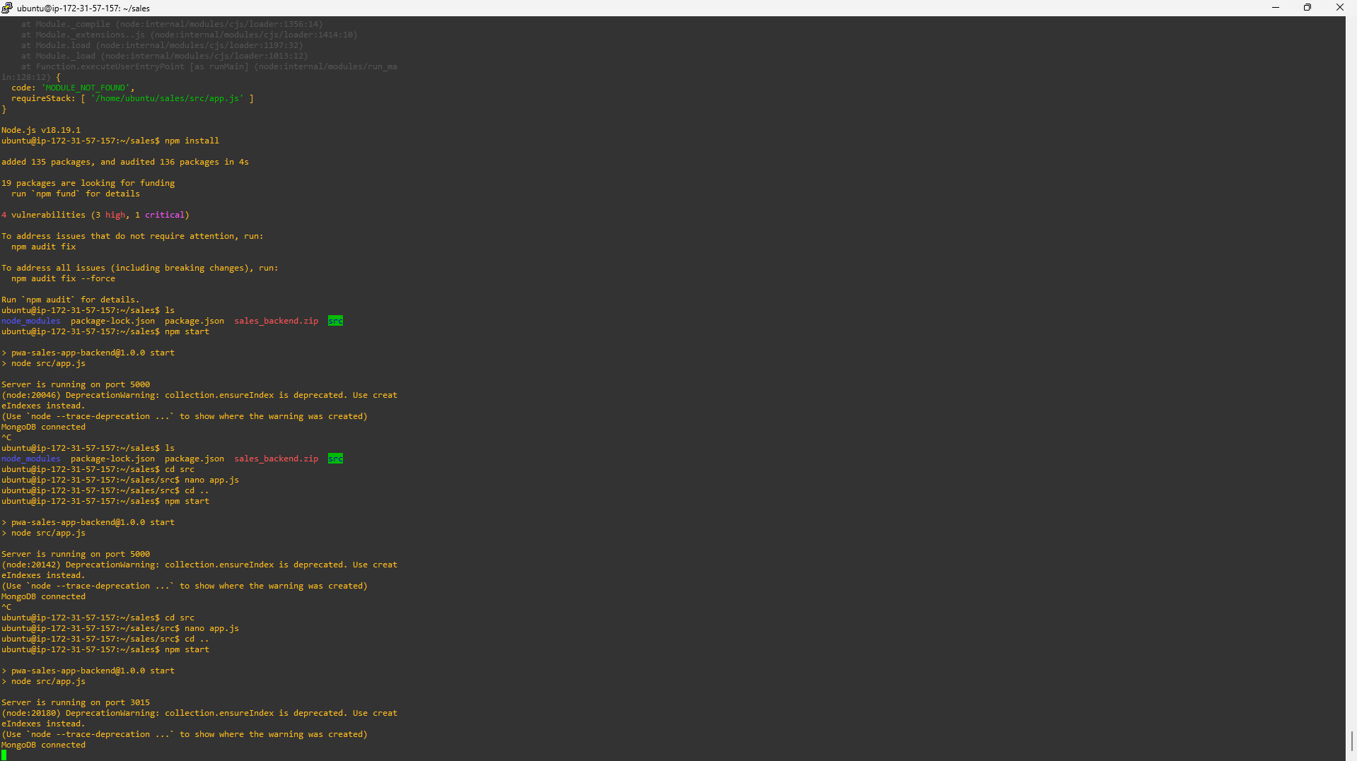

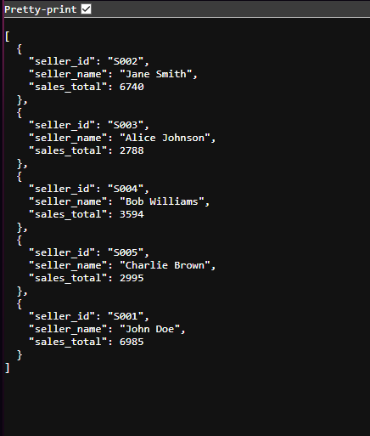

frontend:

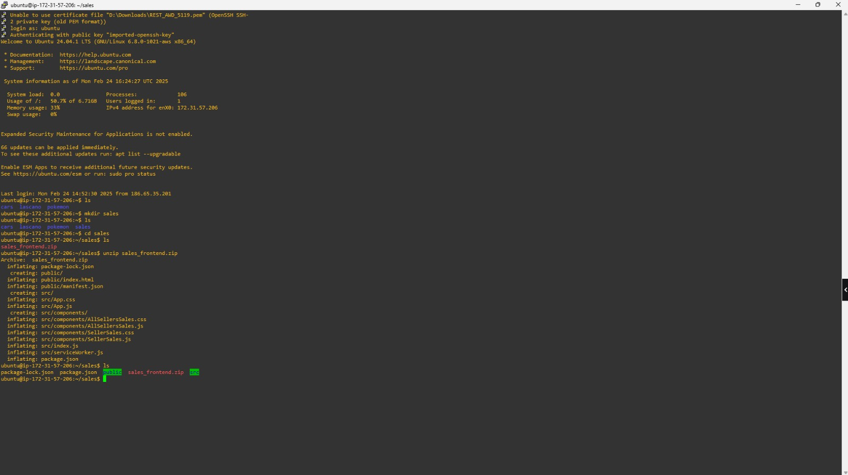

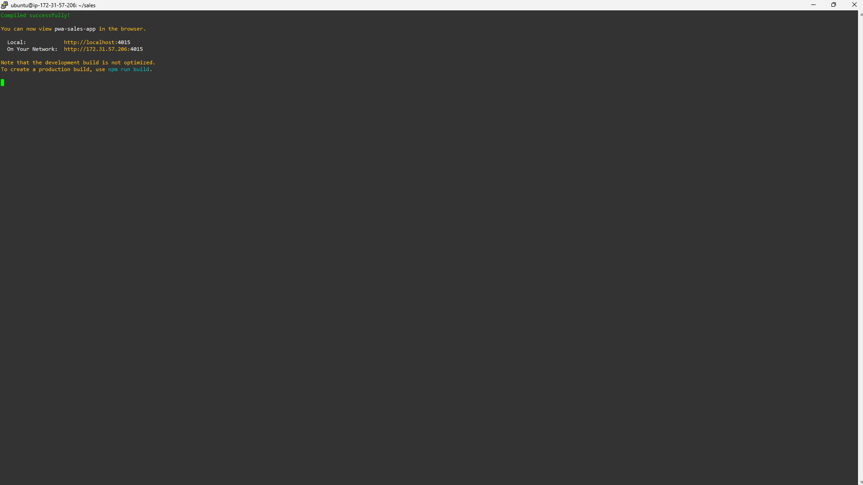



1. Salcedo Micaela 0
2. Sanmartin Jose. 0

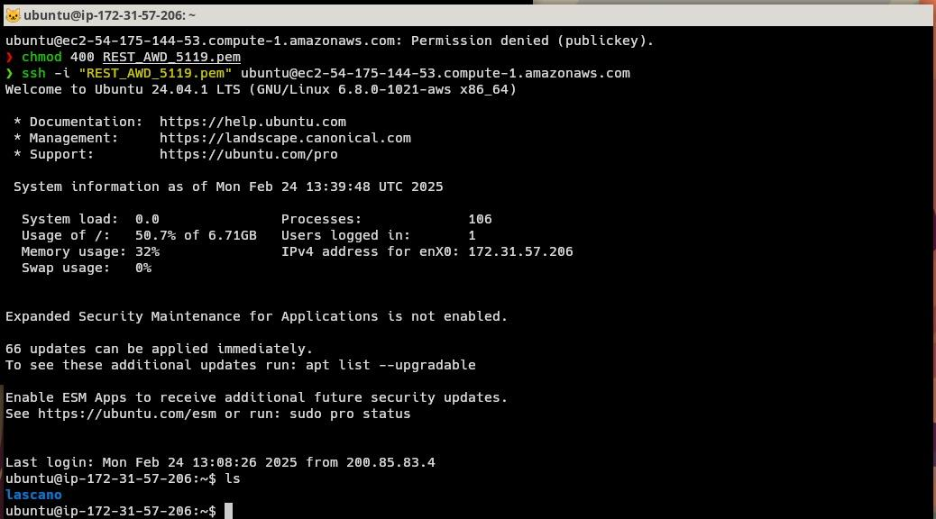

1. Suarez Matias 0
2. Villaroel Justin 8