WORKSHOP # 28

University of the Armed Forces ESPE

Computer Science Department

Software Engineering



ADVANCE WEB DEVELOPMENT

Workshop and Quiz

NRC 2296

06/11/2024

1. Asmal Kevin 5 , 5

1. Casignia Diego 7, 7

discount

1. Chavez Kleber 5, 5
2. Chiliquinga Yeshua 8, 10

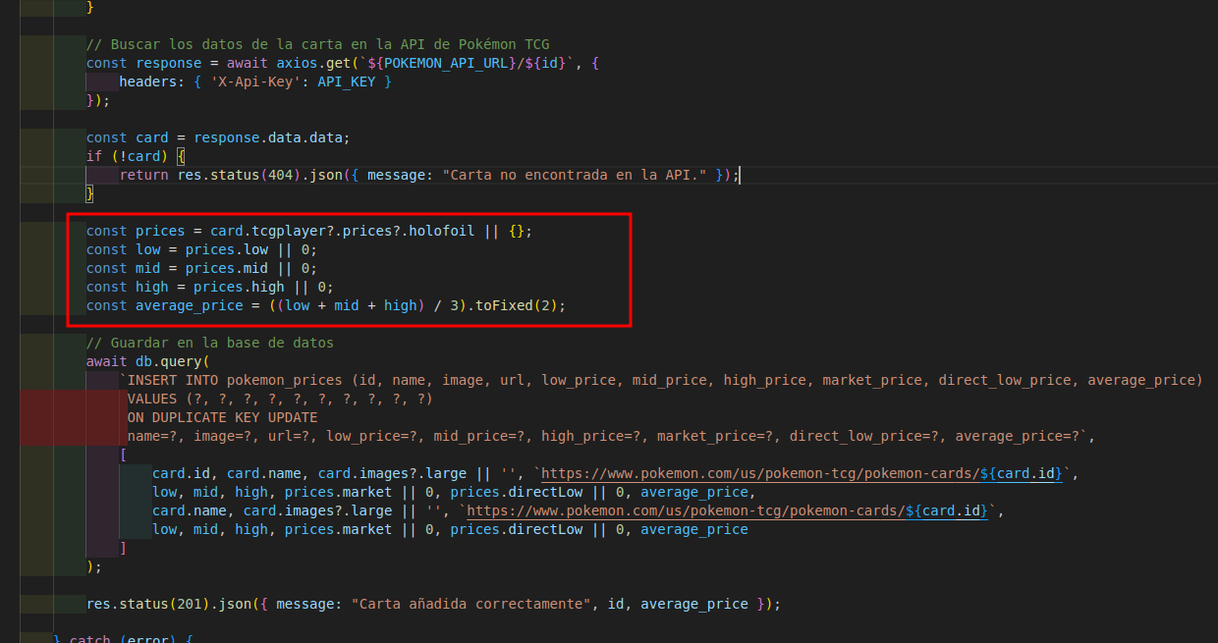

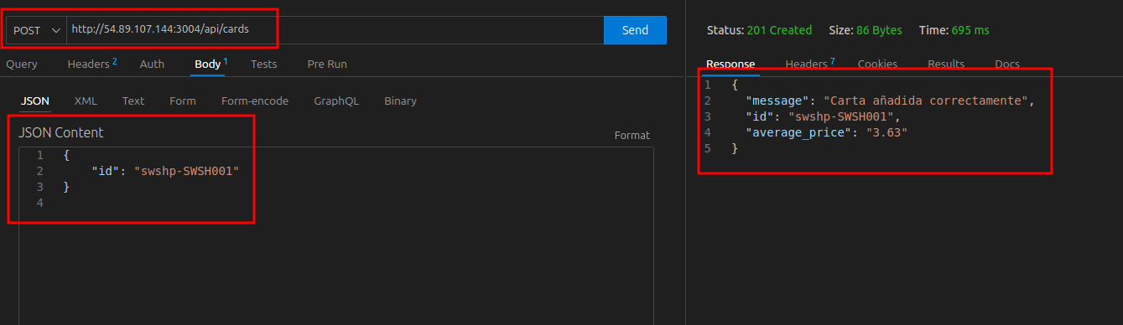

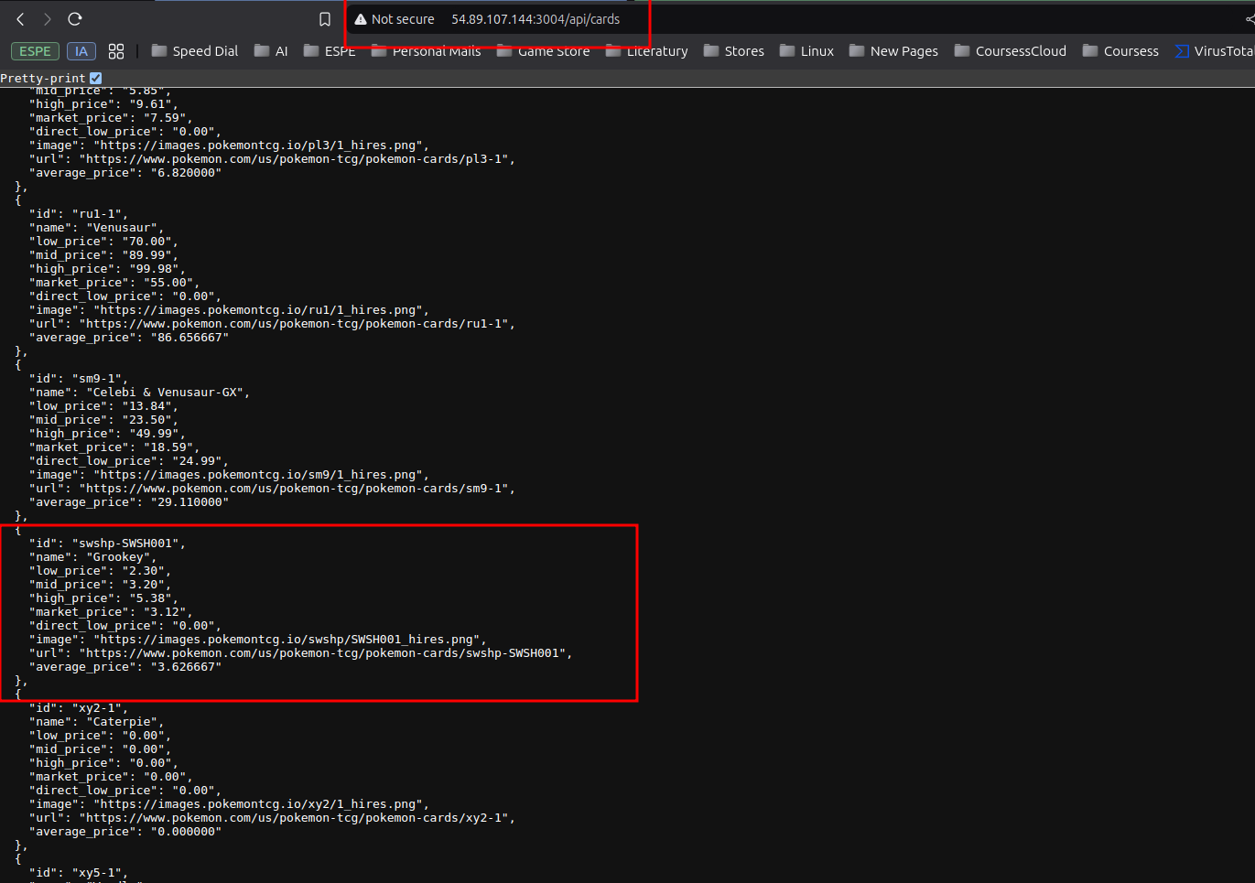

1. Cuadrado Alejandro 5, 7
2. Escobar Isaac 5, 7
3. Espin Andres 7, 10
4. Gualichico Josue 7, 10
5. Jaya Carlos 5, 7
6. Lugmaña Matias 10 , 10

Topic: Is Adult?

Inputs:

-Day

-Month

-Year

age = current_year - birth_year - ((current_month < birth_month) OR (current_month == birth_month AND current_day < birth_day))

### **Example 1:**

Birthdate: June 15, 2005

Current Date: March 10, 2023

Calculate Age:

* + Age = 2023 - 2005 = 18
  + Since March (3) is before June (6), subtract 1 from the age.
  + Age = 18 - 1 = 17 (Mino

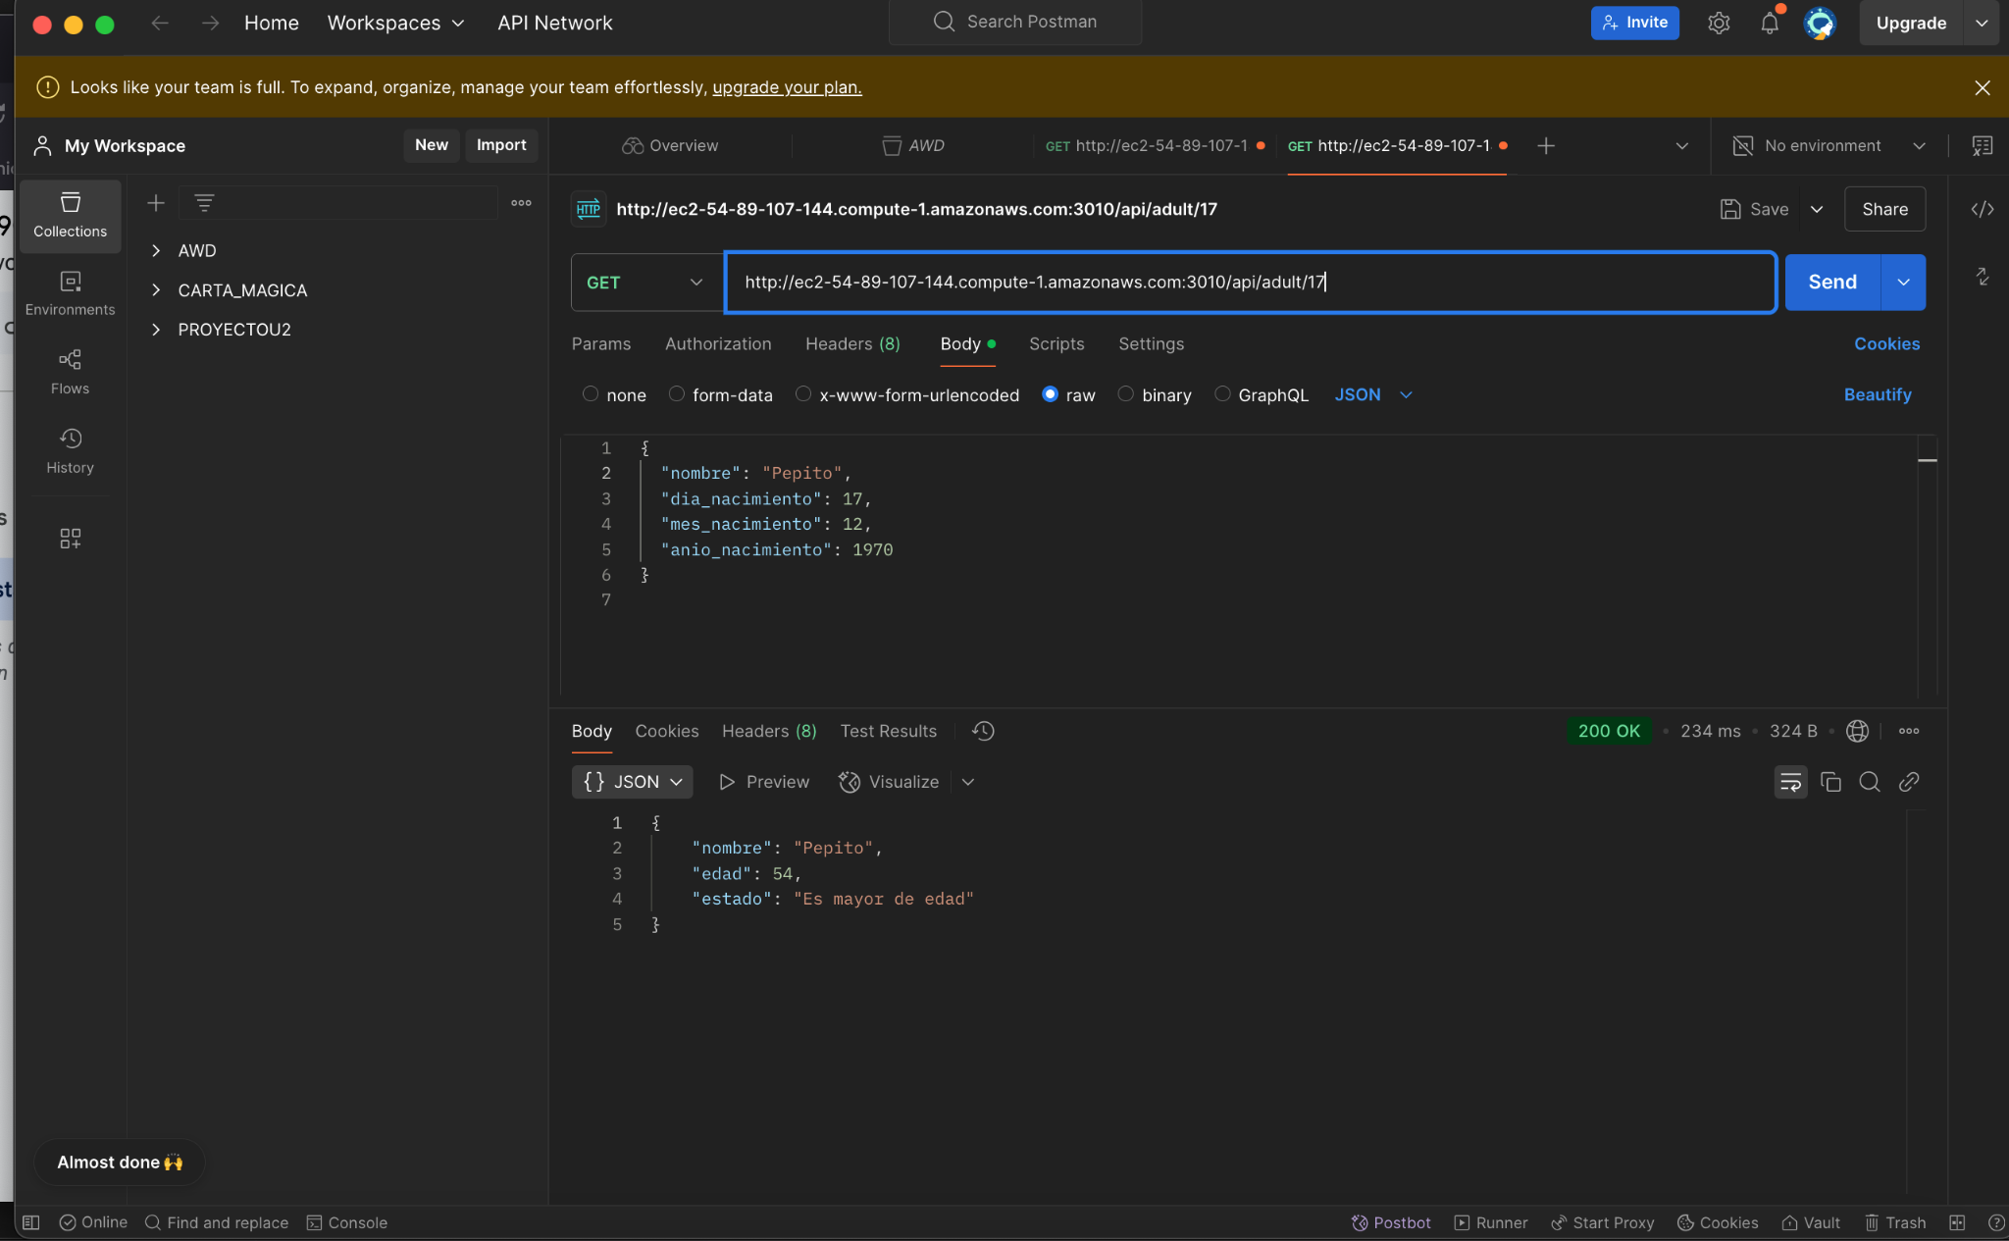

1. Marin Josue 0
2. Orrico Camilo 0
3. Pabon Elkin 10 , 10

Topic: Investors

Inputs:

* profitPerDay: 175.26
* sales: 100
* performance

performance=(profitPerDay×100/Sales+1)

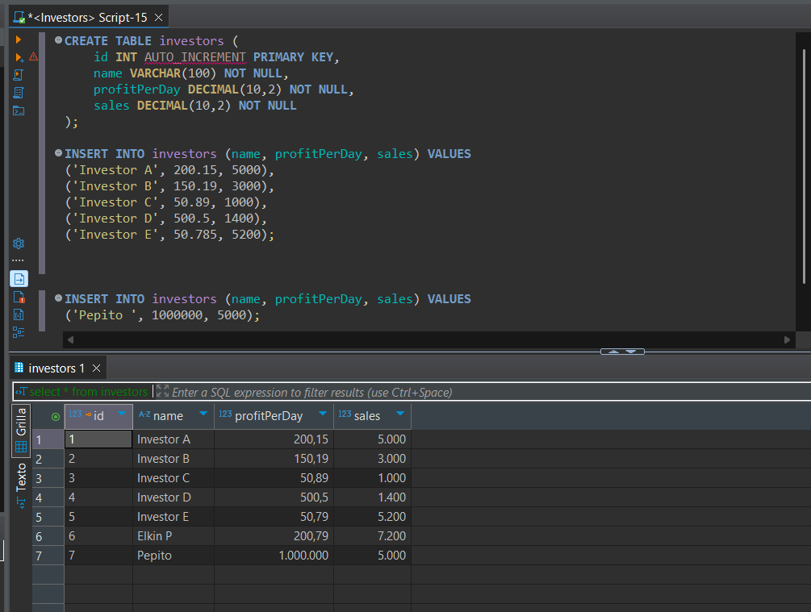

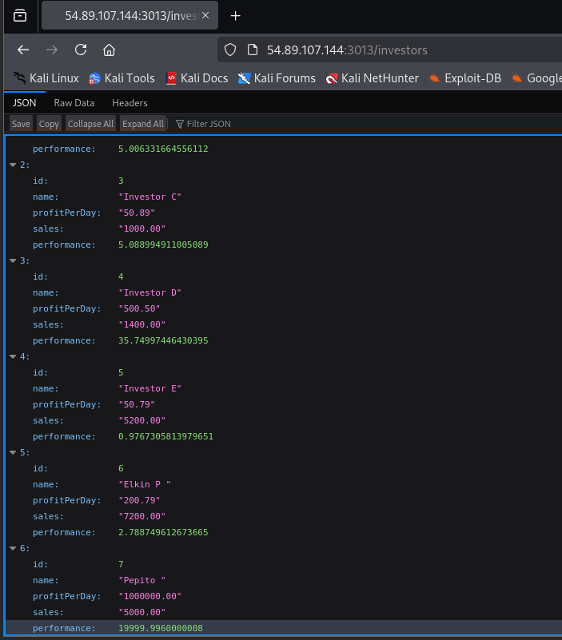

1. Darwin Panchez 7, 10
2. Proaño Jose 10, 10

Inputs

* Weight: 10 kg
* Distance: 10 km

Formula:

The formula used in the calculateCost method is:

const baseRate = 5; // Base rate for shipping

const weightRate = 1.5; // Rate per kg

const distanceRate = 0.5; // Rate per km

const cost = baseRate + (weight * weightRate) + (distance * distanceRate);

Calculation

1. Base Rate: 5
2. Weight Component: 10 kg * 1.5 (rate per kg) = 15
3. Distance Component: 10 km * 0.5 (rate per km) = 5

Now, sum these components:

const cost = 5 + 15 + 5;

Result

The total shipping cost is:

const cost = 25;

Database:

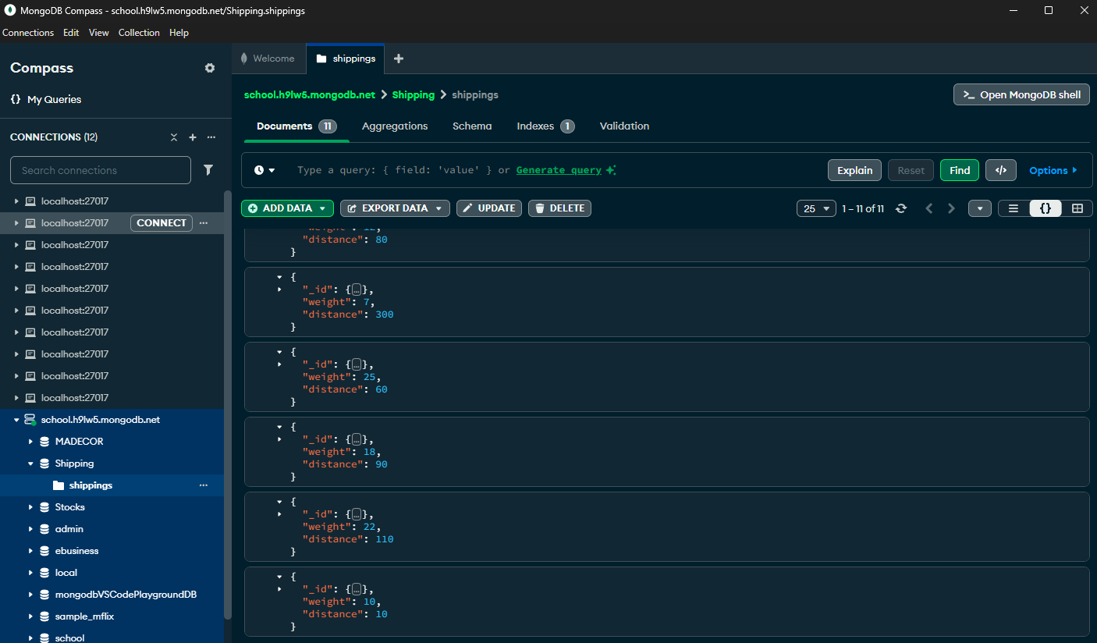Browser:

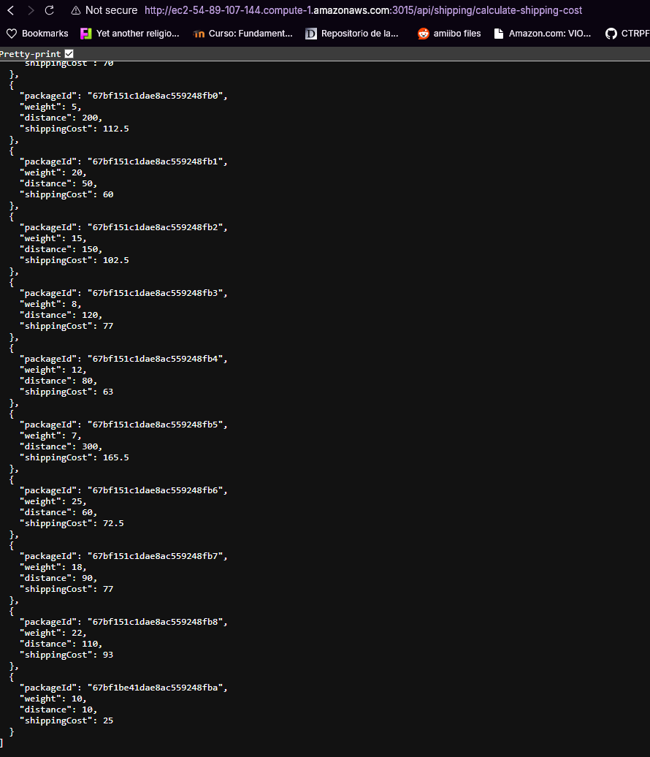

1. Salcedo Micaela 0
2. Sanmartin Jose. 7, 7



1. Suarez Matias 8, 10

Calculate final grade:

Grade1: 20

Grade2: 16.50

Final Grade:

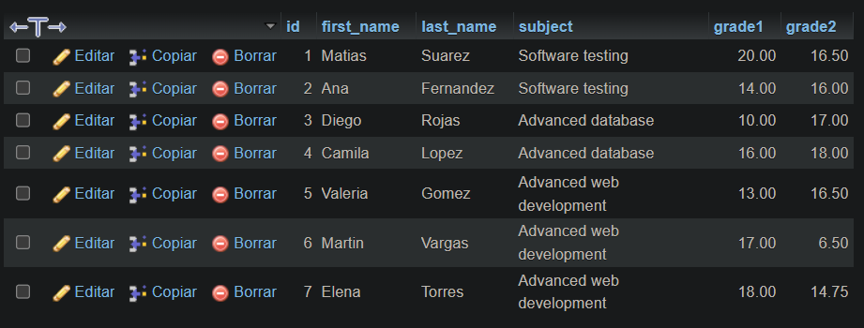

1. Villaroel Justin 0, 0