WORKSHOP # 30

University of the Armed Forces ESPE

Computer Science Department

Software Engineering



ADVANCE WEB DEVELOP

NRC 2296

06/11/2024

1. Asmal Kevin 0/10
2. Casignia Diego 0/10
3. Chavez Kleber 0/10
4. Chiliquinga Yeshua 0/10

1. Cuadrado Alejandro 0/10
2. Escobar Isaac 0/10
3. Espin Andres 0/10
4. Gualichico Josue 9/10

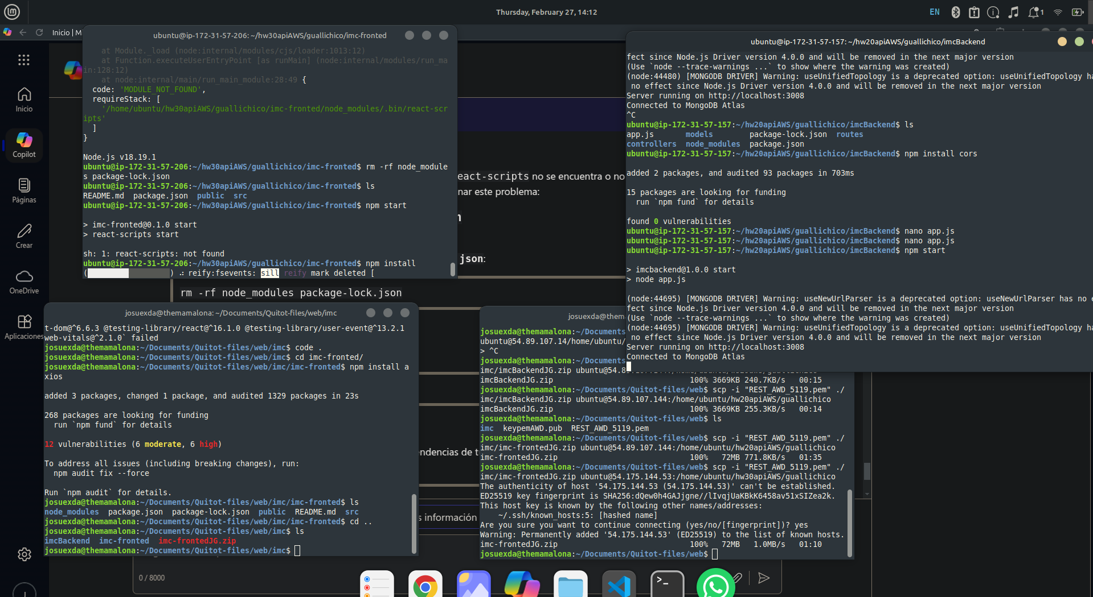

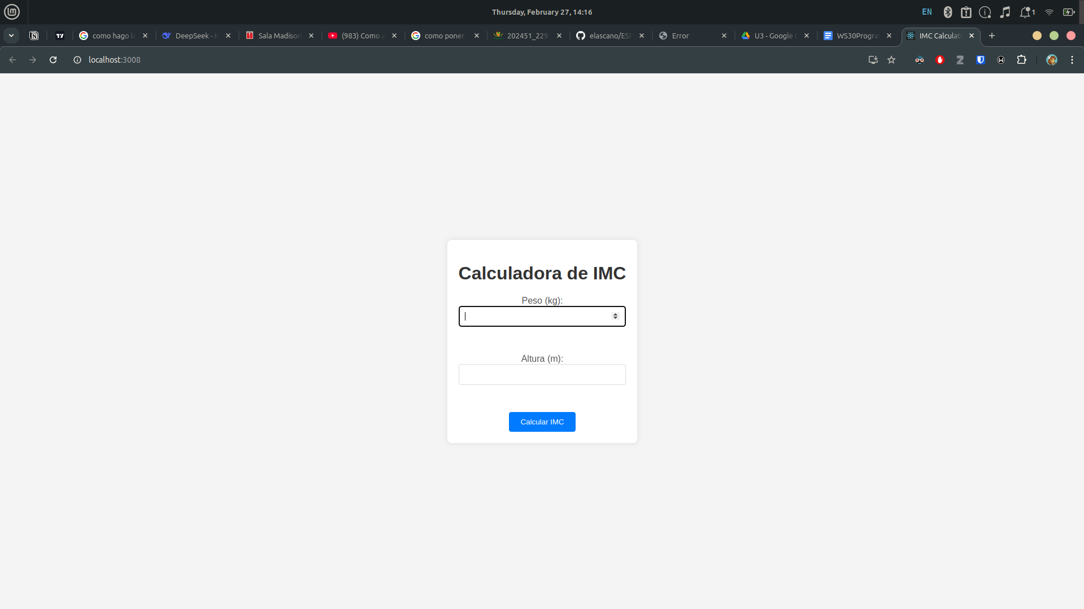

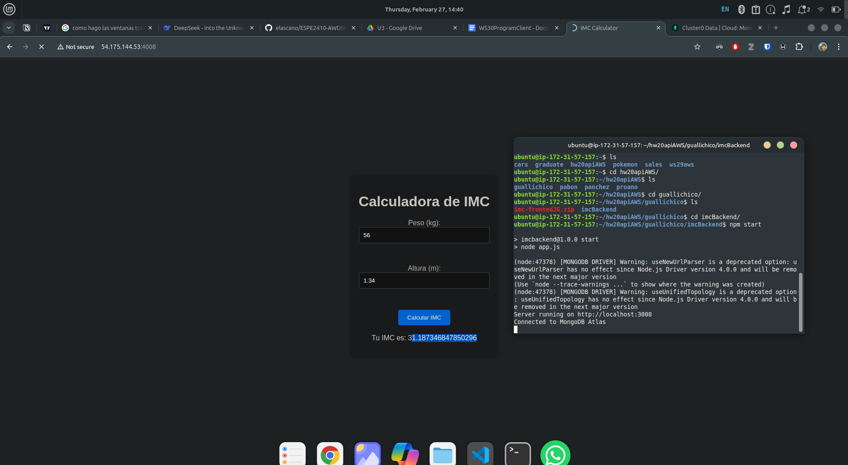

1. Jaya Carlos 0/10
2. Lugmaña Matias 9/10

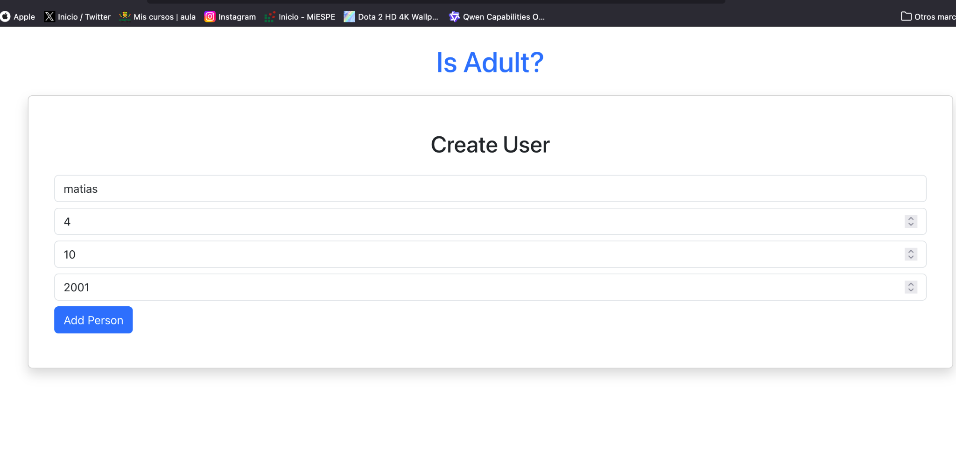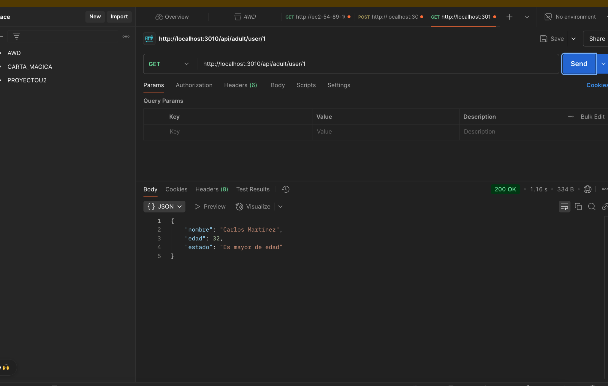

1. Marin Josue 8/10

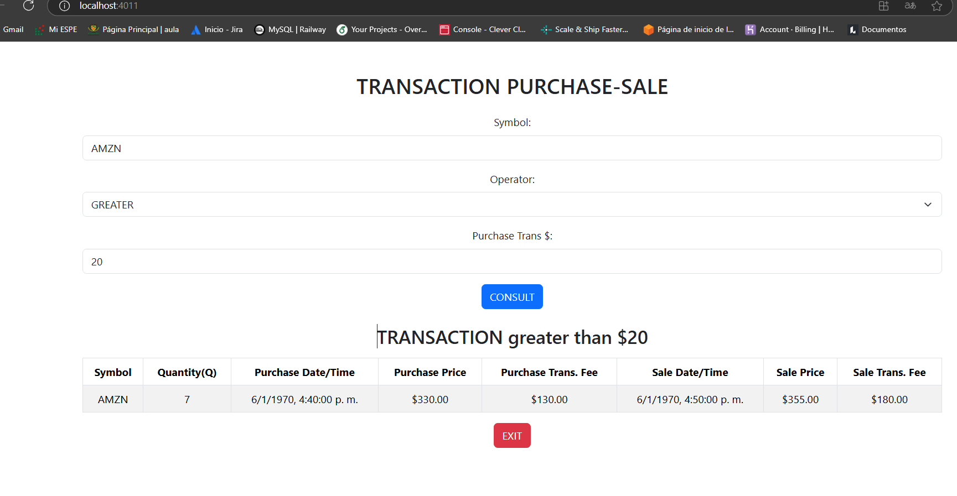

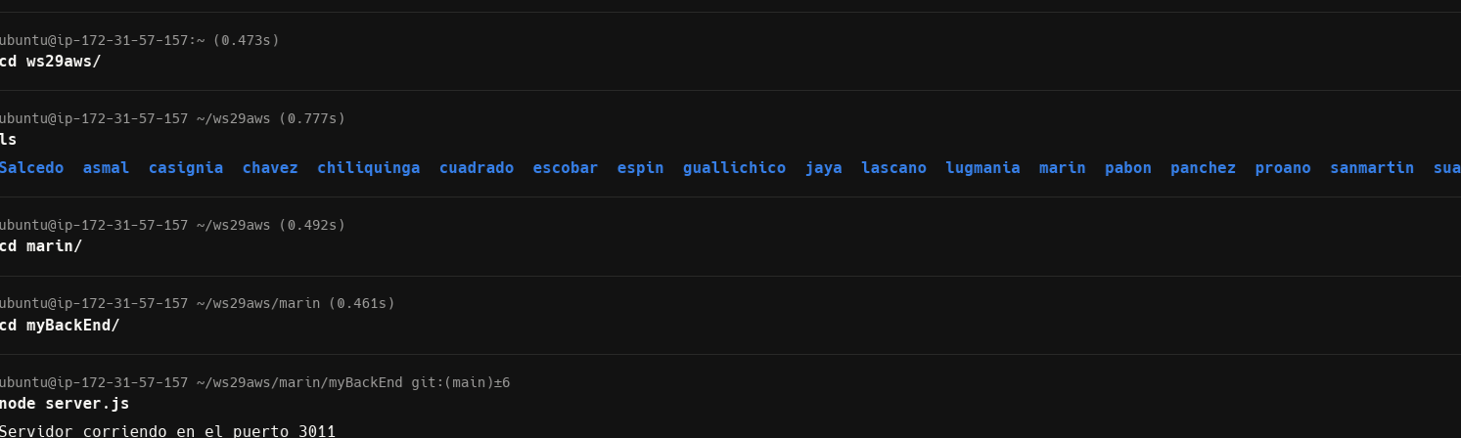

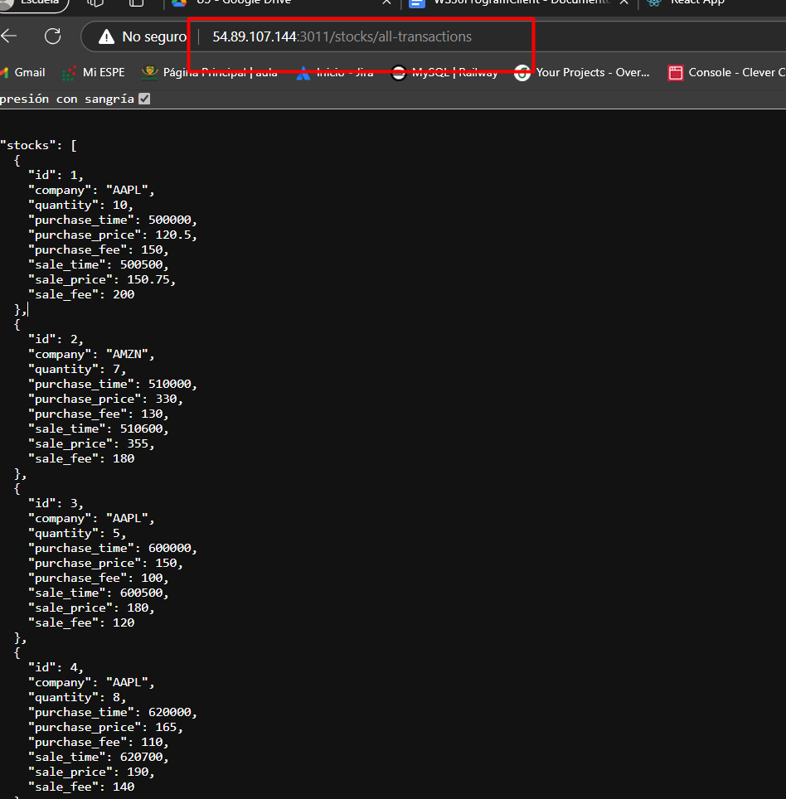

1. Orrico Camilo 6/10

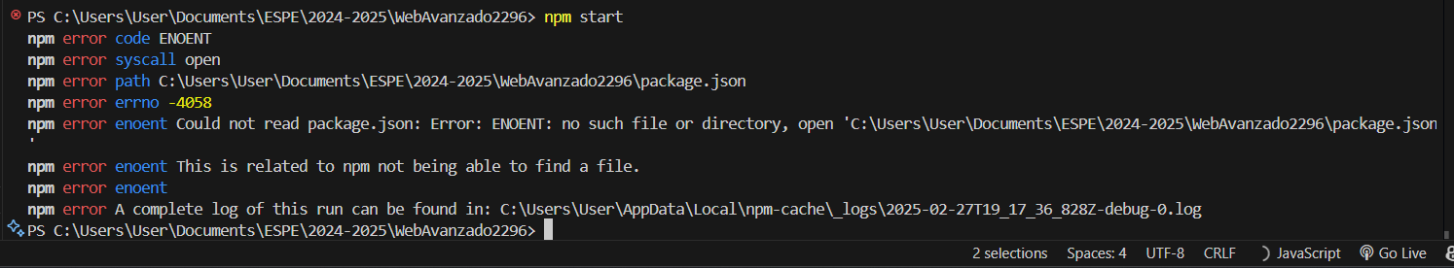

1. Pabon Elkin 0/10
2. Darwin Panchez 8/10

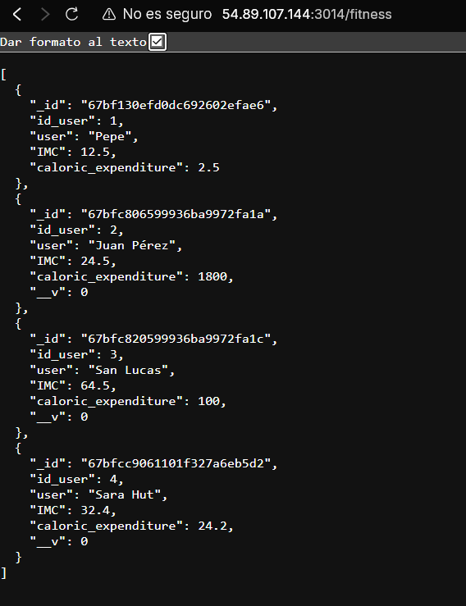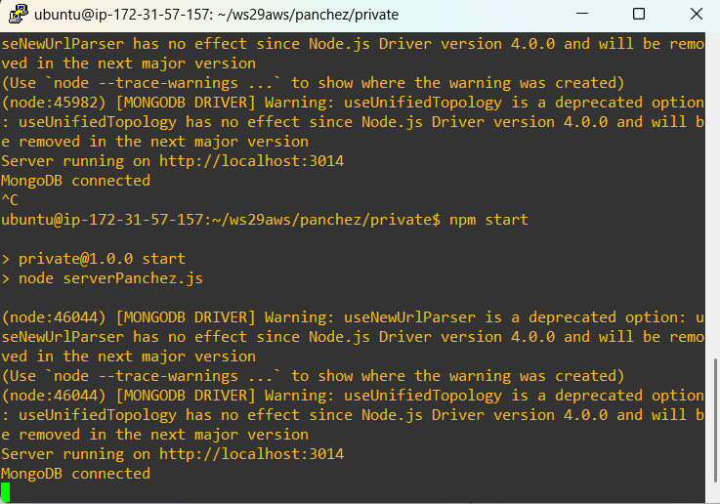

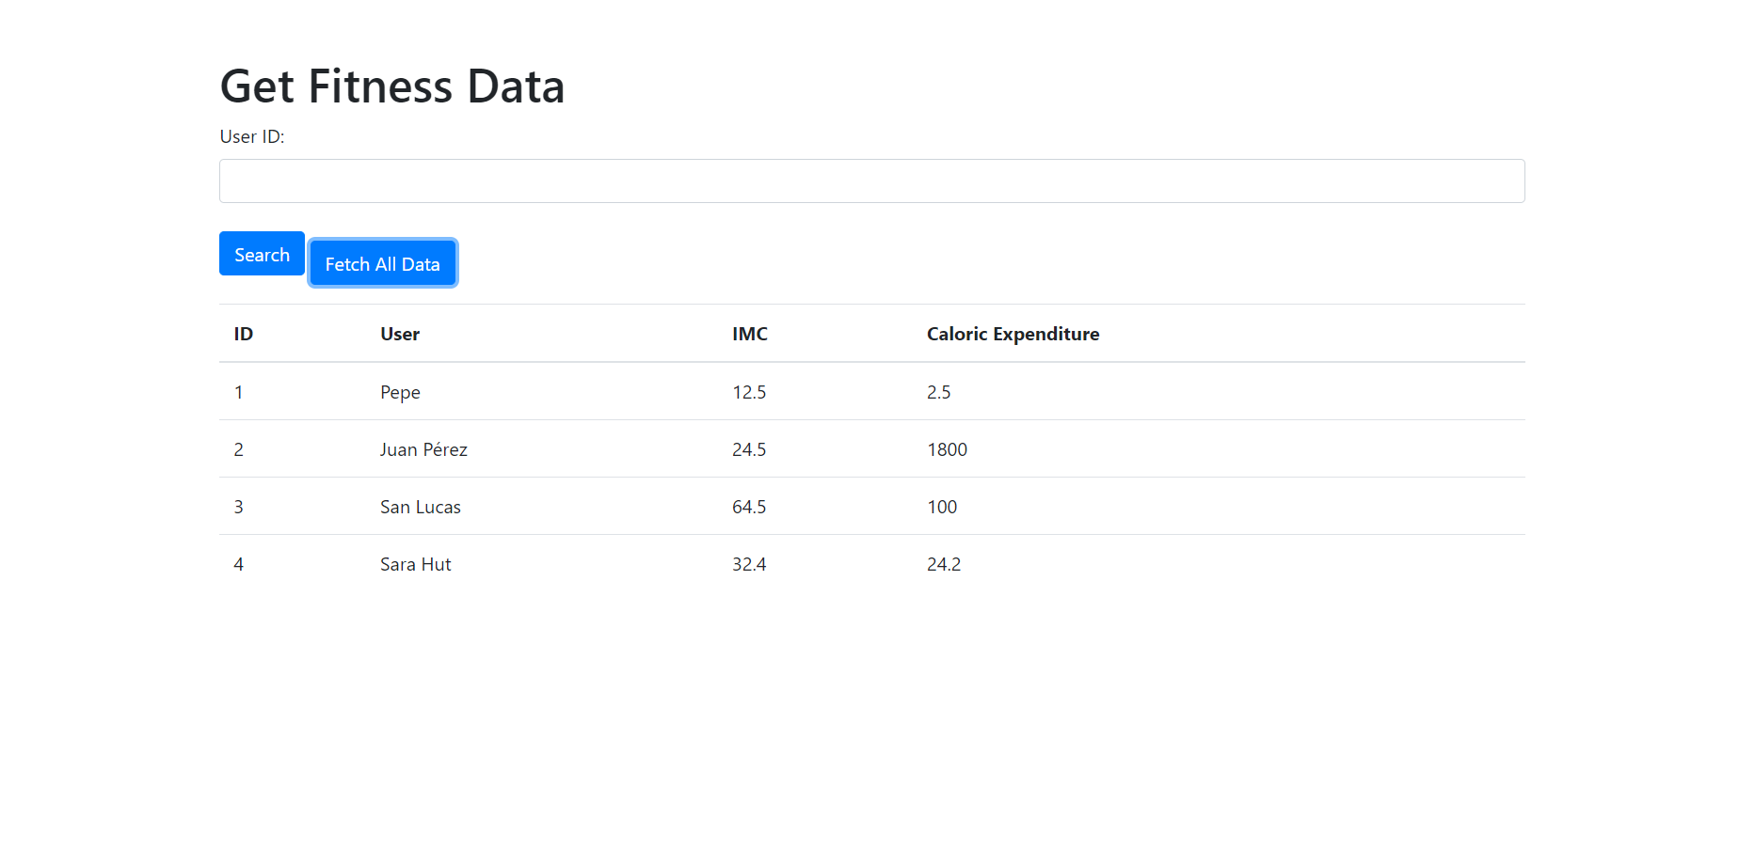

1. Proaño Jose 10/10

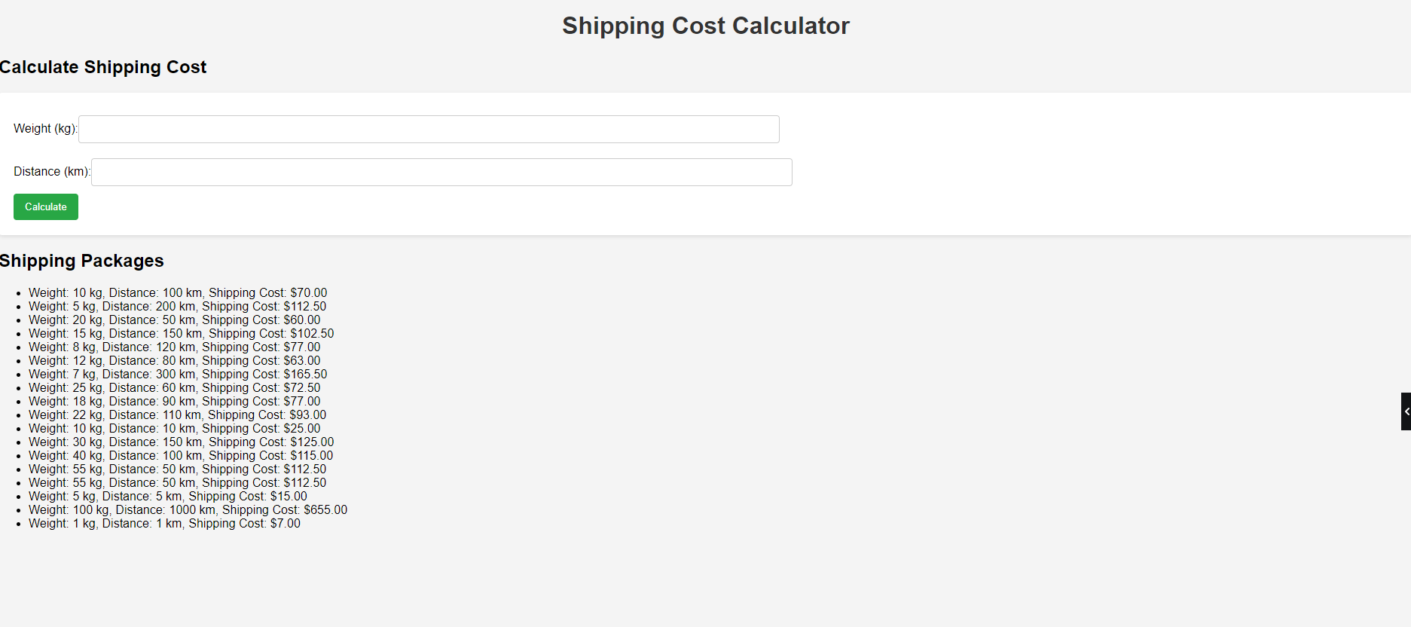

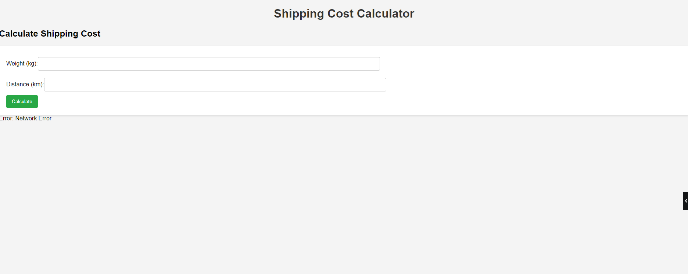

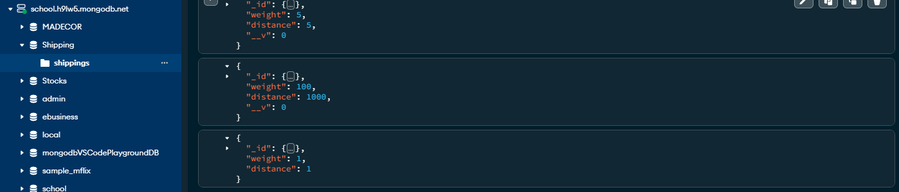

1. Salcedo Micaela 8/10

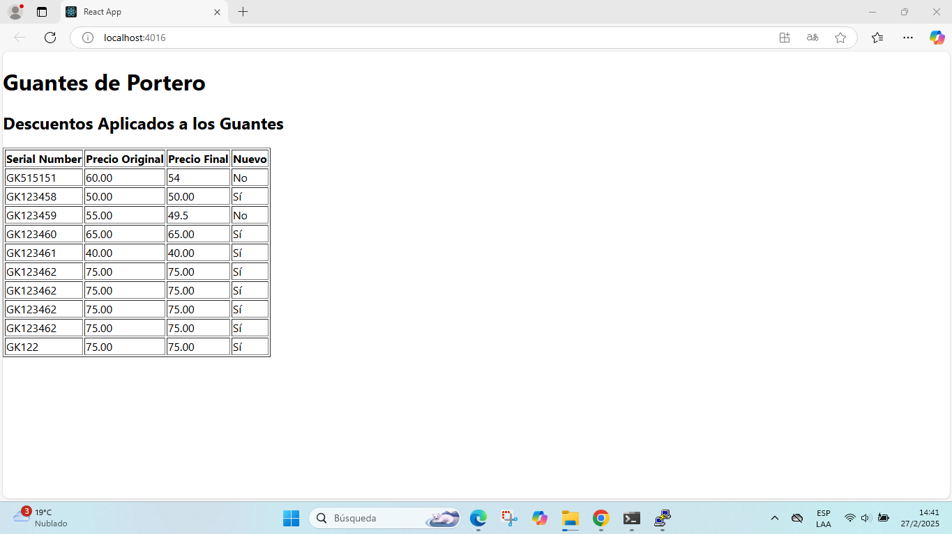

1. Sanmartin Jose 0/10
2. Suarez Matias 0/10
3. Villaroel Justin 9/10

