Putty, Ubuntu:

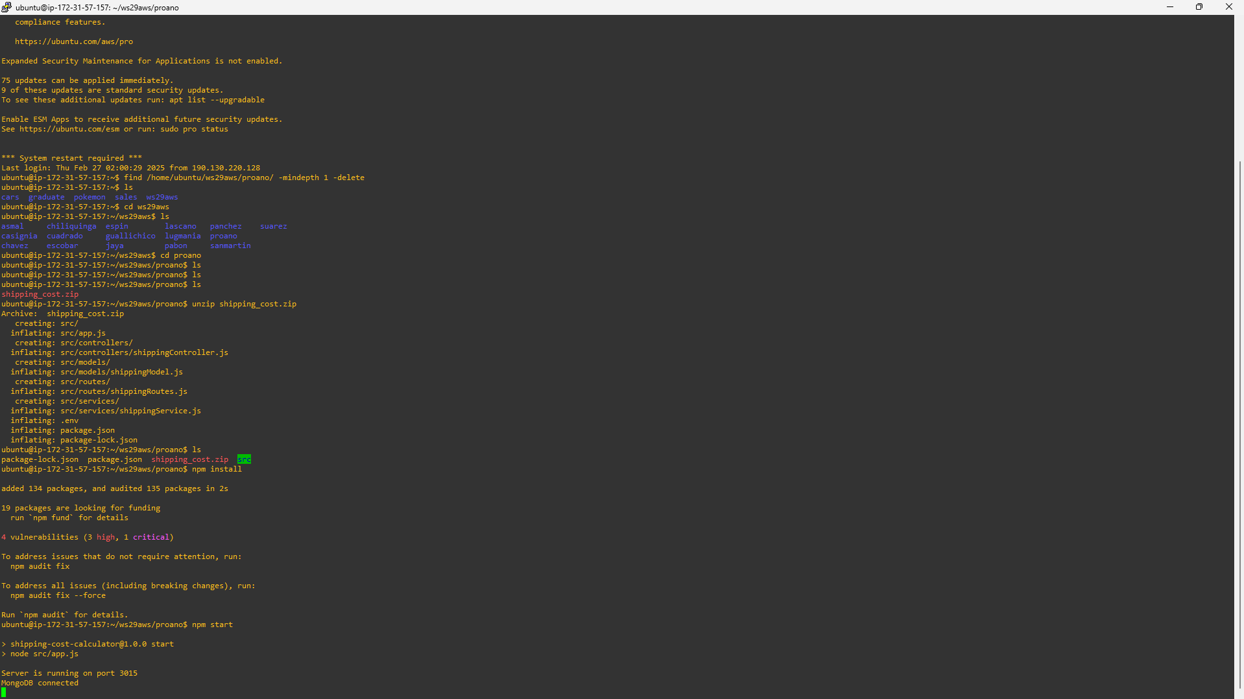

GET: (http://ec2-54-89-107-144.compute-1.amazonaws.com:3015/api/shipping/calculate-shipping-cost)

POST: (http://ec2-54-89-107-144.compute-1.amazonaws.com:3015/api/shipping/add-shipping-package)

PUT: (http://ec2-54-89-107-144.compute-1.amazonaws.com:3015/api/shipping/update-shipping-package/:id)

DELETE: (http://ec2-54-89-107-144.compute-1.amazonaws.com:3015/api/shipping/delete-shipping-package/:id)

