**UNIVERSITY OF ARMY FORCES ESPE**

**NAME:** DAVID CEPEDA

**DATE:** 30/04/2025

**WS_05_AWDProjectInspection**

Team 1: Code Synergy

Link: <https://quickquote.infinityfreeapp.com>

Project: Quick Quote Catering

Leader: Campoverde Carlos

Github: <https://github.com/CarlosCampoverde/ESPE-2025-team1-CodeSynergy.git>

Inspector Team 4: CrimsonCode,  Leader:

1. Benalcazar Moises
2. Campoverde Carlos
3. Cepeda David

|  |  |  |
| --- | --- | --- |
| TOPIC | EVAL | OBSERVATIONS |
| 1. Definition | 9.5/10 | The background wasn't explicit enough about other type features. |
| 2. SRS | 9/10 | (-0.2) there is not the table content and not well structured  (-0.2) the product perspective is not well explained  (-0.1) there's one requirement less of 10  (-0.5) The requirements are ambiguous |
| 3. Class and UC Diagrams | 7/10 | (-3) There’s only eight case of use diagram, do more use of cases to explain better the cases of use in the system, there can be other feature as (create catering) for users and manage caterings reserves for the administrator  (-1) Theres no cardinality that explains the multiplicity between the classes |
| 4. ER (10 tables)/CSV (10files) | 9.5/10 | (-0.5) The E/R diagram in their entities uses names that are ambiguous and not representative |
| 5. Mockup | 8/10 | The mockups should show how the final product should look, the mockup shown is too basic, the final user might not get the idea with the mockup presented |
| 6-7. Clean Code | 17/20 | (-0.5) Theres a mix of type of coding with camel case and snake case  (-1) Some code is in Spanish in the js and html |
| 8-9-. Functionality | 18/20 | The system works appropriately, while showing all the data fetched, but its not as efficient or usable as the SRS described it would be |
| 10. persistence (consistency) | 10/10 | The data is well prepared and manages, and the database shows the changes are done, also has control if a user has the same name in the database and other changes too |
| TOTAL | 88/100 |  |

EVIDENCE

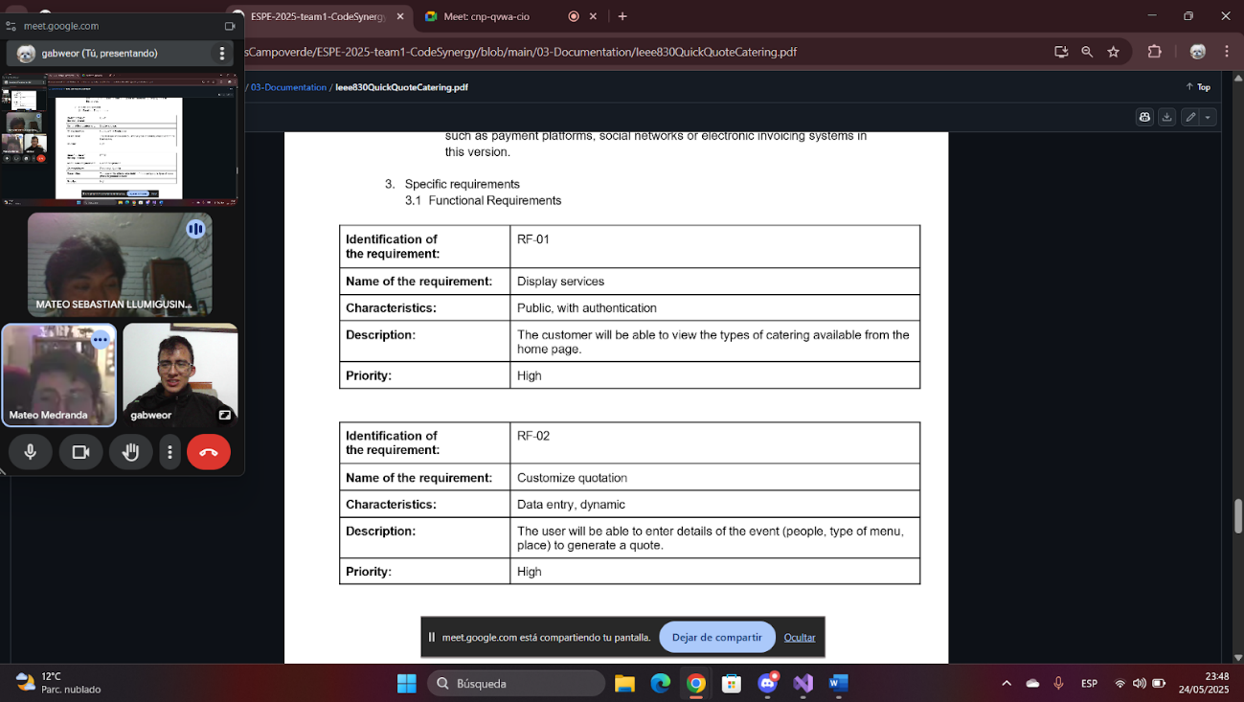

1. Definition

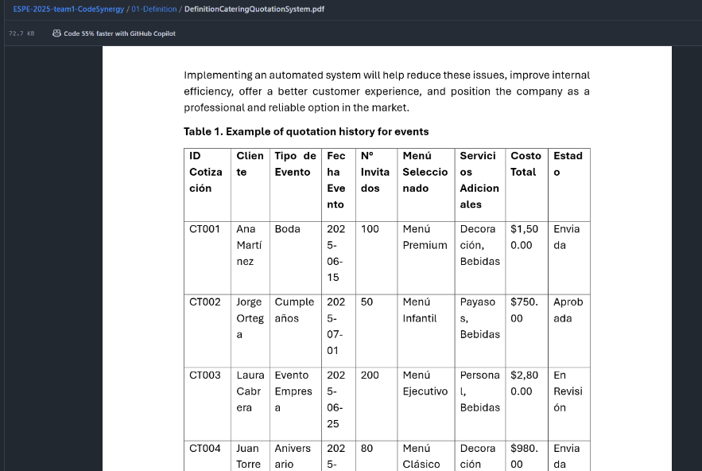

2. SRS

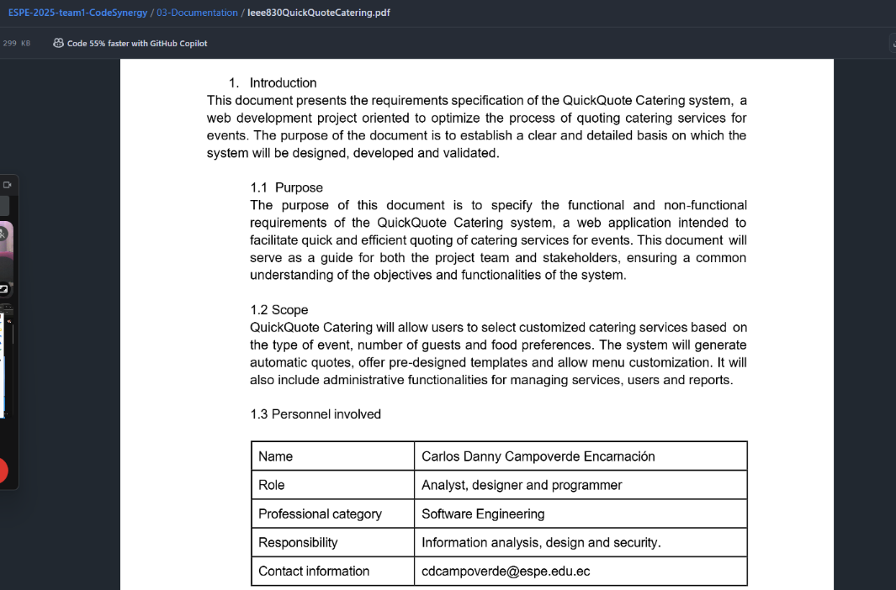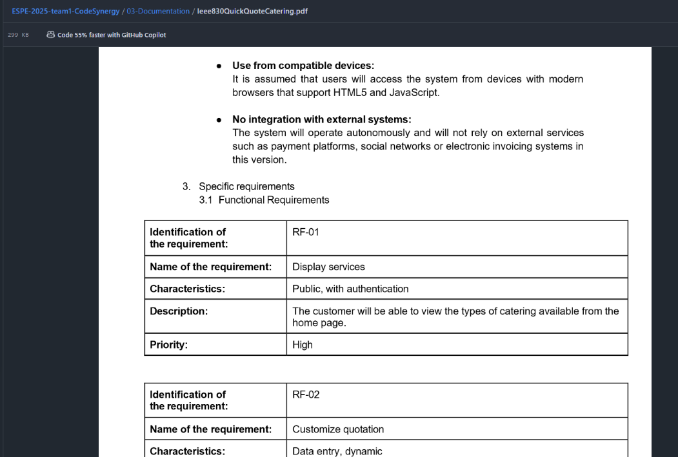

3. Class and UC Diagrams

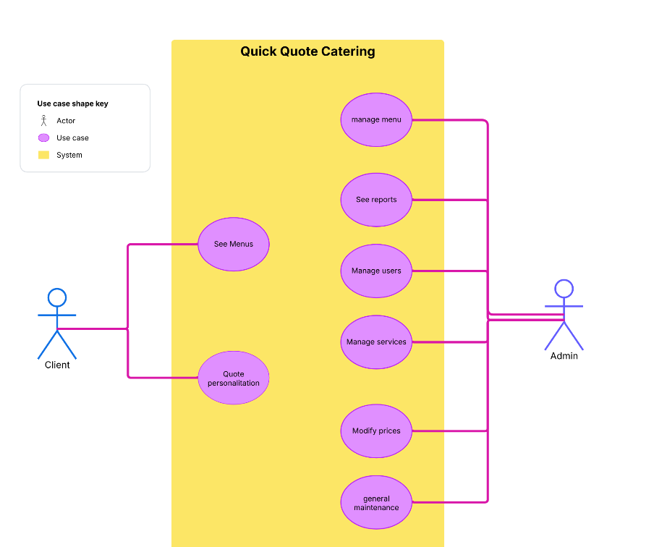

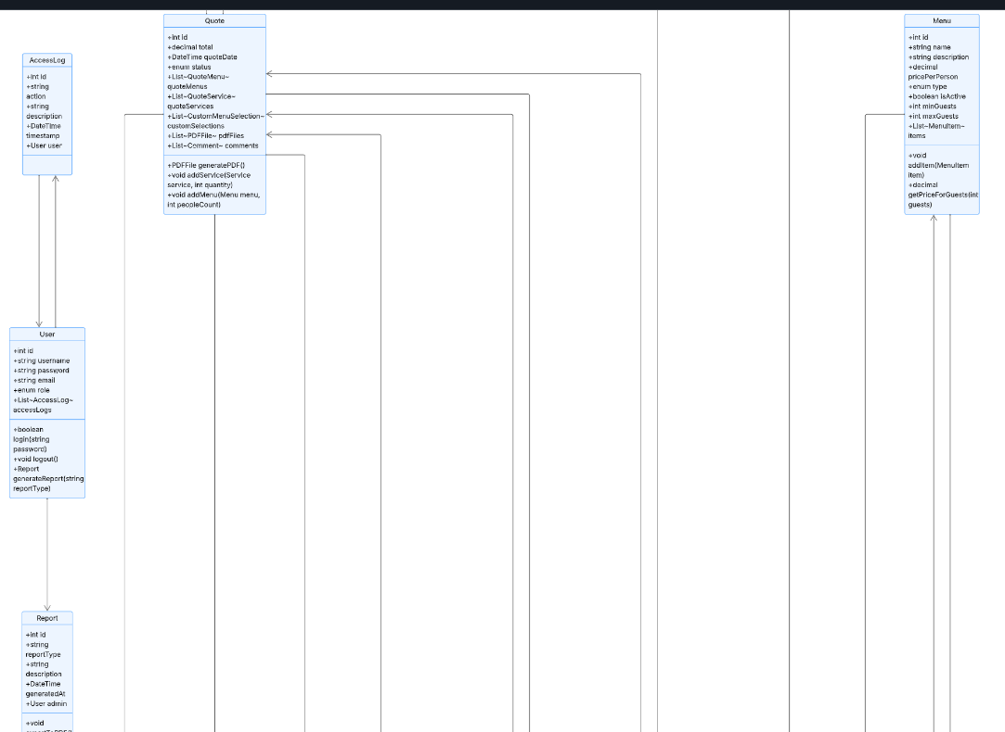

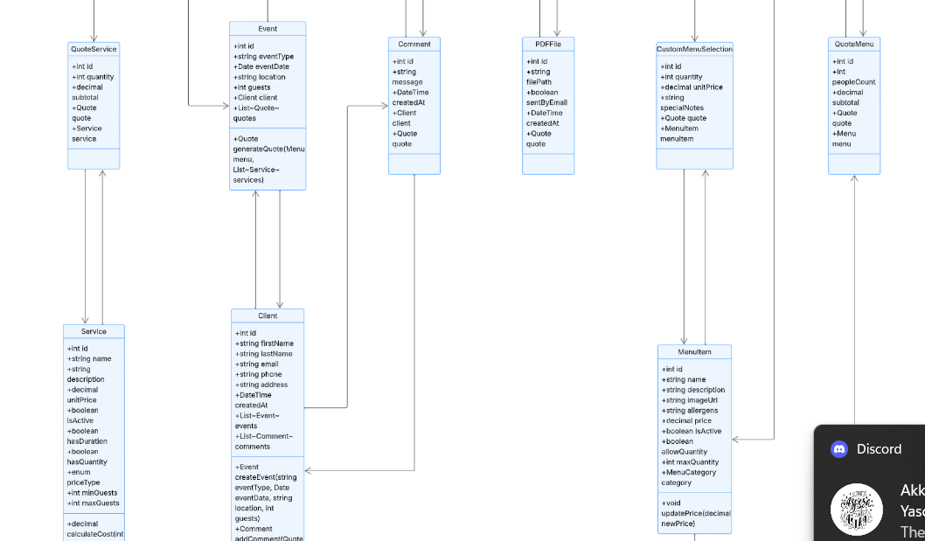

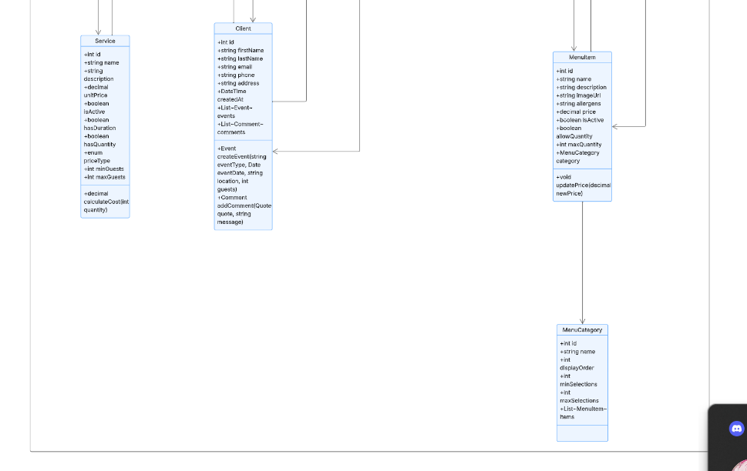

4. ER (10 tables)/CSV (10 files)

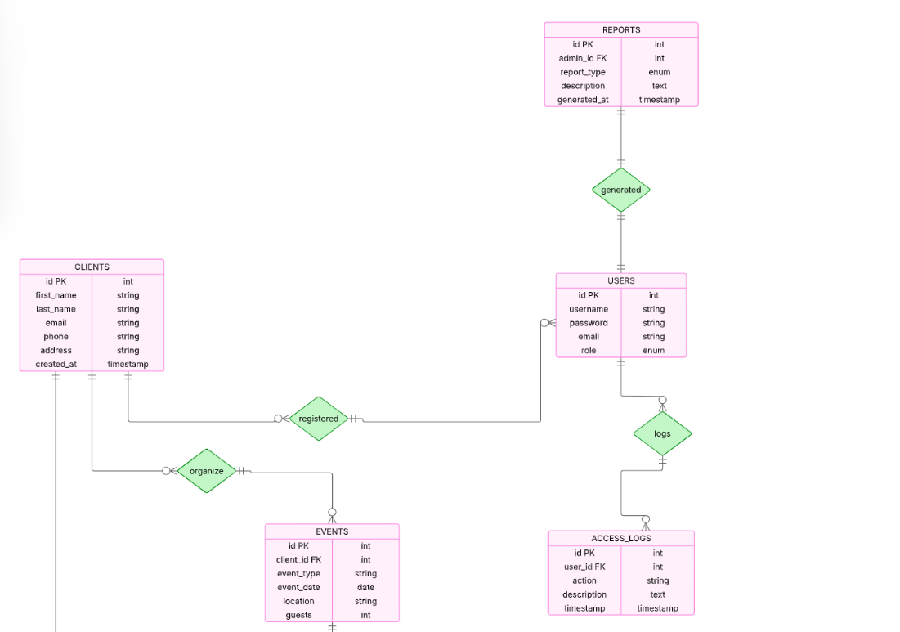

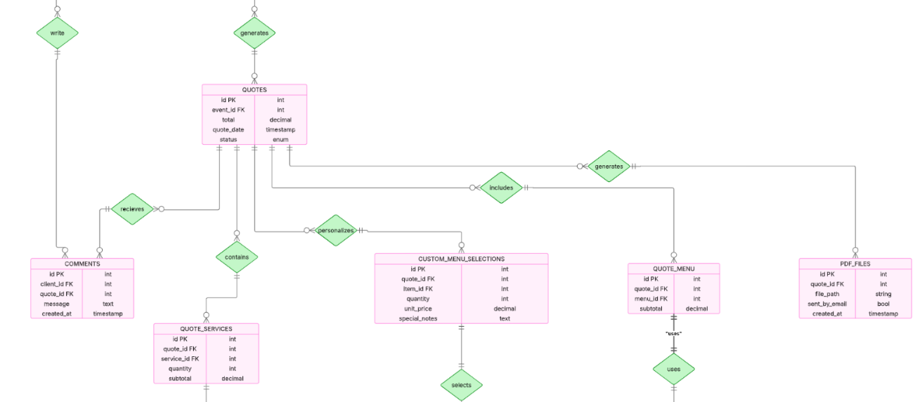

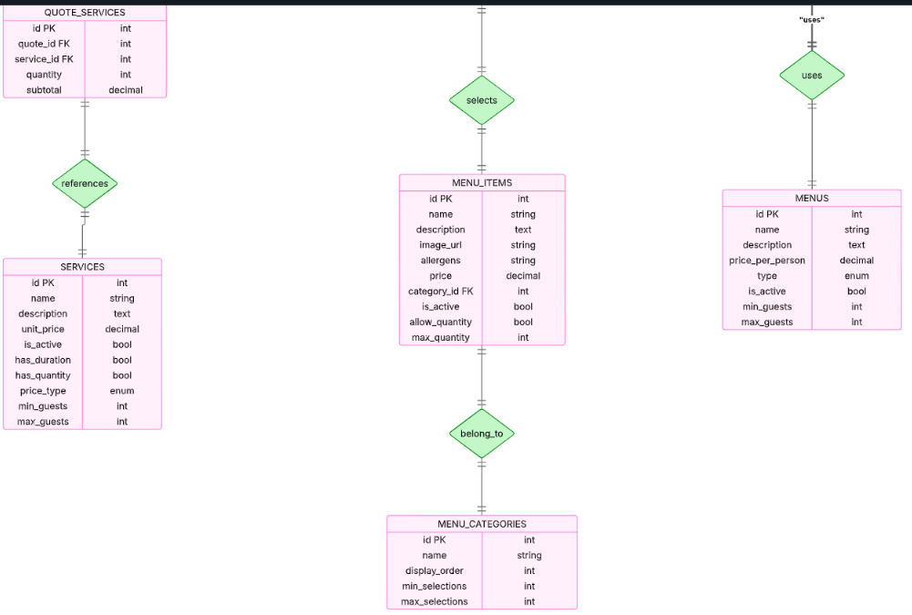

5. Mockup

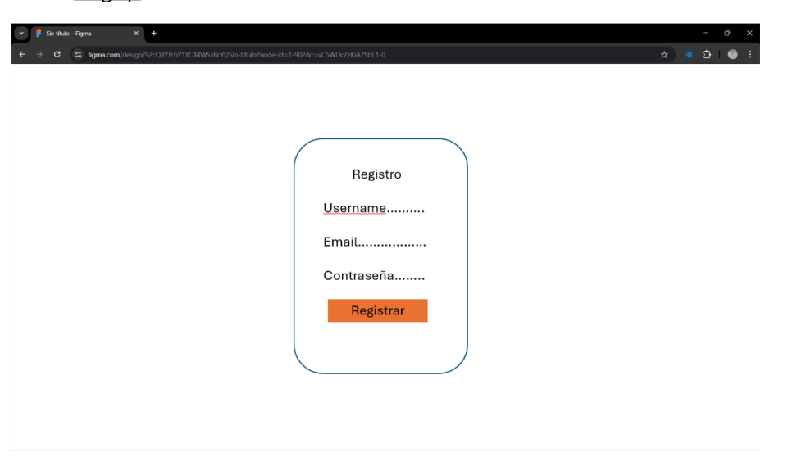

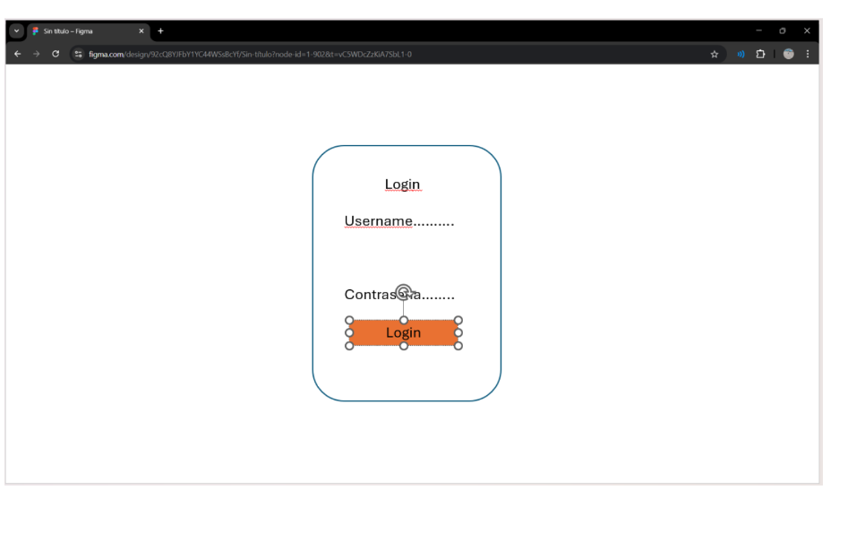

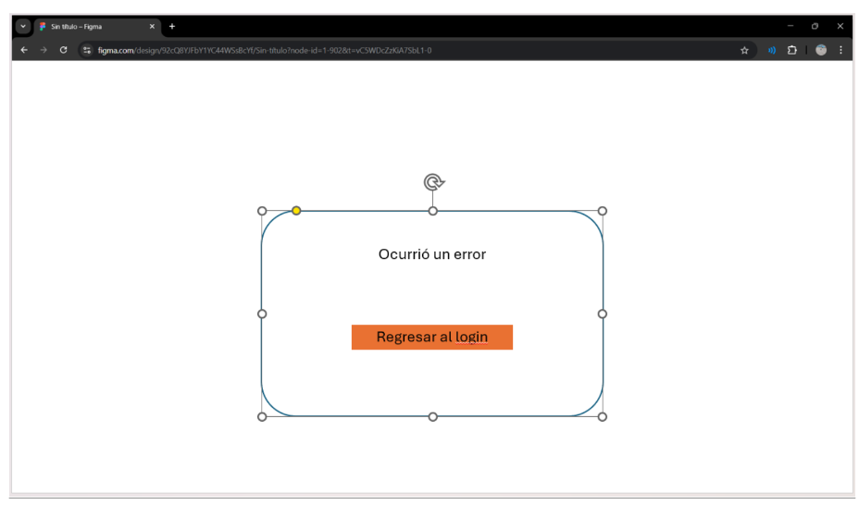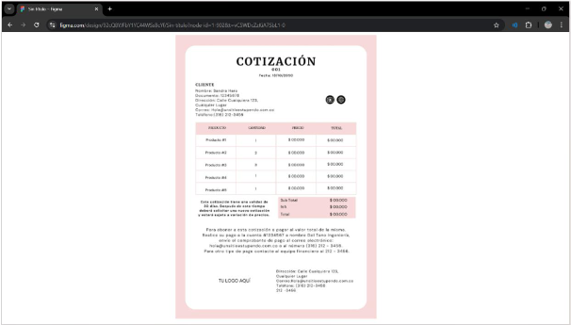

6-7. Clean Code

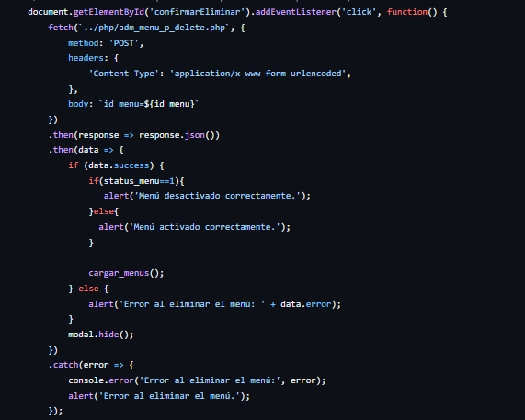

8-9-. Functionality

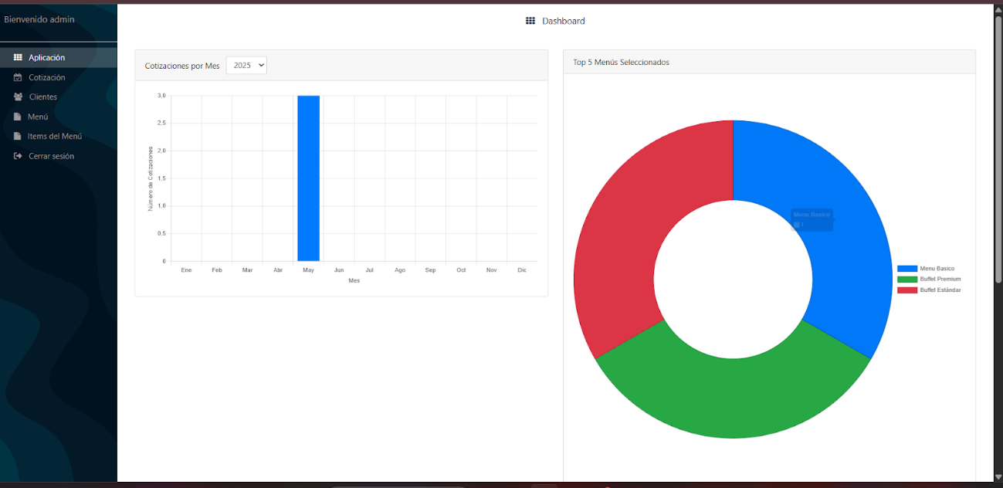

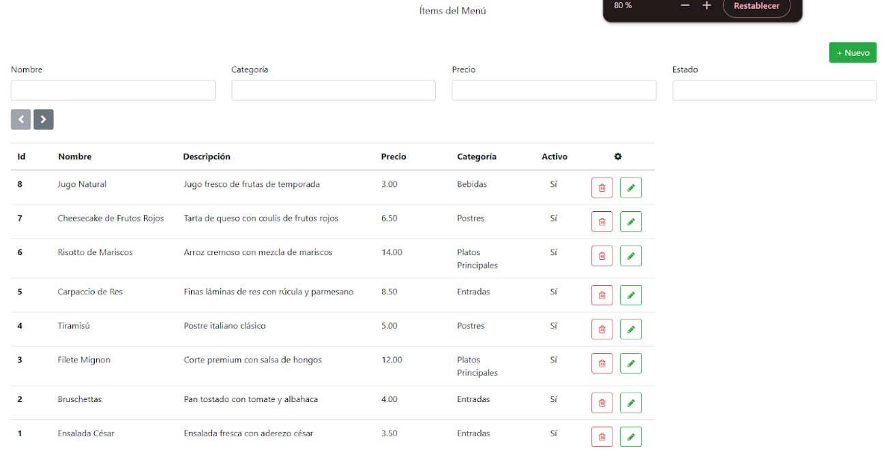

10. persistence (consistency)

