**UNIVERSITY OF ARMY FORCES ESPE**

**NAME:** DAVID CEPEDA

**DATE:** 30/04/2025

**WS_07_ExamInspection**

1. CEPEDA SALGUERO DAVID GUSTAVO

Inspector: Carlos Campoverde

architecture: 0/10

mockup: 10/10

calculate:0/10

show: 10/10

clean code: 7/10

mockup=10

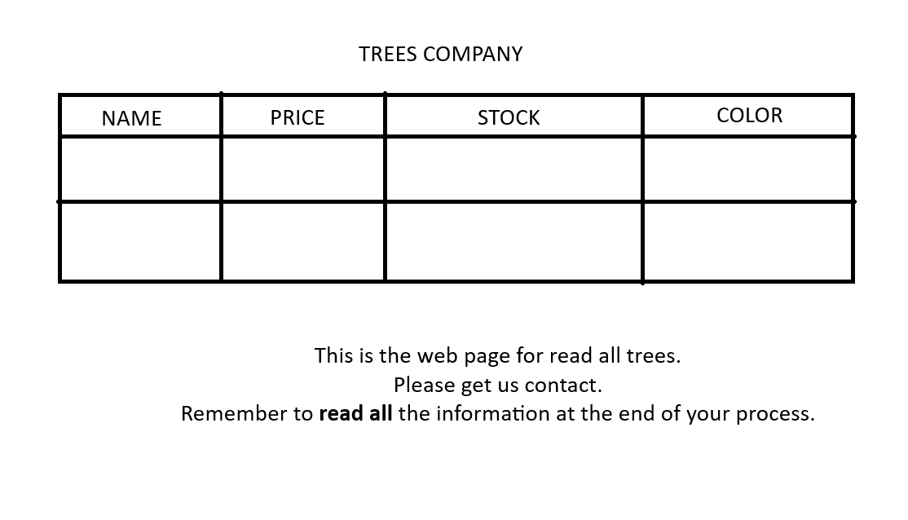

mostrar=10

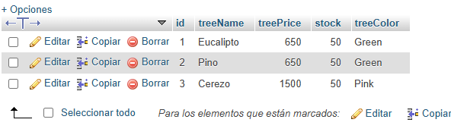

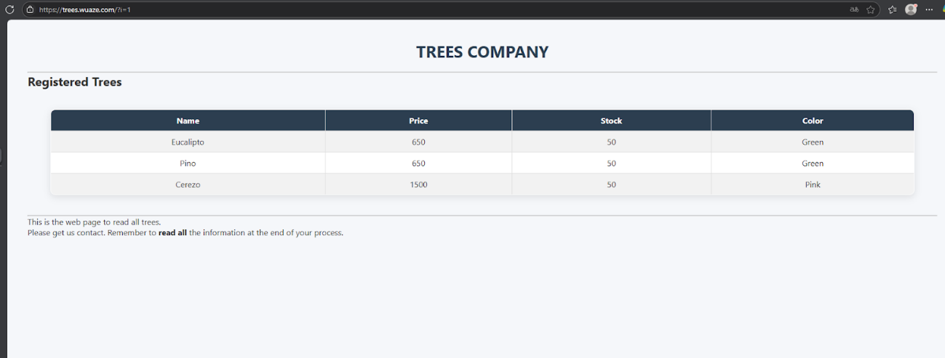

el calculo estaba en el js del filemanager

clean code=7

