

**DCCO**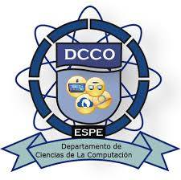

**Second Semester**

**Homework 07 DevelopEnvironment**

**OOP - 23217**

**Professor: Edison Lascano**

**2025-05-11**

**HW07DevelopEnvironment 11/5/2025**

Caizapanta Tammy

Screenshot:

