INSPECTOR T3(Knowledge Encapsulated), Leader: LOZA QUISHPE STEVEN SEBASTIAN
PROJECT INVESTIGATION T1:TAP. Leader: CARVAJAL BENITEZ JOSUE GABRIEL
Project: Parking LOTS
GitHub: https://github.com/MattOso182/T1-OPP-Parking
Data Folder: data
EVIDENCE:
Ord. Artifact, evaluation/10, observations:
1. Overview
Its overview is very well structured, there is not much to say

2. SRS
It was not possible to identify functional requirements with non-functional requirements in a good way.
Features
2.1. Register entry and exit of people who are rotating.
2.2.Track parking space status (available or occupied) dynamically.
2.3.Assign and manage parking spot.
2.4.Verify user and visitor authorization for access control.
2.5.Search and verify vehicle or license plate information.
2.6.Validate and update vehicle. registration automatically.
2.7.Manage rentals and temporary parking assignments.
2.8.Generate reports and usage statistics automatically.
3. Prioritized Features
The features are very well structured, there is not much to say

4. Tasks
Some tasks did not match the commits they made.

5. Plan
Their plan was quite well structured but perhaps some activities could not be carried out in the time they specified.
Design
6. Architecture
The program worked quite well, the detail that was found is that a clean and build had to be done

7. Use Case
Quite well structured, there is not much to say, perhaps it is too simple

8. Class Diagram
It's well done but it has a lot to cover and sometimes it's a little confusing to understand.

9. Mockups
Prototype:
CMD,
10. functionality validation
Works pretty well

Order / Artifact |  | Evaluation/10 | Observations
1. Overview |  | 10 | OK
2. SRS |  | 8 | functional requirements alongside non-functional requirements
Features | 3. Prioritized Features | - ok  - ok  - ok  - ok  - review the data  - ok  - ok  - ok | correct part of records.
 | 4. Tasks | 8.5 | Some tasks do not match the commits in their repository
 | 5. Plan | 9 | ok
Design | 6. Architecture | 8.5 | It works well, but to start, we had to do a clean and build in order for it to compile.
 | 7. Use Case | 9 | ok
 | 8. Class Diagram | Class: 8.5  Atributts: 9  Methods: 8.5 | fulfills attributes and methods
 | 9. Mockups | 8.5 | The system requires the common feature which is security
Prototype: cloud | 10. Functionality validation | 10 | ok

MEET EVIDENCE:
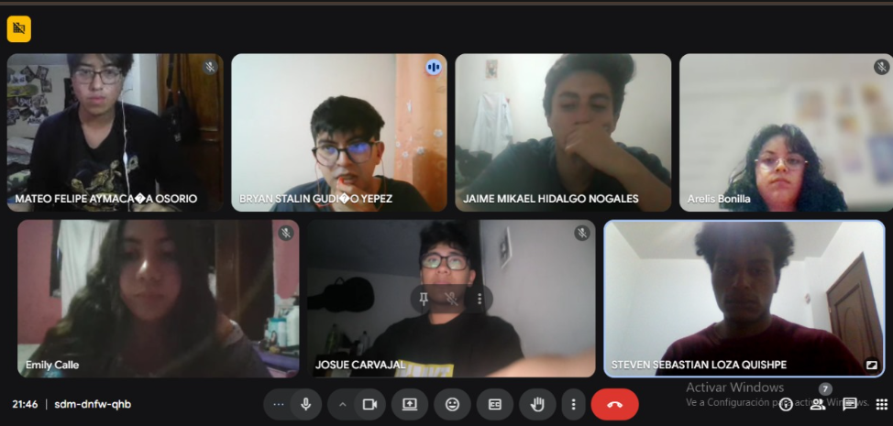

EVIDENCE CODE:
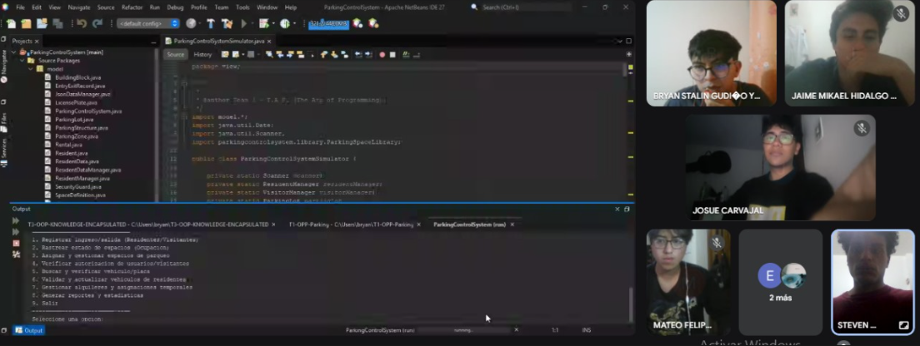

EVIDENCE .JSON:
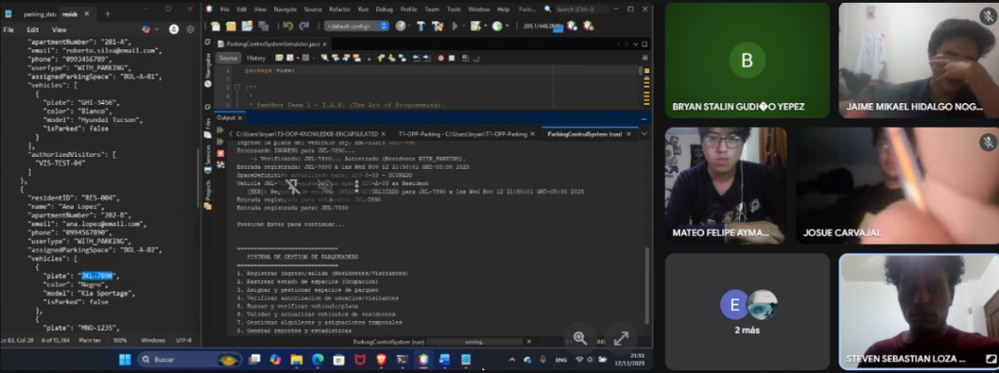
EVIDENCE OF COMMITS:
