Bryan Gudino (JAVA) #9

BubbleSort
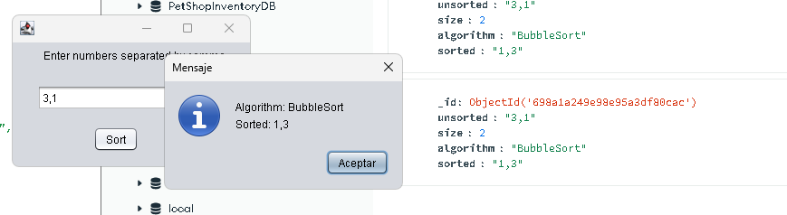
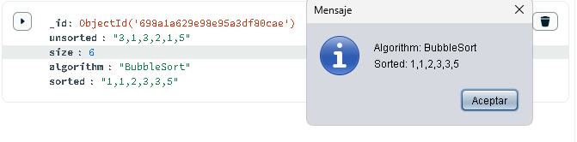
InsertionSort
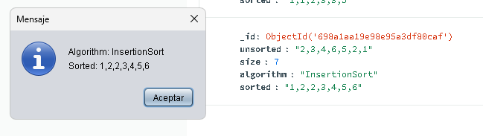
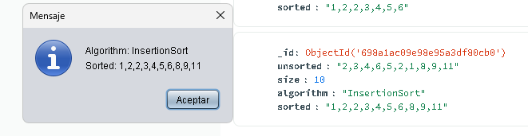
QuickSort
