MongoDB
Compass: mongodb+srv://Emily:<db_password>@cluster0.ynnit6l.mongodb.net/
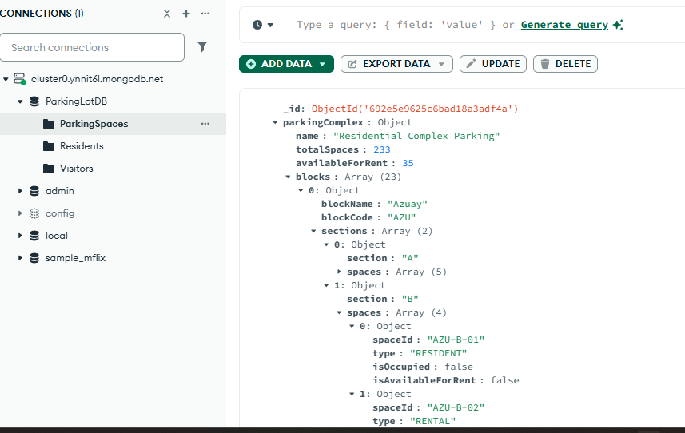
Shell: mongosh "mongodb+srv://cluster0.ynnit6l.mongodb.net/" --apiVersion 1 --username Emily

