HW17-Homework17

Group to review:

T2:Object Masters. Leader: CEVALLOS PAGUAY MATEO DAVID
Project: Creative Studio
GitHub: https://github.com/cevallosmateo07-byte/T2-OPP-CreAltiva-Studio/tree/main
Inspector: , Leader:
5. CEVALLOS PAGUAY MATEO DAVID
6. CHALAN YAMBERLA KEVIN ANTHONY
7. CHICAIZA SAMBACHI FERNANDO DANIEL
8. COLLAGUAZO NAZATE PABLO JOSE

Rubric:

 | Evaluation/10 | Observations:
1 Overview | 10 | It is well written, it clearly describes what will be done
2 SRS | 9 | The requirements are well written, however they were not very clear.
3. Prioritized Features | 10 | Features are well prioritized according to the functions the program will perform.
4. Tasks | 8,5 | The established deadlines were not met.
5. Plan | 10 | Complied with the established plan for the features
6. Architecture | 10 | They ran the program in console mode and with JSON files as requested.
7. Use Case | 10 | The use cases are well organized and are consistent in both the code and the diagram.
8. Class Diagram | 9 | The diagram was mostly correct except for some associations that were not very clear.
9. Mockups (Prototype:  CMD, ) | 9 | The prototype fails validation when entering data.
10. functionality validation | 9 | A correct date validation is missing.

Observation:
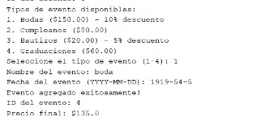

The screenshot shows that the date validation is missing; it allows any year, any month, and any day to be entered.

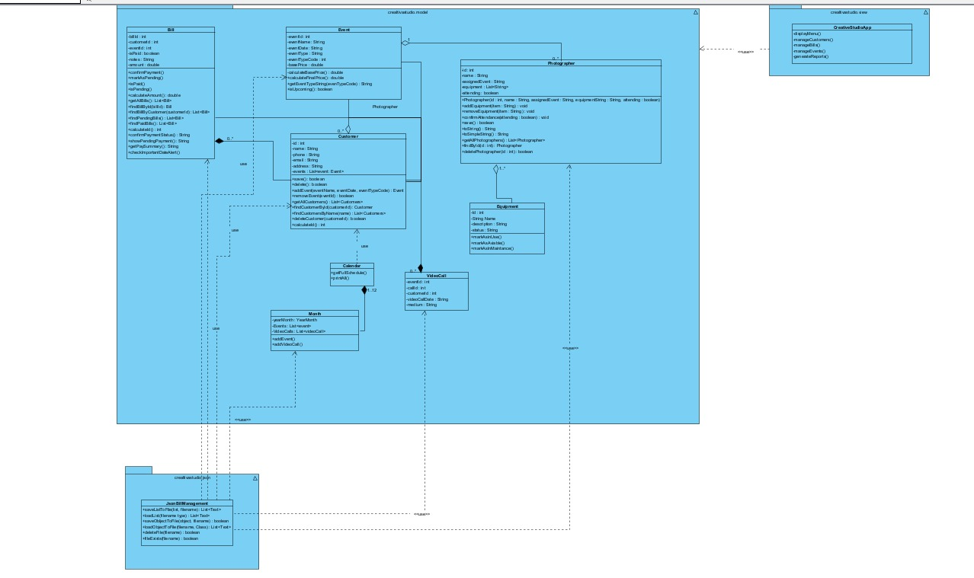
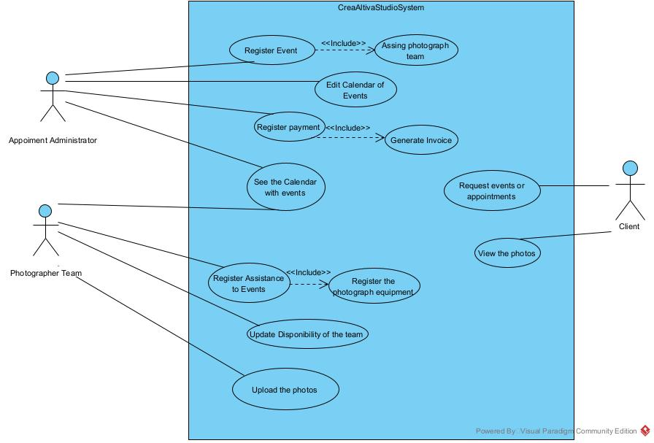

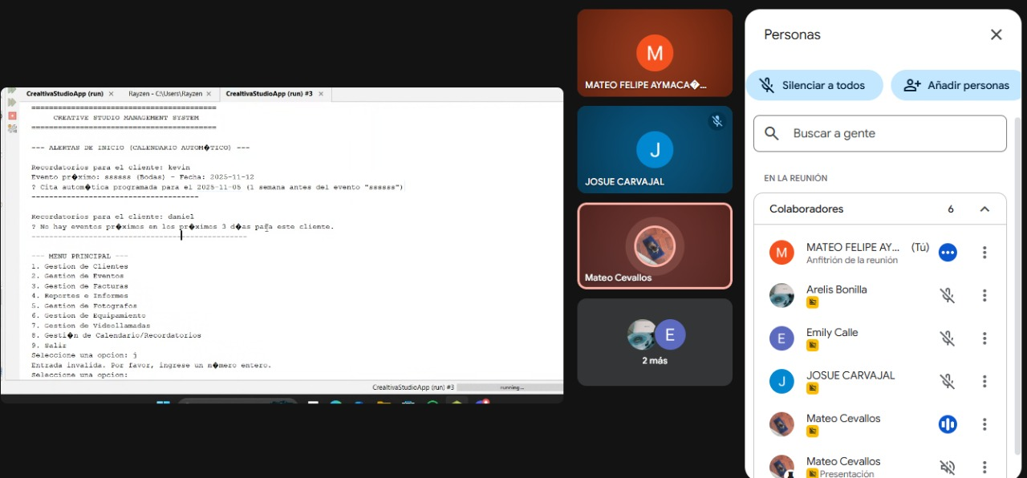

Note - Evidence of the meeting

