

Universidad de las Fuerzas Armadas

DEPARTMENT OF COMPUTER SCIENCE

Object-Oriented Programming
ws16: UnitTest

Edison Lascano PhD
NRC: 36862



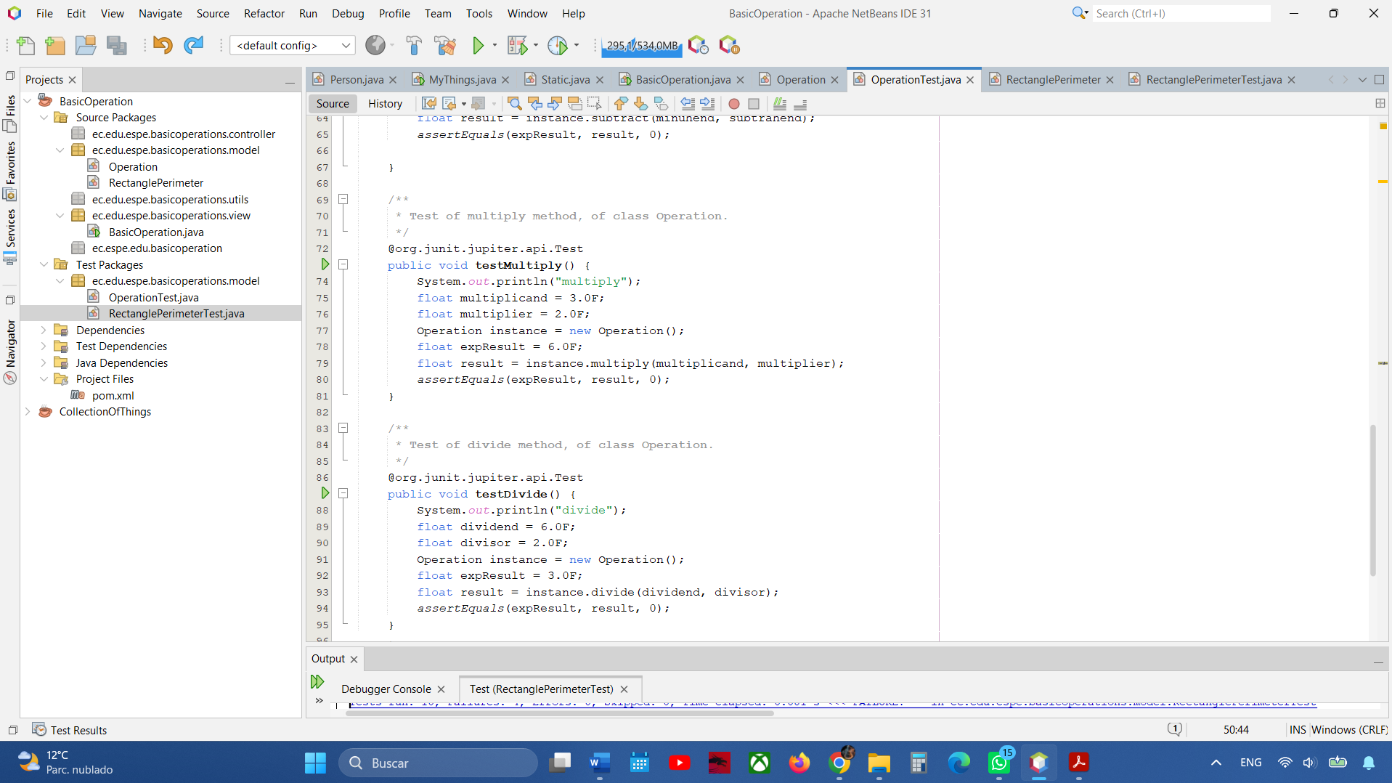
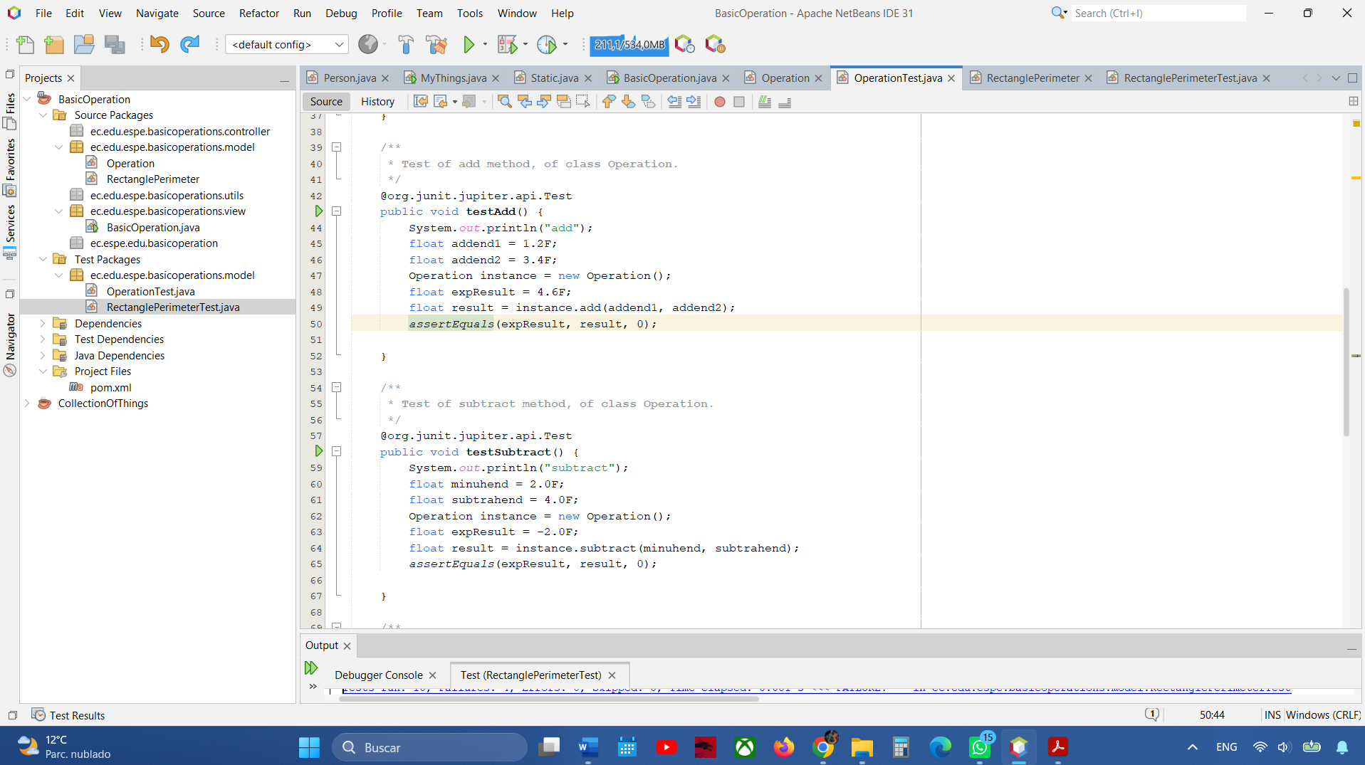
.

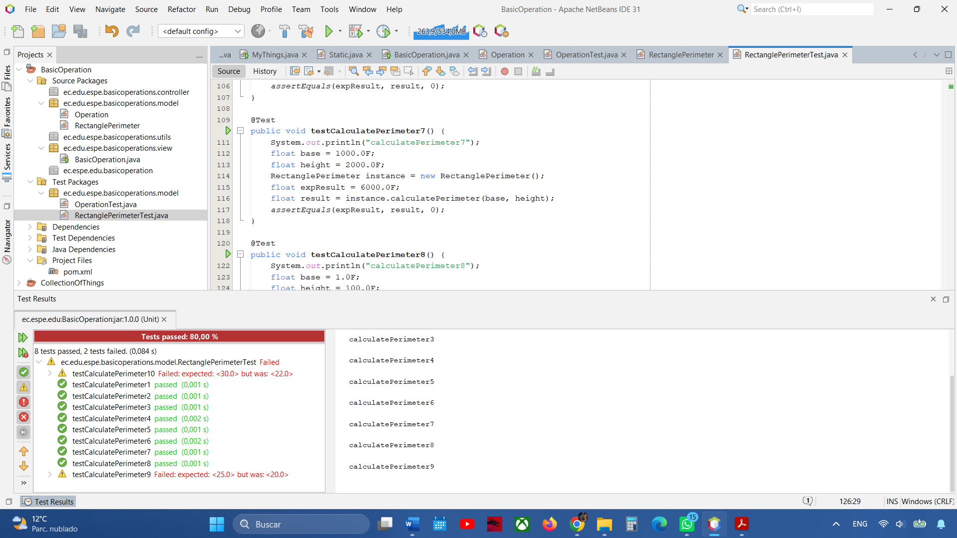
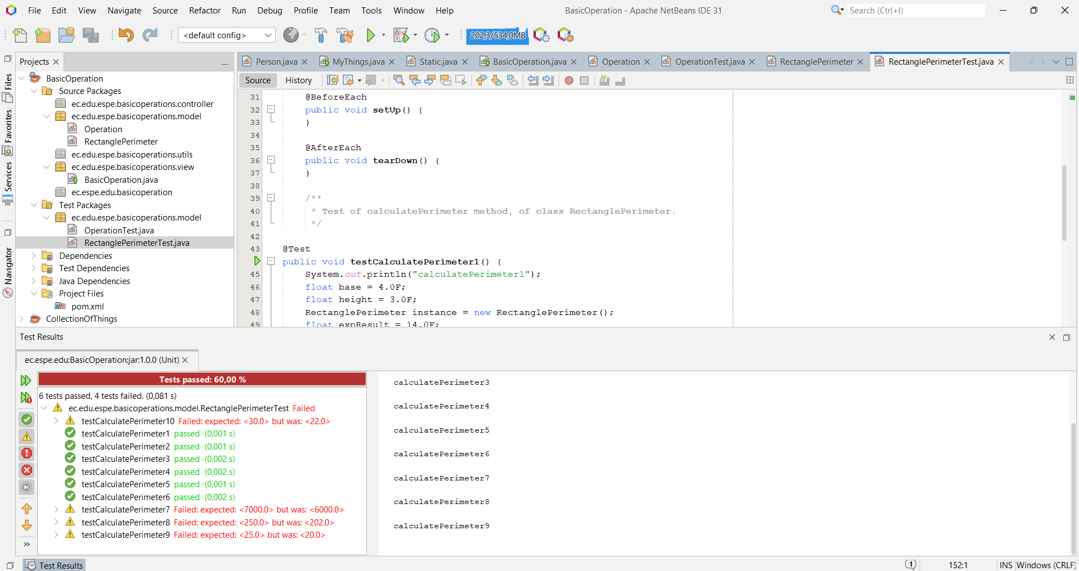
My exercise (RectanglePerimeter)

