Evidence
Hello.py
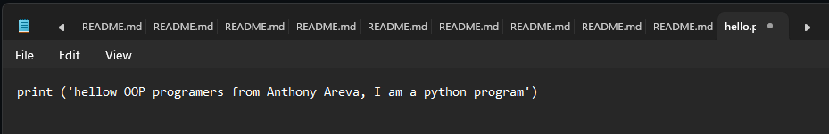
Functions.py
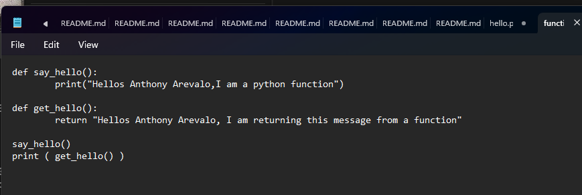
Hello.ts
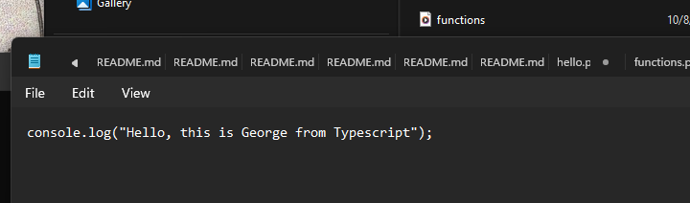
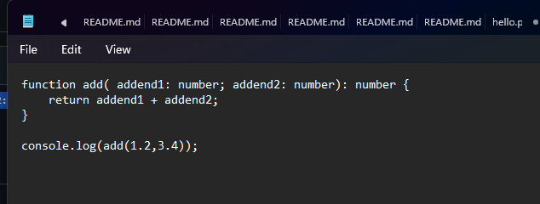
Functions.ts

Hello.java
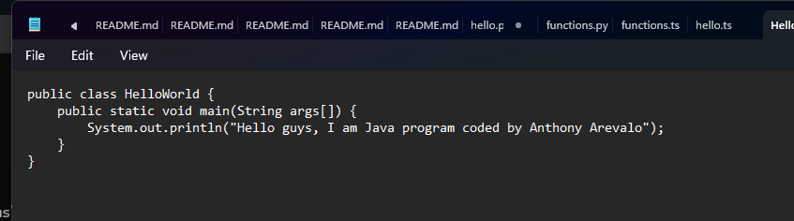

Run the consola
