

UNIVERSITY OF THE ARMED FORCES - ESPE

Department of Exact Sciences
Object - Oriented Programming

PROJECT PROPOSAL
Eurotoldo Event Management System

JORGE EDISON LASCANO

October 05, 2026

OBJECT-ORIENTED PROGRAMMING
PARTIAL 1 – WORKSHOP 1
INSTALLATION EVIDENCE
Student: Dylan Cumbajin
Course: Object-Oriented Programming
Workshop: 1
Partial: 1
Date: October 2, 2026
Verification of Installed Software
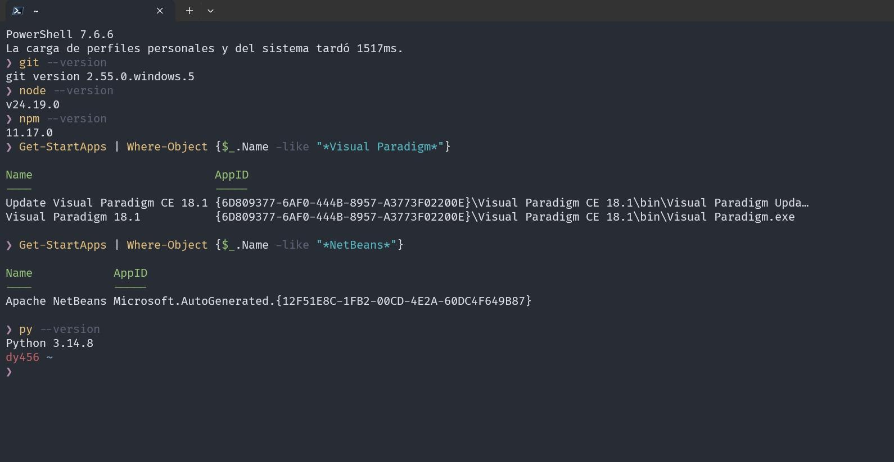
1. Git Installation Evidence
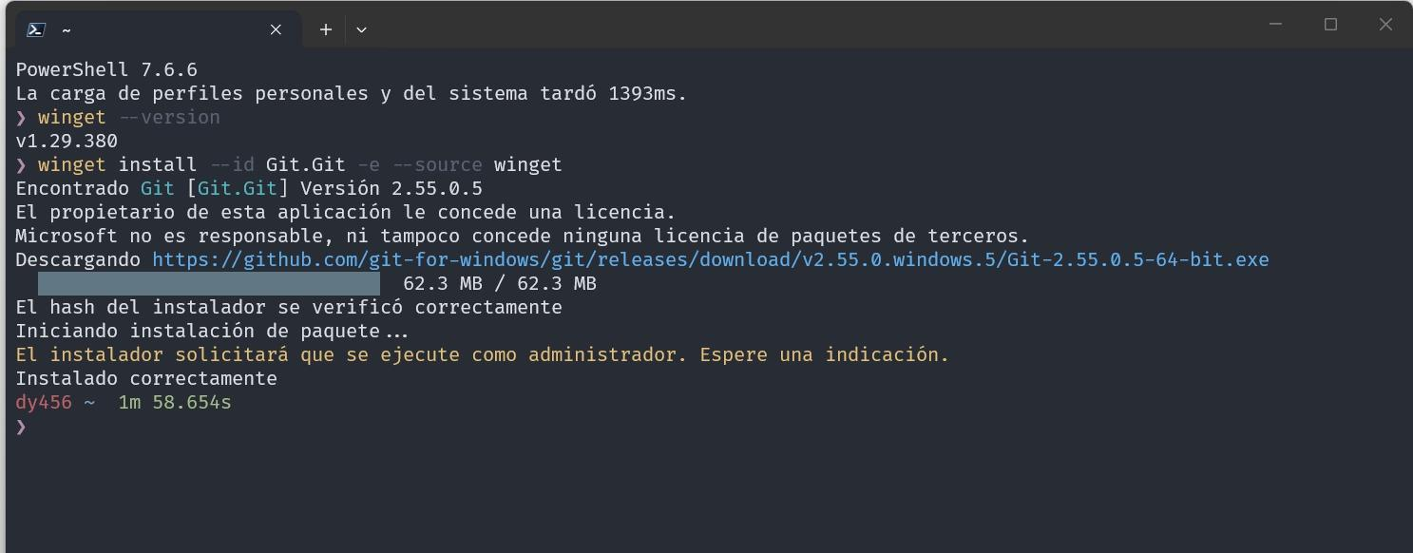
2. Node.js Installation Evidence
The software was already installed on the computer.

3. Python Installation Evidence
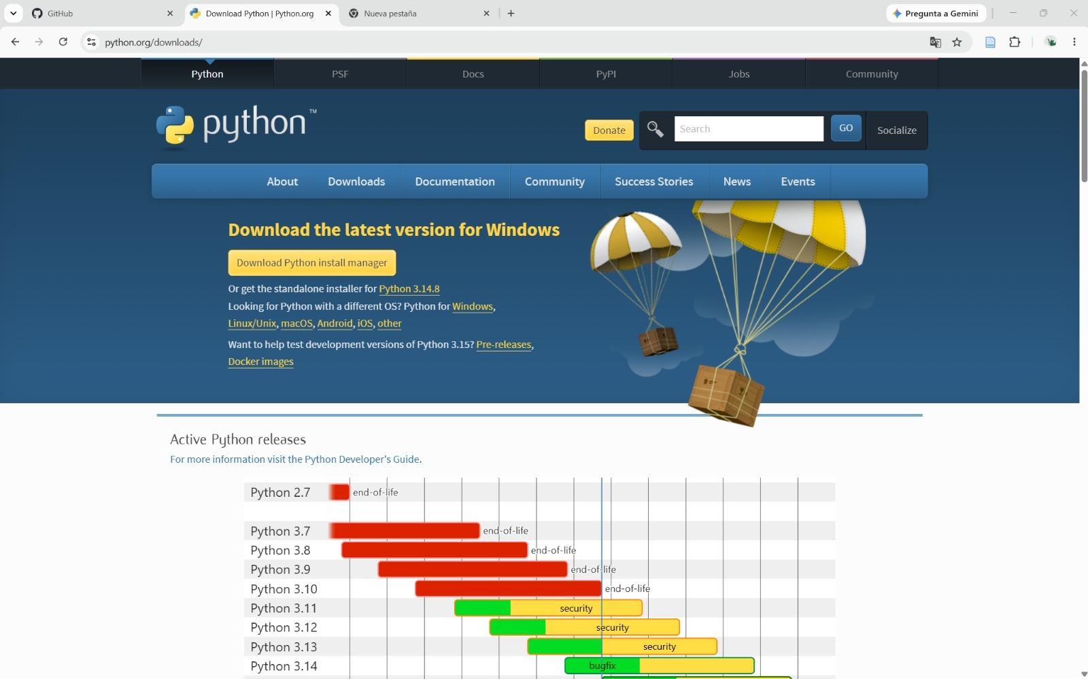
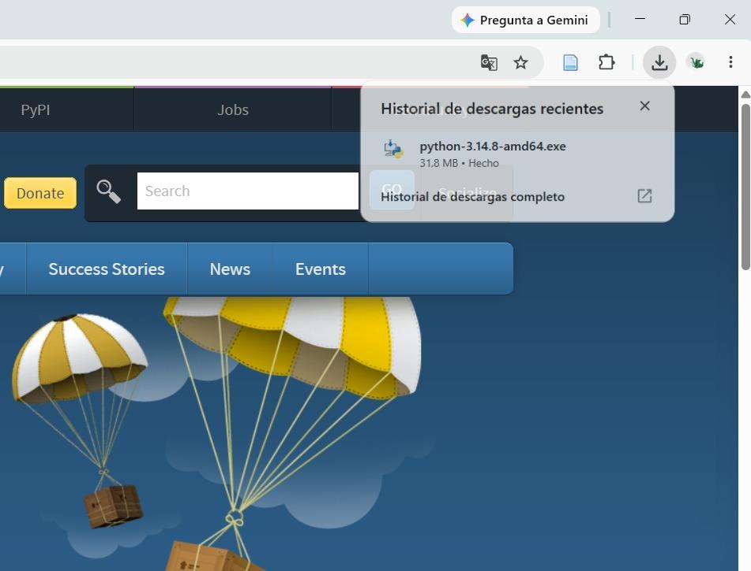
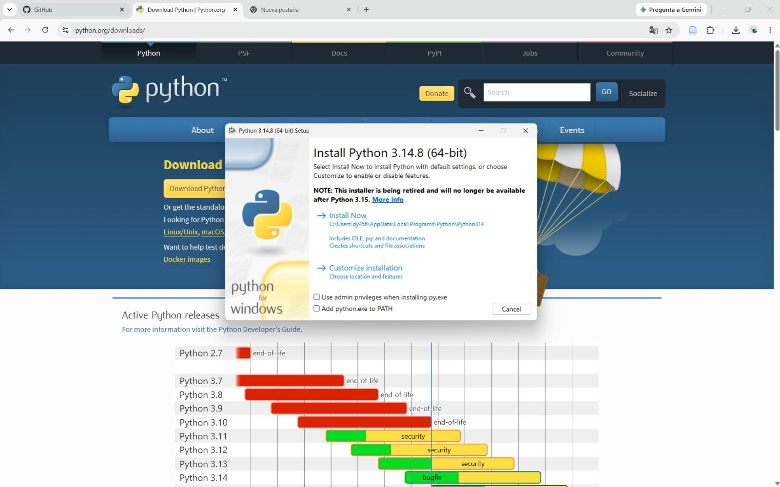

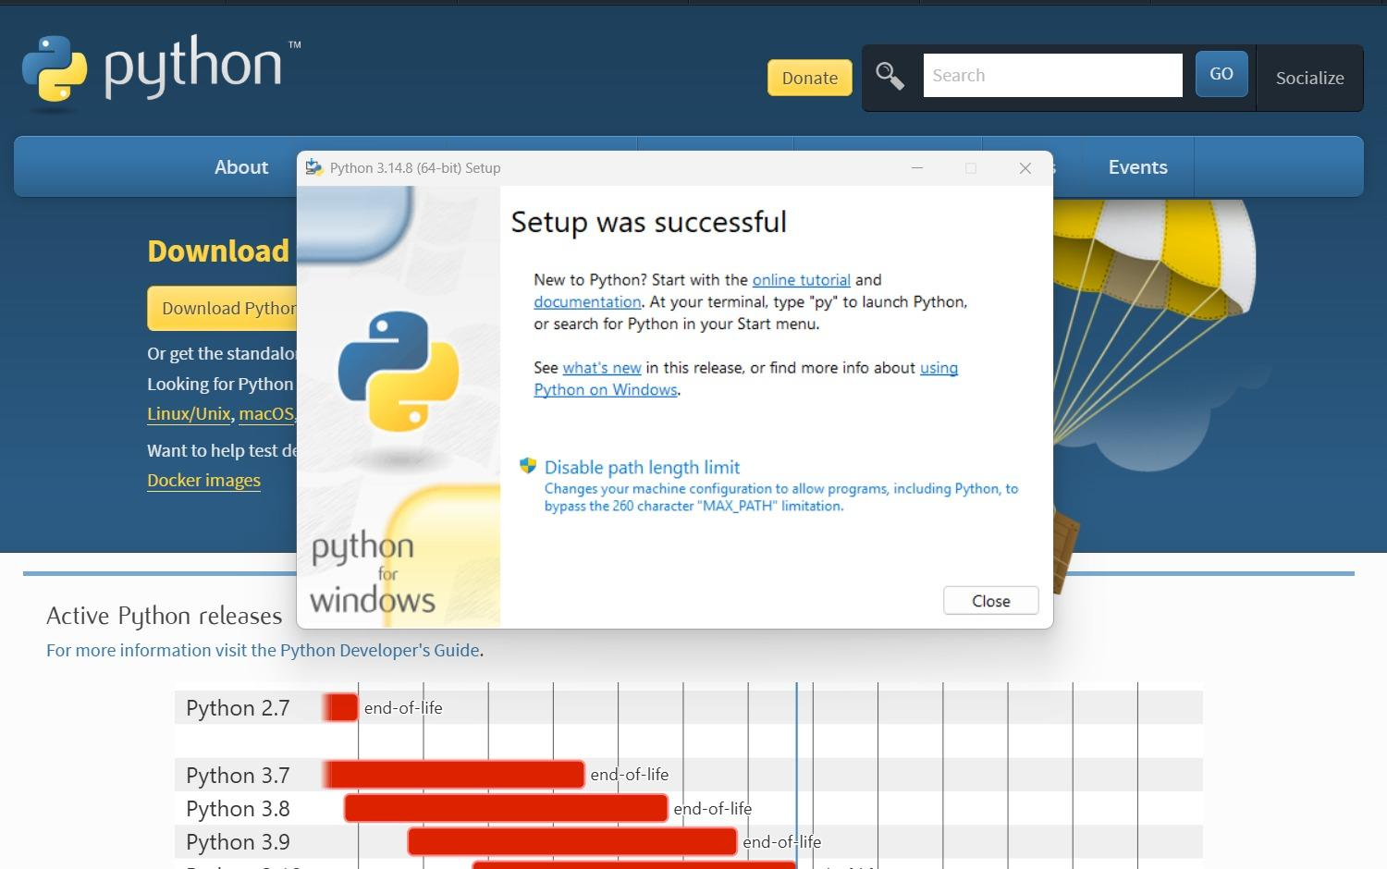

4. Apache NetBeans Installation Evidence
The software was already installed on the computer.
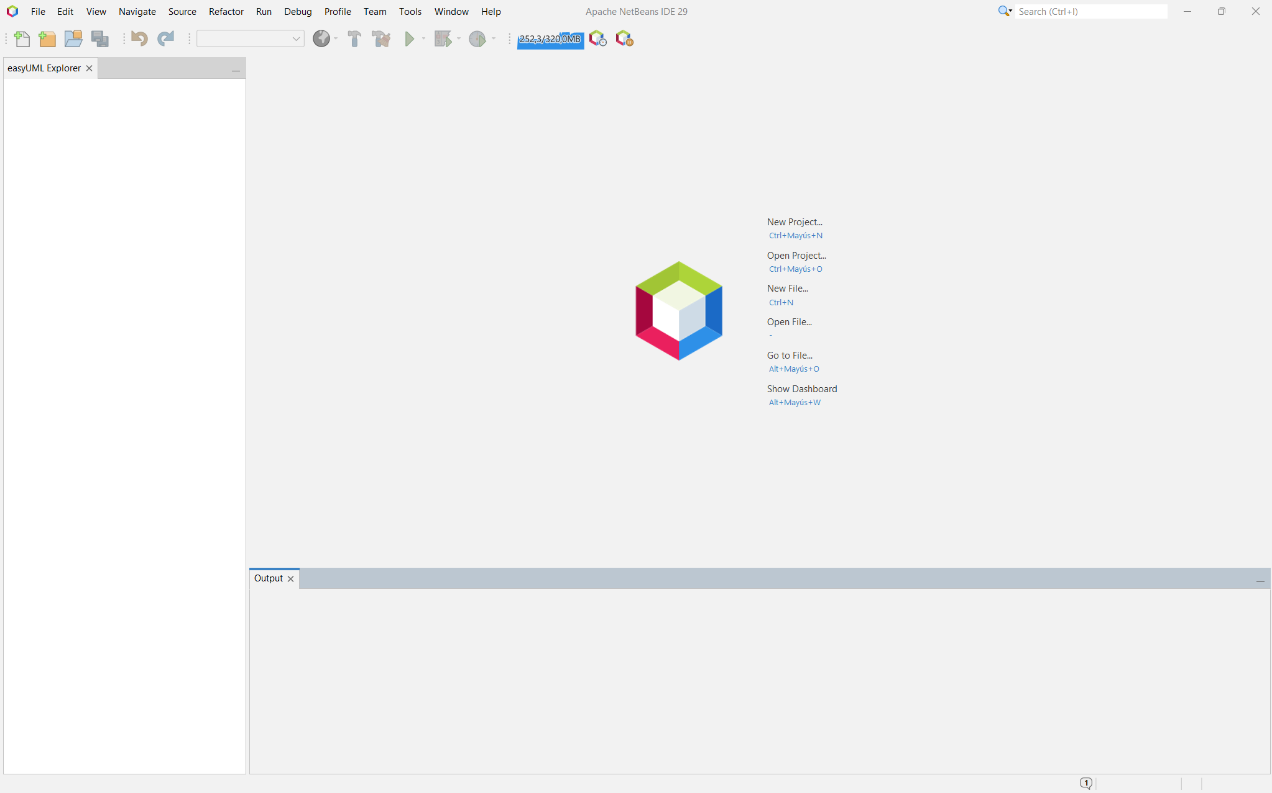

5. Visual Paradigm Installation Evidence



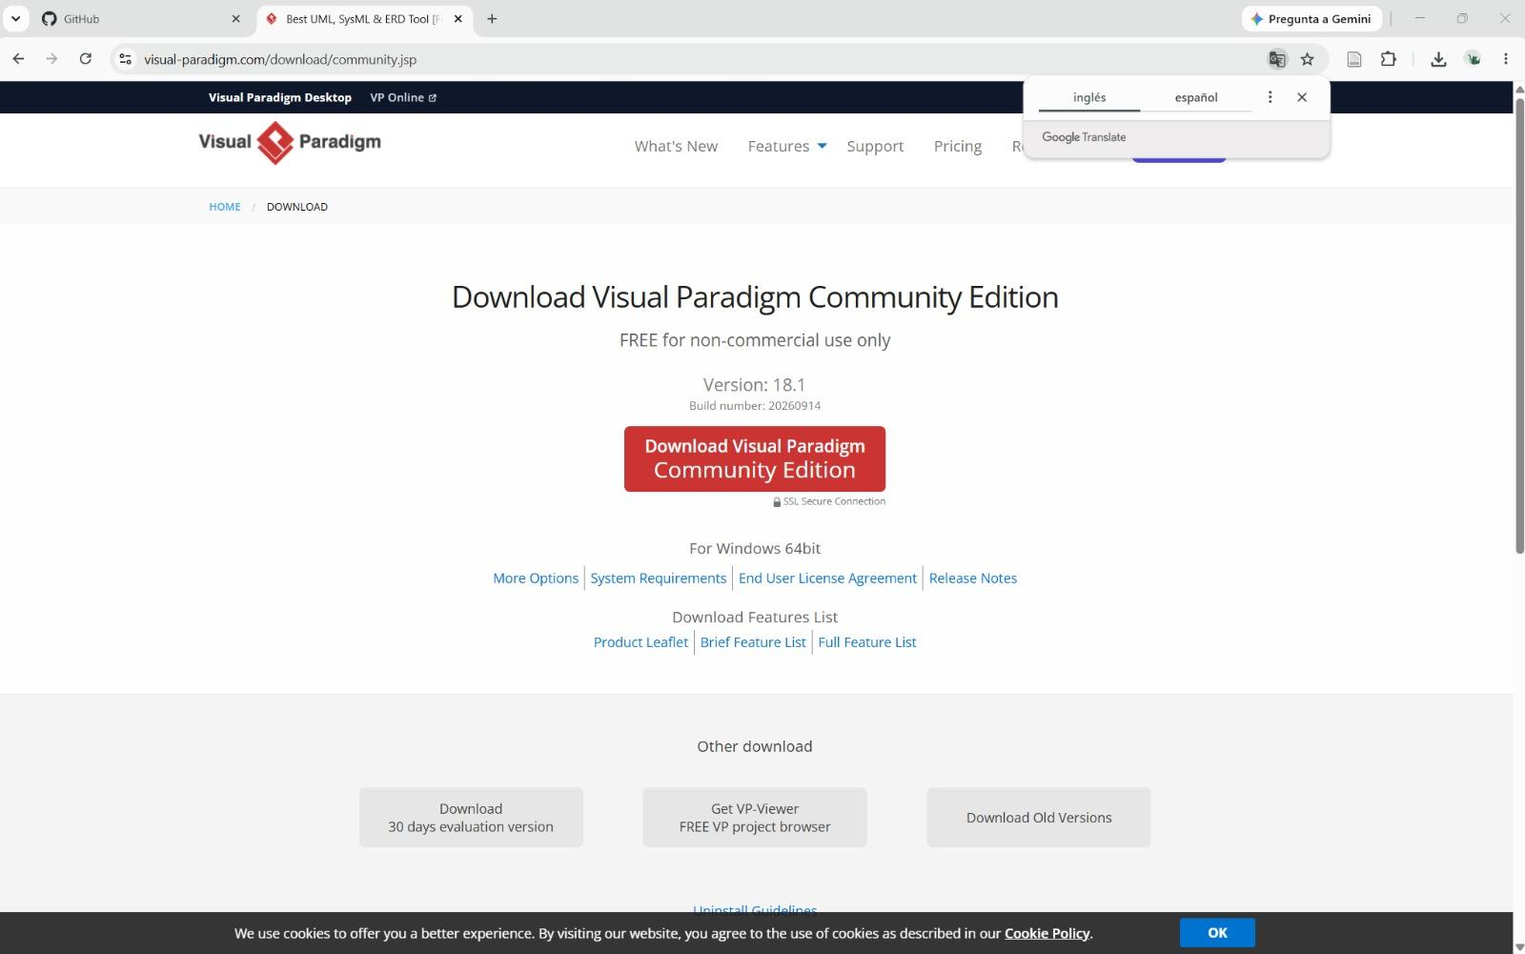

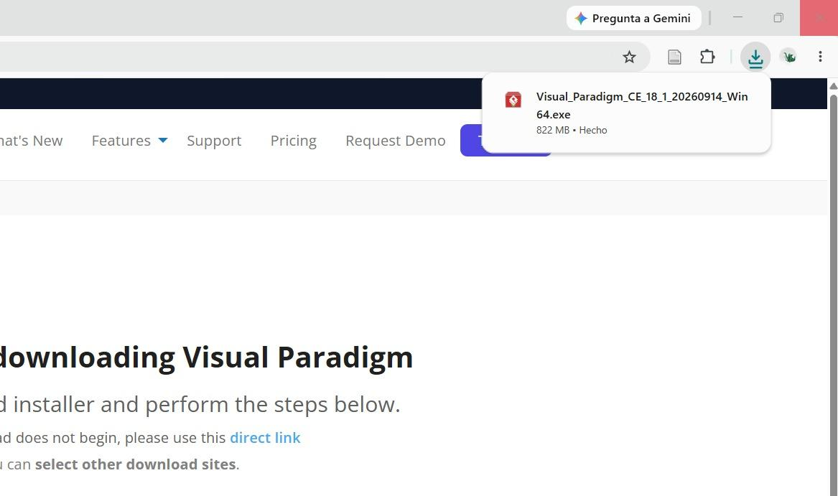

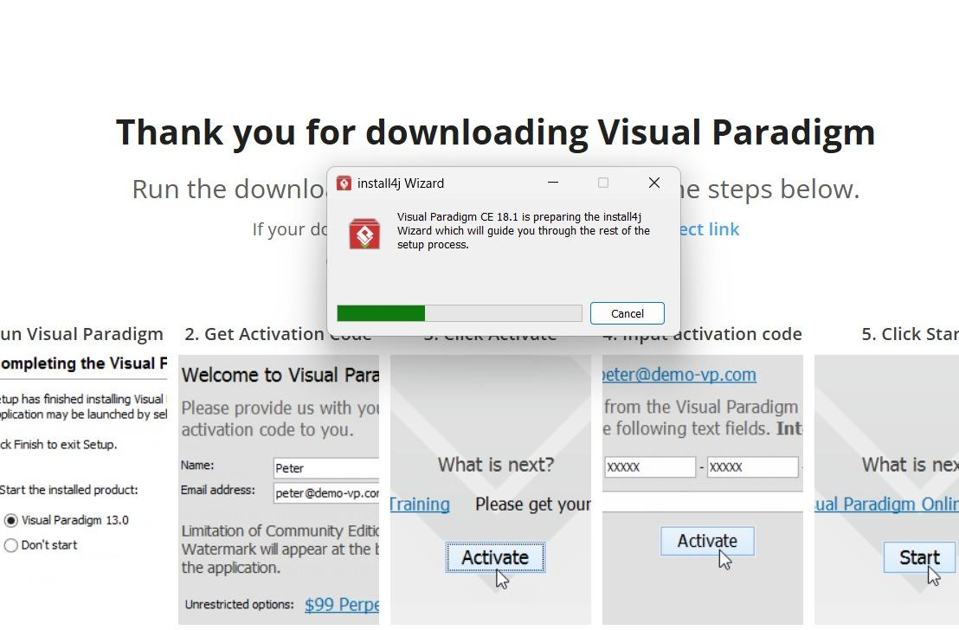
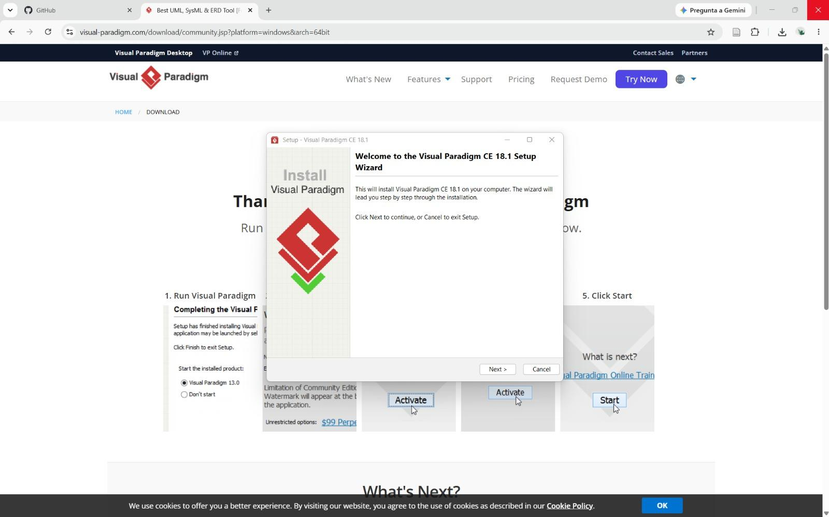
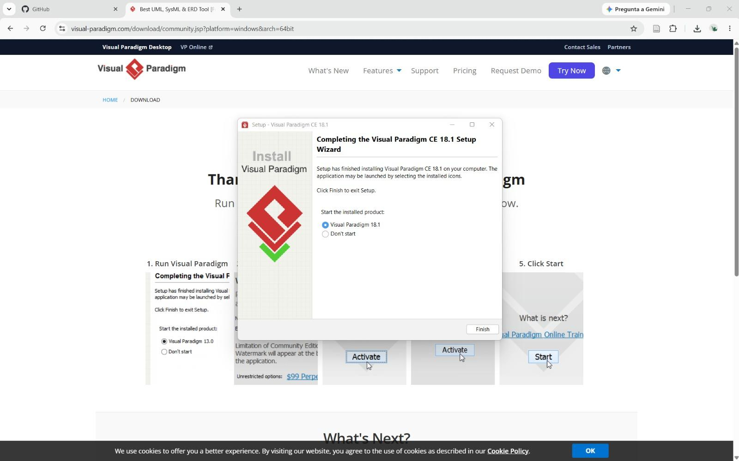
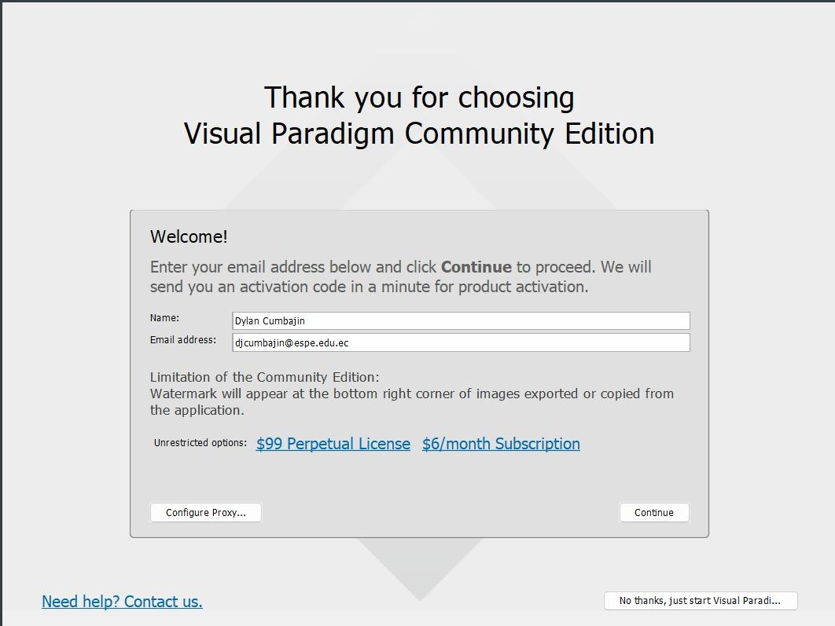


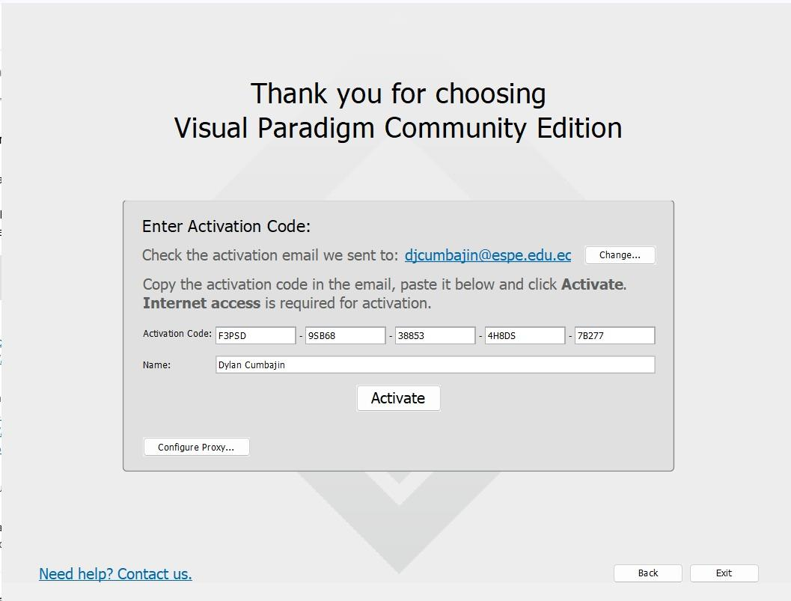

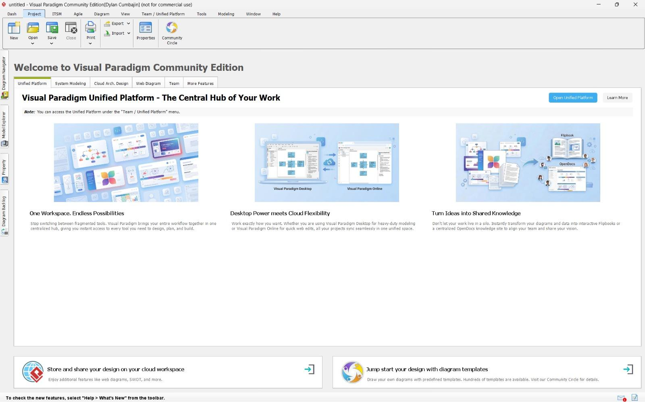

6. Visual Studio Code
The software was already installed on the computer.
