Sound Mixer Registration
The first run saved a 10-channel Yamaha MG10 with ID MX-001. The second run loaded the same mixer from the JSON file.

1 Create a sound mixer
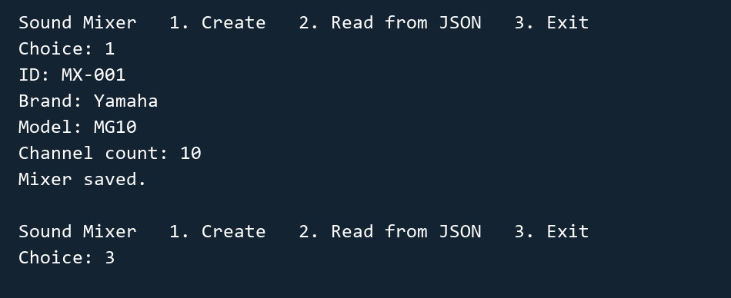

2 Read the mixer after restarting


