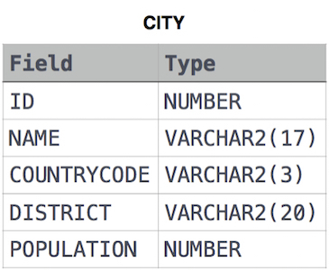SQL:

1/ Query all columns for all American cities in **CITY** with populations larger than 100000.

<https://www.hackerrank.com/rest/contests/master/challenges/revising-the-select-query/hackers/minhtuan9698/download_solution>

2/ Query the names of all American cities in **CITY** with populations larger than 120000. The CountryCode for America is USA.

<https://www.hackerrank.com/rest/contests/master/challenges/revising-the-select-query-2/hackers/minhtuan9698/download_solution>

3/ Query all columns (attributes) for every row in the **CITY** table.

<https://www.hackerrank.com/rest/contests/master/challenges/select-all-sql/hackers/minhtuan9698/download_solution>

4/ Query all columns for a city in **CITY** with the ID 1661.

<https://www.hackerrank.com/rest/contests/master/challenges/select-by-id/hackers/minhtuan9698/download_solution>

5/ Query all attributes of every Japanese city in the **CITY** table. The COUNTRYCODE for Japan is JPN.

<https://www.hackerrank.com/rest/contests/master/challenges/japanese-cities-attributes/hackers/minhtuan9698/download_solution>

6/ Query a list of CITY and STATE from the **STATION** table.

<https://www.hackerrank.com/rest/contests/master/challenges/japanese-cities-name/hackers/minhtuan9698/download_solution>

7/ Query a list of CITY names from **STATION** with even ID numbers only. You may print the results in any order, but must exclude duplicates from your answer.

<https://www.hackerrank.com/rest/contests/master/challenges/weather-observation-station-3/hackers/minhtuan9698/download_solution>

8/ Let N be the number of CITY entries in **STATION**, and let N’ be the number of distinct CITY names in **STATION**; query the value of N-N’ from **STATION**. In other words, find the difference between the total number of CITY entries in the table and the number of distinct CITY entries in the table.

<https://www.hackerrank.com/rest/contests/master/challenges/weather-observation-station-4/hackers/minhtuan9698/download_solution>

9/ Query the two cities in **STATION** with the shortest and longest CITY names, as well as their respective lengths (i.e.: number of characters in the name). If there is more than one smallest or largest city, choose the one that comes first when ordered alphabetically.

<https://www.hackerrank.com/rest/contests/master/challenges/weather-observation-station-5/hackers/minhtuan9698/download_solution>

10/ Query the list of CITY names starting with vowels (i.e., a, e, i, o, or u) from **STATION**. Your result cannot contain duplicates.

<https://www.hackerrank.com/rest/contests/master/challenges/weather-observation-station-6/hackers/minhtuan9698/download_solution>

Python:

1/ Python If-Else

<https://www.hackerrank.com/rest/contests/master/challenges/py-if-else/hackers/minhtuan9698/download_solution>

# 2/ Arithmetic Operators

# <https://www.hackerrank.com/rest/contests/master/challenges/python-arithmetic-operators/hackers/minhtuan9698/download_solution>

# 3/ Python: Division

# <https://www.hackerrank.com/rest/contests/master/challenges/python-division/hackers/minhtuan9698/download_solution>

# 4/Loops

# <https://www.hackerrank.com/rest/contests/master/challenges/python-loops/hackers/minhtuan9698/download_solution>

# 5/Print Function

# <https://www.hackerrank.com/rest/contests/master/challenges/python-print/hackers/minhtuan9698/download_solution>