Virtual Key for Repositories
This document contains sections for:
- Sprint planning and Task completion
- Core concepts used in project
- Flow of the Application.
- Demonstrating the product capabilities, appearance, and user interactions.
- Unique Selling Points of the Application
- Conclusions

The code for this project is hosted at https://github.com/elavaluthi/hlo
The project is developed by Manielavaluthi.

Sprints planning and Task completion
The project is planned to be completed in 1 sprint. Tasks assumed to be completed in the sprint are:
- Creating the flow of the application
- Initializing git repository to track changes as development progresses.
- Writing the Java program to fulfill the requirements of the project.
- Testing the Java program with different kinds of User input
- Pushing code to GitHub.
- Creating this specification document highlighting application capabilities, appearance, and user interactions.

Core concepts used in project
Collections framework, File Handling, Sorting, Flow Control, Recursion, Exception Handling, Streams API

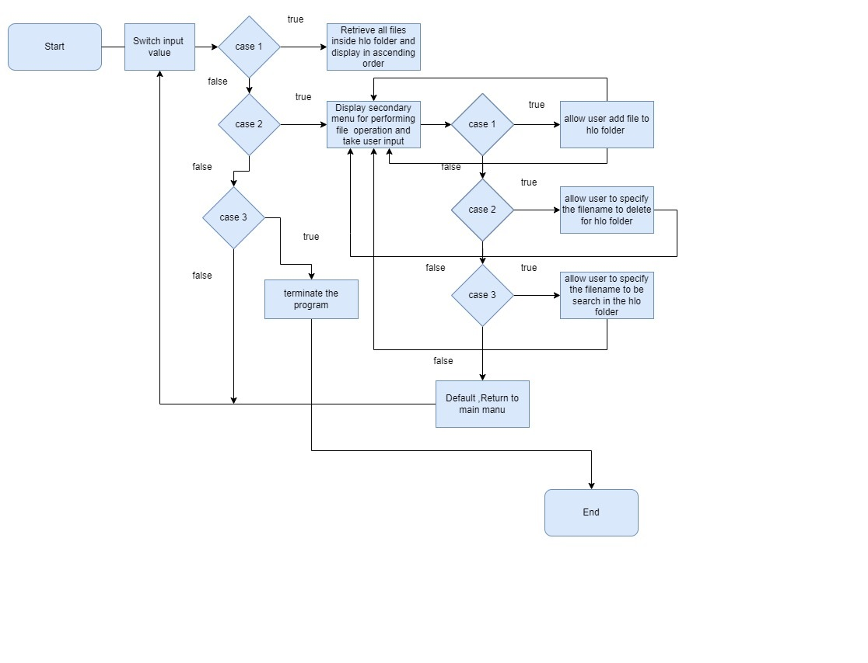

Demonstrating the product capabilities, appearance, and user interactions

To demonstrate the product capabilities, below are the sub-sections configured to highlight appearance and user interactions for the project:
1. creating project on eclipse.
- Display the files in order.
- Performing file operation.
- Closing the program

CREATING PROJECT ON ECLIPSE.
- Open Eclipse
- Go to File -> New -> Project -> Java Project -> Next.
- Type in any project name and click on “Finish.”
- Select your project and go to File -> New -> Class.
- Enter hlo in any class name, check the checkbox “public static void main(String[] args)”, and click on “Finish.”

DISPLAY THE FILES IN ORDER.

File f=new File(path);
File filename[]=f.listFiles();
for(File ff:filename) {
System.out.println(ff.getName());}

PERFORMING FILE OPERATION.
ADD:
{Scanner sc2=new Scanner(System.in);

ArrayList<String> al=new ArrayList<>();
while(true) {
System.out.println("enter the file name to create");
String filename=sc.next();
String finalname=path+filename;
System.out.println(finalname);
//create a file
File f=new File(finalname);
boolean b=f.createNewFile();
if(b!=true) {
System.out.println("the file not created");
}
else {
al.add(filename);
System.out.println("file created");
}
System.out.println("the collection of files is "+ al);
break;
DELETE
Scanner sc3=new Scanner(System.in);
System.out.println("enter the file name to be deleted");
String filname=sc.next();
String finalfile=path+filname;
File file=new File(finalfile);
file.delete();
System.out.println("file deleted");

SEARCH
File f=new File(path);
Scanner sc4=new Scanner(System.in);
System.out.println("enter the file name to search");
String filsearchname=sc.next();
File filename[]=f.listFiles();
int flag=0;
for(File ff:filename) {
if(ff.getName().equals(filsearchname)) {
flag=1;
break;
}
else {
flag=0;
}
}
if(flag==1) {
System.out.println("found the file");
}
else {
System.out.println("file is not found");
}
RETURN TO MAIN MENU
{

}break;

CLOSING THE PROGRAM

System.exit(0);

