**India Agricultural Crop Production (1997 – 2021)**

**PROJECT REPORT**

1. **INTRODUCTION**

**1:1 Overview:**

Healthy ,sustaintanable and inclusive food systems are critical to achieve the world’s development goals. Agricultural development is one of the most powerful tools to end extreme poverty,boost shared prosperity,and feet a projected 10 billion people by 2050. Growth in the agriculture sector is two to 4 times more effective in raising incomes among the poorest compared to other sectors.

**1:2 Purpose:**

The purpose of agriculture is to manage Earth’s natural resources to the benefit of mankind. Agriculture is practiced for the purpose of producing food and other human needs such as clothing,medicines,weapons,tools,as a business for economic gain.

Not many attempts have been made to be more precise and it is quite difficult to arrive at a definition that is both useful and specific. Incidentally, there are many useful 'umbrella' terms that can and do cover a multitude of different things and their usefulness may be reduced if they are too rigidly defined. 'Competition', 'growth' and 'animal' are examples. The only satisfactory definitions are very broad and do not really exclude everything that does not strictly belong; stricter definitions, on the other hand, exclude things that one wishes to include. The best solution in these cases is to attach strict definitions to classified or qualified groups within the big category. Thus, 'growth in length' is more specific, as is 'competition for light': 'coldblooded animal' or, for example, 'unicellular animal' both become more specific by the use of an adjective.

**2.PROBLEM DEFINITION & DESIGN THINKING:**

**2:1 EMPATHY MAP**

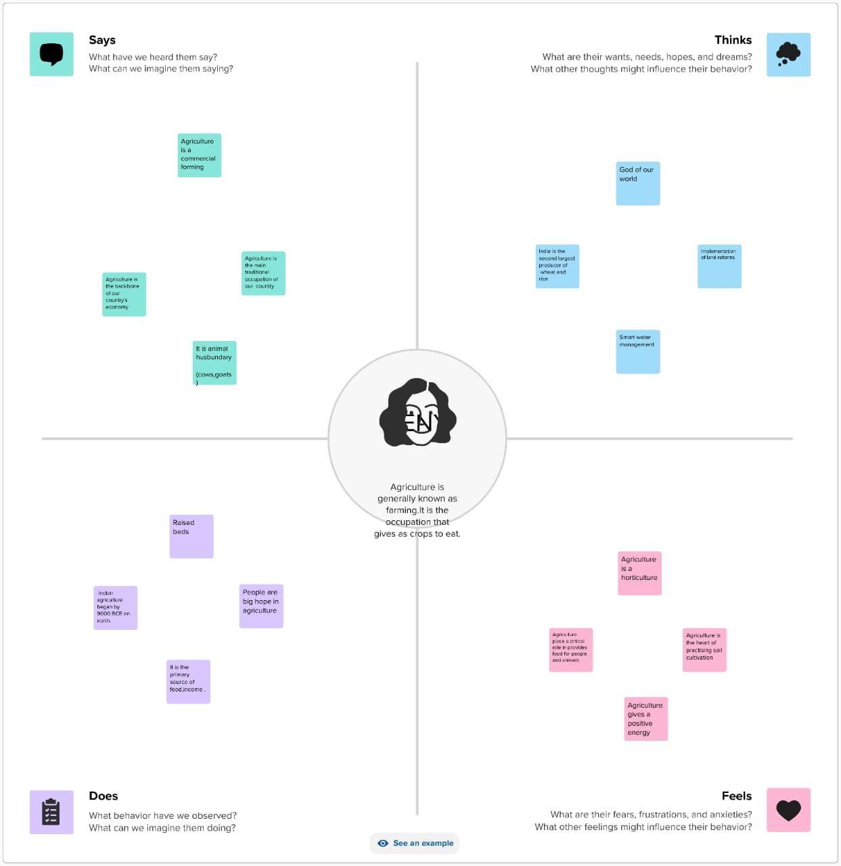

**2:2 IDEATION & BRAINSTORMING MAP:**

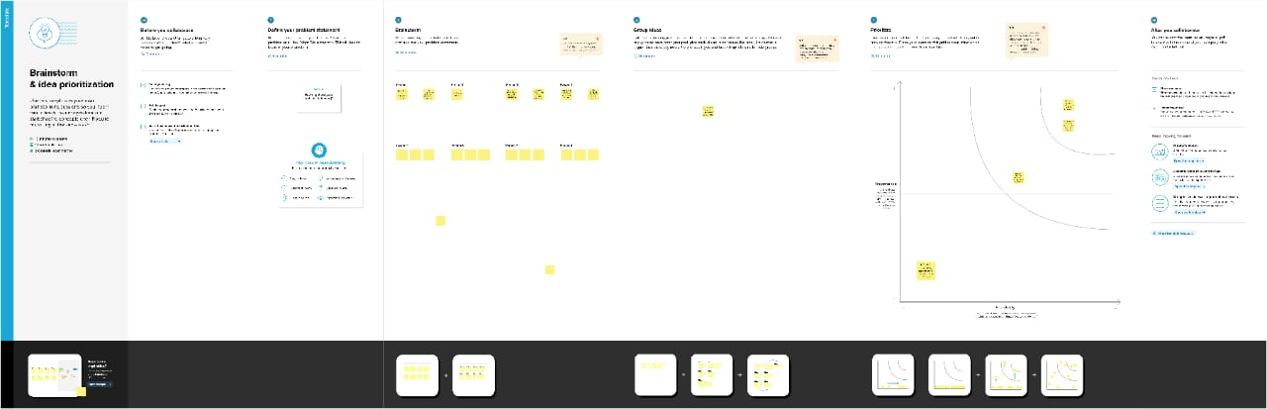

**3.RESULT:**

This is about how to useful to agriculture for human being. My map was very clear explanation for agricultural cultivation.

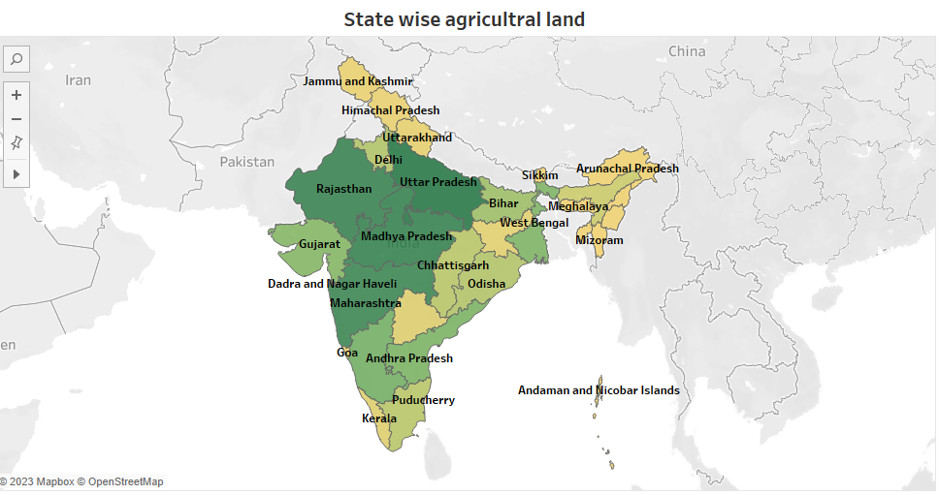

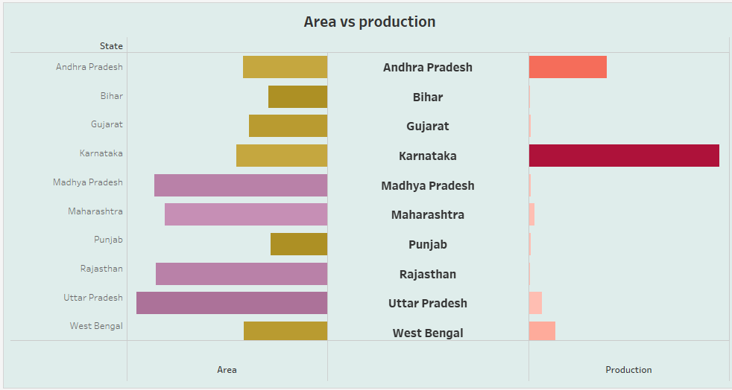

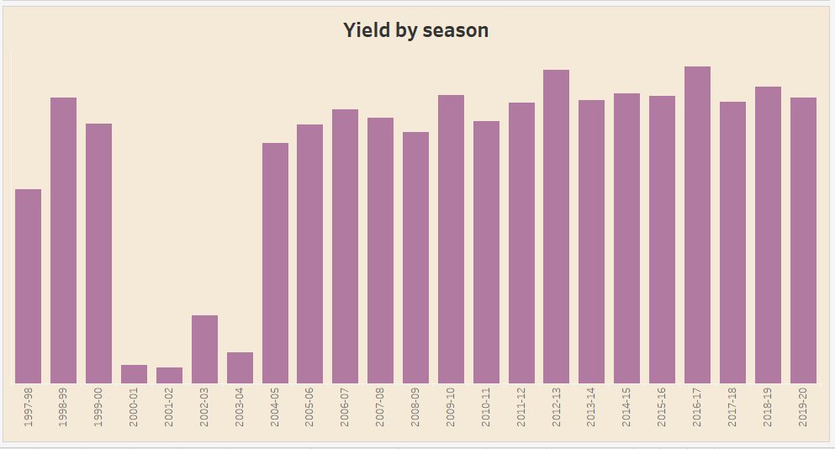

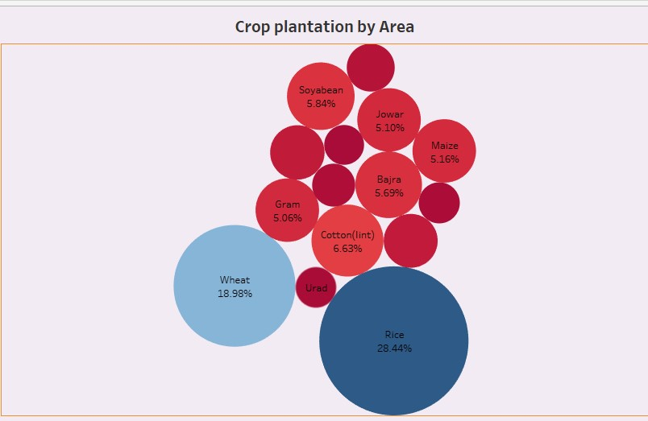

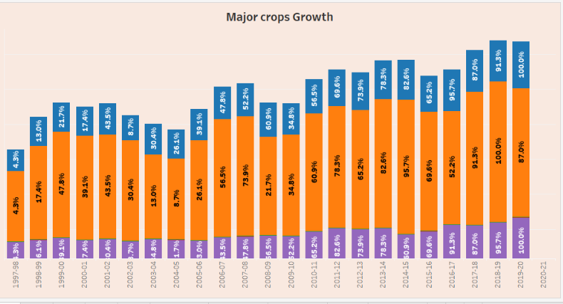

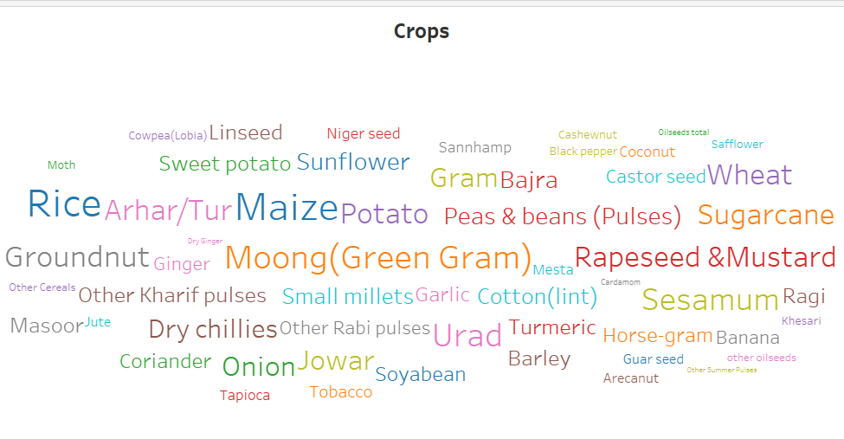

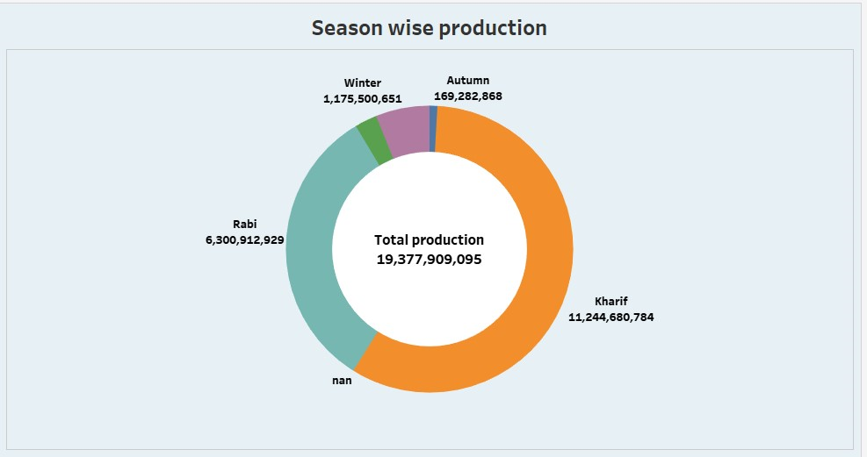

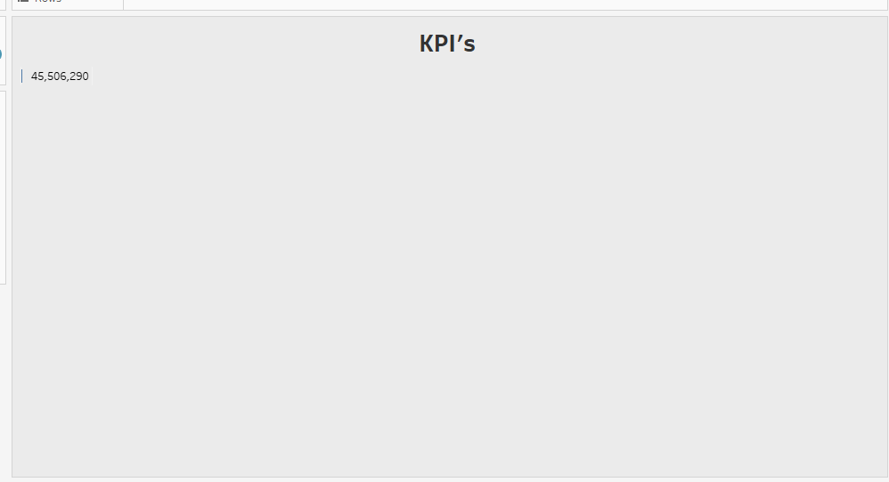

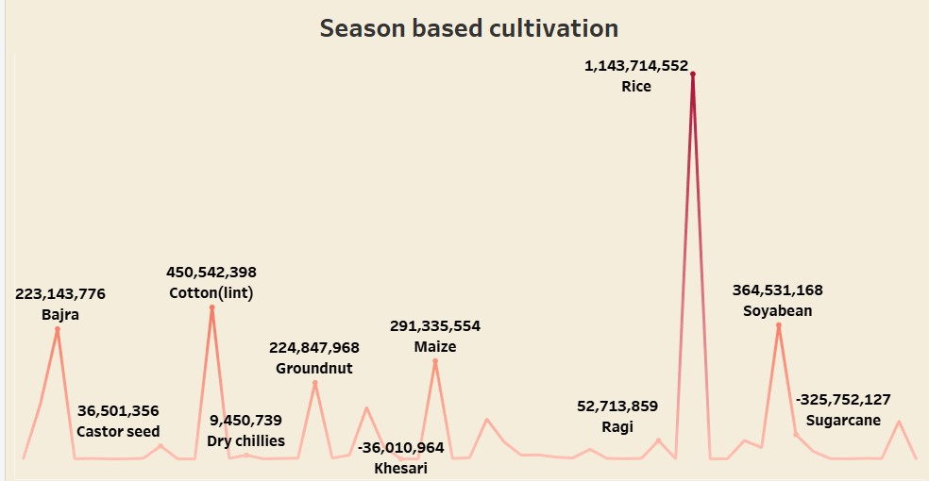

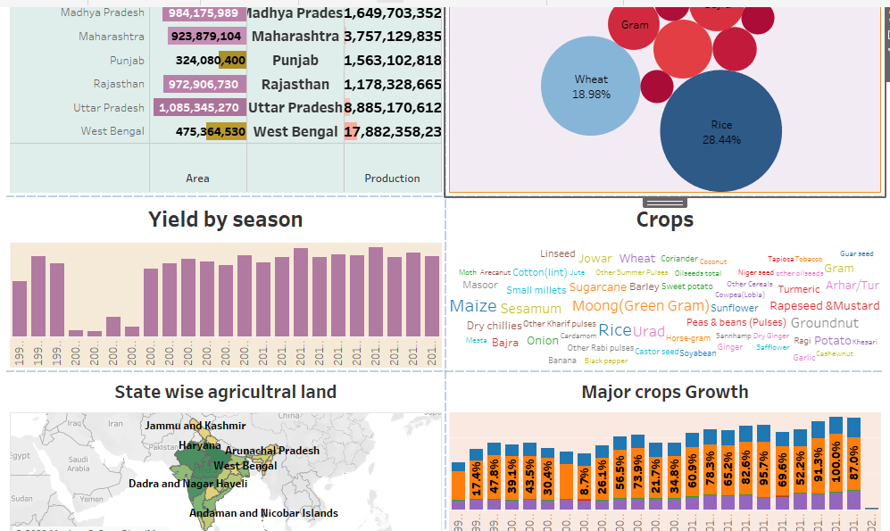

**4.ADVANTAGE & DISADVANTAGE**

**4.1Advantage:**

* Agriculture is the backbone of the Indian economy.
* Good for surroundings.
* Food for animals.
* Providing Raw meterials.
* Balance the ecosystem.

**4.2 Disadvantage:**

 Intensive agriculture can lead to soil erosion, deforestation, water pollution, and loss of biodiversity. Depletion of natural resources: Agriculture can lead to the depletion of natural resources such as water and soil, and can lead to land degradation and desertification.

**5. APPLICATION:**

An Agricultural is very important of our life. Drones can be used for a wide range of tasks in the agriculture sector, including crop mapping, soil analysis, irrigation, and pest management

**6.CONCLUSION**:

Agriculture is the source of food production for any society. Many people depend on agriculture for both commercial production and local production.

This is very important to the small-scale farmers simply because they may not have employment. Agriculture is the background of food security.

**7. FUTURE SCOPE:**

Agriculture sector have an enormous scope in India as of the future refrence because agriculture sector is the largest sector with 49% of country's population works in Agriculture sector by occupation. India is also a developing country with about 16% of its GDP is contributed by this sector.