FITBUDDY
AI-POWERED FITNESS PLANNER
Project Documentation
“Build a plan that fits your week.”
An AI-powered fitness planner that creates a structured 7-day routine from a user's fitness profile.

1. Introduction
FitBuddy is an AI-powered fitness planner designed to help users create a structured weekly workout routine. The application collects basic details such as name, User ID, age, weight, fitness goal, and workout intensity. Based on these inputs, FitBuddy generates a personalized 7-day workout plan together with nutrition and recovery guidance.

2. Application Home Screen
The home screen introduces FitBuddy as an AI-powered fitness planner. It provides the fitness profile form and the option to generate a 7-day plan. The screen also highlights three main ideas: Personalized, Adaptive, and Persistent.
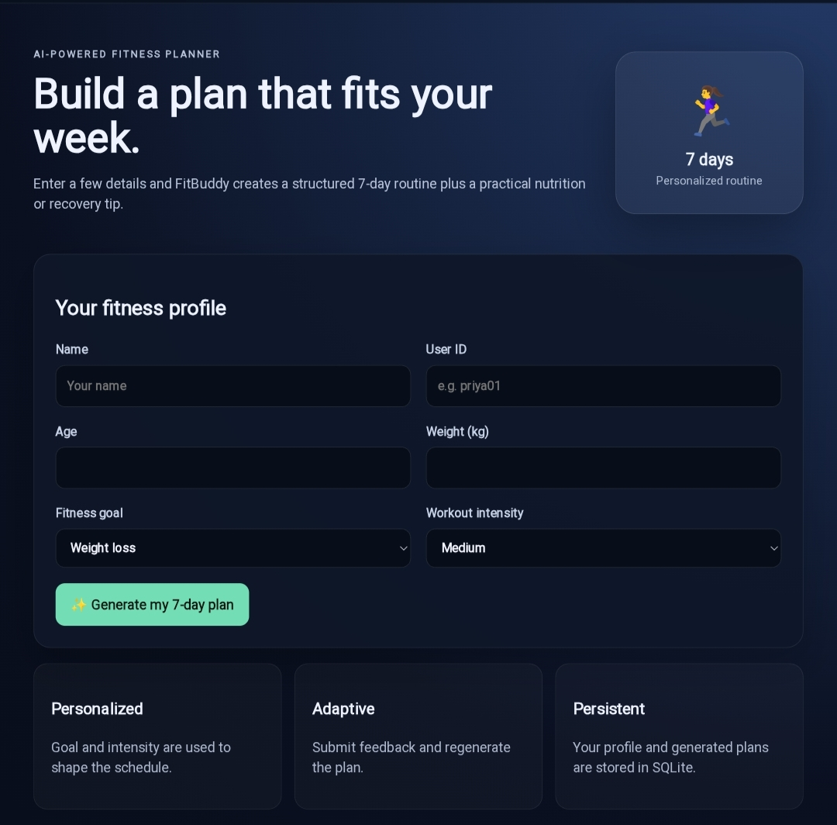
Figure 1: FitBuddy home screen with the fitness profile form and plan-generation option.

3. Objectives
- To collect basic fitness information from the user.
- To generate a structured 7-day workout routine.
- To personalize the routine according to the user's fitness goal and workout intensity.
- To provide nutrition and recovery guidance.
- To allow the user to refine the generated plan using AI.
- To maintain the user's profile and generated plans.

4. Key Features
Feature | Description
Personalized Planning | Uses the selected fitness goal and intensity to shape the weekly routine.
7-Day Workout Plan | Displays a structured routine from Day 1 to Day 7.
Nutrition & Recovery | Provides general nutrition and recovery guidance.
Adaptive Planning | Allows the user to request changes and update the plan with AI.
Persistent Data | The interface indicates that profiles and generated plans are stored in SQLite.

5. User Profile and Input
The user enters the following information before generating the plan:
Input | Purpose
Name | Identifies the user.
User ID | Provides a user identifier.
Age | Basic profile information.
Weight (kg) | Body-weight information entered by the user.
Fitness Goal | Defines the main fitness objective, such as Weight Loss.
Workout Intensity | Defines the preferred level, such as Medium.
In the sample shown in the screenshot, the generated profile displays Priyadharshini, age 22, weight 50.0 kg, Weight Loss goal, and Medium intensity.

6. Generated 7-Day Workout Plan
After the user clicks “Generate my 7-day plan”, FitBuddy displays a structured weekly workout routine. Each day contains a workout focus, warm-up, exercises, sets/repetitions or duration, rest time, notes, and a cool-down.
Day | Workout Focus | Main Activities
Day 1 | Full Body Cardio & Mobility | Bodyweight squats, jumping jacks, incline push-ups
Day 2 | Core & Lower Body Endurance | Walking lunges, plank hold, glute bridges
Day 3 | Active Recovery & Mobility | Outdoor walking, full-body mobility flow
Day 4 | Upper Body & Interval Cardio | High knees, rows, Superman hold
The following screenshot shows the generated plan for Days 1–4, including warm-ups, exercises, sets/reps, rest periods and notes.
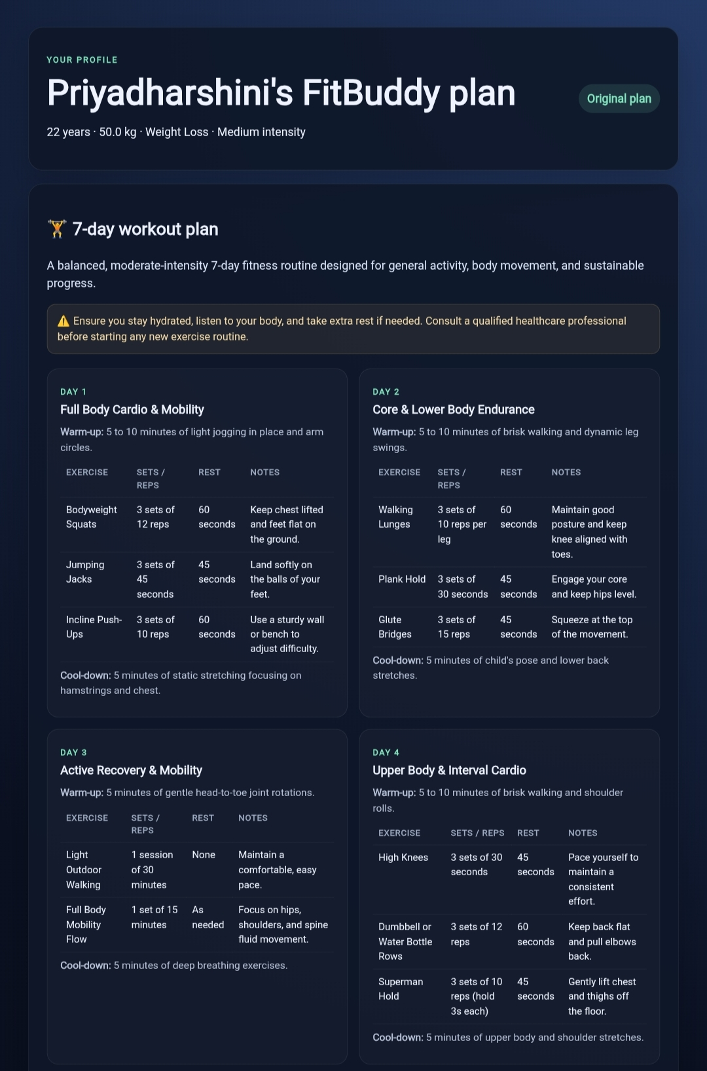
Figure 2: Generated FitBuddy workout plan – Days 1 to 4.

7. Continuation of the Workout Plan
Day | Workout Focus | Main Activities
Day 5 | Lower Body & Core Strength | Sumo squats, mountain climbers, side planks
Day 6 | Total Body Aerobic Exercise | Aerobic dance/low-impact HIIT, bicycle crunches
Day 7 | Rest & Full Recovery | Gentle stretching and relaxation
The next screenshot shows the remaining days of the 7-day routine.
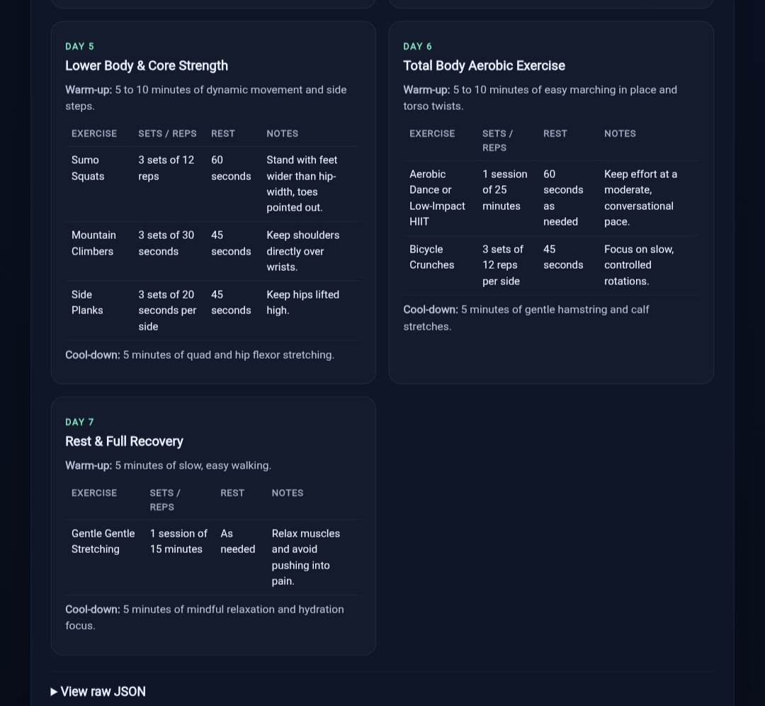
Figure 3: Generated FitBuddy workout plan – Days 5 to 7.

8. Nutrition & Recovery
FitBuddy provides a separate Nutrition & Recovery section after the workout plan. The sample output recommends balanced meals with lean proteins, high-fiber vegetables, and whole grains. It also highlights adequate sleep and rest as part of recovery.
- Balanced meals with lean proteins, high-fiber vegetables, and whole grains.
- Adequate sleep and recovery are encouraged.
- For personalized diet plans or specific health concerns, a qualified professional should be consulted.
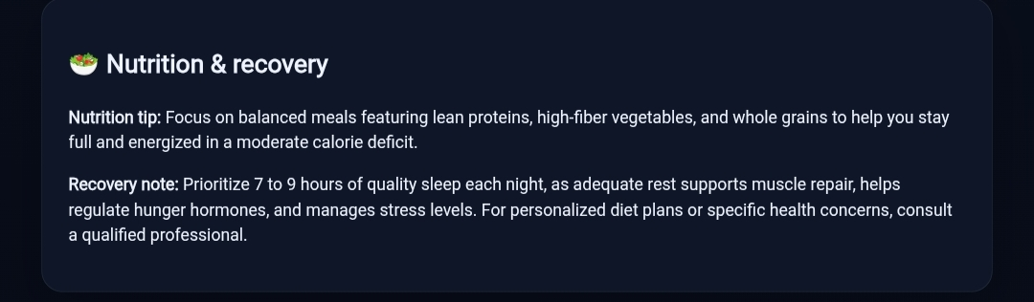
Figure 4: FitBuddy Nutrition & Recovery section.

9. Refine Your Plan
FitBuddy includes a Refine Your Plan section so that the user can describe the changes they want. For example, the user can request more cardio or an additional recovery day. The “Update plan with AI” button is then used to update the generated plan.
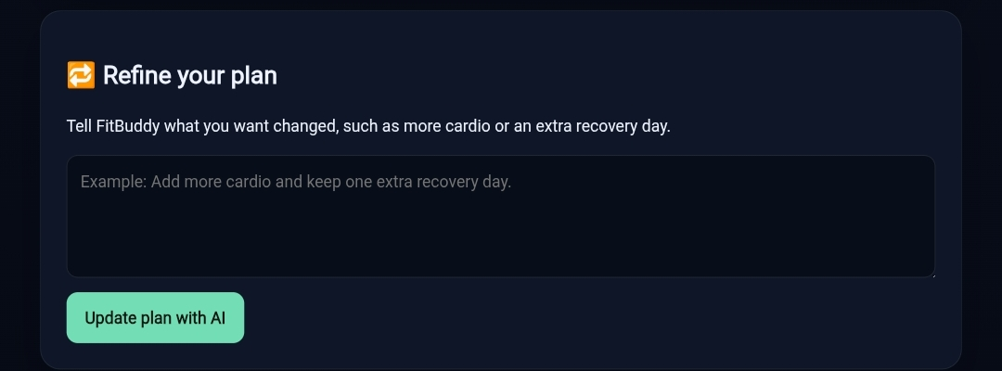
Figure 5: FitBuddy Refine Your Plan section.

10. Working Flow
1. Open the FitBuddy application.
2. Enter the Name and User ID.
3. Enter Age and Weight.
4. Select the Fitness Goal.
5. Select the Workout Intensity.
6. Click “Generate my 7-day plan”.
7. View the generated 7-day workout routine.
8. View Nutrition & Recovery guidance.
9. Enter feedback or requested changes in “Refine your plan”, if required.
10. Click “Update plan with AI” to refine the routine.

11. Technology / Storage Indicated in the Interface
The interface indicates AI-assisted personalization and adaptive plan generation. It also states that the profile and generated plans are stored in SQLite.
- AI-assisted personalized planning
- Adaptive plan refinement
- SQLite storage
- Form-based user interaction
- Structured workout, nutrition, and recovery output

12. Conclusion
FitBuddy is a simple AI-powered fitness planning application that converts basic user inputs into a structured weekly routine. It combines workout scheduling, nutrition guidance, recovery information, and AI-based plan refinement in one application. The screenshots demonstrate the complete user flow from entering a fitness profile to generating and refining a 7-day plan.

13. Project Note
The workout and nutrition information in this document is documented from the provided FitBuddy application screenshots. It is presented for project demonstration and documentation purposes and is not a substitute for individualized professional advice.

