Outline of Research Proposal for the Social & Behavioral Sciences Institutional Review Board (SBS-IRB)
Project Title: The Relationship Between Spatial Search, Creativity, Information Search and Search Termination
PI: Kinneret Teodorescu (kinnerett@technion.ac.il) &Yoed Kenett (yoedk@technion.ac.il)
- Purpose of study:
The purpose of the proposed research is to investigate whether a domain-general cognitive search mechanism, rooted in biological foraging, jointly governs spatial search, creative exploration, information search and search termination, and whether the spatial structure of the environment can affect search dynamics in other search domains. In particular, the study examines (1) whether the spatial distribution of resources in a foraging task causally alters exploration-exploitation dynamics in two subsequent tasks measuring creativity and information search, and (2) whether stable individual differences in search dynamics are correlated across domains in the absence of any environmental manipulation. By combining controlled online experiments with computational measures of exploration and exploitation, the project aims to establish that environmental structure shapes a shared Central Executive Search Process (CESP) (Hills, Todd, & Goldstone, 2008, 2010) that manifests in how people navigate creative possibility spaces, how they search for information in knowledge networks, and how they decide when to stop searching and commit.
- Research plan and tools. What will the research subjects have to do?
The current project includes the following 3 tasks:
Task 1: Spatial Foraging Game (SFG), approximately 10 minutes: Participants control an on-screen agent navigating a two-dimensional environment to collect hidden resources across five 2-minute rounds (Hills et al., 2008). Resources are revealed within a limited detection radius around the agent. Participants will be randomly assigned to one of two conditions: In the Clumpy condition, resources are concentrated in three to four spatially distinct clusters; in the Diffuse condition, resources are distributed approximately uniformly across the environment. Participants are instructed to collect as many resources as possible within each round.
Task 2: Creative Foraging Game (CFG), 12 minutes: Participants move squares on a 10×10 grid to construct shapes (Hart et al., 2017). They start from a 10-square horizontal line and can move any square to an adjacent position (keeping all squares connected, not diagonally). Participants are instructed to find shapes they consider “interesting and beautiful” and save them to a personal gallery by pressing a designated button. Participants can create and save as many shapes as they wish within the 12-minute period. The task involves no deception, no risk, and no sensitive content.
Task 3: Knowledge-Foraging Task (Wikipedia Task) based on, 10 minutes per question (total of 2 questions): Participants are presented with an open-ended question on the left side of a split screen, alongside a cloned Wikipedia browser on the right side (Kedrick et al., 2026). They are instructed to search for relevant information across Wikipedia pages and compose a written answer in the provided textbox. Participants may navigate freely between Wikipedia pages, and their browsing trajectory is recorded. Each question has a 15-minute time limit. The sequence of Wikipedia pages visited serves as the primary behavioral measure, capturing exploration-exploitation dynamics in knowledge search. The task involves no deception, no risk, and no sensitive content.
We plan to conduct several online studies via Prolific. Each study will use two of the above tasks. Tentatively, the first two studies will include Task 1 (2 conditions, between participants), followed by Task 2 or Task 3 - to examine whether the spatial manipulation in Task 1 affect behavior in each of the subsequent tasks. The third planned study will include Task 2 and Task 3 (without Task 1) to examine potential correlations of search dynamics between the tasks in the absence of a spatial manipulation.
Summary of participant experience per study:
Each participant takes part in one study only. In Study 1, participants complete two consecutive computerized tasks (SFG + CFG) totalling approximately 30 minutes. In Study 2, they complete the SFG and the Knowledge-Foraging Task, totalling approximately 40 minutes. In Study 3, they complete the CFG and the Knowledge-Foraging Task, totalling approximately 40 minutes. All tasks involve simple, game-like interactions (navigating an agent, moving squares on a grid, or browsing Wikipedia) with no sensitive content, no deception, and no physical or psychological risk.
- Explain how you are going to recruit your subjects. Will participants receive compensation? If so what sort of compensation?
Participants will be recruited from Prolific - an online platform for running experimental studies. In order to participate in the experiment, the participants must be over 18 and speak English fluently.
Compensation is calculated at a rate of £1 per 6 minutes of study time (including time for reading instructions and practice). The exact duration and corresponding payment will be finalized after running pilot studies. For Study 1, we estimate approximately 30 minutes, and participants will receive £5. The attached consent form reflects this estimation for Study 1; if needed, the stated duration and compensation will be adjusted accordingly. The estimated study duration and total payment are presented to participants in advance, both in the consent form and upon entering the study on Prolific, so they are fully informed before beginning.
- Dangers and benefits for research subjects.
No potential risks are expected for participation in the current studies. The tasks involve simple, game-like computerized interactions with no sensitive content, no deception, and no physical or psychological risk. The benefits mainly include the monetary compensation mentioned above.
- The way confidentiality and anonymity of subjects will be secured
The only personal identification participants are being asked to provide is their Prolific ID number. This information is necessary in order to verify completion of the study and to provide each participant with the correct payment.
Once participants are paid - this information will be deleted, and the analyses will be conducted on anonymous data. This procedure is explained explicitly in the consent form.
- How will you inform the participants that their participation is voluntary and that they can withdraw at any time with no negative consequences for them
The consent form emphasizes that taking part in the study is voluntary and withdrawal is possible at any point.
References
Hart, Y., Mayo, A. E., Mayo, R., Rozenkrantz, L., Tendler, A., Alon, U., & Noy, L. (2017). Creative foraging: An experimental paradigm for studying exploration and discovery. PLoS ONE, 12(8), e0182133. https://doi.org/10.1371/journal.pone.0182133
Hills, T. T., Todd, P. M., & Goldstone, R. L. (2008). Search in external and internal spaces: Evidence for generalized cognitive search processes. Psychological Science, 19(8), 802–808. https://doi.org/10.1111/j.1467-9280.2008.02160.x
Hills, T. T., Todd, P. M., & Goldstone, R. L. (2010). The central executive as a search process: Priming exploration and exploitation across domains. Journal of Experimental Psychology: General, 139(4), 590–609. https://doi.org/10.1037/a0020666
Kedrick, K., Burhite, K., Vilares, I., & Schrater, P. R. (2026). Creative foraging and the explore–exploit trade-off in knowledge networks. Cognition, 271, 106451. https://doi.org/10.1016/j.cognition.2026.106451

Appendix
Screenshots from the experiment:
Spatial Foraging Game (SFG)
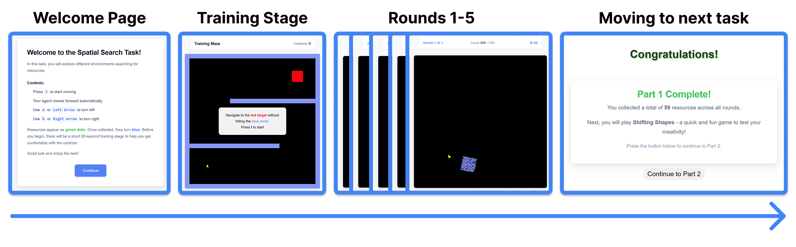

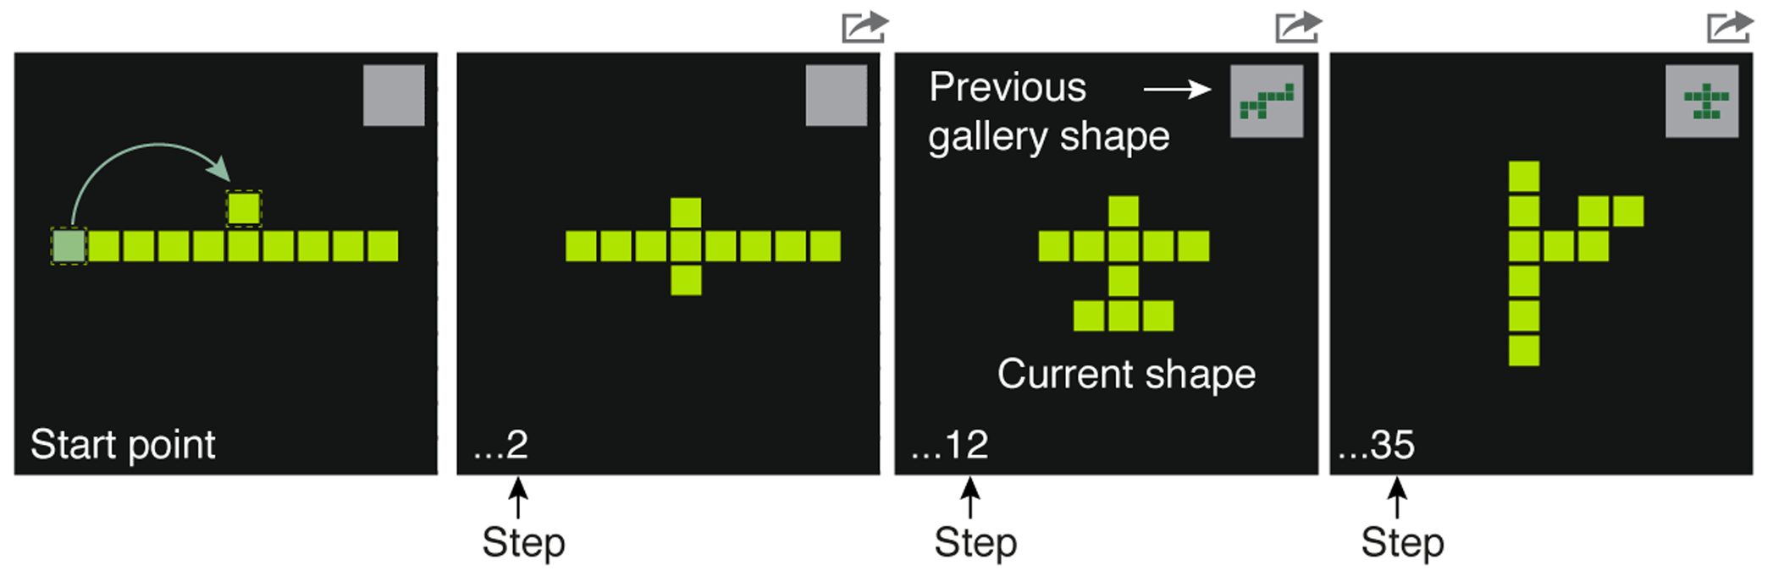
Creative Foraging Game (CFG)

Knowledge-Foraging Task (Wikipedia Task)
