Junit Test:

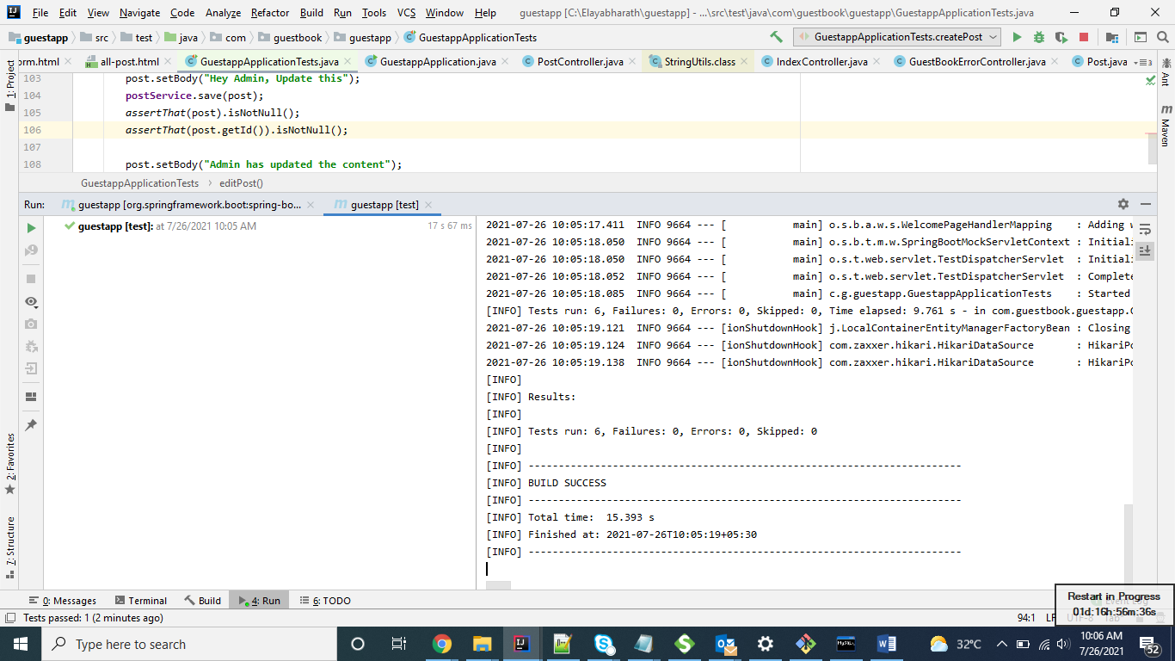

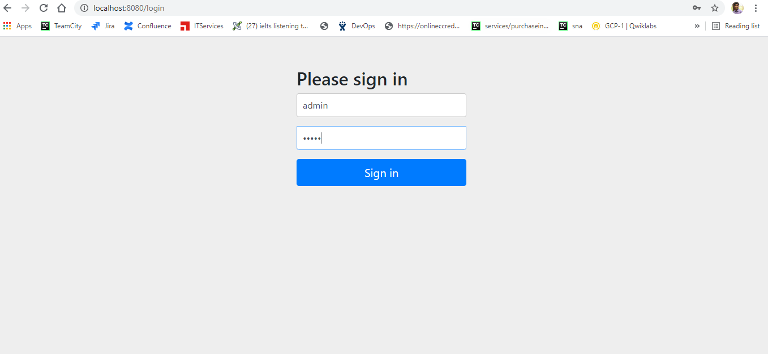

All posts page:

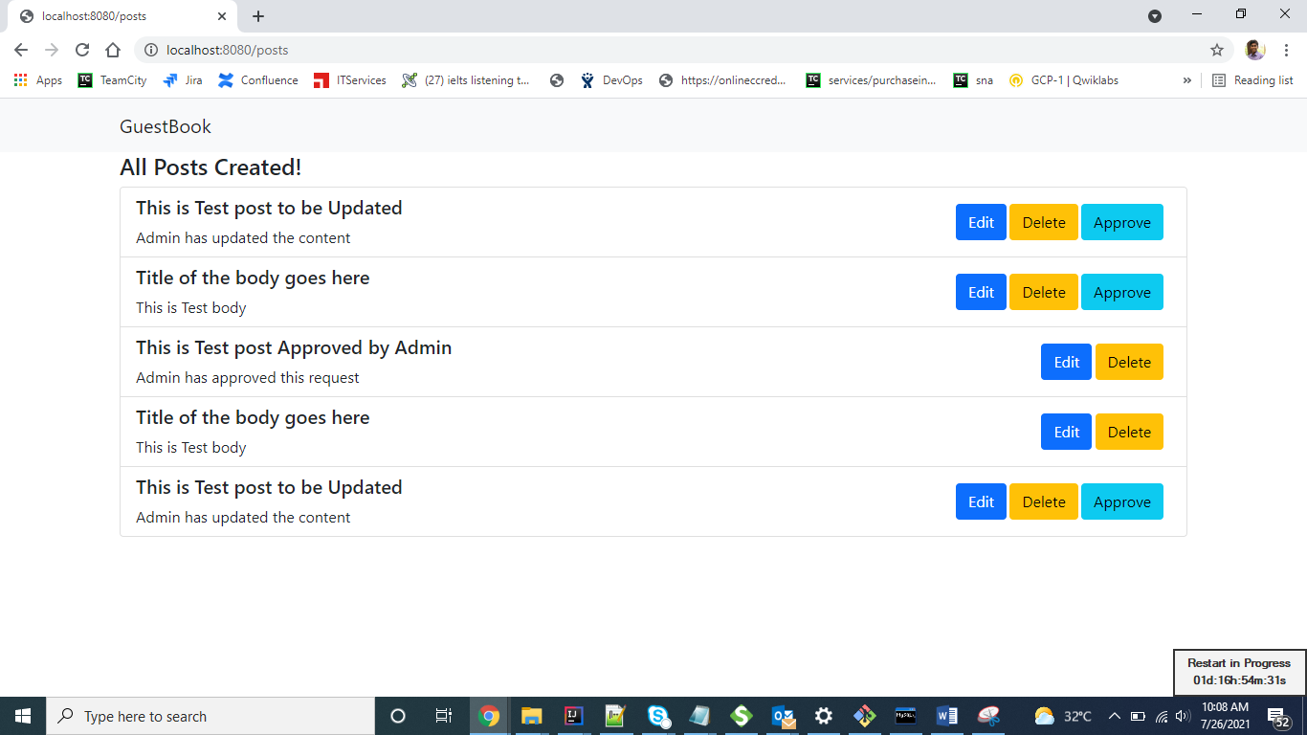

After deleting two posts:

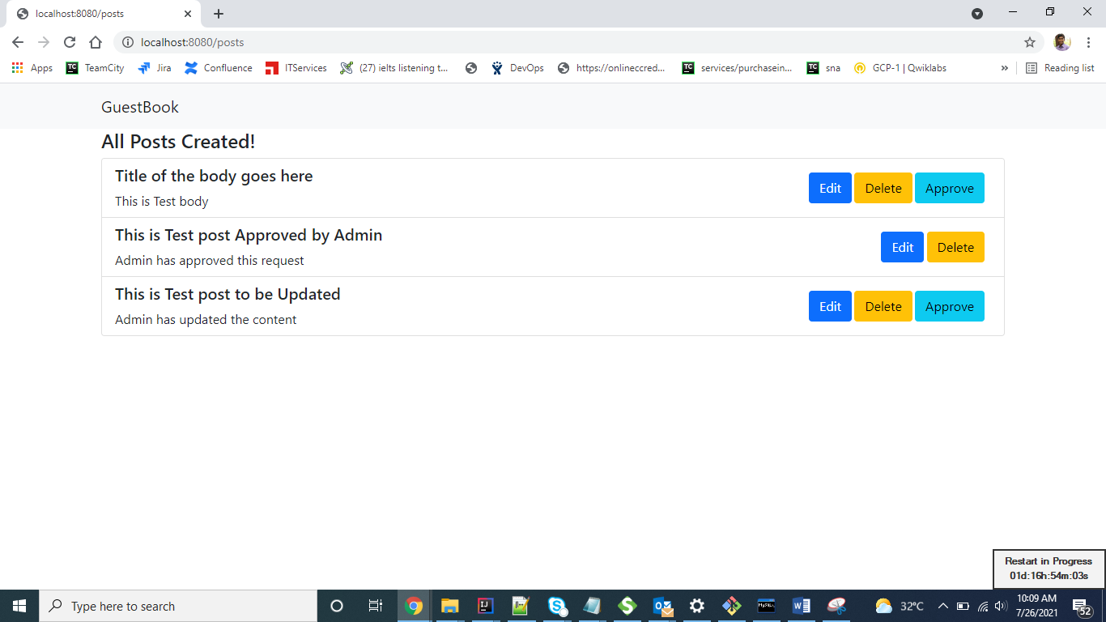

Edit Form:

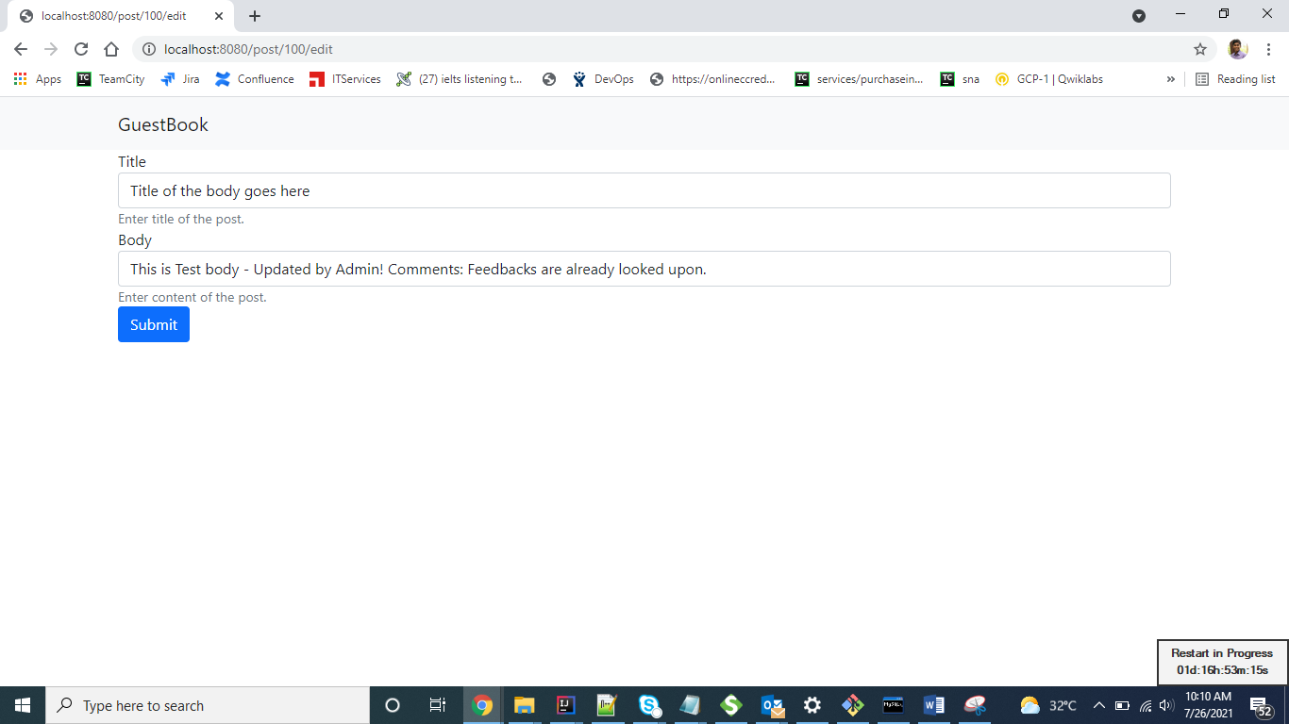

Edited successfully:

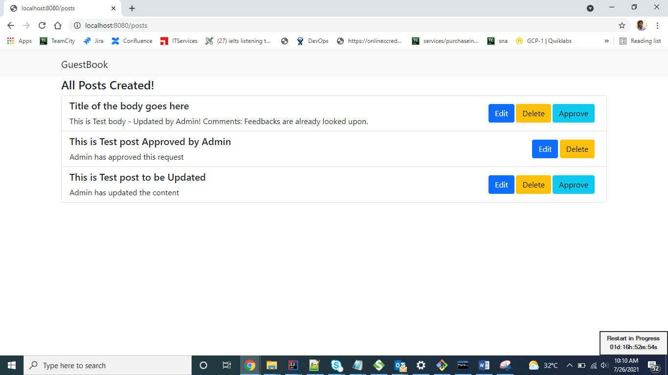

Approve the edited form:

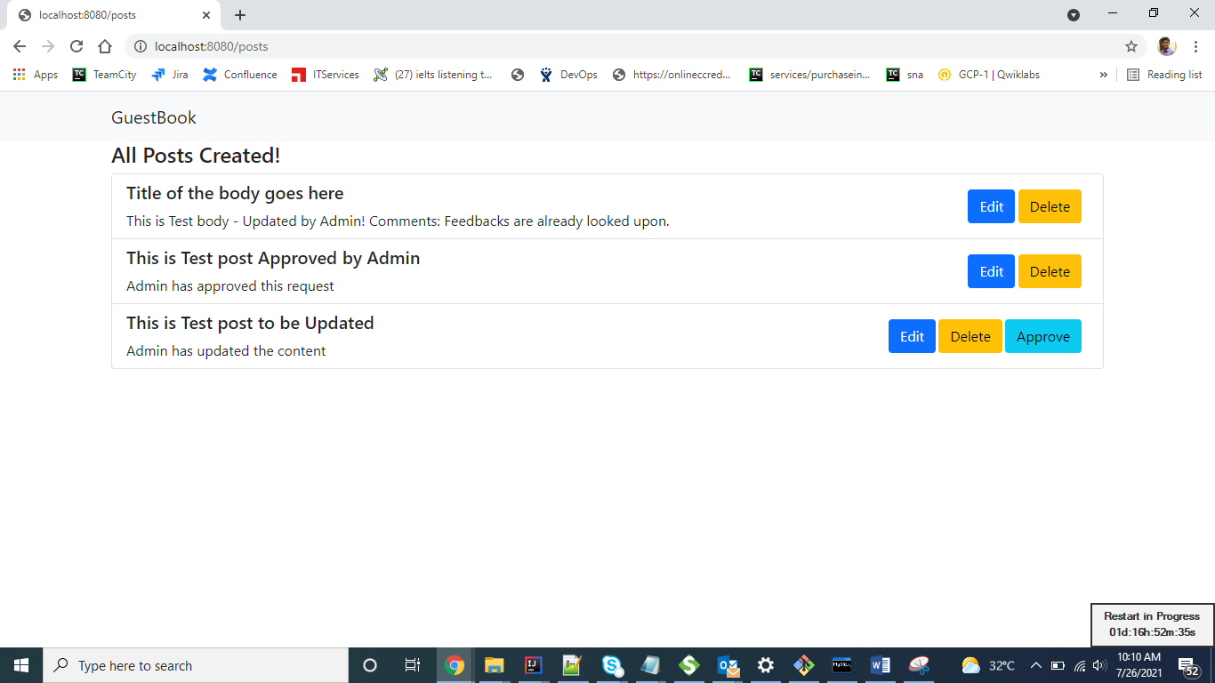

Admin can only view/edit/approve the posts created by guest.

Admin can’t create the posts. When admin tries to access the create new post,

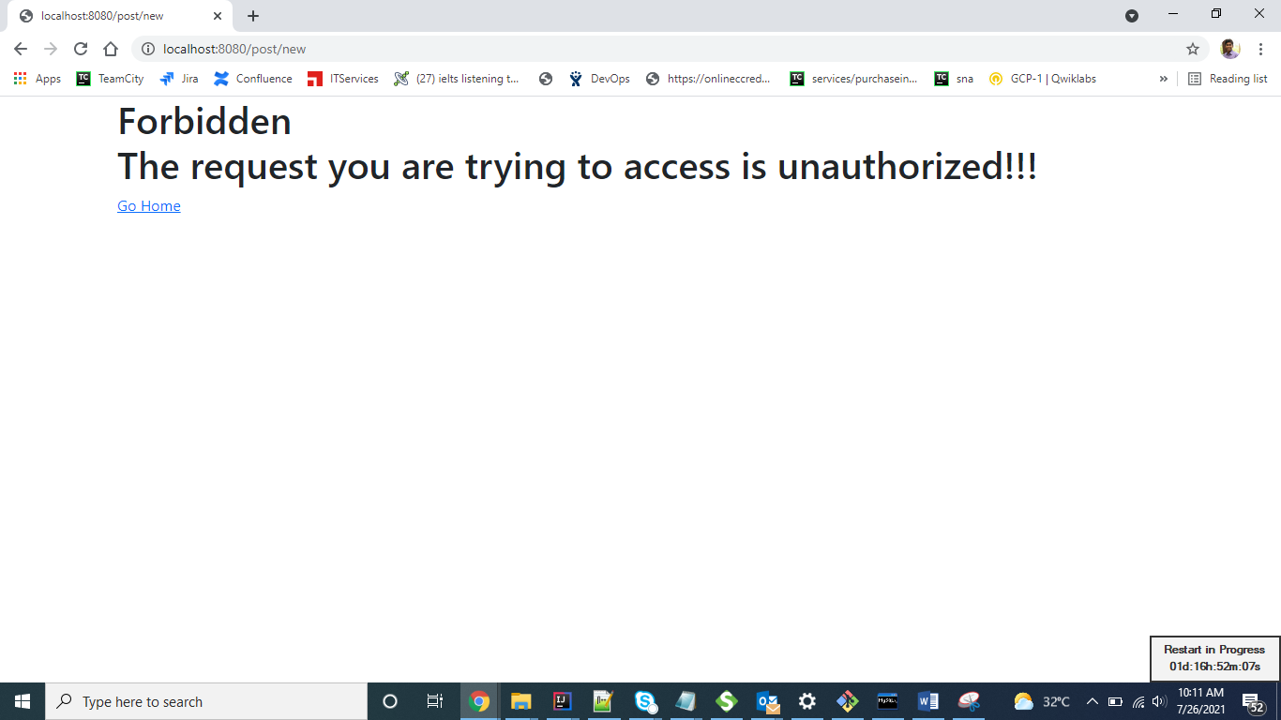

Guest Login:

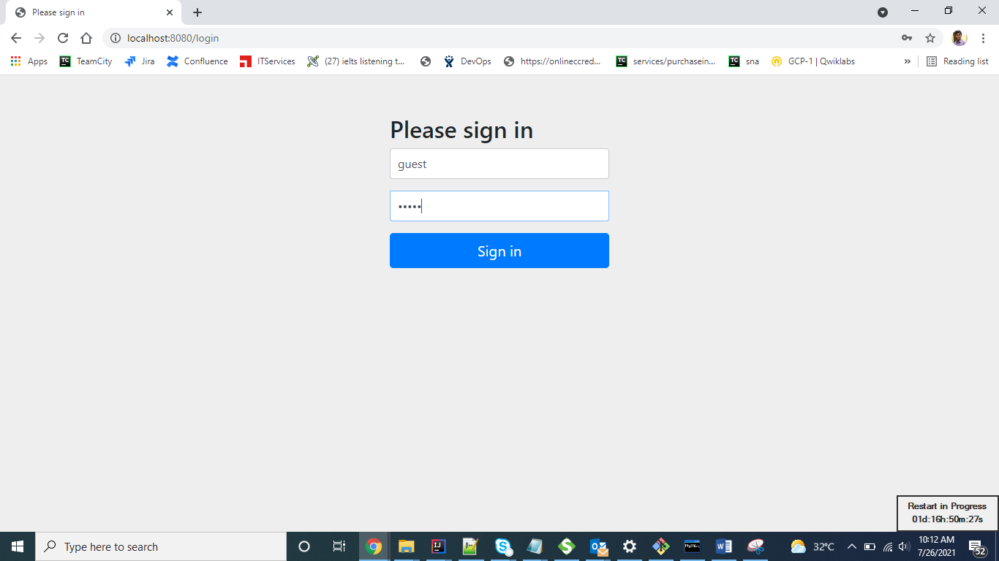

Guest Home Page:

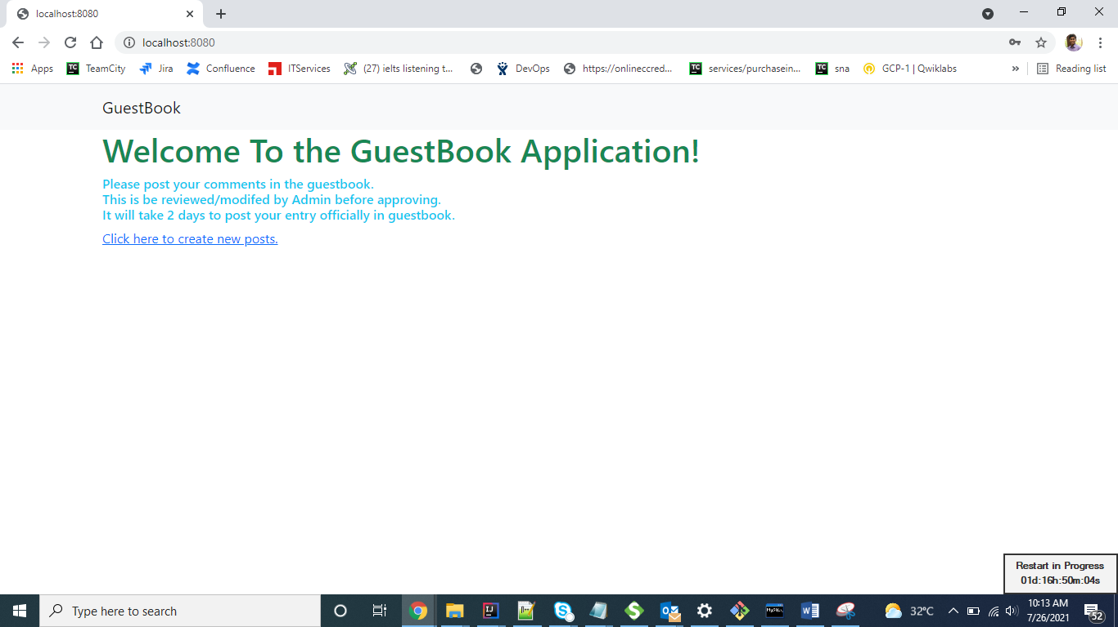

New post creation page:

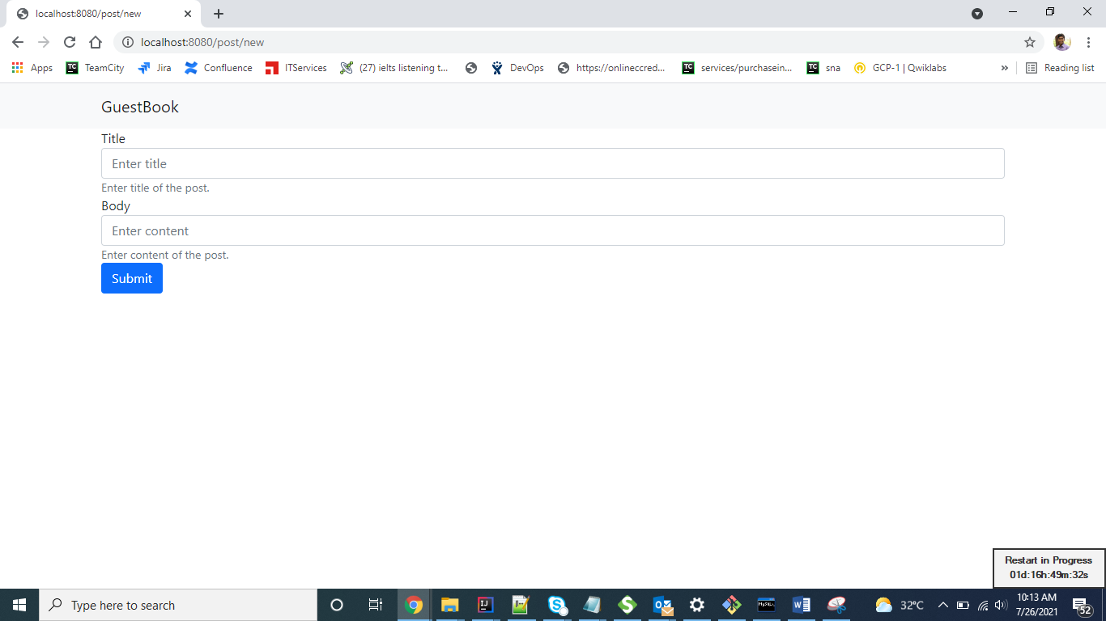

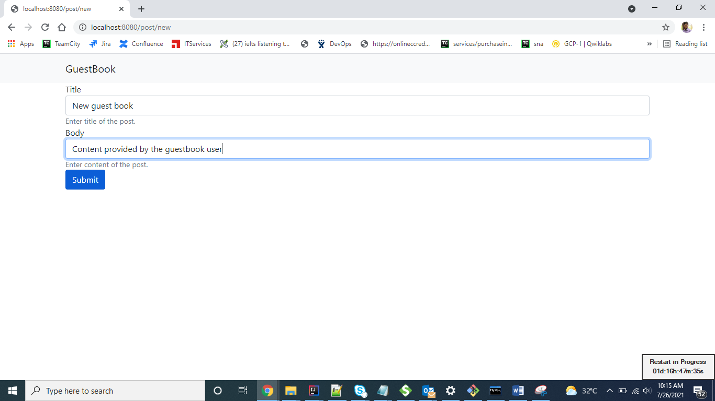

Page Success page:

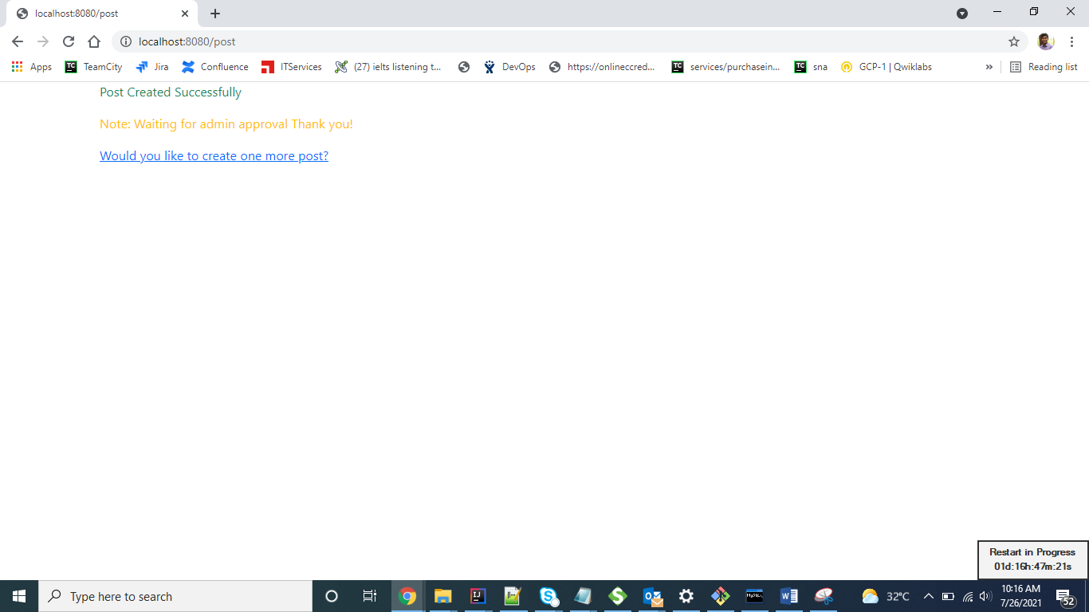

When guest user tries to access all posts page

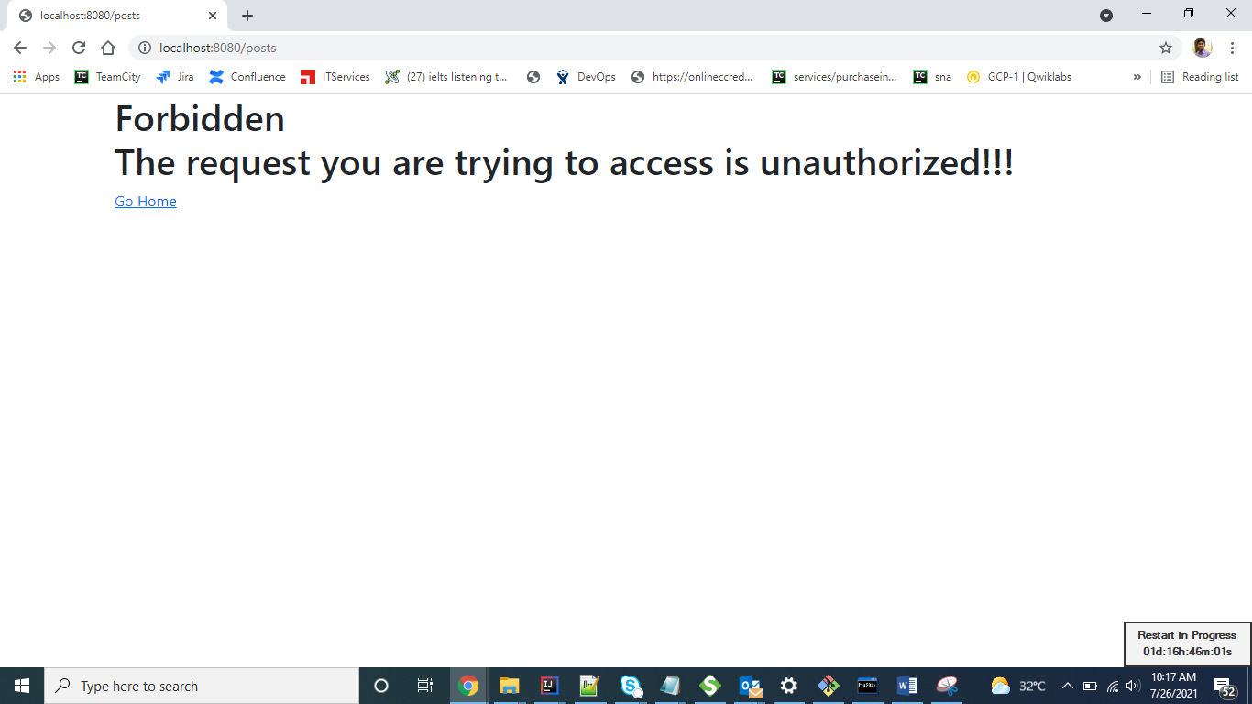

When admin/guest tries to access url which doesn’t exists

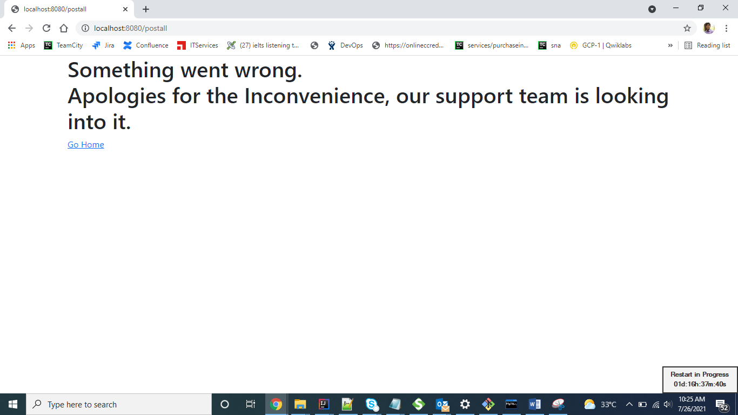

Table:

CREATE TABLE users (

username VARCHAR(50) NOT NULL,

password VARCHAR(100) NOT NULL,

enabled TINYINT NOT NULL DEFAULT 1,

PRIMARY KEY (username)

);

CREATE TABLE authorities (

username VARCHAR(50) NOT NULL,

authority VARCHAR(50) NOT NULL,

FOREIGN KEY (username) REFERENCES users(username)

);

INSERT INTO users (username, password, enabled)

values ('admin',

'$2a$10$tSXNdUe1SolOuejwgRTj9.ossMufGejhryGg9hnrzkXnD6uQY2G0u',

1);

INSERT INTO users (username, password, enabled)

values ('guest',

'$2a$10$tgDoBvMpYQNNbz2CyK/yZ.VZAuRfhvUQ9Ks67Tn844zqg6b3amtTW',

1);

INSERT INTO authorities (username, authority)

values ('admin', 'ROLE_ADMIN');

INSERT INTO authorities (username, authority)

values ('guest', 'ROLE_USER');

CREATE TABLE post(id INT NOT NULL AUTO_INCREMENT, title varchar(50) not null, body text, approved_status boolean default false, primary key(id));

