Junit Test:

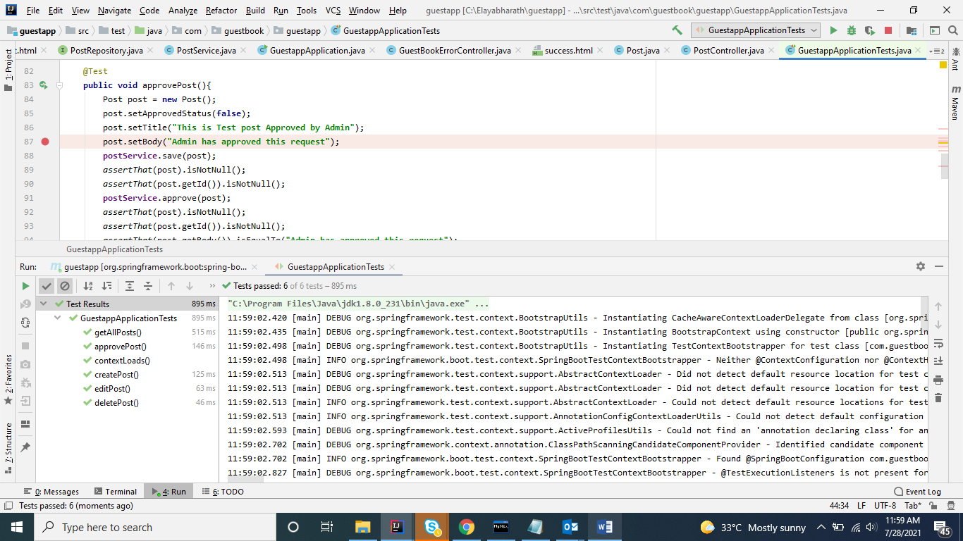

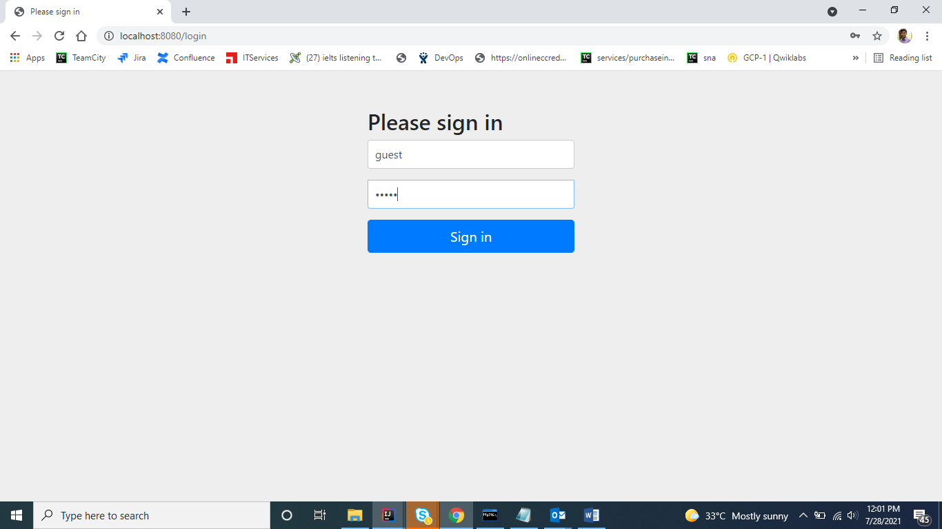

Guest Home Page:

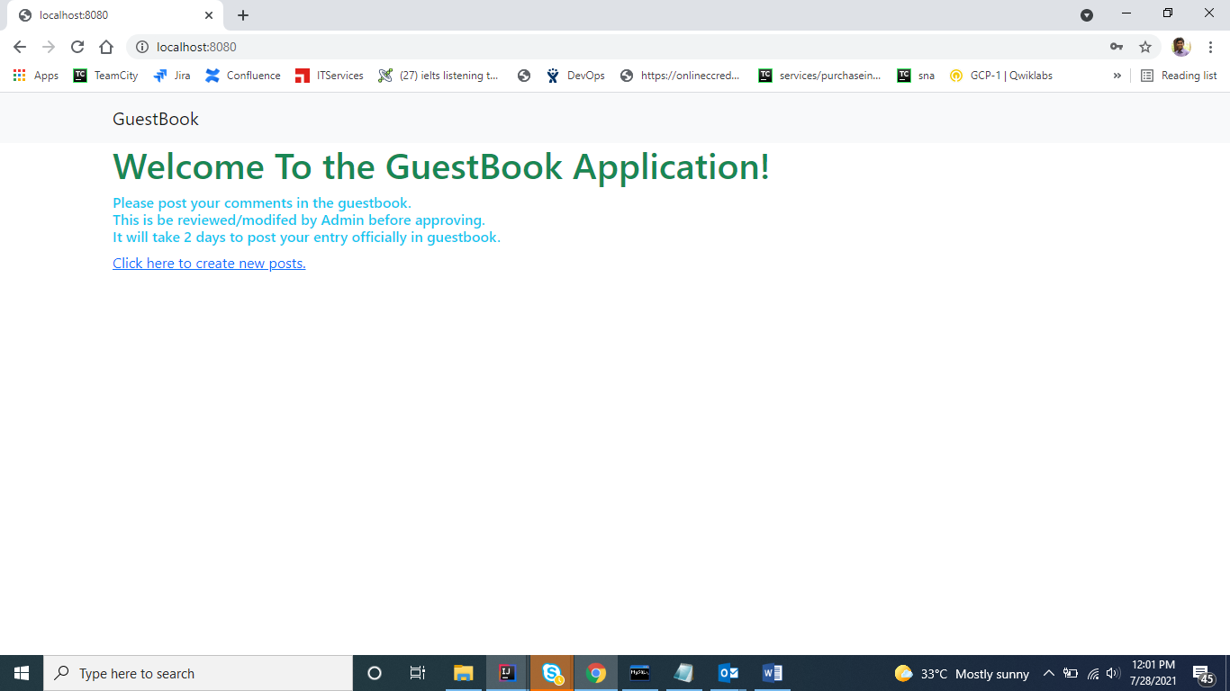

On clicking create new post

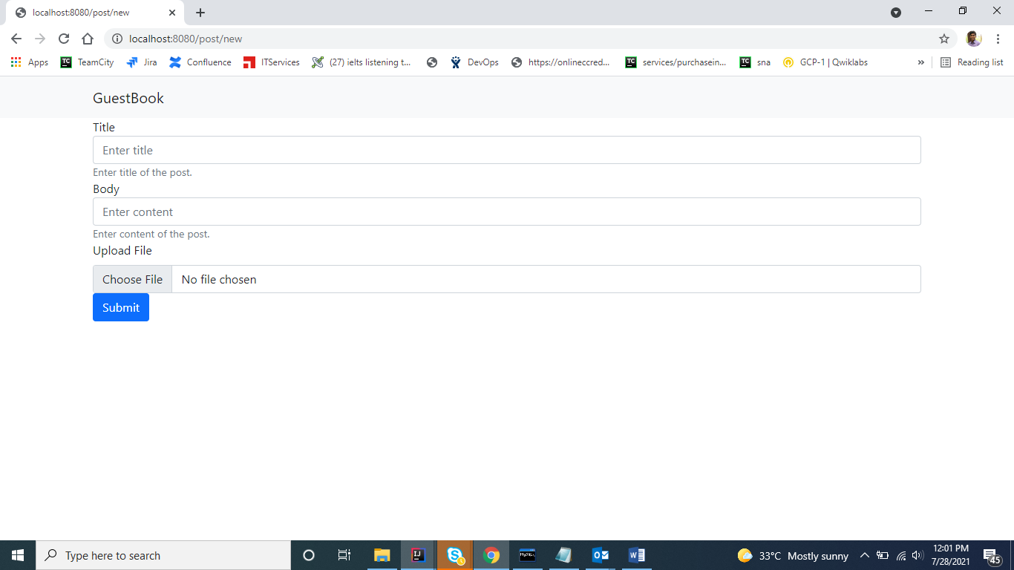

After entering the form details and uploading image

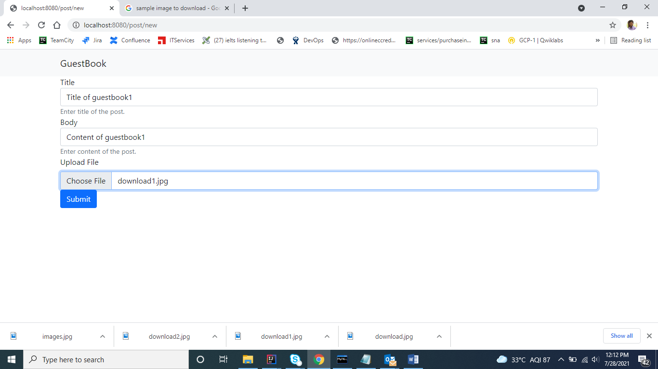

On clicking submit

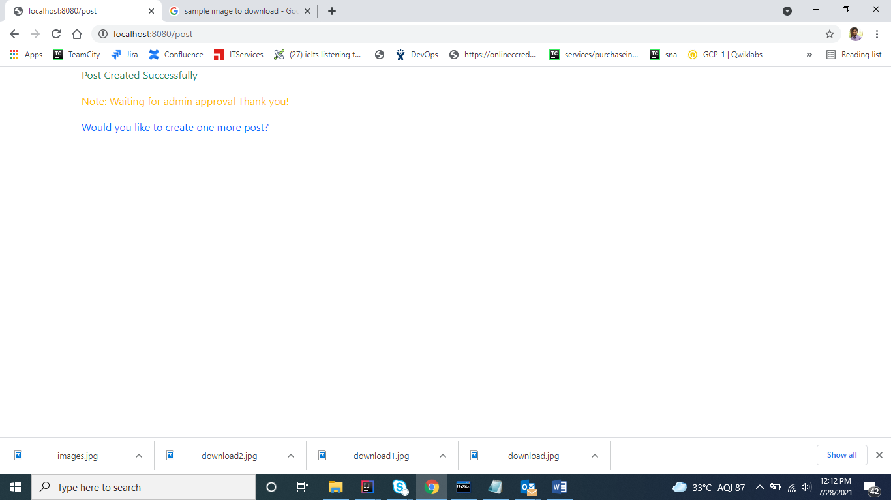

On clicking “would you like to create one more post” and entering the details

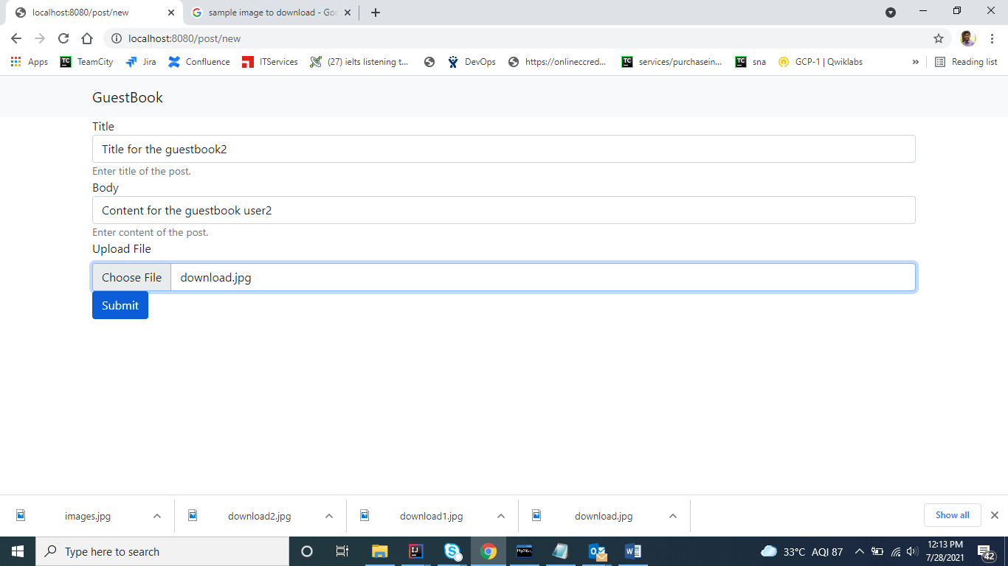

Admin login:

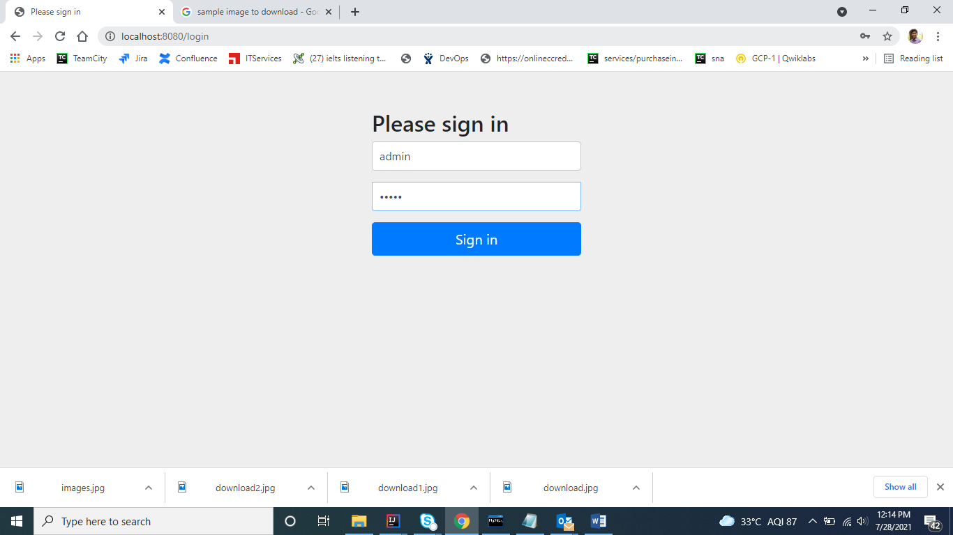

List of all posts:

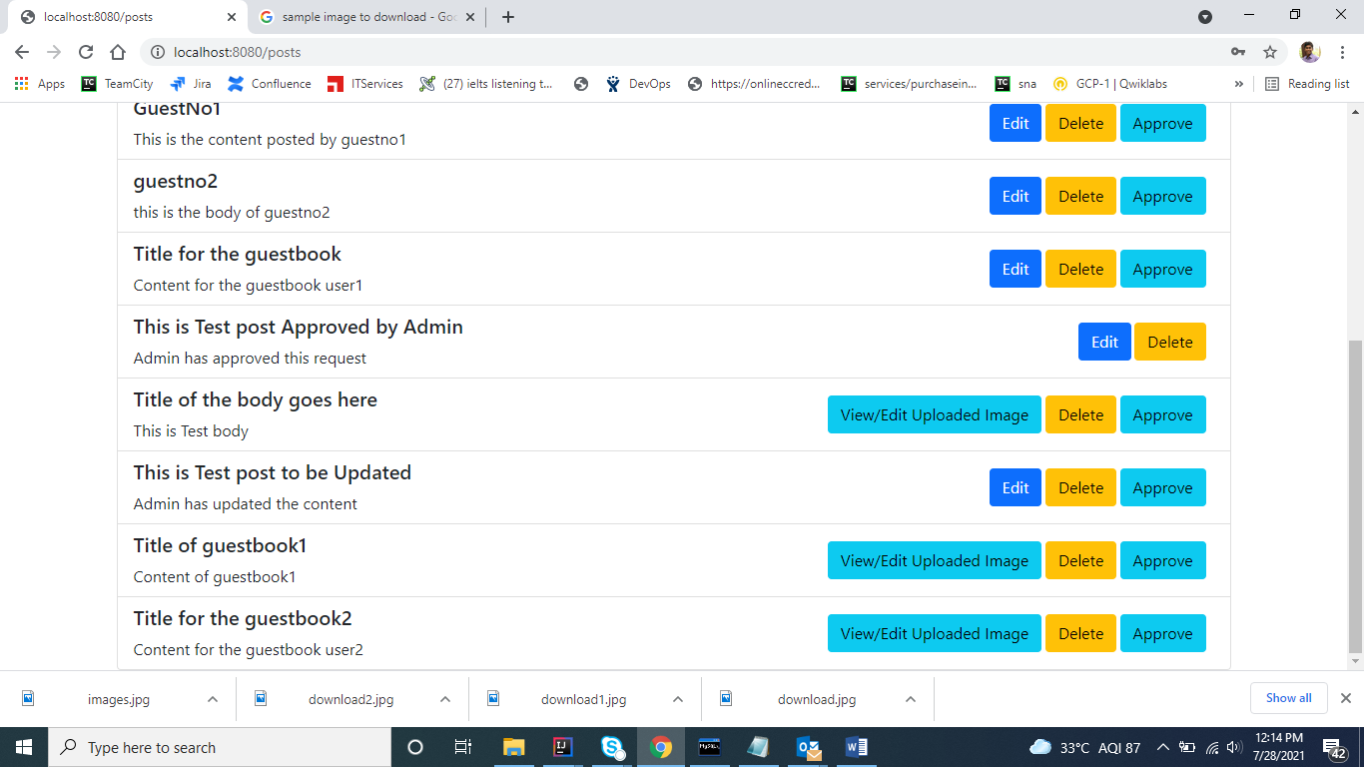

If only content is available edit button will be displayed, if image uploaded then view/edit uploaded image will be displayed.

After Deleting few posts

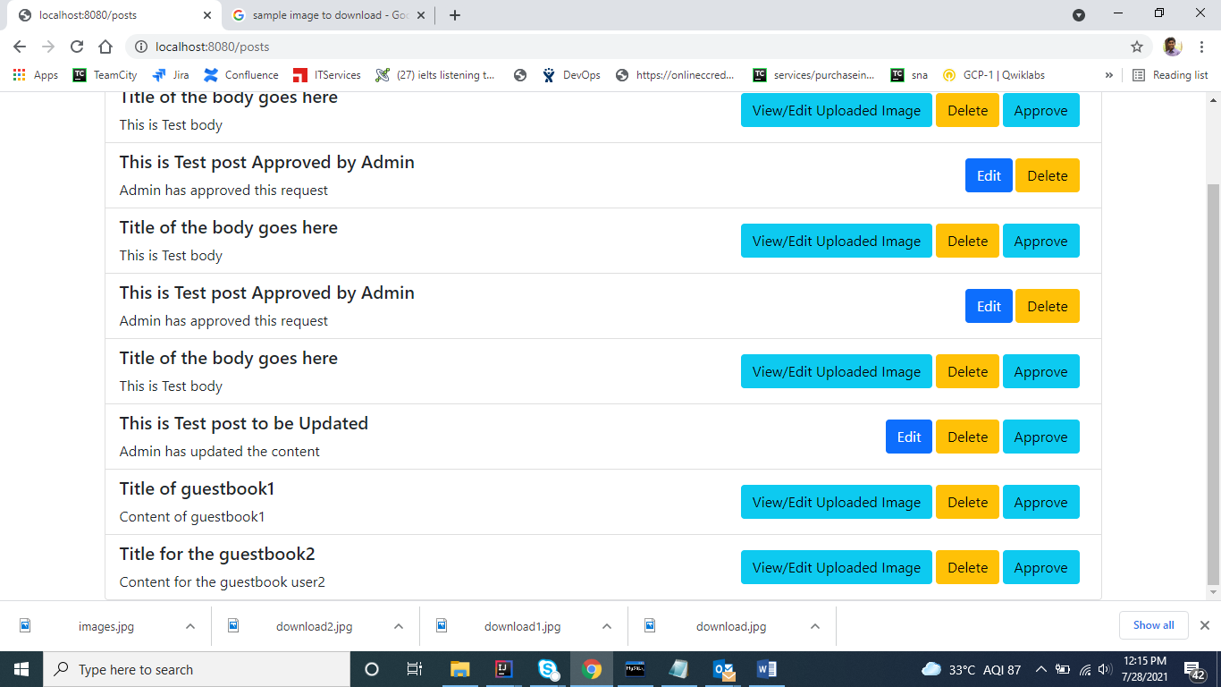

On clicking view/edit uploaded image for guestbook1:

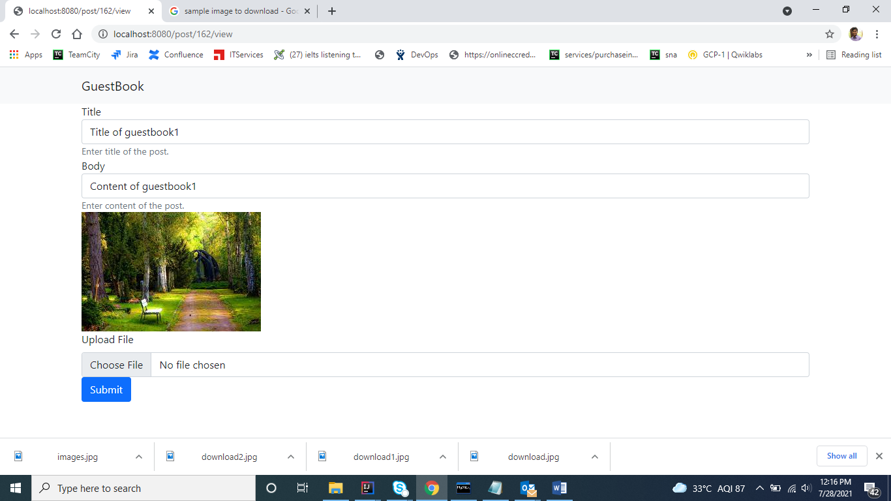

Edited the image and content for guestbookuser1

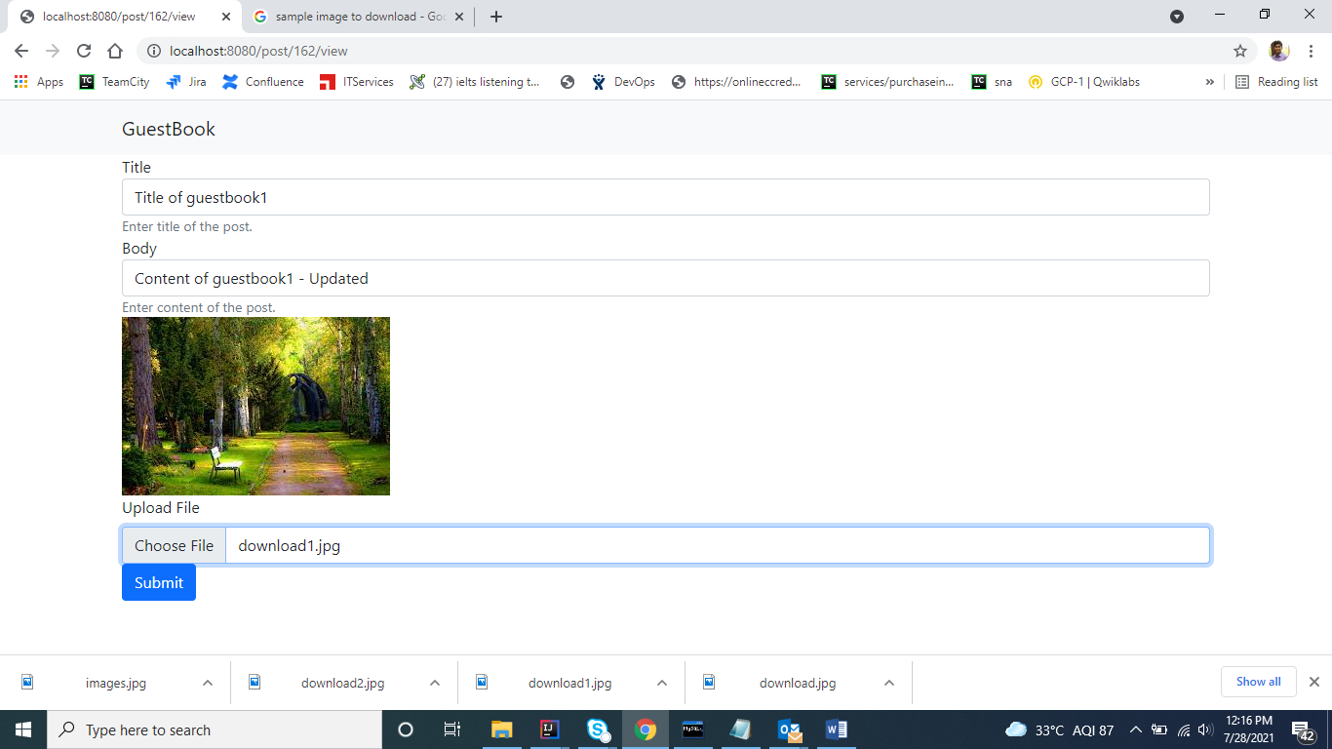

Content/image updated

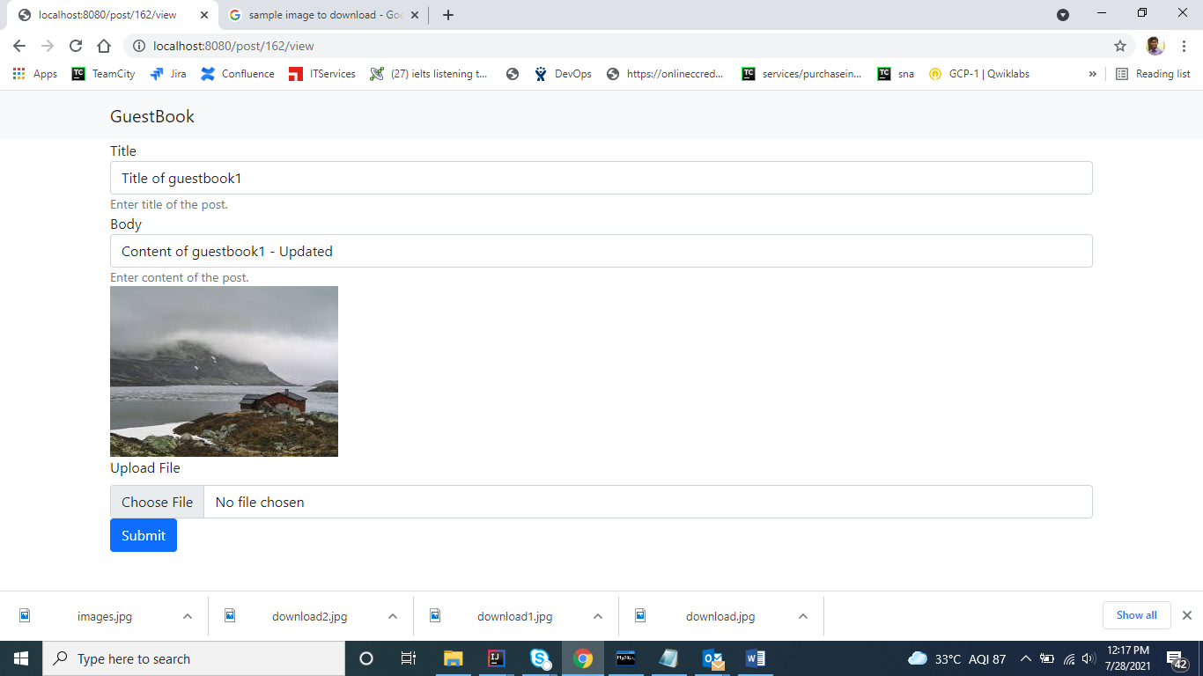

After approving the guesbook1 user

Approved button disabled

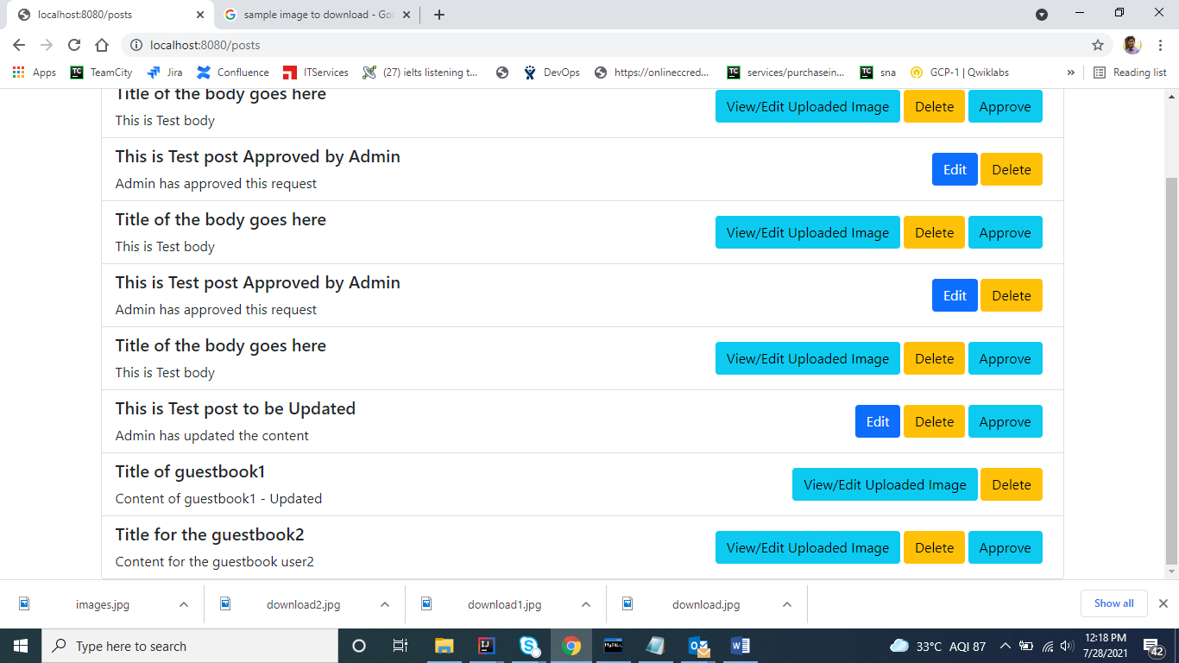

When admin tries to create new posts:

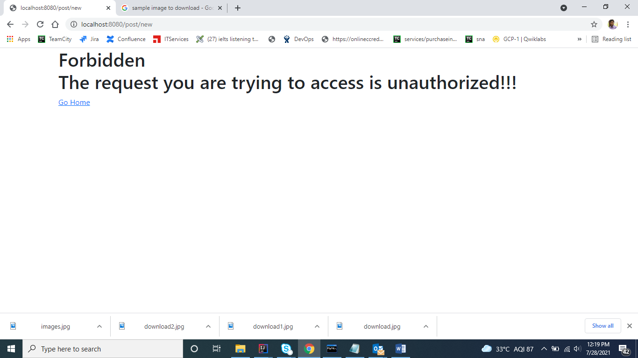

When admin tries to open some random url:

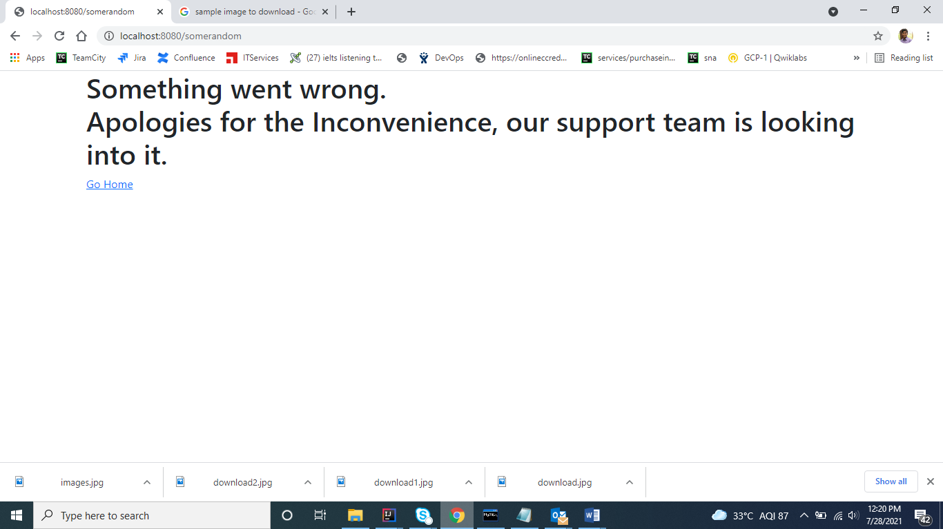

Table:

CREATE TABLE users (

username VARCHAR(50) NOT NULL,

password VARCHAR(100) NOT NULL,

enabled TINYINT NOT NULL DEFAULT 1,

PRIMARY KEY (username)

);

CREATE TABLE authorities (

username VARCHAR(50) NOT NULL,

authority VARCHAR(50) NOT NULL,

FOREIGN KEY (username) REFERENCES users(username)

);

INSERT INTO users (username, password, enabled)

values ('admin',

'$2a$10$tSXNdUe1SolOuejwgRTj9.ossMufGejhryGg9hnrzkXnD6uQY2G0u',

1);

INSERT INTO users (username, password, enabled)

values ('guest',

'$2a$10$tgDoBvMpYQNNbz2CyK/yZ.VZAuRfhvUQ9Ks67Tn844zqg6b3amtTW',

1);

INSERT INTO authorities (username, authority)

values ('admin', 'ROLE_ADMIN');

INSERT INTO authorities (username, authority)

values ('guest', 'ROLE_USER');

CREATE TABLE entry(id INT NOT NULL AUTO_INCREMENT, title varchar(50) not null, body text, approved_status boolean default false, content longblog null, name varchar(100), primary key(id));