Eric Lazarski

3/2/2019

CPSC 57100 – Artificial Intelligence 1

Spring 1, 2019

MP4

1. Bayesian network definition
   1. 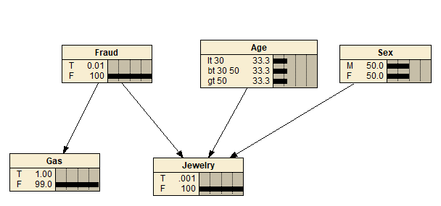

|  |  |  |  |  |  |  |  |  |  |  |  |  |  |  |  |  |
| --- | --- | --- | --- | --- | --- | --- | --- | --- | --- | --- | --- | --- | --- | --- | --- | --- |
|  | | Age < 30 | | | | | | | Age 30-50 | | | | Age > 50 | | | |
|  | | Sex M | | | | Sex F | | | Sex M | | Sex F | | Sex M | | Sex F | |
|  | | Jewelry T | | Jewelry F | | Jewelry T | Jewelry F | | Jewelry T | Jewelry F | Jewelry T | Jewelry F | Jewelry T | Jewelry F | Jewelry T | Jewelry T |
| Fraud-T | | 5 | | 95 | | 5 | 95 | | 5 | 95 | 5 | 95 | 5 | 95 | 5 | 95 |
| Fraud-F | | 0.0001 | | 99.9999 | | 0.0005 | 99.9995 | | 0.0004 | 99.9996 | 0.002 | 99.998 | 0.0002 | 99.9998 | 0.001 | 99.999 |
|  | | Gas-T | | Gas-F | | |
| Fraud-T | | 20 | | 80 | | |
| Fraud-F | | 1 | | 99 | | |

1. Minimizing/Maximizing Fraud
   1. Minimum values – {0.008%, 99.992%}
      1. No gas, no jewelry, male < 30
      2. No gas, no jewelry, female < 30
      3. No gas, no jewelry, male 30-50
      4. No gas, no jewelry, female 30-50
      5. No gas, no jewelry, male >50
      6. No gas, no jewelry, female >50
   2. Maximum values – {99%, 0.99%}
      1. gas, jewelry male < 30
2. Probabilities
   1. P(Fraud|gasPurchase,jewelryPurchase) = {93.5%, 6.54%}
   2. P(Fraud|gasPurchase,!jewelryPurchase) = {0.19%, 99.8%}
   3. P(Fraud|!gasPurchase,jewelryPurchase) = {36.6%, 63.4%}
   4. P(Fraud|!gasPurchase,!jewelryPurchase) = {0.008%, 99.992%}