Evis Lazimi CS 389 Git Tutorial

1) GitHub is an online source code management system where users can work on code as a group or as individuals.

2) It was founded February 8th 2008 by Tom Preston-Werner, Chris Wanstrath and PJ Hyett.

3) Apparently there are things such as GitLab, but Github is the most widely known and used system.

4) I would use such a platform when working on a project as a group. You can work on projects with people that are across the world just as easy as you would if they were near you and it is very easy to use.

4A)

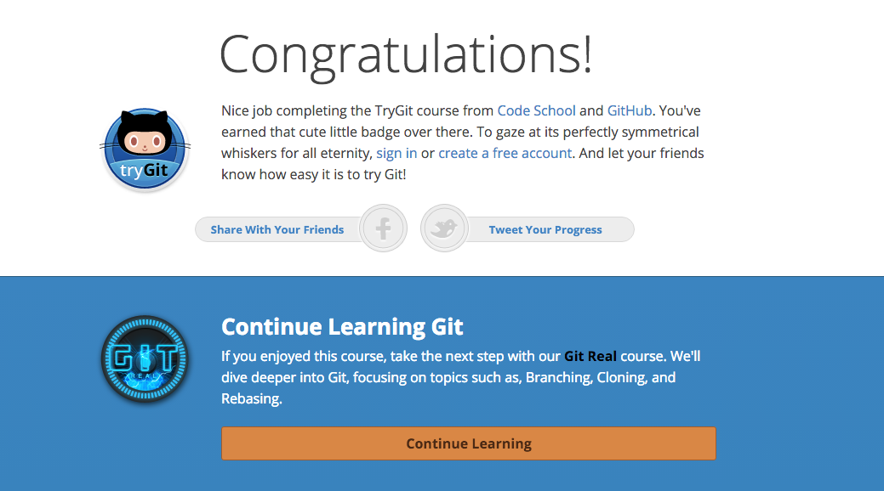

**Part 5:**

Define the following terms in the context of Git (2 lines maximum):

* Repository – A place where your work history is stored
* Commit – A commit is when you save all of your work or commit new work
* Push – A push is when you send your changes to the project so others can see
* Branch – A branch is when you see all branches of the repository
* Fork – A fork is a copy of a repository where changes you make don’t affect the project. Useful when proposing changes.
* Merge – When you are done working on a branch, you can merge the branch with the master branch, or the main project.
* Clone – A git clone is when you get a copy of the project (repository). Useful when working with someone else on a project.
* Pull – A pull is when you request updates from the server
* Pull request – A pull request is when you send changes for other to review