

CISAC

MVP Matching Rules – Design

# Document Control

## Change Record

|  |  |  |
| --- | --- | --- |
| Date | Person | Version/Reference |
| 24th Apr 2019 | John Corley | Initial version |
| 28th May 2019 | John Corley | Updates following feedback from first workshop and subsequent reviews |
| 18th Jun 2019 | John Corley & Curnan Reidy | Updates from previous workshop + completion of Processing pipeline component details |

## Reviewers

Zsófia Szöllősi - ARTISJUS

Nóra Varga - ARTISJUS

Györgyi Németh - ARTISJUS

Bolmar Carrasquilla - ASCAP

Janise Hooper - BMI

Ed Oshanani - BMI

José Macarro - CISAC

Didier Roy - FastTrack

Hanna Mazur - FastTrack

Jens Vinsby - KODA

Katrien Tielemans - SABAM

Cynthia Lipskier - SACEM

Xavier Costaz - SACEM

Declan Rudden - SaorServices

Niamh McGarry-SaorServices

Roisin Jones – Saor Services

Curnan Reidy - SpanishPoint

Peter Klauser - SUISA

## Distribution

Reviewers

## Approval

This document was approved electronically via email by the following people on the following dates:

|  |  |  |
| --- | --- | --- |
| Date/Time | Person | Note |
|  |  |  |

# Table of Contents

Document Control 2

Change Record 2

Reviewers 2

Distribution 3

Approval 3

Table of Contents 4

1 Introduction 7

What does this document contain? 7

Who should read this document? 7

Glossary 7

References 7

2 Overview 8

2.1 Scope 8

2.2 Matching Rule Configuration 8

2.3 Matching Rule Implementation 8

3 ISWC Database Matching Pipeline 10

3.1 Submission Data 12

3.1.1 POST/submission 12

3.1.1.1. “body” Parameter 12

3.1.1.2. Example “body” Parameter value 14

3.1.2 PUT/submission 15

3.1.3 DELETE/submission 15

3.1.4 POST/iswc/merge 15

3.1.5 GET /iswc/workflowTasks 16

3.1.6 PATCH /iswc/workflowTasks 17

3.1.7 GET /iswc/searchByIswc 18

3.1.8 GET /iswc/searchByAgencyWorkCode 20

3.1.9 POST /iswc/searchByTitleAndContributor 21

3.2 Matching Engine API 22

3.3 Matching Engine API 23

3.3.1 GET/Work/Match 23

3.3.1.1. InputWorkInfo Parameter 23

3.3.1.2. MatchResult Response 25

3.4 Matching for ISWC Eligible Submitter 26

3.5 Matching for ISWC Non-Eligible Submitter 27

3.6 Match for Search 28

3.7 Match an Existing Submission for ISWC Eligible Submitter 29

3.8 Match an Existing Submission for ISWC Non-Eligible Submitter 30

3.9 Rank Results 31

3.9.1 Initial Ranking 31

3.9.2 Following “LinkedTo” chain 32

3.10 Match Related ISWCs (Derived or Merged) 32

3.11 Alter IPs and then redo matching 33

4 Matching Rule Configuration 35

4.1 Existing Spanish Point Matching Engine Configuration Tool 35

4.2 Key Proposed Matching Settings for CISAC ISWC Database 37

4.2.1 Configuration for “Eligible” Source 38

4.2.2 Configuration for “NonEligible” Source 40

5 ISWC Processing (Assignment) Pipeline 44

5.1 Scenario AS/01 – ISWC Eligible Submission Associated with existing Preferred ISWC 44

5.1.1 WorkInfo 44

5.1.2 Title 45

5.1.3 DisambiguationISWC 45

5.1.4 DerivedFrom 46

5.1.5 Creator 46

5.1.6 Publisher 47

5.1.7 Performer 47

5.1.8 WorkInfoPerformer 48

5.1.9 WorkInfoInstrumentation 48

5.2 Scenario AS/02 – ISWC Ineligible Submission Associated with existing Preferred ISWC 48

5.2.1 WorkInfo 48

5.3 Scenario AS/03 – ISWC Eligible Submission with new Preferred ISWC level details 49

5.3.1 ISWC 50

5.3.2 WorkInfo 50

5.3.3 Title 51

5.3.4 DisambiguationISWC 51

5.3.5 DerivedFrom 52

5.3.6 Creator 52

5.3.7 Publisher 53

5.3.8 Performer 53

5.3.9 WorkInfoPerformer 54

5.3.10 WorkInfoInstrumentation 54

5.4 Scenario AS/04 – Update ISWC Eligible Submission with new Preferred ISWC level details 54

5.4.1 Title 55

5.4.2 Creator 55

5.4.3 Publisher 56

5.5 Scenario AS/05 – Update ISWC Eligible Submission with valid Preferred ISWC level details where the Preferred ISWC is different from the current Preferred ISWC 56

5.5.1 ISWCLinkedTo 57

5.6 Scenario AS/08 – Update ISWC Ineligible Submission with valid Preferred ISWC level details where the Preferred ISWC is different from the current Preferred ISWC 57

5.7 Scenario AS/09 – Delete ISWC Submission 58

5.8 Scenario AS/10 – Recalculating ISWC Eligible and Authoritative flags 58

5.9 Approval Workflow Tasks (Formerly Known as Corrections Tasks) 58

5.9.1 Workflow Types 58

5.9.2 Workflow Task Data Structure 59

5.9.3 Adding Update Approval Workflows 61

5.9.4 Adding Merge Approval Workflows 61

5.9.5 Retrieving and Actioning Workflow Tasks 61

Appendix A – Open and Closed Items 64

1. Introduction

## What does this document contain?

The purpose of this design document is to take the matching rules agreed in the WBS 1.2 (MVP 'To Be' Business Rules) document and describe in detail how these rules will be implemented in the new ISWC database.

## Who should read this document?

CISAC development and project management personnel. Spanish Point development team members.

## Glossary

## References

|  |  |
| --- | --- |
| Reference | Description |
| SPE_20190218_ISWCDataModel.docx | New ISWC Database Data Model |
| REQ_20190212_MVP To Be Business Rules.xlsx | ‘To Be’ Business Rules |
| SPE_20190424_MVPValidationRules.docx | Validation Rules specification |
|  |  |
|  |  |
|  |  |
|  |  |
|  |  |

1. Overview

This chapter provides an overview of the proposed solution for implementing matching rules in the new ISWC Database solution.

## Scope

This document covers the implementation of the agreed ‘To Be’ business rules as described in the following tabs of the MVP ‘To Be’ Business Rules document (see references above):

* Matching
* Processing (Assignment)

## Matching Rule Configuration

We propose to use the existing Spanish Point Matching Engine configuration application to support the configuration of matching rules required for the ISWC Database solution. The matching engine configuration application and any specific enhancements needed for the ISWC database are described in chapter four of this specification.

## Matching Rule Implementation

All matching will be carried out by the Spanish Point Matching Engine. The existing matching engine will be extended to cater for rules not currently in place in the matching engine.

The following diagram outlines the overall architecture of the new ISWC Database system and indicates where this component fits within that solution.



Components tagged in the diagram (1-4) above have more detailed explanations below:

1. The main processing component for the new ISWC database will be a new custom developed REST based Web API. This Web API will process both individual transactions and batches of transactions
2. The ISWC Database REST based Web API will use a Validation Pipeline to implement all validation rules. This is covered in the MVP Validation Rules specification. See the references section of this document for details.
3. The ISWC Database Web API will use a Matching Pipeline that will in turn call the Spanish Point Matching Engine through its own web API to carry out all matching tasks. This is described in Chapter 3 of this specification document.
4. The ISWC Database Web API will update the core ISWC database and assign ISWCs through a custom developed Processing (Assignment) pipeline.
5. ISWC Database Matching Pipeline

The matching pipeline will be used by the ISWC Database REST based Web API to call the matching engine with the appropriate parameters depending in the type of submission.



The matching pipeline consists of a sequence of pipeline components. Each pipeline component will be implemented as a .net core class within the Web API solution and will be loaded dynamically as a distinct versioned .dll.

Each matching pipeline component will call the matching engine using a specific mapping of data from the submission. Some pipeline components are only applicable to certain types of submission.

All matching pipeline components will use a common error handling framework for identifying error codes and corresponding messages. It will capture these along with the pipeline component version and rule identifiers in a set of tracking data that will be logged along with the transaction in the system (stored in the Cosmos DB No SQL database).

All matching pipeline components will be deployed through an automated Azure Dev Ops pipeline through the different environment tiers (dev, uat, staging and production). Each pipeline component will have a comprehensive set of associated unit tests built into them and these unit tests will be automatically executed as part of the automated release process.

## Submission Data

The following shows an initial draft of the REST based Web API. The full API will be defined in WBS 1.6. The purpose of this initial draft is to define the data fields available in an ISWC submission so that those specific fields can be referenced in the matching pipeline components’ implementation later in this chapter. Note: Some of this section is also repeated in the WBS 1.4 specification document.

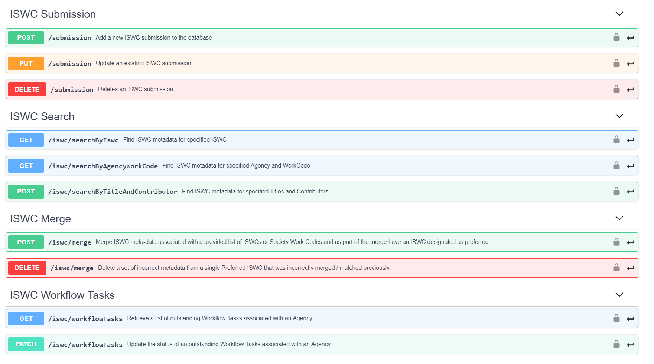

Figure 1 - Operations used in Web API

Notes:

1. Not all operations that will be supported are listed above
2. The operations show above deal with individual submission data. The full Web API will include the ability to process an array of submissions in a single operation.

### POST/submission

This operation represents an add of a new ISWC submission to the database. Equivalent of the CAR transaction in EDI.

#### “body” Parameter

The POST will include the following required “body” parameter:

**Submission{**

|  |  |
| --- | --- |
| **agency\*** | **string *minLength: 3 maxLength: 3*** |
| **sourcedb\*** | **integer($int64)** |
| **workcode\*** | **string** |
| **iswc** | **string *pattern: T[0-9]{9}10***  **The submitted ISWC** |
| **preferredIswc** | **string *pattern: T[0-9]{9}10***  **The preferred ISWC** |
| **category** | **string** |
| **originalTitle\*** | **string** |
| **disambiguation** | **boolean** |
| **disambiguationReason** | **DisambiguationReasonstring**  **Disambiguation Reason Code**  **Enum: [ DIT, DIA, DIE, DIC, DIP, DIV ]** |
| **disambiguateFrom** | **[DisambiguateFrom{**   |  |  | | --- | --- | | **iswc** | **string *pattern: T[0-9]{9}10*** | | **title** | **string** |   **}]** |
| **bvltr** | **BVLTRstring**  **Background, Logo, Theme, Visual or Roled Up Cue**  **Enum: [ Background, Logo, Theme, Visual, RolledUpCue ]** |
| **derivedWorkType** | **DerivedWorkTypestring**  **Derived Work Type- if not provided then this isnt a derived work**  **Enum: [ ModifiedVersion, Excerpt, Composite ]** |
| **derivedFromIswcs** | **[DerivedFrom{**   |  |  | | --- | --- | | **iswc** | **string *pattern: T[0-9]{9}10*** | | **title** | **string** |   **}]** |
| **otherTitles** | **[Title{**   |  |  | | --- | --- | | **title\*** | **string**  **Musical work title** | | **type\*** | **string**  **CISAC desgned work type**  **Enum: Array [ 14 ]** |   **}]** |
| **interestedParties\*** | **[InterestedParty{**   |  |  | | --- | --- | | **nameNumber\*** | **integer($int64)** | | **baseNumber** | **string** | | **role\*** | **stringEnum: Array [ 14 ]** |   **}]** |
| **performers** | **[Performer{**   |  |  | | --- | --- | | **firstName** | **string** | | **lastName\*** | **string** |   **}]** |
| **instrumentation** | **[Instrumentation{**   |  |  | | --- | --- | | **code\*** | **string *minLength: 1 maxLength: 3*** |   **}]** |
| **cisnetCreatedDate** | **string($date-time)** |
| **cisnetLastModifiedDate** | **string($date-time)** |

**}**

#### Example “body” Parameter value

The following shows a simple example body parameter value:

{

"agency": "021",

"sourcedb": 21,

"workcode": "17417509",

"category": " DOM",

"originalTitle": "YESTERDAY",

"disambiguation": false,

"bvltr": "Background",

"otherTitles": [

{

"title": "YESYERDAY",

"type": "AT"

}

],

"interestedParties": [

{

"nameNumber": 17798450,

"baseNumber": " I-001652493-7",

"role": "CA"

}

],

"performers": [

{

"lastName": "THE BEATLES"

}

],

"cisnetCreatedDate": "2019-05-13T09:04:47.833Z",

"cisnetLastModifiedDate": "2019-05-13T09:04:47.833Z"

}

### PUT/submission

This operation represents an update of an existing ISWC submission to the database. Equivalent of the CUR transaction in EDI. The PUT will include the same required “body” parameter as POST above.

### DELETE/submission

This operation represents the deletion of an existing ISWC submission in the database. Equivalent of the CDR transaction in EDI. The DELETE operation accepts the following specific parameters:

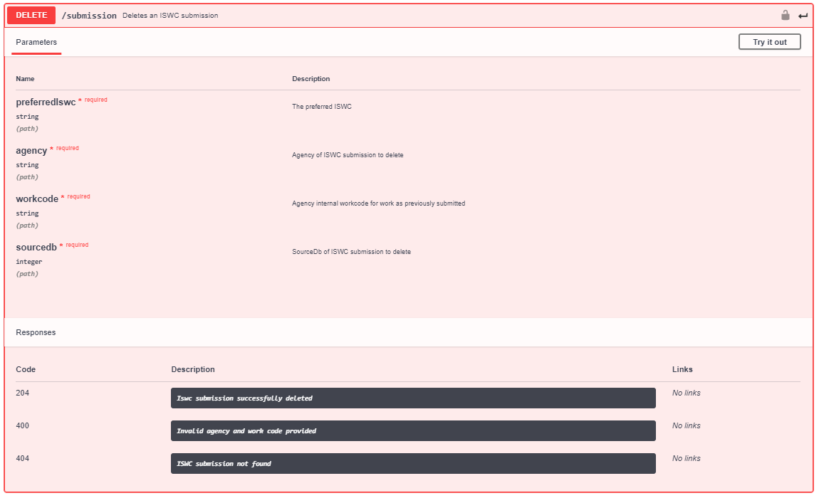

### POST/iswc/merge

This operation represents the merge of two or more ISWCs together.

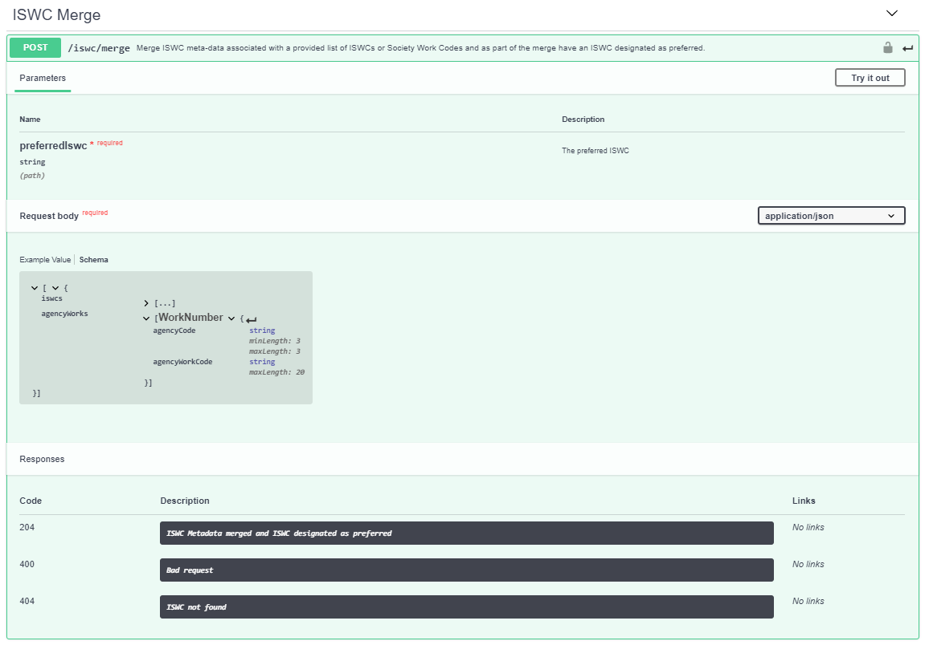

The preferredISWC passed as a parameter into the operation represents the preferredISWC that additional preferred ISWCs will be merged into. The request body contains an array of iswcs or agency work codes. Each preferred iswc pointed to by each array entry will be merged into the designated preferredISWC.

### GET /iswc/workflowTasks

This operation retrieves all outstanding workflow tasks for an Agency. Each task has an associated array of ISWCMetadata objects returned. See GET/iswc/searchByIswc at 3.1.7 below for info on the metadata returned.

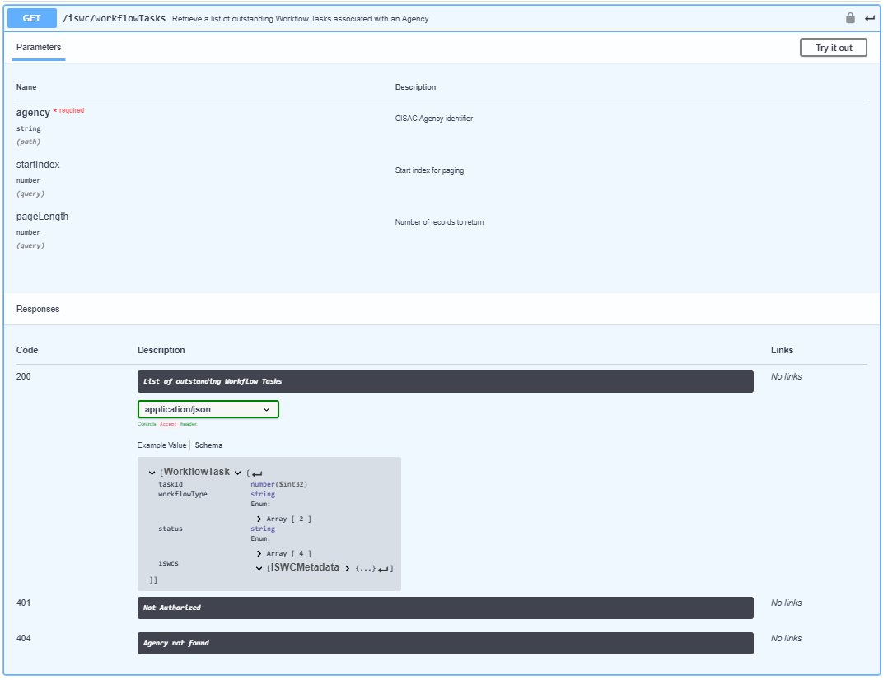

### PATCH /iswc/workflowTasks

This operation enables an Agency to update the status of a set of outstanding workflow tasks:

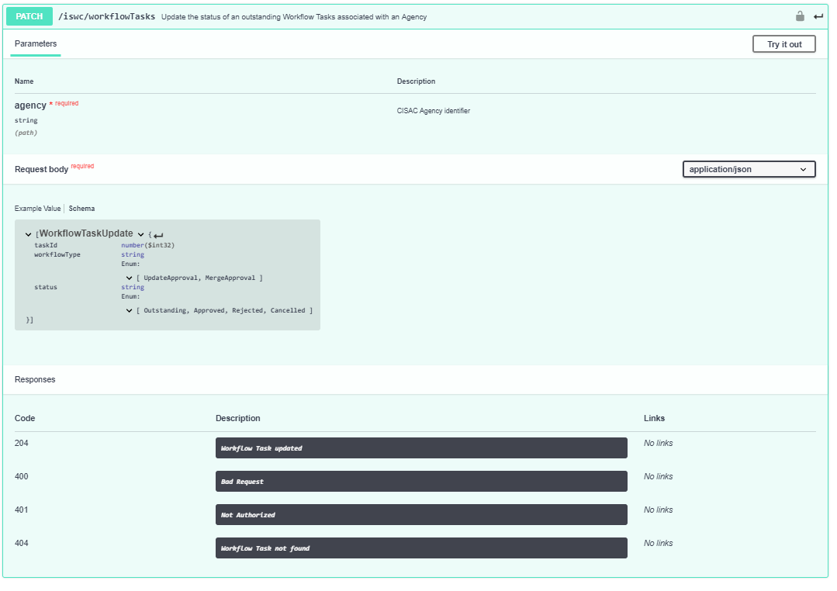

### GET /iswc/searchByIswc

This operation enables an Agency to find ISWC metadata for a specified ISWC:

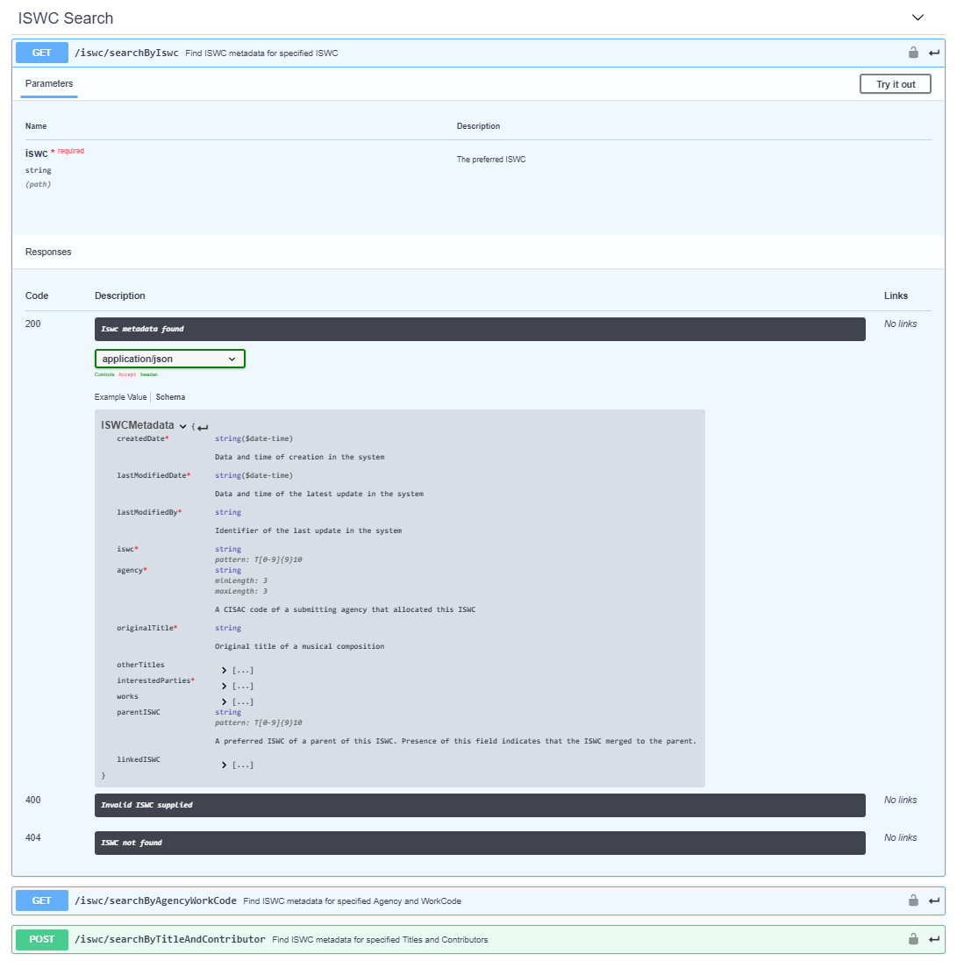

This operation returns its results as an array of ISWCMetadata type objects:

**ISWCMetadata{**

|  |  |
| --- | --- |
| **createdDate\*** | **string($date-time)**  **Data and time of creation in the system** |
| **lastModifiedDate\*** | **string($date-time)**  **Data and time of the latest update in the system** |
| **lastModifiedBy\*** | **string**  **Identifier of the last update in the system** |
| **iswc\*** | **string *pattern: T[0-9]{9}10*** |
| **agency\*** | **string *minLength: 3 maxLength: 3***  **A CISAC code of a submitting agency that allocated this ISWC** |
| **originalTitle\*** | **string**  **Original title of a musical composition** |
| **otherTitles** | **[...]** |
| **interestedParties\*** | **[...]** |
| **works** | **[...]** |
| **parentISWC** | **string *pattern: T[0-9]{9}10***  **A preferred ISWC of a parent of this ISWC. Presence of this field indicates that the ISWC merged to the parent.** |
| **linkedISWC** | **[**  **All linked preferred ISWCs. Presence of this field indicates that those ISWCs merged to this ISWC.**  **string *pattern: T[0-9]{9}10*]** |

**}**

### GET /iswc/searchByAgencyWorkCode

This operation enables an Agency to find ISWC metadata by Agency Work Code (Society Work Code):

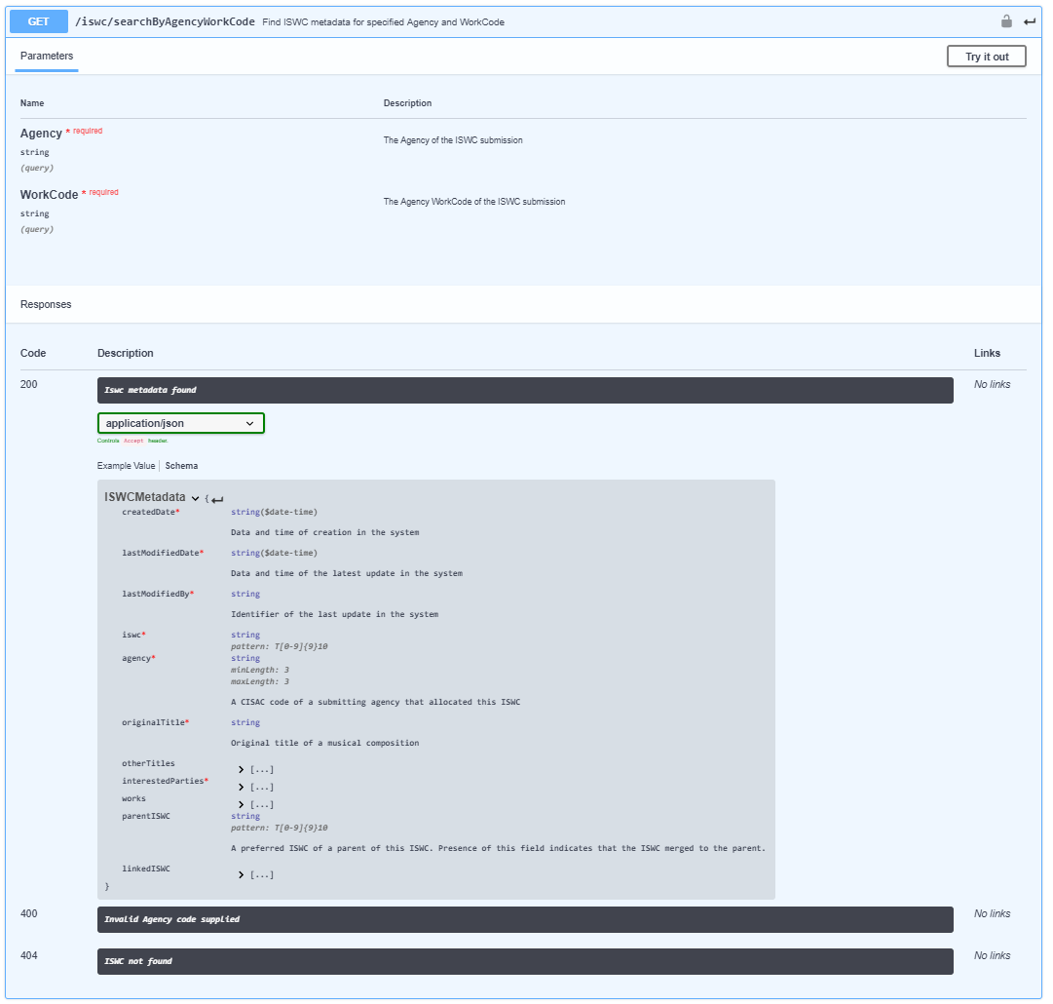

This operation returns its results as an array of ISWCMetadata type objects as per the previous search operation.

### POST /iswc/searchByTitleAndContributor

This operation enables an Agency to find ISWC metadata by a combination of title and contributors:

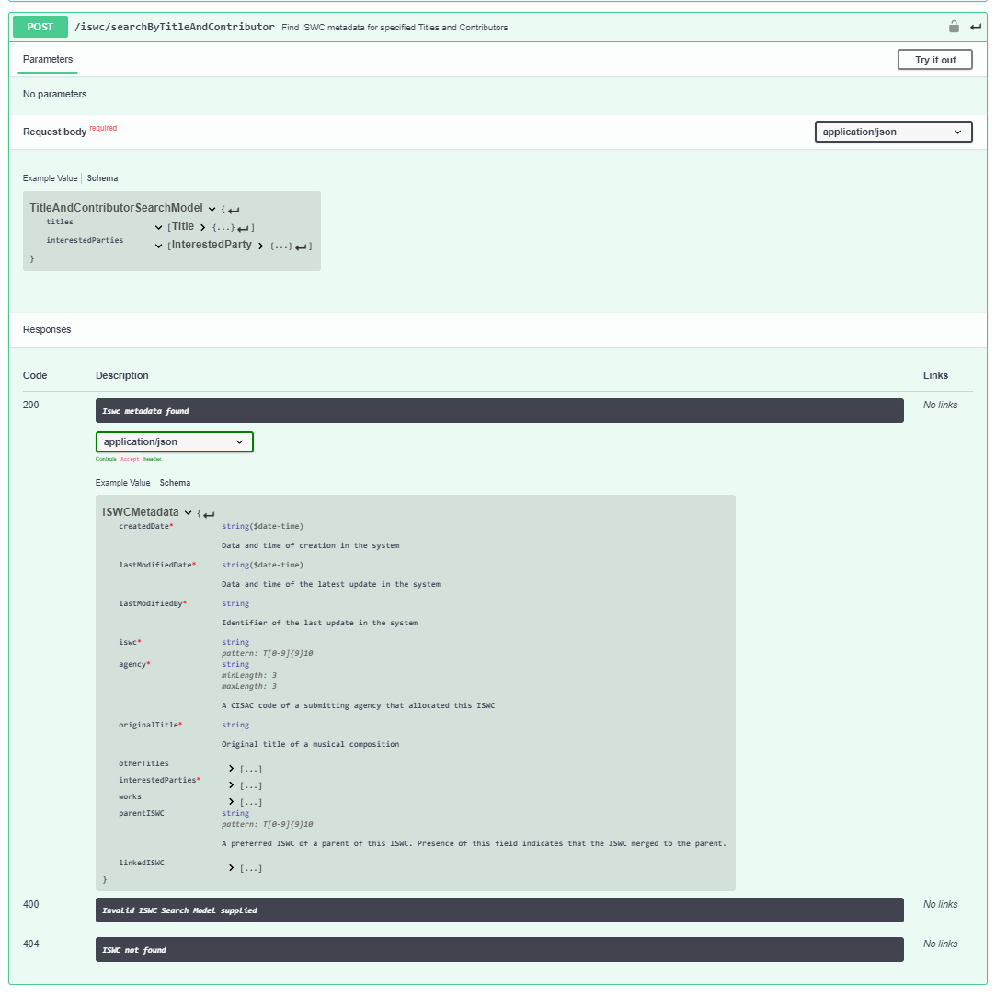

This operation returns its results as an array of ISWCMetadata type objects as per the previous search operation.

## Matching Engine API

The Spanish Point Matching Engine provides a REST API which will be used by the matching pipeline components to carry out the matching.

The relevant parts of that API are listed below:

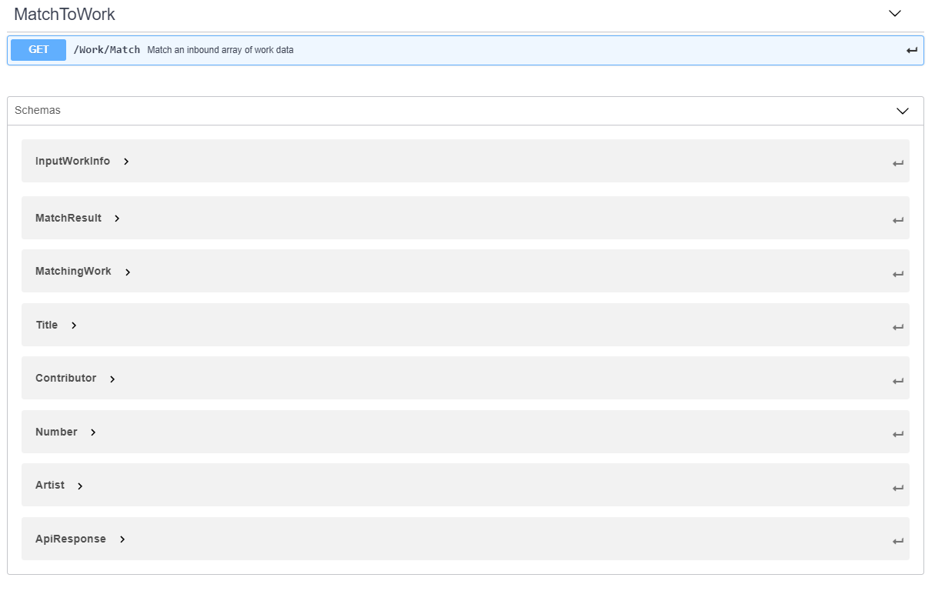

## Matching Engine API

The Spanish Point Matching Engine provides a REST API which will be used by the matching pipeline components to carry out the matching.

### GET/Work/Match

This operation represents the retrieval of an array of work matches for an array on input work information. It has an input parameter that consists of an array of InputWorkInfo objects. It returns an array of MatchResult type objects.

#### InputWorkInfo Parameter

The GET will include the following required InputWorkInfo array parameter:

**InputWorkInfo{**

|  |  |
| --- | --- |
| **id** | **integer($int64)** |
| **source** | **string** |
| **titles** | **[Title{**   |  |  | | --- | --- | | **title\*** | **string**  **Musical work title** | | **type\*** | **string**  **Title Types**  **Enum: Array [ 14 ]** | | **matched** | **string**  **Populated by matching engine as part of match results**  **Enum: Array [ 3 ]** |   **}]** |
| **contributors** | **[Contributor{**   |  |  | | --- | --- | | **name\*** | **string** | | **ipiNumber** | **integer($int64)** | | **ipiBaseNumber** | **string *pattern: [Ii]-[0-9]{9}-[0-9]*** | | **typeCode\*** | **stringEnum: Array [ 2 ]** | | **role** | **stringEnum: Array [ 14 ]** | | **matched** | **string**  **Populated by matching engine as part of match results**  **Enum: Array [ 4 ]** |   **}]** |
| **artists** | **[Artist{**   |  |  | | --- | --- | | **firstName** | **string** | | **lastName\*** | **string** | | **matched** | **string**  **Populated by matching engine as part of match results**  **Enum: Array [ 2 ]** |   **}]** |
| **numbers** | **[Number{**   |  |  | | --- | --- | | **type\*** | **string**  **Number Type. E.G. Code for Society, Publisher, Agency or standard code such as ISWC** | | **number\*** | **string**  **Number of the designated type** | | **matched** | **string**  **Populated by matching engine as part of match results**  **Enum: Array [ 2 ]** |   **}]** |
| **disambiguateFromNumbers** | **[Number{**   |  |  | | --- | --- | | **type\*** | **string**  **Number Type. E.G. Code for Society, Publisher, Agency or standard code such as ISWC** | | **number\*** | **string**  **Number of the designated type** | | **matched** | **string**  **Populated by matching engine as part of match results**  **Enum: Array [ 2 ]** |   **}]** |
| **workType** | **string** |

**}**

#### MatchResult Response

The GET will return an array of the following MatchResult type objects:

**[MatchResult{**

|  |  |
| --- | --- |
| **inputWorkId** | **integer($int64)** |
| **matchTime** | **integer($int64)** |
| **errorMsg** | **string** |
| **matches** | **[MatchingWork{**   |  |  | | --- | --- | | **id** | **integer($int64)** | | **matchType** | **stringEnum: [ Number, Text ]** | | **titles** | **[...]** | | **contributors** | **[...]** | | **artists** | **[...]** | | **numbers** | **[...]** |   **}]** |

**}]**

Note: The above existing matching engine API has be extended to support the following ISWC Database specific match related data:

* Disambiguation IDs (disambiguateFromNumbers)
* Derived Work Types (workType)

## Matching for ISWC Eligible Submitter

This pipeline component performs the initial matching for an ISWC eligible submission.

This pipeline component will be applied to submissions that:

* Are new submissions to the ISWC Database API (POST)
* Submissions that have been determined by the validation pipeline as being valid
* Submissions that have been determined by the validation pipeline as being from an ISWC eligible submitter

It will call the Get/Work/Match REST API using the following mapping of Submission type data to InputWorkInfo type data:

|  |  |  |
| --- | --- | --- |
| **Source (Submission)** | **Destination (InputWorkInfo)** | **Mapping Information** |
|  | Id | Use an internally generated temporary id to uniquely define this matching request |
| “Eligible” | Source | Different matching rules will be configured for “Eligible” and “NonEligible” sources in the matching engine. |
| originalTitle  otherTitles[].title  otherTitles[].type | titles[].title  titles[].type | Original title will be mapped into the titles array with a type of ‘OT’. otherTitles array will be mapped into titles array |
| interestedParties[].baseNumber  interestedParties[].role  interestedParties[].validatedRoleType | contributors[].ipiBaseNumber  contributors[].typeCode  contributors[].role | Populate ipiBaseNumber from baseNumber and role from role. Populated the role field from the validatedRoleType. validatedRoleType is added to the submission by the validation pipeline as part of the validation process. |
| iswc | numbers[].type  numbers[].number | If an iswc is provided in the submission:  Set the type to “ISWC”  Set the number to the submission iswc. |
| agency  workcode | numbers[].type  numbers[].number | Set the type to agency  Set the number to the submission workcode |
| disambiguateFrom[].iswc | disambiguateFromNumbers[].type  disambiguateFromNumbers[].number | If disambiguateFrom iswcs are provided then map these into the DisambiguateFromNumbers[].number field. Set the corresponding type field value to “ISWC” |
| derivedWorkType | workType | If a deivedWorkType is provided then populate it into the WorkType field |

## Matching for ISWC Non-Eligible Submitter

This pipeline component performs the initial matching for an ISWC non-eligible submission.

This pipeline component will be applied to submissions that:

* Are new submissions to the ISWC Database API (POST)
* Submissions that have been determined by the validation pipeline as being valid
* Submissions that have been determined by the validation pipeline as being from a non ISWC eligible submitter

It will call the Get/Work/Match REST API using the following mapping of Submission type data to InputWorkInfo type data:

|  |  |  |
| --- | --- | --- |
| **Source (Submission)** | **Destination (InputWorkInfo)** | **Mapping Information** |
|  | Id | Use an internally generated temporary id to uniquely define this matching request |
| “NonEligible” | Source | Different matching rules will be configured for “Eligible” and “NonEligible” sources in the matching engine. |
| originalTitle  otherTitles[].title  otherTitles[].type | titles[].title  titles[].type | Original title will be mapped into the titles array with a type of ‘OT’. otherTitles array will be mapped into titles array |
| interestedParties[].baseNumber  interestedParties[].role  interestedParties[].validatedRoleType | contributors[].ipiBaseNumber  contributors[].typeCode  contributors[].role | Populate ipiBaseNumber from baseNumber and role from role. Populated the role field from the validatedRoleType. validatedRoleType is added to the submission by the validation pipeline as part of the validation process. |
| iswc | numbers[].type  numbers[].number | If an iswc is provided in the submission:  Set the type to “ISWC”  Set the number to the submission iswc. |
| agency  workcode | numbers[].type  numbers[].number | Set the type to agency  Set the number to the submission workcode |
| disambiguateFrom[].iswc | disambiguateFromNumbers[].type  disambiguateFromNumbers[].number | If disambiguateFrom iswcs are provided then map these into the DisambiguateFromNumbers[].number field. Set the corresponding type field value to “ISWC” |
| derivedWorkType | workType | If a deivedWorkType is provided, then populate it into the WorkType field |

## Match for Search

This pipeline component performs the initial matching for any of the three supported search operations described at 3.1.8, 3.1.9 and 3.1.10 above.

This pipeline component will be applied to submissions that are for the following operations:

* GET /iswc/searchByIswc
* GET /iswc/SearchByAgencyWorkCode
* POST /iswc/searchByTitleAndContributor

It will call the Get/Work/Match REST API using the following mapping of search parameters type data to InputWorkInfo type data:

|  |  |  |
| --- | --- | --- |
| **Source (Submission)** | **Destination (InputWorkInfo)** | **Mapping Information** |
|  | Id | Use an internally generated temporary id to uniquely define this matching request |
| “NonEligible” | Source | We have assumed that the matching settings for search should be the same as the settings for “NonEligible” source. If needed an additional search specific source could be set up and used instead. The source for this pipeline component should be configurable at deployment time (not at run time). |
| originalTitle  otherTitles[].title  otherTitles[].type | titles[].title  titles[].type | These fields will be mapped for the /iswc/ searchByTitleAndContributor operation only. |
| interestedParties[].baseNumber  interestedParties[].role  interestedParties[].validatedRoleType | contributors[].ipiBaseNumber  contributors[].typeCode  contributors[].role | These fields will be mapped for the /iswc/ searchByTitleAndContributor operation only.  Populate ipiBaseNumber from baseNumber and role from role. Populated the role field from the validatedRoleType. validatedRoleType is added to the submission by the validation pipeline as part of the validation process. |
| agency  workcode | numbers[].type  numbers[].number | These fields will be mapped for the /iswc/SearchByAgencyWorkCode operation only.  Set the type to agency  Set the number to the submission workcode |
| iswc | numbers[].type  numbers[].number | These fields will be mapped for the /iswc/SearchByIswc operation only.  Set the type to “ISWC”  Set the number to the submission iswc. |
|  |  |  |

## Match an Existing Submission for ISWC Eligible Submitter

This pipeline component performs the initial matching for an update/delete/merge of an existing submission by an eligible submitter.

This pipeline component will be applied to submissions that:

* Are update/delete/merges to a previous submission made (PUT/DELETE)
* Submissions that have been determined by the validation pipeline as being valid
* Submissions that have been determined by the validation pipeline as being from an ISWC eligible submitter

It will call the Get/Work/Match REST API using the following mapping of Submission type data to InputWorkInfo type data:

|  |  |  |
| --- | --- | --- |
| **Source (Submission)** | **Destination (InputWorkInfo)** | **Mapping Information** |
|  | Id | Use an internally generated temporary id to uniquely define this matching request |
| “Eligible” | Source | Different matching rules will be configured for “Eligible” and “NonEligible” sources in the matching engine. |
| originalTitle  otherTitles[].title  otherTitles[].type | titles[].title  titles[].type | Original title will be mapped into the titles array with a type of ‘OT’. otherTitles array will be mapped into titles array |
| interestedParties[].baseNumber  interestedParties[].role  interestedParties[].validatedRoleType | contributors[].ipiBaseNumber  contributors[].typeCode  contributors[].role | Populate ipiBaseNumber from baseNumber and role from role. Populated the role field from the validatedRoleType. validatedRoleType is added to the submission by the validation pipeline as part of the validation process. |
| agency  workcode | numbers[].type  numbers[].number | Set the type to agency  Set the number to the submission workcode |
| disambiguateFrom[].iswc | disambiguateFromNumbers[].type  disambiguateFromNumbers[].number | If disambiguateFrom iswcs are provided then map these into the DisambiguateFromNumbers[].number field. Set the corresponding type field value to “ISWC” |
| derivedWorkType | workType | If a deivedWorkType is provided then populate it into the WorkType field |

## Match an Existing Submission for ISWC Non-Eligible Submitter

This pipeline component performs the initial matching for an update/delete/merge of an existing submission by a non-eligible submitter.

This pipeline component will be applied to submissions that:

* Are update/delete/merges to a previous submission made (PUT/DELETE)
* Submissions that have been determined by the validation pipeline as being valid
* Submissions that have been determined by the validation pipeline as being from a non ISWC eligible submitter

It will call the Get/Work/Match REST API using the following mapping of Submission type data to InputWorkInfo type data:

|  |  |  |
| --- | --- | --- |
| **Source (Submission)** | **Destination (InputWorkInfo)** | **Mapping Information** |
|  | Id | Use an internally generated temporary id to uniquely define this matching request |
| “NonEligible” | Source | Different matching rules will be configured for “Eligible” and “NonEligible” sources in the matching engine. |
| originalTitle  otherTitles[].title  otherTitles[].type | titles[].title  titles[].type | Original title will be mapped into the titles array with a type of ‘OT’. otherTitles array will be mapped into titles array |
| interestedParties[].baseNumber  interestedParties[].role  interestedParties[].validatedRoleType | contributors[].ipiBaseNumber  contributors[].typeCode  contributors[].role | Populate ipiBaseNumber from baseNumber and role from role. Populated the role field from the validatedRoleType. validatedRoleType is added to the submission by the validation pipeline as part of the validation process. |
| agency  workcode | numbers[].type  numbers[].number | Set the type to agency  Set the number to the submission workcode |
| disambiguateFrom[].iswc | disambiguateFromNumbers[].type  disambiguateFromNumbers[].number | If disambiguateFrom iswcs are provided then map these into the DisambiguateFromNumbers[].number field. Set the corresponding type field value to “ISWC” |
| derivedWorkType | workType | If a deivedWorkType is provided then populate it into the WorkType field |

## Rank Results

This pipeline component analyses the results arising from earlier matching to rank them.

This pipeline component will be applied to submissions that:

* Are POST /submission (Add)
* Are PUT/submission update(Update)
* Are POST /iswc (Search)
* Call to the matching engine has resulted in one or more MatchingWork entries being found in the MatchResult object returned.

### Initial Ranking

This pipeline component will use the MatchResult object returned by the Get/Work/Match REST API call made by an earlier pipeline component. This returned object contains the following information that will be used for ranking:

* MatchingWork[].MatchType – Indicates if the match was made by number (ISWC) or text (title + IPs etc)
* Each MatchingWork[] entry contains the titles, contributors, artists and numbers returned for the matching work as follows:
  + titles[].matched – Indicates if that specific title was matched with an input title. Possible values are: “Not Matched”, “Exact Match”, “Fuzzy Match”
  + contributors[].matched indicates if that specific contributor was matched with an input contributor. Possible values are: “Not Matched”, “Matched Base Number”, ”Matched Name Number”, “Matched Name”
  + artists[] match results aren’t relevant for the ISWC database
  + numbers[].matched – Indicates if that specific number was matched with an input number. Possible values are: “Not Matched”, “Matched”

The following formula will be used for calculating a score for each match result:

* Where there is an exact title match

Score = 100 + (10 * (#contributors matching by base number / #contributors))

* Where there is a fuzzy title match

Score = 90 + (10 * (#contributors matching by base number / #contributors))

Where there are two match results that have the same highest score then add 1 to the score of the one with the oldest creation date.

### Following “LinkedTo” chain

For the highest ranking match result identify if there are any linkedToISWC items present in the ISWCMetadata returned and if there are retrieve the metadata for the last of the linkedISWC items (top of the LinkedTo chain) and use this preferred ISWC as the matched Preferred ISWC.

## Match Related ISWCs (Derived or Merged)

This pipeline component matches listed DerivedFrom ISWCs or agency work codes / iswcs that are going to be merged into a specific preferred iswc to ensure that they exist in the ISWC database.

For DerivedFrom ISWCS this pipeline component will be applied to submissions that:

* Are POST/submission or PUT/submission for ISWC eligible or ineligible submitters that are flagged with a value in the derviedWorkType field and have one or more values in the derviedFromIswcs[].iswc field

It will call the Get/Work/Match REST API using the following mapping of Submission type data to InputWorkInfo type data for each source derivedFromIswcs[].iswc value:

|  |  |  |
| --- | --- | --- |
| **Source (Submission)** | **Destination (InputWorkInfo)** | **Mapping Information** |
|  | Id | Use an internally generated temporary id to uniquely define this matching request |
| “Eligible” or “NonEligible” | Source | Different matching rules will be configured for “Eligible” and “NonEligible” sources in the matching engine. |
| derivedFromIswcs[].iswc | numbers[].type  numbers[].number | Set the type to “ISWC”  Set the number to the derviedFromIswcs[] .iswc. |
|  |  |  |

For merge operations this pipeline component will be applied to submissions that:

* Are POST/iswc/merge

It will call the Get/Work/Match REST API using the following mapping of request body information to InputWorkInfo type data for each source iswcs and agencyWorks array entry:

|  |  |  |
| --- | --- | --- |
| **Source (Submission)** | **Destination (InputWorkInfo)** | **Mapping Information** |
|  | Id | Use an internally generated temporary id to uniquely define this matching request |
| “Eligible” | Source | Different matching rules will be configured for “Eligible” and “NonEligible” sources in the matching engine. |
| Iswcs[].iswc | numbers[].type  numbers[].number | Set the type to “ISWC”  Set the number to the derviedFromIswcs[] .iswc. |
|  |  |  |

|  |  |  |
| --- | --- | --- |
| **Source (Submission)** | **Destination (InputWorkInfo)** | **Mapping Information** |
|  | Id | Use an internally generated temporary id to uniquely define this matching request |
| “Eligible” | Source | Different matching rules will be configured for “Eligible” and “NonEligible” sources in the matching engine. |
| agencyWorks[].agencyCode | numbers[].type |  |
| agencyWorks[].agencyWorkCode | numbers[].number |  |
|  |  |  |

Each related ISWC (of any type) must result in exactly one matching preferred ISWC.

## Alter Ips and then redo matching

This pipeline removes Public Domain Ips from the list of Ips submitted where no match has been found by the previous matching attempt so that matching can be retried with this smaller list of Ips.

This pipeline component will be applied to submissions that:

* Are new submissions to the ISWC Database API (POST)
* Submissions that have been determined by the validation pipeline as being valid
* Submissions that have no MatchingWork[] records after matching was carried out
* Submissions that have been determined by the validation pipeline as containing at least one non-Public Domain Ips (See validation specification rule IV/24 for details)

If the submission contains one or more of the following Ips then remove them from the InputWorkInfo parameter of the GET/Work/Match operation and then go back to the applicable matching pipeline component (ISWC Eligible or ISWC Non-Eligible) to attempt to match again:

* Public Domain (IP Base Number: I-00-1635861-3)
* DP (IP Base Number: I-001635861-3)
* TRAD (IP Base Number: I-002296966-8)
* Unknown Composer Author (IP Base Number I-001635620-8)

Otherwise, If the submission contains one or more creator type Ips that are designated as Public Domain due to having a date of death > 80 years (see validation specification rule IV/24 for details) then remove these Ips from the InputWorkInfo parameter of the GET/WorkMatch operation and then go back to the applicable matching pipeline component (ISWC Eligible or ISWC Non-Eligible) to attempt to match again.

1. Matching Rule Configuration

This chapter describes how the existing Spanish Point Matching Engine Configuration Tool will be used to configure the required matching rules for the ISWC database. In addition, it describes the additional configuration parameters that will be added to the configuration tool and matching engine that are required to support the agreed ISWC database matching rules.

## Existing Spanish Point Matching Engine Configuration Tool

The following screenshot shows the configuration tool for the Spanish Point matching engine:

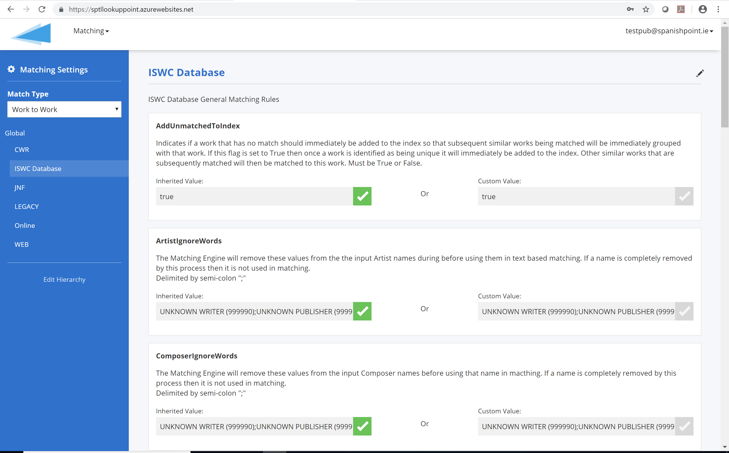

Figure 2 – Matching Engine Config Tool

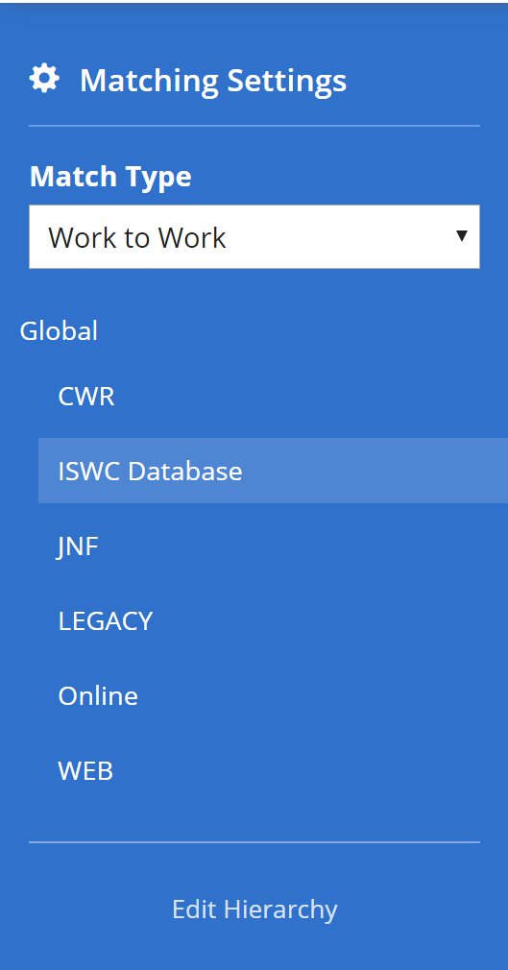Once the “Matching/Settings” top level menu option has been selected then the configuration tool shows the matching settings single page application.

The left-hand panel shows two sections:

* Match Type

This selects the entity types being matched with each other. For the ISWC Database, only the “Work to Work” type applies. I.E. This means match inbound work information with existing work information.

Other Match Entity Types, such as “Recording To Recording”, “Recording To Work”, “Usage to Work”, “Usage to Recording” etc. are not relevant for the ISWC database.

* Input Data Source Hierarchy

For the match type selected above the panel shows the hierarchy of sources of input information for this match type. In the example shown here we have the default “Global” source of data which contains an “ISWC Database” source representing all ISWC Database submissions. Sub-Sources for each submitting society could be set up if there were different rule configurations needed for different societies though this is not expected for the ISWC database.

The list of matching configuration parameters available for the selected input data source is shown in the main area of the page as per below:

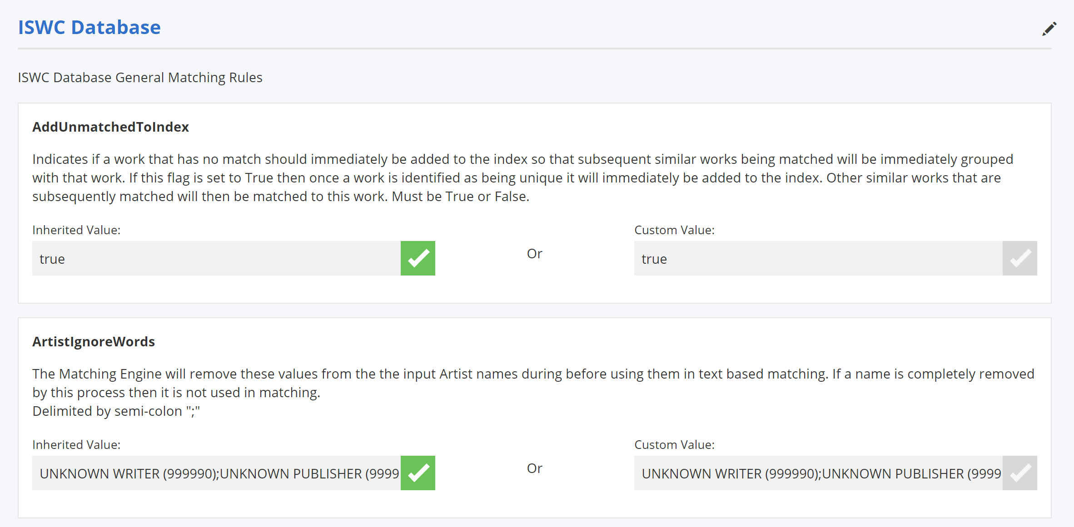

For each parameter available the following information is shown:

* The parameter name. This is a unique fixed name given to the parameter that is implemented in the matching engine logic
* Parameter Description. This is a description of matching rule that is being configured along with info on the available configuration parameter values for this rule. These descriptions are loaded into the system at installation time but can be overwritten / updated on a deployment by deployment basis.
* Inherited Value. This shows the configuration value(s) set for the parameter for the current parameter’s parent input source. A green check box for the Inherited Value field means that this parameter’s configuration is inherited from the parent source rather than being uniquely configured for the selected source.
* Custom Value. This shows the configuration value(s) set for the parameter for the selected source. If this field is checked it means that a unique value is configured for this parameter for the selected source.

## Key Proposed Matching Settings for CISAC ISWC Database

The following key settings will be configured through the configuration tool shown above in order to deliver on the agreed ISWC Database matching rules:

### Configuration for “Eligible” Source

The following table describes the key existing matching engine parameters that will be configured to deliver the agreed matching rules. Note: Only key parameters are shown below, parameters that don’t apply to the CISAC database matching have been omitted:

|  |  |  |
| --- | --- | --- |
| **Parameter** | **Description** | **Configuration** |
| ComposerMatchWritersOnly | If this flag is set to True then only the writers/composers on the input work must match with a work in the index in order for the work to be determined a match. I.E. Non writer/composer contributors such as publishers will not be taken into account.  True or False. | True |
| ContributorMatchingAlgorithm | The matching criteria that will be used. NumberAndText means number based matching will be carried out first and if no match is found then text based matching will be used. Number means number based matching will be used only. Text means text based matching will be used only. | Number |
| EnsureAllContributorsMatch | If this is set to True then in order for a definite match to be identified all contributors (subject to the ComposerMatchWritersOnly flag) on the inbound work must match the contributors on the repertoire work. If this is set to False and there is only one potential match then this potential match will be designated as a definite match. | True |
| WorkMatchingAlgorithm | The matching criteria that will be used. “All” means number based matching will be carried out first and if no match is found then title based matching will be used. “Number” means number based matching will be used only. “Title” means title based matching will be used only. | All |
| WorkTitleSimilarity | Threshold % of similarity between the search string and the returned potential work title. If the % figure returned >= this threshold value then the title (and therefore its corresponding work) will be considered in the bucket of works to be further examined to see if they are a match. | 90 |
| TitleIgnoreWords | The Matching Engine will remove these values from the input title before using that title in text based matching. This modified title is then used for matching and comparison. E.G. A configuration value of “?” will result in all of the “?” mark characters being removed from an input title before it is used for text based matching. Note: Any works which don’t have a title after the Ignore Words have been removed will be excluded from further text based matching.  Delimited by semi-colon “;”. | UNKNOWN;? |
| WorkSearchDepth | Configures the maximum number of rows that match the text based query that will be returned. This figure can be configured globally and by Source of the given intray work. | 10000 |

The following table describes the new matching engine parameters that will be added to the matching engine and configuration tool:

|  |  |  |
| --- | --- | --- |
| **Parameter** | **Description** | **Configuration** |
| TitleFuzzyMatchTypes | When doing fuzzy text matching (as opposed to exact title matching), only include the specified title types. E.G. “OT,AT” means that only OT and AT type titles on the work info to be matched will be matched against OT and AT type titles in the index. | Blank |
| ContributorsMatchCounts | Only works in the index that have the same number of contributors as the input work info will be eligible as matches. True or False | True |
| WorkTypeMustMatch | Only works in the index that have the same type as the input work info will be eligible as matches. True or False. | False[1] |
| ApplyDisambiguation | If disambiguateFromNumbers are provided in the input work then all works in the index that have matching numbers and number types will be eliminated as possible matches for this input work. True or False | True |

### Configuration for “NonEligible” Source

The following table describes the key existing matching engine parameters that will be configured to deliver the agreed matching rules. Note: Only key parameters are shown below, parameters that don’t apply to the CISAC database matching have been omitted:

|  |  |  |
| --- | --- | --- |
| **Parameter** | **Description** | **Configuration** |
| ComposerMatchWritersOnly | If this flag is set to True then only the writers/composers on the input work must match with a work in the index in order for the work to be determined a match. I.E. Non writer/composer contributors such as publishers will not be taken into account.  True or False. | True |
| ContributorMatchingAlgorithm | The matching criteria that will be used. NumberAndText means number based matching will be carried out first and if no match is found then text based matching will be used. Number means number based matching will be used only. Text means text based matching will be used only. | NumberAndText |
| EnsureAllContributorsMatch | If this is set to True then in order for a definite match to be identified all contributors (subject to the ComposerMatchWritersOnly flag) on the inbound work must match the contributors on the repertoire work. If this is set to False and there is only one potential match then this potential match will be designated as a definite match. | True |
| MinMatchingWriters | The minimum number of writers on the input work that must match with a work in the index in order for the work to be determined a match. Note: The exact type of match (potential or definite) is determined by the EnsureAllContributorsMatch parameter setting. | 1 |
| WorkMatchingAlgorithm | The matching criteria that will be used. “All” means number based matching will be carried out first and if no match is found then title based matching will be used. “Number” means number based matching will be used only. “Title” means title based matching will be used only. | All |
| WorkTitleSimilarity | Threshold % of similarity between the search string and the returned potential work title. If the % figure returned >= this threshold value then the title (and therefore its corresponding work) will be considered in the bucket of works to be further examined to see if they are a match. | 90 |
| TitleIgnoreWords | The Matching Engine will remove these values from the input title before using that title in text based matching. This modified title is then used for matching and comparison. E.G. A configuration value of “?” will result in all of the “?” mark characters being removed from an input title before it is used for text based matching. Note: Any works which don’t have a title after the Ignore Words have been removed will be excluded from further text based matching.  Delimited by semi-colon “;”. | UNKNOWN;? |
| WorkSearchDepth | Configures the maximum number of rows that match the text based query that will be returned. This figure can be configured globally and by Source of the given intray work. | 10000 |

The following table describes the new matching engine parameters that will be added to the matching engine and configuration tool:

|  |  |  |
| --- | --- | --- |
| **Parameter** | **Description** | **Configuration** |
| TitleFuzzyMatchTypes | When doing fuzzy text matching (as opposed to exact title matching), only include the specified title types. E.G. “OT,AT” means that only OT and AT type titles on the work info to be matched will be matched against OT and AT type titles in the index. | Blank |
| ContributorsMatchCounts | Only works in the index that have the same number of contributors as the input work info will be eligible for matching. True or False | True |
| WorkTypeMustMatch | Only works in the index that have the same type as the input work info will be eligible as matches. True or False. | False |
| ApplyDisambiguation | If disambiguateFromNumbers are provided in the input work then all works in the index that have matching numbers and number types will be eliminated as possible matches for this input work. True or False | True |
| MinMatchingWritersByNumberPct | The minimum number of writers on the input work (expressed as a % of the total number of writers on the input work) that must match with a work in the index by IP Number in order for the work to be determined a match. Note: The exact type of match (potential or definite) is determined by the EnsureAllContributorsMatch parameter setting. | 60% |

1. ISWC Processing (Assignment) Pipeline

This chapter lists the implementation for processing transaction scenarios in the MVP version of the ISWC database after all matching and validation has taken place.

## Scenario AS/01 – ISWC Eligible Submission Associated with existing Preferred ISWC

An ISWC eligible society submission with valid new WorkInfo details that should be associated with a found Preferred ISWC. The ISWC database mapping for this will be as follows:

### WorkInfo

A single record will be added to the ISWC.WorkInfo table using the following mapping:

|  |  |
| --- | --- |
| Column | Source (Submission) |
| WorkInfoID | N/A |
| Status | 1 |
| Concurrency | N/A |
| CreatedDate | Current Timestamp |
| LastModifiedDate | Current Timestamp |
| LastModifiedUserID | WEBSERVICE |
| IswcID | preferredIswc |
| ArchivedIswc | iswc |
| CisnetLastModifiedDate | cisnetLastModifiedDate |
| CisnetCreatedDate | cisnetCreatedDate |
| IPCount | Count of interestedParties[] |
| IsDeleted | 0 |
| IswcEligible | *For details see: Scenario AS/10* |
| MatchTypeID | MatchingWork.MatchType |
| MwiCategory | category |
| AgencyID | agency |
| AgencyWorkCode | workcode |
| SourceDatabase | sourcedb |
| Disambiguation | disambiguation |
| DisambiguationReasonID | disambiguationReason |
| BVLTR | bvltr |
| DerivedWorkTypeID | derivedWorkType |

### Title

A record will be added to the ISWC.Title table for the Submission.originalTitle field and a record for each of the items in the Submission.otherTitles array using the following mapping:

|  |  |
| --- | --- |
| Column | Source (Submission) |
| TitleID | N/A |
| Status | 1 |
| Concurrency | N/A |
| CreatedDate | Current Timestamp |
| LastModifiedDate | Current Timestamp |
| LastModifiedUserID | WEBSERVICE |
| IswcID | N/A |
| WorkInfoID | N/A |
| StandardizedTitle | originalTitle / otherTitles.title |
| Title | originalTitle / otherTitles.title |
| TitleTypeID | OT / otherTitles.type |

### DisambiguationISWC

A record will be added to the ISWC.DisambiguationISWC table for each record in the Submission.disambiguateFrom array using the following mapping:

|  |  |
| --- | --- |
| Column | Source (Submission.disambiguateFrom) |
| DisambiguationIswcID | N/A |
| Status | 1 |
| Concurrency | N/A |
| CreatedDate | Current Timestamp |
| LastModifiedDate | Current Timestamp |
| LastModifiedUserID | WEBSERVICE |
| Iswc | iswc |
| WorkInfoID | N/A |

### DerivedFrom

A record will be added to the ISWC.DerivedFrom table for each record in the Submission.derivedFromIswcs array using the following mapping:

|  |  |
| --- | --- |
| Column | Source (Submission.derivedFromIswcs) |
| DerivedFromID | N/A |
| Status | 1 |
| Concurrency | N/A |
| CreatedDate | Current Timestamp |
| LastModifiedDate | Current Timestamp |
| LastModifiedUserID | WEBSERVICE |
| Iswc | iswc |
| Title | title |
| WorkInfoID | N/A |

### Creator

A record will be added to the ISWC.Creator table for each record in the Submission.interestedParties array that is a Creator type using the following mapping:

|  |  |
| --- | --- |
| Column | Source (Submission.interestedParties) |
| IPBaseNumber | baseNumber |
| WorkInfoID | N/A |
| Status | 1 |
| Concurrency | N/A |
| CreatedDate | Current Timestamp |
| LastModifiedDate | Current Timestamp |
| LastModifiedUserID | WEBSERVICE |
| IsDispute | False |
| Authoritative | *For details see: Scenario AS/10* |
| RoleTypeID | role |
| IswcID | N/A |
| IPNameNumber | nameNumber |

### Publisher

A record will be added to the ISWC.Publisher table for each record in the Submission.interestedParties array that is a Publisher type using the following mapping:

|  |  |
| --- | --- |
| Column | Source (Submission.interestedParties) |
| IPBaseNumber | baseNumber |
| WorkInfoID | N/A |
| Status | 1 |
| Concurrency | N/A |
| CreatedDate | Current Timestamp |
| LastModifiedDate | Current Timestamp |
| LastModifiedUserID | WEBSERVICE |
| RoleTypeID | role |
| IswcID | N/A |
| IPNameNumber | nameNumber |

### Performer

A record will be added to the ISWC.Performer table for each record in the Submission.performers array using the following mapping if a matching record does not already exist:

|  |  |
| --- | --- |
| Column | Source (Submission.performers) |
| PerformerID | N/A |
| Status | 1 |
| Concurrency | N/A |
| CreatedDate | Current Timestamp |
| LastModifiedDate | Current Timestamp |
| LastModifiedUserID | WEBSERVICE |
| FirstName | firstName |
| LastName | lastName |

### WorkInfoPerformer

A record will be added to this table for each Performer record created to link to the WorkInfo table.

### WorkInfoInstrumentation

A record will be added to the ISWC.WorkInfoInstrumentation table for each record in the Submission.instrumentation array using the following mapping:

|  |  |
| --- | --- |
| Column | Source (Submission.instumentation) |
| WorkInfoID | N/A |
| InstrumentationID | code |
| Status | 1 |
| Concurrency | N/A |
| CreatedDate | Current Timestamp |
| LastModifiedDate | Current Timestamp |
| LastModifiedUserID | WEBSERVICE |

## Scenario AS/02 – ISWC Ineligible Submission Associated with existing Preferred ISWC

An ISWC eligible society submission with valid new WorkInfo details that should be associated with a found Preferred ISWC. The ISWC database mapping for this will be the same as Scenario AS/01 except for the WorkInfo table:

### WorkInfo

A single record will be added to the ISWC.WorkInfo table using the following mapping:

|  |  |
| --- | --- |
| Column | Source (Submission) |
| WorkInfoID | N/A |
| Status | 1 |
| Concurrency | N/A |
| CreatedDate | Current Timestamp |
| LastModifiedDate | Current Timestamp |
| LastModifiedUserID | WEBSERVICE |
| IswcID | preferredIswc |
| ArchivedIswc | iswc |
| CisnetLastModifiedDate | cisnetLastModifiedDate |
| CisnetCreatedDate | cisnetCreatedDate |
| IPCount | Count of interestedParties[] |
| IsDeleted |  |
| IswcEligible | *For details see: Scenario AS/10* |
| MatchTypeID | MatchingWork.MatchType |
| MwiCategory | category |
| AgencyID | agency |
| AgencyWorkCode | workcode |
| SourceDatabase | sourcedb |
| Disambiguation | disambiguation |
| DisambiguationReasonID | disambiguationReason |
| BVLTR | bvltr |
| DerivedWorkTypeID | derivedWorkType |

## Scenario AS/03 – ISWC Eligible Submission with new Preferred ISWC level details

This scenario represents the assignment of a new Preferred ISWC and the addition of this new ISWC along with its other Preferred ISWC level information to the ISWC database by a society that is ISWC eligible for this submission. The ISWC database mapping for this will be as follows:

### ISWC

A single record will be added to the ISWC.ISWC table using the following mapping. The Iswc value will be taken from iswc field in the Cosmos DB ISWC collection.

|  |  |
| --- | --- |
| Column | Source |
| IswcID | N/A |
| Status | 1 |
| Concurrency | N/A |
| CreatedDate | Current Timestamp |
| LastModifiedDate | Current Timestamp |
| LastModifiedUserID | WEBSERVICE |
| Iswc | iswc (Cosmos DB) |
| AgencyID | agency |

### WorkInfo

A single record will be added to the ISWC.WorkInfo table using the following mapping:

|  |  |
| --- | --- |
| Column | Source (Submission) |
| WorkInfoID | N/A |
| Status | 1 |
| Concurrency | N/A |
| CreatedDate | Current Timestamp |
| LastModifiedDate | Current Timestamp |
| LastModifiedUserID | WEBSERVICE |
| IswcID | preferredIswc |
| ArchivedIswc | iswc |
| CisnetLastModifiedDate | cisnetLastModifiedDate |
| CisnetCreatedDate | cisnetCreatedDate |
| IPCount | Count of interestedParties[] |
| IsDeleted |  |
| IswcEligible | *For details see: Scenario AS/10* |
| MatchTypeID | MatchingWork.MatchType |
| MwiCategory | category |
| AgencyID | agency |
| AgencyWorkCode | workcode |
| SourceDatabase | sourcedb |
| Disambiguation | disambiguation |
| DisambiguationReasonID | disambiguationReason |
| BVLTR | bvltr |
| DerivedWorkTypeID | derivedWorkType |

### Title

A record will be added to the ISWC.Title table for the Submission.originalTitle field and a record for each of the items in the Submission.otherTitles array using the following mapping:

|  |  |
| --- | --- |
| Column | Source (Submission) |
| TitleID | N/A |
| Status | 1 |
| Concurrency | N/A |
| CreatedDate | Current Timestamp |
| LastModifiedDate | Current Timestamp |
| LastModifiedUserID | WEBSERVICE |
| IswcID | N/A |
| WorkInfoID | N/A |
| StandardizedTitle | originalTitle / otherTitles.title |
| Title | originalTitle / otherTitles.title |
| TitleTypeID | OT / otherTitles.type |

### DisambiguationISWC

A record will be added to the ISWC.DisambiguationISWC table for each record in the Submission.disambiguateFrom array using the following mapping:

|  |  |
| --- | --- |
| Column | Source (Submission.disambiguateFrom) |
| DisambiguationIswcID | N/A |
| Status | 1 |
| Concurrency | N/A |
| CreatedDate | Current Timestamp |
| LastModifiedDate | Current Timestamp |
| LastModifiedUserID | WEBSERVICE |
| Iswc | iswc |
| WorkInfoID | N/A |

### DerivedFrom

A record will be added to the ISWC.DerivedFrom table for each record in the Submission.derivedFromIswcs array using the following mapping:

|  |  |
| --- | --- |
| Column | Source (Submission.derivedFromIswcs) |
| DerivedFromID | N/A |
| Status | 1 |
| Concurrency | N/A |
| CreatedDate | Current Timestamp |
| LastModifiedDate | Current Timestamp |
| LastModifiedUserID | WEBSERVICE |
| Iswc | iswc |
| Title | title |
| WorkInfoID | N/A |

### Creator

A record will be added to the ISWC.Creator table for each record in the Submission.interestedParties array that is a Creator type using the following mapping:

|  |  |
| --- | --- |
| Column | Source (Submission.interestedParties) |
| IPBaseNumber | baseNumber |
| WorkInfoID | N/A |
| Status | 1 |
| Concurrency | N/A |
| CreatedDate | Current Timestamp |
| LastModifiedDate | Current Timestamp |
| LastModifiedUserID | WEBSERVICE |
| IsDispute | False |
| Authoritative | *For details see: Scenario AS/10* |
| RoleTypeID | role |
| IswcID | N/A |
| IPNameNumber | nameNumber |

### Publisher

A record will be added to the ISWC.Publisher table for each record in the Submission.interestedParties array that is a Publisher type using the following mapping:

|  |  |
| --- | --- |
| Column | Source (Submission.interestedParties) |
| IPBaseNumber | baseNumber |
| WorkInfoID | N/A |
| Status | 1 |
| Concurrency | N/A |
| CreatedDate | Current Timestamp |
| LastModifiedDate | Current Timestamp |
| LastModifiedUserID | WEBSERVICE |
| RoleTypeID | role |
| IswcID | N/A |
| IPNameNumber | nameNumber |

### Performer

A record will be added to the ISWC.Performer table for each record in the Submission.performers array using the following mapping if a matching record does not already exist:

|  |  |
| --- | --- |
| Column | Source (Submission.performers) |
| PerformerID | N/A |
| Status | 1 |
| Concurrency | N/A |
| CreatedDate | Current Timestamp |
| LastModifiedDate | Current Timestamp |
| LastModifiedUserID | WEBSERVICE |
| FirstName | firstName |
| LastName | lastName |

### WorkInfoPerformer

A record will be added to this table for each Performer record created to link to the WorkInfo table.

### WorkInfoInstrumentation

A record will be added to the ISWC.WorkInfoInstrumentation table for each record in the Submission.instrumentation array using the following mapping:

|  |  |
| --- | --- |
| Column | Source (Submission.instumentation) |
| WorkInfoID | N/A |
| InstrumentationID | code |
| Status | 1 |
| Concurrency | N/A |
| CreatedDate | Current Timestamp |
| LastModifiedDate | Current Timestamp |
| LastModifiedUserID | WEBSERVICE |

## Scenario AS/04 – Update ISWC Eligible Submission with new Preferred ISWC level details

An ISWC eligible society submission with valid Preferred ISWC level details and the Preferred ISWC indicated in the submission is the same as the current Preferred ISWC for the Society Code, Source DB Code and Society Work Code designated in the submission. This scenario represents an update of the core existing Preferred ISWC data. The ISWC database mapping for this will be as follows:

### Title

A record will be added to the ISWC.Title table for the Submission.originalTitle field and a record for each of the items in the Submission.otherTitles array and does not already exist using the following mapping. If a record already exists, it should be updated using the following mapping.

|  |  |
| --- | --- |
| Column | Source (Submission) |
| TitleID | N/A |
| Status | 1 |
| Concurrency | N/A |
| CreatedDate | Current Timestamp |
| LastModifiedDate | Current Timestamp |
| LastModifiedUserID | WEBSERVICE |
| IswcID | N/A |
| WorkInfoID | N/A |
| StandardizedTitle | originalTitle / otherTitles.title |
| Title | originalTitle / otherTitles.title |
| TitleTypeID | OT / otherTitles.type |

### Creator

A record will be added to the ISWC.Creator table for each record in the Submission.interestedParties array that is a Creator type and does not already exist using the following mapping. If a record already exists, it should be updated using the following mapping.

|  |  |
| --- | --- |
| Column | Source (Submission.interestedParties) |
| IPBaseNumber | baseNumber |
| WorkInfoID | N/A |
| Status | 1 |
| Concurrency | N/A |
| CreatedDate | Current Timestamp |
| LastModifiedDate | Current Timestamp |
| LastModifiedUserID | WEBSERVICE |
| IsDispute | False |
| Authoritative | *For details see: Scenario AS/10* |
| RoleTypeID | role |
| IswcID | N/A |
| IPNameNumber | nameNumber |

### Publisher

A record will be added to the ISWC.Publisher table for each record in the Submission.interestedParties array that is a Publisher type and does not already exist using the following mapping. If a record already exists, it should be updated using the following mapping.

|  |  |
| --- | --- |
| Column | Source (Submission.interestedParties) |
| IPBaseNumber | baseNumber |
| WorkInfoID | N/A |
| Status | 1 |
| Concurrency | N/A |
| CreatedDate | Current Timestamp |
| LastModifiedDate | Current Timestamp |
| LastModifiedUserID | WEBSERVICE |
| RoleTypeID | role |
| IswcID | N/A |
| IPNameNumber | nameNumber |

## Scenario AS/05 – Update ISWC Eligible Submission with valid Preferred ISWC level details where the Preferred ISWC is different from the current Preferred ISWC

An ISWC eligible society submission with valid Preferred ISWC level details and the Preferred ISWC indicated in the submission is different from the current Preferred ISWC for the Society Code, Source DB Code and Society Work Code designated in the submission. This scenario represents the merging of two pre-existing Preferred ISWCs in the ISWC Database. The ISWC database mapping for this will be as follows:

### ISWCLinkedTo

A record will be created in the ISWCLinkedTo table to store the reference between the source “Preferred ISWC” and the destination “Preferred ISWC” using the following mapping:

|  |  |
| --- | --- |
| Column | Source |
| IswcLinkedToID | N/A |
| Status | 1 |
| Concurrency | N/A |
| CreatedDate | Current Timestamp |
| LastModifiedDate | Current Timestamp |
| LastModifiedUserID | WEBSERVICE |
| IswcID | Source “Preferred ISWC” IswcID |
| LinkedToIswc | Destination “Preferred ISWC” Iswc code |

## Scenario AS/08 – Update ISWC Ineligible Submission with valid Preferred ISWC level details where the Preferred ISWC is different from the current Preferred ISWC

This scenario represents a move of WorkInfo information from one Preferred ISWC (source) to another Preferred ISWC (destination) by an ISWC ineligible submitter. It essentially represents the changing of the Preferred ISWC that a submitters WorkInfo (Agency Work Code, Archived ISWC) should be associated with to a different existing Preferred ISWC by an ISWC ineligible submitter. The IswcID value in the following database tables will be changed from the existing Preferred ISWC value to the new Preferred ISWC value:

* WorkInfo
* Title
* DisambiguationISWC
* DerivedFrom
* Creator
* Publisher
* WorkInfoPerfomer
* WorkInfoInstrumentation

The WorkInfo.IswcEligible flag will be also recalculated as per Scenario AS/10.

## Scenario AS/09 – Delete ISWC Submission

This scenario represents a request to delete an ISWC Submission. The WorkInfo record identified in the matching phase will be logically deleted for ISWC eligible submissions. For ISWC ineligible submissions the WorkInfo record identified will be physically deleted.

If there are ISWC eligible WorkInfo records from another society associated with the Preferred ISWC identified, then the corrections process as per AS/07 will be triggered.

If there are no remaining WorkInfo records from ISWC eligible submitters left on the source Preferred ISWC after the deletion then all remaining associated Title, Creator and Publisher records associated with that ISWC record should be logically deleted. All WorkInfo records from non ISWC eligible societies remaining on the source Preferred ISWC will be physically deleted.

## Scenario AS/10 – Recalculating ISWC Eligible and Authoritative flags

This scenario represents the need to recalculate the ISWC Eligible flag and Authoritative flag when adding or updating WorkInfo records.

The ISWC Eligible flag will be set to True if the submitter is deemed to be ISWC eligible for the work based on rules EL/01, EL/02 and EL/03. The ISWC Eligible flag will be set to False if the submitter is deemed not to be ISWC eligible based on the same rules.

The Authoritative flag for each associated Creator should be set to True if the creator is a member of the submitting society at the date of submission of the transaction for a musical work related agreement.

## Approval Workflow Tasks (Formerly Known as Corrections Tasks)

Multiple assignment/processing actions require the generation of approval workflow tasks. This section describes how approval workflow tasks will be implemented.

### Workflow Types

The types of workflow and the sources of each workflow type are listed below:

|  |  |  |
| --- | --- | --- |
| Workflow Type | Description | Sources |
| Update Approval | Update of core existing Preferred ISWC data where there are one or more additional ISWC eligible submitters for the work | AS/04 – Update to core existing Preferred ISWC data |
| Merge Approval | Merge of two or more existing Preferred ISWCs where there are one or more additional ISWC eligible submitters for any of the works being merged | AS/05 – Merge two pre-existing Preferred ISWCs |
| Demerge Approval | Deletion of a LinkedTo record where there are one or more additional ISWC eligible submitters for the work being demerged. | Demerge two pre-existing Preferred ISWCs |

### Workflow Task Data Structure

**WorkflowInstance**

The WorkflowInstance table stores information about each instance of a workflow. For example, an Update Approval Workflow.

|  |  |  |  |
| --- | --- | --- | --- |
| Column | Data Type | Required | Description |
| WorkflowInstanceID | Bigint | Yes | Unique auto generated identifier for the workflow instance |
| WorkflowType | Int | Yes | 1 (Update Approval), 2 (Merge Approval) |
| WorkInfoID | Bigint | No | Unique ID for related WorkInfo record that contains the modified data. Must be populated if the WorkflowType is 1. |
| MergeRequestID | Bigint | No | Unique ID for related MergeRequest record that contains the requested merge info. Must be populated if the WorkflowType is 2. |
| CreatedDate | Datetime2(0) | Yes | Date/time that the WorkflowInstance was created |
| LastModifiedDate | Datetime2(0) | Yes | Date/time that the WorkflowInstance was last modified |
| LastModifiedUserID | Int | Yes | The last modifying user |
| InstanceStatus | Int | Yes | 0 (Outstanding), 1 (Approved), 2 (Rejected), 3 (Cancelled) |
| IsDeleted | Bit | Yes | Logically deleted flag |

**WorkflowTask**

The WorkflowTask table stores each approval task associated with an instance of a workflow.

|  |  |  |  |
| --- | --- | --- | --- |
| Column | Data Type | Required | Description |
| WorkflowTaskID | Bigint | Yes | Unique auto generated identifier for the workflow task |
| WorkflowInstanceID | Bigint | Yes | Unique ID for related WorkflowInstance record |
| LastModifiedDate | Datetime2(0) | Yes | Date/time that the WorkflowInstance was last modified |
| AssignedAgencyID | Char(3) | Yes | ID of related Agency record for the agency to which the approval task is assigned. |
| LastModifiedUserID | Int | Yes | The last modifying user |
| TaskStatus | Int | Yes | 0 (Outstanding), 1 (Approved), 2 (Rejected), 3 (Cancelled) |
| IsDeleted | Bit | Yes | Logically deleted flag |

### Adding Update Approval Workflows

A WorkflowInstance record should be created for a set of updates captured in an associated WorkInfo record if any WorkflowTasks need to be created.

A WorkflowTasks should be created for each Agency, excepting the agency carrying out the update, that has a WorkInfo record associated with the ISWC being updated, that is flagged as ISWC Eligible. In addition, the following criteria should be met:

* The update must have altered the list of creator Ips associated with ISWC (added or removed at least one creator IP) OR
* Have altered the original title of the ISWC

### Adding Merge Approval Workflows

A WorkflowInstance record should be created for a merge request if any WorkflowTasks need to be created.

A WorkflowTasks should be created for each Agency, excepting the agency carrying out the merge, that has a WorkInfo record associated with any of the ISWCs being merged from, that are flagged as ISWC Eligible.

### Retrieving and Actioning Workflow Tasks

Societies will be able to retrieve a list of outstanding workflow approval tasks and provide updates on those tasks using any of the following methods:

* REST API (GET iswc/WorkflowTasks / PATCH iswc/WorkflowTasks) as outlined in 3.1 above
* Modern EDI Messaging (will be specified as part of WBS 1.7 )
* New ISWC Database Portal (will be specified as part of WBS 1.8)

## Implementing Merge transactions through LinkedTo Information

Merges of two or more existing Preferred ISWCs can be carried out through explicit merge transactions or through updates of ISWC metadata as per section 5.5 above.

In these instances, the Preferred ISWC(s) being merged into a target Preferred ISWC will have ISWCLinkedTo records created for them to implement the merge (and an associated header MergeRequest record). During regular transaction processing time limited Approval Workflow Tasks may also be generated as per section 5.9 above.

ISWCLinkedTo records will have a status values that correspond to the following: (Active, Pending, Deleted) and the parent MergeRequest record will have MergeStatus values that correspond to Pending or Complete.

In addition to the above, draft merge requests will be created by the post migration data cleanup process. This will be covered by a sperate specification. This post migration data cleanup process can create Pending (Draft) merge requests that can be confirmed in bulk by societies with or without time limited workflows depending on the rules agreed. These Pending merge requests will have associated ISWCLinkedTo records that are at status Pending until confirmed by societies.

## Note on Multilingual Titles and Matching

The REST based services and underlying ISWC database are designed to cater for multi-lingual character sets (Unicode). It is expected that societies will continue to transliterate original titles but can now submit additional titles that are in languages other than English.

The Azure Search Index will contain both the standardized titles and the titles without standardization. All matching activities (as per 3.4,3.5,3.6,3.7 and 3.8 above) will be carried out against both the standardized and non-standardized titles.

The Azure Search Index will use the default Apache Lucene Standard Analyzer. This general-purpose analyzer performs well for most languages and scenarios. For more information on this analyzer[2] see <https://unicode.org/reports/tr29/>

The Spanish Point Matching Engine uses a general-purpose language independent similarity calculation algorithm that works well with most common languages.

# Appendix A – Open and Closed Items

This appendix provides a tracking list of specific issues/queries raised by CISAC during the specification process and how they were incorporated or excluded from this specification:

|  |  |  |  |  |
| --- | --- | --- | --- | --- |
| **Open and Closed Items** | | | | |
| **ID** | **Description** | **Response** | **Status** | **Next Action By** |
| 1 | MVP Business rule AS/06 was not signed off as part of that document. Need to sign off the business requirement for this rule during this specification as per note from SG Meeting on 20th April 2019. | Details of how the workflow tasks will be generated updated have been included in this specification. See 3.1.5, 3.1.6 and 5.9 | Closed | Design Team to review |
| 2 | Chapter covering assignment pipeline component to be added |  | Closed |  |
| 3 | “Match Derived from ISWCs” and “ | Added this to section 3.9 | Closed |  |
| 4 | Addition of disambiguation list configuration parameter for matching to be added in Chapter 4 | I’ve enhanced the matching engine API to cater for this data (see 3.2), updated the mapping to map the submission data into these new fields (see 3.4, 3.5, 3.6 and 3.7) and added two additional matching rules that are specific to the ISWC Database at 4.2.1 and 4.2.2. | Closed |  |
| 5 | Need to confirm that MAT/42 is still required.  “MAT/42 – After the initial matching carried out at MAT/03, MAT/04 or MAT/41:  - Remove any IP’s for the purposes of further matching that have a YOD (as per IPI info) that is more than 80 years past  - Redo phases 1 & 2 of matching as per MAT/03 above using this reduced list of contributors” | New section 3.11 added that reflects the agreed revised logic. | Closed |  |
| 6 | Need to confirm the initial configuration of the WorkTypeMustMatch flag | Originally, in the MVP Business Rules document this rule was agreed to be in place. However, we propose to carry out initial UAT testing with the rule switched off given the high volume of data without DerivedFrom information available in CIS-Net. Based on the results of this testing we propose to issue a recommending for the flags setting for production use. | Open | UAT team to revisit after UAT. |
| 7 | Need to clarify a) if it will be possible to merge derived and non-derived works together and b) what affect this will have on the matching. | For matching an inbound submission to an existing Preferred ISWC the proposal is as follows:  If the WorkTypeMustMatch matching parameter is set to False then it will be possible for a derived work to match, and therefore merge, with a non-derived work and vice versa. If the WorkTypeMustMatch parameter is set to True then it wont be possible for a derived work to match, and therefore merge, with a non-derived work and vice versa.  For merging two existing Preferred ISWCs together it will be possible to merge a derived work with a non-derived work. If, say a derived work is merged into (linked to) a non-derived work then incoming submissions can still match to either the derived work or the non-derived work depending on their metadata and the configuration of the WorkTypeMustMatch flag but any matches to the original derived work will be promoted up (through the linked to structure) to the non-derived work. | Closed |  |
| 8 | Need to define in a separate specification the background job that will run and auto accept workflow tasks that are outstanding beyond a specified time frame | Will be catered for through a separate specification | Open |  |
| 9 | Open Item: In the case of the 3.11 (Alter Ips and then redo matching) we will test the ranking logic as defined and may decide to enhance it so that it rejects rather than picks the first where more than one matches have been found or that we just return all equally ranked items with no definite selected. | Decision will be made after initial UAT of MVP | Open |  |
| 10 | Need to walk-through and confirm how the LinkedTo construct will be used for three different scenarios (to be listed by Ed) | Action: John C to document that linkedTo records can be created at Draft (Potential) status as part of the post go live data clean-up. Once that is done this functionality is ok to get signed off.  Added section 5.10 to take this into account now. | Closed |  |
| 11 | Need to document summary of multi-lingual capability that is included in the above design. Also, for UAT, need to include societies that use different character sets | I’ve added section 5.11 above to describe this. | Closed |  |

1. Initially in the MVP Business Rules it was envisaged that this rule would be enabled but we are proposing to first test the system with the rule switched off. See open items section in Appendix A for more information.
2. An analyzer is a component of the full text search engine responsible for processing text in query strings and indexed documents. Different analyzers manipulate text in different ways depending on the scenario.