

DEDICATION
بسم الله الرحمن الرحيم
Between patience and perseverance, between doubt and certainty, I have learned that every effort carries within it the promise of a reward, and that the most demanding paths often lead to the most precious arrivals.
To Allah, the Almighty and the Most Merciful, for the patience He granted me, the light He placed on my path, and the strength He gave me every time exhaustion caught up with me.
To myself, to the version of me who held on, who kept learning through every doubt, and who turned every long night into one more step toward the completion of this work.
To my dear parents, my two pillars, my refuge and the greatest blessing of my life; for their unconditional love, their silent prayers, and every invisible sacrifice that carried me to where I stand today. No word can express my gratitude.
To my family, whose quiet but constant support walked with every one of my steps, and without whom this path would not have had the same meaning.
To my supervisors, Mr. Thameur Dhieb and Mr. Omar Abbes, whose rigour, patience, and precious advice guided every stage of this work.
To every person who encouraged me, supported me, and believed in me; your words, your gestures, and your presence have left a lasting mark on this journey.
Hachem Zenati
ٱلْحَمْدُ لِلَّهِ رَبِّ ٱلْعَٰلَمِينَ
Surah Al-Fātiḥah — Verse 2

ACKNOWLEDGEMENTS
At the end of this final-year project, I wish to express my deep gratitude to every person and institution who, by their guidance, their advice, and their support, contributed to bringing this work to completion.
I would first like to address my sincere thanks to the International School of Business of Sfax for the quality of the training I received throughout my studies, and for the rigorous and stimulating academic environment that prepared me to carry out this work.
I extend my most sincere thanks to my academic supervisor, Mr. Thameur Dhieb, for his rigorous guidance, his constant availability, the relevance of his advice, and the precious support he provided throughout the realisation of this project.
I am equally grateful to my professional supervisor at INET, Mr. Omar Abbes, who welcomed me into the company, helped me understand the real needs of the field, and accompanied me throughout the internship with patience and kindness.
I also wish to thank the whole team at INET (Informatique.Net) for their availability, their kindness, and the working conditions that allowed me to carry out this project in the best circumstances.
My respectful thanks go as well to the members of the jury for the honour they do me in evaluating this work, and for the time, attention, and interest they have devoted to it.
I would also like to express my recognition to all the teachers of the International School of Business of Sfax for the quality of their teaching, their commitment, and the knowledge they have transmitted to me throughout my education.
Finally, my sincere thanks go to every person who, near or far, contributed to the success of this work through their support and their precious encouragement.

TABLE OF CONTENTS
Right-click and choose “Update Field” to generate this list.

LIST OF FIGURES
Right-click and choose “Update Field” to generate this list.

LIST OF TABLES
Right-click and choose “Update Field” to generate this list.

LIST OF ABBREVIATIONS
Abbreviation | Meaning
API | Application Programming Interface
BI | Business Intelligence
CDD | Fixed-term employment contract
CDI | Permanent employment contract
CORS | Cross-Origin Resource Sharing
DAX | Data Analysis Expressions
DW | Data Warehouse
ETL | Extract, Transform, Load
HR | Human Resources
HTTP | HyperText Transfer Protocol
JWT | JSON Web Token
KPI | Key Performance Indicator
ML | Machine Learning
OLAP | Online Analytical Processing
OLTP | Online Transaction Processing
ORM | Object-Relational Mapping
PFE | Final-Year Project
RBAC | Role-Based Access Control
REST | Representational State Transfer
RF | Random Forest
SCD | Slowly Changing Dimension
SQL | Structured Query Language
UML | Unified Modeling Language

GENERAL INTRODUCTION

Human resources have become one of the areas where companies generate the most data and exploit it the least. Every working day, an organisation records who arrived, at what time, who was late, who was absent, who requested leave. In most small and medium structures this information is captured by a time clock or a basic payroll tool and then left untouched until the end of the month, when it is used only to compute salaries. The data exists, but it does not inform any decision.
This gap is exactly the kind of problem Business Intelligence was created to solve. BI is not about collecting more data; it is about turning the data a company already owns into indicators, trends, and forecasts that a manager can act on. Applied to human resources, it means moving from a monthly, backward-looking payroll view to a continuous, forward-looking reading of attendance: which department is drifting, which month concentrates absences, and — more ambitiously — which employees are likely to become a problem before they actually do.
The present project was carried out at INET (Informatique.Net), a company in Sfax whose own business is built around exactly this type of data. INET sells and installs time clocks, payroll software, and attendance-tracking solutions for its clients. Yet, like many of the organisations it equips, INET had no decision layer on top of that raw attendance data. The need was therefore concrete and not merely academic: build, on top of the operational HR data, an intelligent decision-support dashboard that an HR manager can open every morning and immediately understand the state of the workforce — and be warned about the risks building up inside it.
From this need, the central question of this work can be stated as follows:
The objective of the project is to answer that question with a working system rather than a prototype. Concretely, the work aims to:
- design and build an operational system that records the daily HR activity (attendance, lateness, absences, leave) for a realistic workforce;
- model and load a dedicated data warehouse following the Kimball star-schema approach, fed by an automated ETL pipeline;
- expose the analytical layer through a Power BI [2] report and through role-based web dashboards aimed at the HR manager;
- add a predictive layer that estimates each employee's absenteeism risk, validated in a way that does not simply restate the data it was trained on, and that detects abnormal attendance behaviour automatically;
- automate the whole chain so that the data warehouse, the alerts, and the model stay up to date without manual intervention.
The report is organised into seven chapters that follow the natural progression of the project. Chapter 1 presents the general framework: the host company, the way the internship unfolded, the problem observed on the ground, a study of existing solutions, the proposed solution, and the methodology adopted. Chapter 2 establishes the theoretical foundations the project relies on: HR indicators, Business Intelligence, data warehousing, the ETL process, the machine-learning techniques used, and dashboard design. Chapter 3 is devoted to requirements analysis: actors, functional and non-functional requirements, the product backlog, the global use-case diagram, and the work-breakdown structure of the project. Chapter 4 refines every major use case identified in Chapter 3 with its dedicated diagram, explanatory table, and alternative-scenarios table. Chapter 5 turns the requirements into a system design: the four-tier architecture, the layered software organisation, the design of the operational database, the Kimball data warehouse, the class diagram and the key sequence diagrams. Chapter 6 describes the implementation: the development environment, the way the data was sourced, the ETL pipeline, the predictive models, the automation, and the security mechanisms. Chapter 7 presents and evaluates the results: the web dashboards, the Power BI [2] report, the measured performance of the models, the recommendations they enable, and the validation tests. A general conclusion then reviews the contributions, the limits of the work, and the perspectives for its continuation.

CHAPTER 1 : GENERAL FRAMEWORK OF THE PROJECT

1.1. Introduction
This first chapter sets the scene for the whole project. It introduces the company that hosted the internship, INET (Informatique.Net), and the way the internship itself was organised. It then moves from the general to the specific: the problem observed on the ground, a review of the solutions that already exist for that problem, a critical reading of their limits, and the solution proposed in response. The chapter closes with the development methodology and the planning adopted to carry the project from a need to a working system. The aim of the chapter is to justify why this project was undertaken before the following chapters explain how it was built.

1.2. Presentation of the host company

1.2.1. General description
INET, whose full name is Informatique.Net and whose commercial name is I.Net, is a Tunisian company based in Sfax and operating in the information-technology sector. The company is specialised in two complementary activities: the commercialisation of IT equipment and the distribution of management software. It positions itself as a single provider able to cover both the hardware and the software needs of its clients, which are mostly small and medium businesses.

Figure 1.1 — Logo of INET (Informatique.Net)

1.2.2. History
INET was founded in 2013. Over more than ten years of activity, the company has built an offer that goes beyond simple resale: it accompanies its clients in their digital transformation by combining quality products, software solutions adapted to their requirements, an installation and configuration service, and continuous technical support. This experience has given INET a solid knowledge of the day-to-day management needs of Tunisian SMEs — including, directly relevant to this project, the management of employee attendance.

1.2.3. Activities and offer
The company's catalogue is organised around two families.
IT equipment. INET sells and installs computers, servers, printers, networks, point-of-sale touch terminals, PDAs, and — a detail that matters for this project — time clocks (pointeuses) used by its clients to record employee attendance.
Management software. INET distributes business software covering accounting, invoicing, payroll and attendance tracking (paie et pointage), commercial management, stock management, and ERP solutions.
To these two families the company adds a service layer: installation, parameterisation and maintenance, technical support, and continuous assistance to users.
Table 1.1 — Identification sheet of the host company
Field | Value
Company name | Informatique.Net
Commercial name | I.Net (INET)
Sector | Information technology
Main activities | IT hardware retail and integration; management software distribution
Year founded | 2013
Location | Sfax, Tunisia
Experience | More than 10 years

1.2.4. Organisational structure
INET is directed by a management cell composed of the CEO (PDG), Mr. Riadh Abbes, and the project manager (Chef de projet), Mr. Omar Abbes, who was also the company supervisor for this internship. The company is then organised into three departments:
- the Development department, headed by Ms. Emna Abbes, which groups web development, mobile development, and software development;
- the Assistance department, which covers the support levels, user assistance, incident and request management, the knowledge base, and quality supervision;
- the Administration department, which handles administration, accounting and finance on one side, and commercial development, customer relations and sales follow-up on the other.
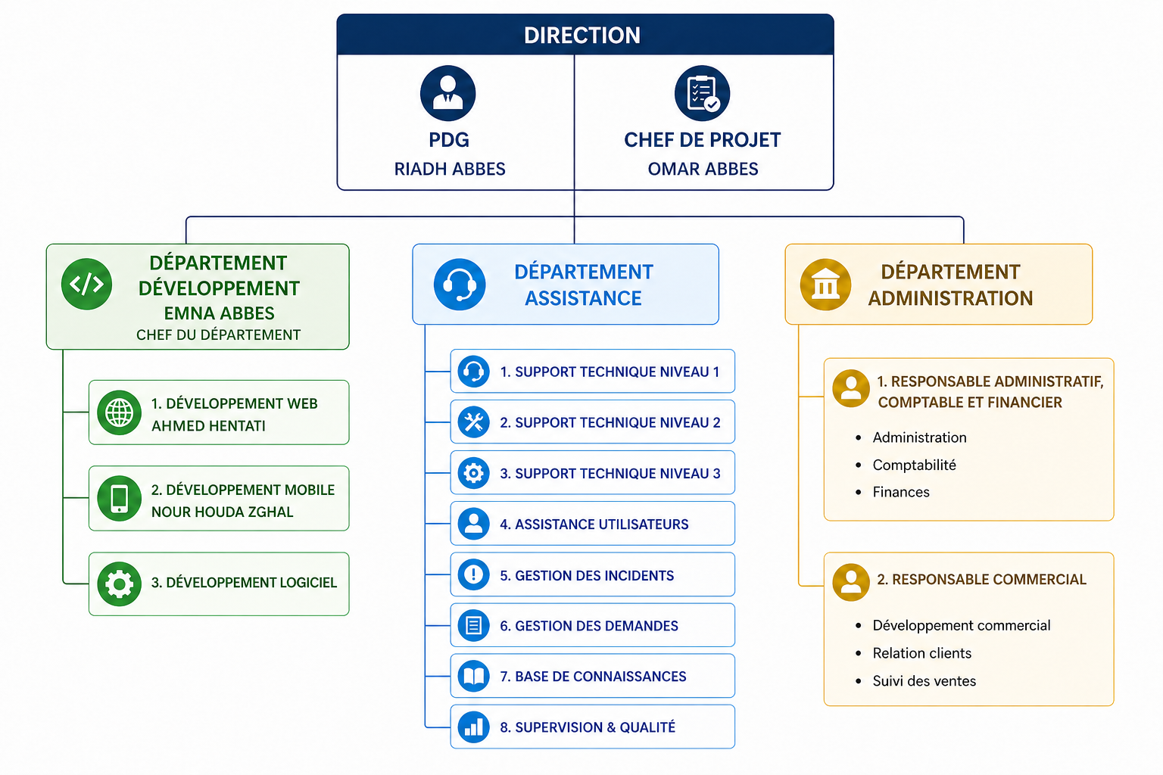
Figure 1.2 — Organisational chart of INET

1.2.5. Positioning of the project within the company
The position of this project inside INET is worth underlining, because it explains why the subject was relevant and not artificial. INET equips its clients with the very tools that produce HR data — time clocks and payroll/attendance software — but neither the company nor most of its clients exploit that data beyond payroll. The project therefore sits naturally in the Development department: it builds, on top of attendance data, the decision and prediction layer that the existing products do not provide.
A practical consequence of this positioning is that the project did not have to invent a data source: every concept it manipulates — a clock-in event, an absence motif, a leave request — already exists in the systems INET sells. What was missing was a coherent layer above those systems, and that is the layer the project provides. From a learning standpoint, this was also a useful constraint, because it kept the work close to a real industrial setting rather than to a textbook scenario.

1.3. Course of the internship

1.3.1. Department and integration
The internship took place within the Development department, under the supervision of the project manager, Mr. Omar Abbes. Being a Business Intelligence student, my role was not to extend an existing product but to design and build, end to end, a decision-support solution around HR attendance data. I therefore worked at the intersection of three concerns the department deals with daily: data, software, and the concrete needs of an SME.

1.3.2. Missions and tasks performed
The work was progressive. The main tasks I carried out during the internship were the following:
- understanding the HR domain and the way attendance, lateness, absences, and leave are recorded and used in practice;
- analysing the functional and non-functional needs of an HR manager who has to monitor a workforce on a daily basis;
- designing the operational database able to store the full HR activity of a realistic workforce;
- designing and loading a dedicated data warehouse following the Kimball star-schema approach, fed by an automated ETL pipeline;
- developing the operational system (back-end API and role-based web interfaces) that records and exposes the data;
- building the predictive layer (absenteeism-risk model and anomaly detection) and validating it seriously;
- building the decision dashboards, both in Power BI [2] and in the web application;
- automating the whole chain so that it keeps running without manual intervention.

1.3.3. Skills acquired
Beyond the deliverable, the internship was a genuine professional immersion. It allowed me to confront the theoretical concepts of Business Intelligence with the realities of a concrete project: modelling a data warehouse against messy operational data, choosing and validating a machine-learning model honestly, and assembling a full chain in which every component must feed the next. It also strengthened skills that are not purely technical — analysing a real need, organising the work in iterations, and presenting results to a non-technical interlocutor.
The technical skills consolidated during the internship cover the four layers the project relies on. On the back-end side, I worked with Python and the FastAPI [1] framework, the SQLAlchemy [7] ORM and the layered service architecture that decouples models, repositories and routes; I also handled authentication with JWT [5] and bcrypt, role-based access control, and the structuring of a REST API consumed by a separate front-end. On the data side, I wrote the SQL DDL of an OLTP schema with sixteen tables, then the DDL of a Kimball star schema (date / employee / department dimensions, three fact tables, surrogate keys) and the Python ETL that feeds it. On the analytics side, I built the predictive layer with scikit-learn [6] (Random Forest and Isolation Forest), validated it with a temporal split and a 5-fold cross-validation, and produced the Power BI [2] report and its DAX measures. On the front-end side, I built a Next.js [4] / TypeScript application with three role-based portals (Administrator, HR Manager, Employee) and the decision dashboards that consume the API.
The non-technical skills that grew with this project are, in my own experience, the ones that take longer to acquire and that the academic programme alone cannot deliver. The first is the discipline of cutting scope: every sprint I had to decide what to ship and what to postpone, knowing that an unfinished feature is worse than an absent one. The second is the habit of defending evaluation rather than results: in front of supervisors, the F1 number is less interesting than the way it was obtained. The third is communicating with a non-technical interlocutor — translating "the model's F1 was 0.65 on a temporal split" into "the system identifies, in roughly two thirds of the cases, the employees who will become problematic before they actually do." The Product Owner's first reaction was always the latter, not the former, and that taught me to put the manager's question above the data scientist's reflex.

1.4. Project context and problem statement
The starting observation is simple. In the type of organisation INET serves, HR attendance data is collected continuously but used only once a month, for payroll. Between two payrolls, an HR manager has no consolidated view of what is happening in the workforce. The information is scattered: a time clock produces raw clock-in and clock-out logs, leave requests are handled informally, absences are noticed rather than tracked, and nothing connects these pieces into a single picture.
This fragmentation has direct consequences:
- No consolidated view. The HR manager cannot answer, at a glance, basic questions such as what is the absenteeism rate this month, and how does it compare to last year? or which department is drifting?
- No anticipation. Absenteeism is only observed once it has already happened. There is no mechanism that flags an employee whose behaviour is deteriorating before the situation becomes a problem.
- No decision support. Even when the data exists, it is not turned into indicators or recommendations. The manager reacts; he does not steer.
The problem this project addresses can therefore be summarised in one sentence: the HR data of an SME is collected but not exploited, which keeps HR management manual, fragmented, and purely reactive.

1.5. Study of existing solutions
To position the proposed solution, it is necessary to look at what already exists. Two families of tools are relevant here.

1.5.1. National solutions: traditional HR and payroll software
The first family is the kind of software INET itself distributes and that is widely used by Tunisian SMEs: payroll and attendance applications. These tools are reliable for what they are designed to do — register clock-in/clock-out events and compute salaries. However, they remain transactional: they record data, they do not analyse it. They offer few or no analytical dashboards, no consolidated multi-year view, and no predictive capability. The HR manager still has to export data and build indicators by hand, typically in a spreadsheet.
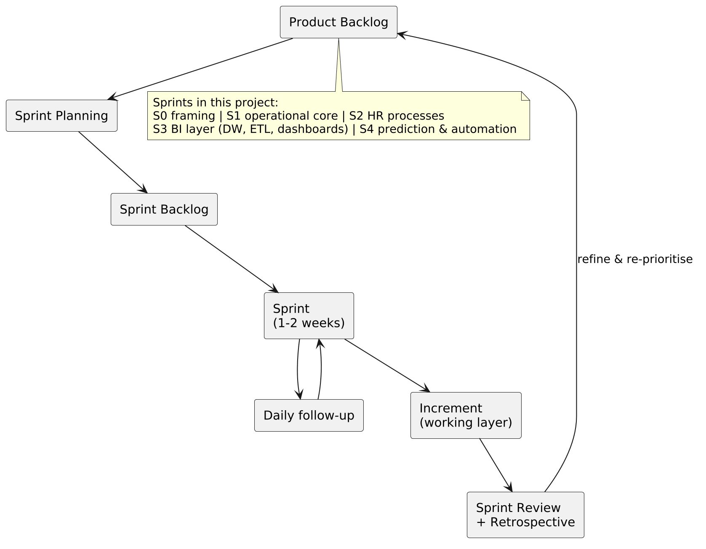
Figure 1.3 — Illustration of a national payroll & time-tracking software

1.5.2. International solutions: HR analytics and BI platforms
The second family is made of international HR-analytics modules — typically delivered as a module of a larger HR-IS suite such as Workday, SAP SuccessFactors or Oracle HCM — and general-purpose Business Intelligence suites such as Power BI [2], Tableau or Qlik plugged into an external HR data source. These platforms are powerful and offer rich dashboards and, in their advanced editions, predictive analytics. Howson (2014) notes that the difficulty of these large BI platforms is rarely the technology itself but the gap between what they can do and what an organisation is actually equipped to consume, and that the most successful deployments are the ones that start narrow rather than broad. For the context targeted here, the limits of these platforms are of exactly that nature: they are generic rather than tailored to the specific attendance data of a Tunisian SME, they are costly, and they require an integration effort that is disproportionate for the size of the structures INET serves.

1.5.3. Open-source middle ground
A third, less visible family is worth mentioning: the open-source middle ground — Metabase, Apache Superset, Pentaho — coupled with a generic ETL such as Airflow or NiFi. These tools close part of the cost gap, but they do not bring an HR-specific data model. The HR manager would still have to pay for a vertical on top of the horizontal BI platform, which is the entry cost that excluded the international suites in the first place. The empty space is therefore not "any BI tool"; it is "a BI tool that already speaks HR".

1.5.4. Comparative analysis
Table 1.2 — Comparison of existing solutions against the target need
Criterion | Traditional HR/payroll software | International HR-analytics / BI platforms | Need targeted by this project
Data centralisation | Partial (payroll-oriented) | Yes | Yes
Analytical dashboards | Very limited | Yes | Yes
Multi-year consolidated view | No | Yes | Yes
Predictive analytics (absenteeism) | No | Sometimes (advanced editions) | Yes
Cost | Low | High | Low
Fit for a Tunisian SME | Yes (for payroll only) | Low | Yes
Customisation to the company's data | Low | Medium | High

1.6. Critique of the existing
The comparison shows a clear gap. Traditional HR software is affordable and adapted to the SME but stops at recording data; it offers no analysis and no anticipation. International BI platforms offer the analysis and the anticipation but are generic, expensive, and oversized for the structures concerned. Neither family delivers, at an accessible cost and on the company's own attendance data, the combination that an HR manager actually needs: a consolidated decision view and a forward-looking risk indicator. This empty space is precisely what justifies a dedicated solution.

1.7. Proposed solution
The solution proposed in this project, named iNET RH, is not a single dashboard but a complete Business Intelligence chain built specifically on HR attendance and leave data. It is structured in four layers:
- an operational system — a back-end API and three role-based web interfaces (Administrator, HR Manager, Employee) — that records the daily HR activity: attendance, lateness, absences, leave, training, and documents;
- a data warehouse modelled with the Kimball star-schema approach and fed by an automated ETL pipeline, which turns the transactional data into an analysis-ready structure;
- a decision layer — a Power BI [2] report connected to dedicated SQL views, plus web dashboards aimed at the HR manager — that exposes the key indicators (attendance rate, absenteeism rate, lateness rate, departmental breakdown, trends);
- a predictive layer that estimates each employee's absenteeism risk with a Random Forest model and detects abnormal attendance behaviour with an Isolation Forest, the whole being kept up to date automatically by a scheduler.
The aim of this architecture is to move HR follow-up from a manual, monthly, reactive process to an automated, continuous, and anticipative one — at a cost and a level of customisation compatible with the SME context INET serves.

1.8. Development methodology

1.8.1. Choice of an agile approach
The project was conducted with an agile approach, for a reason that comes from its own nature: the need was clear in its objective (a decision-support solution on HR data) but open in its details, and the system is made of layers that had to be built and validated one after another. An incremental method, delivering a working layer at each step and adjusting the next one in light of it, was therefore more suitable than a single up-front specification.
Among agile methods, Scrum (Schwaber and Sutherland, 2020) was retained for its clear structure: short, time-boxed iterations producing a usable increment, an explicit backlog driving the priorities, and short ceremonies (planning, review, retrospective) framing each iteration. A more traditional V-cycle was considered and ruled out, because it would have postponed the most uncertain layer of the project — the predictive one — to the end, and a late discovery there would have invalidated parts of the data model already locked.

1.8.2. Scrum team and roles
Scrum defines three responsibilities — Product Owner, Scrum Master, and Development Team — that were mapped onto the people available in this academic project as follows.
Table 1.3 — Scrum team and roles on the project
Role | Person | Responsibility on the project
Product Owner | Mr. Omar Abbes (INET) | Expressed the business need, prioritised the backlog, validated each increment against the HR reality.
Scrum Master (methodological framing) | Mr. Thameur Dhieb (ISB Sfax) | Ensured the agile discipline (sprint cadence, review of artefacts), removed methodological obstacles, oriented the modelling and BI choices.
Development Team | Hachem Zenati | Analysis, design, implementation, testing, and documentation of every increment, on the back-end, the ETL, the AI layer, and the front-end.

1.8.3. Scrum values
The five values defined by the Scrum guide — commitment, courage, focus, openness, and respect — translated, in the context of this project, into concrete behaviours rather than abstract principles. Commitment meant delivering a working increment at the end of every sprint, even at the cost of trimming scope. Courage meant exposing intermediate results — including the honest absenteeism-model evaluation that does not flatter the model — to the supervisors rather than waiting for a perfect version. Focus was enforced by the sprint backlog: only the items selected for a sprint were worked on. Openness took the form of weekly readbacks to the company supervisor on what had been built, what remained, and what needed to be reconsidered. Respect was the working assumption that each supervisor's feedback — methodological or business — was a legitimate constraint to be incorporated rather than an opinion to defend against.

1.8.4. Scrum cycle applied to the project
The work was organised into successive sprints, each delivering a usable increment:
- Sprint 0 — framing: needs specification, functional perimeter, product backlog, technical environment;
- Sprint 1 — operational core: authentication, role-based access, employee and attendance management;
- Sprint 2 — HR processes: leave and absence management, validation workflows;
- Sprint 3 — Business Intelligence layer: data-warehouse modelling, ETL pipeline, Power BI [2] report and web dashboards;
- Sprint 4 — predictive layer and automation: absenteeism-risk model, anomaly detection, scheduler.
This decomposition is presented here as the methodology of the project; the report itself, however, is organised by concern (analysis and design, implementation, results) rather than sprint by sprint, so that each part of the system can be read as a whole.
Table 1.4 gives, for each sprint, its main backlog items, the duration that was allocated to it, and the increment that was reviewed at the end.
Table 1.4 — Sprint plan, backlog items, and increments reviewed
Sprint | Duration | Main backlog items | Reviewed increment
Sprint 0 — Framing | ≈ 1 week | Needs interviews, functional perimeter, product backlog, technical environment, OLTP draft. | A reviewed backlog (Table 3.1) and a working development environment.
Sprint 1 — Operational core | ≈ 3 weeks | Authentication & RBAC (US-01), employee management (US-02), department & user management (US-03), attendance recording (US-04). | A working portal where an HR manager can manage employees and an employee can record attendance.
Sprint 2 — HR processes | ≈ 3 weeks | Attendance supervision (US-05), absence management (US-06), leave management with validation (US-07), HR KPIs (US-08). | The full HR workflow (record → consolidate → validate) on the operational data.
Sprint 3 — Business Intelligence layer | ≈ 3 weeks | Kimball star schema, ETL pipeline, Power BI report, role-based dashboards. | A populated data warehouse, a five-page Power BI report, and the web dashboards described in Chapter 7.
Sprint 4 — Predictive layer and automation | ≈ 2 weeks | Absenteeism prediction (US-09), anomaly detection & alerts (US-10), decision dashboard (US-11), Power BI reporting (US-12), the five-job scheduler. | A trained Random Forest with its evaluation, the alert generator, the consolidated decision dashboard, and the autonomous scheduler.

Each sprint ended with a review with the supervisors — the increment was demonstrated on the running system — and a short retrospective: what to keep (the layered back-end made integration smooth), what to improve (the synthetic-data evaluation needed sharper validation, which was then introduced from Sprint 4 onward), and what to drop (over-engineered fields that no view actually consumed).

1.8.5. Modelling language
The Unified Modeling Language (UML) was used to model the system. It provides a standard, graphical way to describe the actors, the use cases, the static structure (classes and database), and the dynamic behaviour (sequence of interactions). The diagrams produced with UML are presented in Chapter 3.
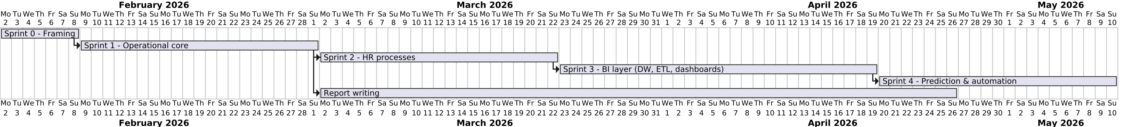
Figure 1.4 — Scrum development cycle applied to the project
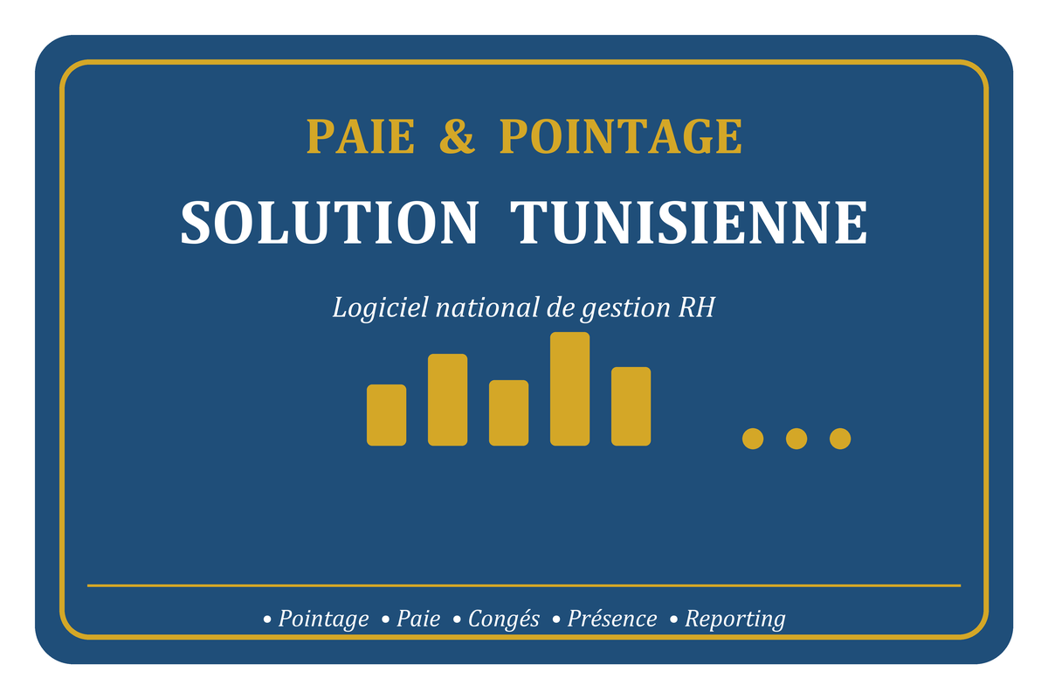
Figure 1.5 — Development environment tools

1.9. Conclusion
This chapter has established why the project exists. INET, a company whose own business revolves around attendance hardware and payroll software, faced — internally and on behalf of the SMEs it serves — a concrete gap: HR data is collected but neither consolidated nor used to anticipate. The study of existing solutions confirmed that no accessible tool fills that gap on the company's own data, which justified the proposed solution: a complete Business Intelligence chain, built incrementally with Scrum and modelled with UML. The next chapter lays down the theoretical foundations on which this solution rests, before Chapter 3 (Sprint 0) turns to the framing of its requirements and specification.

CHAPTER 2 : THEORETICAL FOUNDATIONS

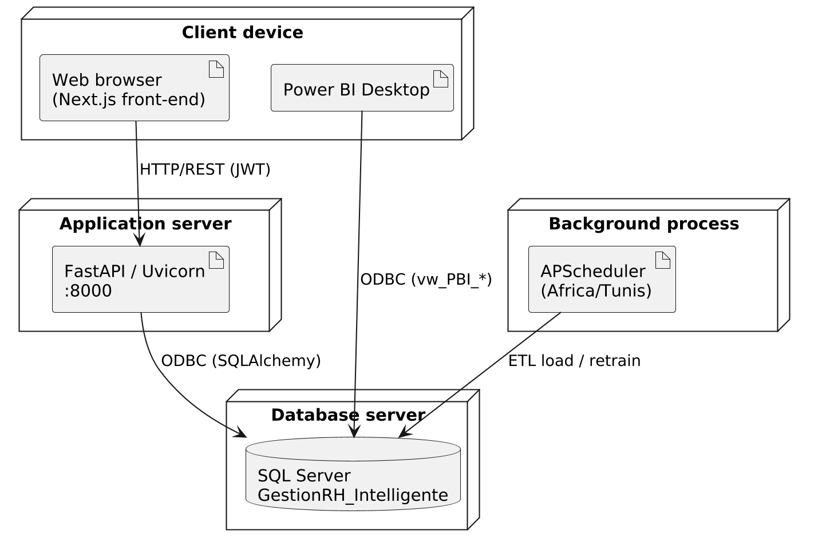
Figure 2.1 — BI maturity levels
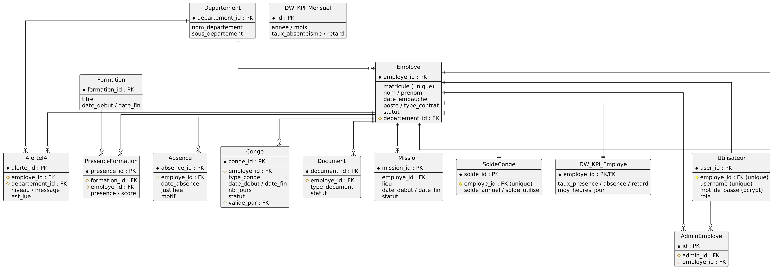
Figure 2.2 — HR KPI framework
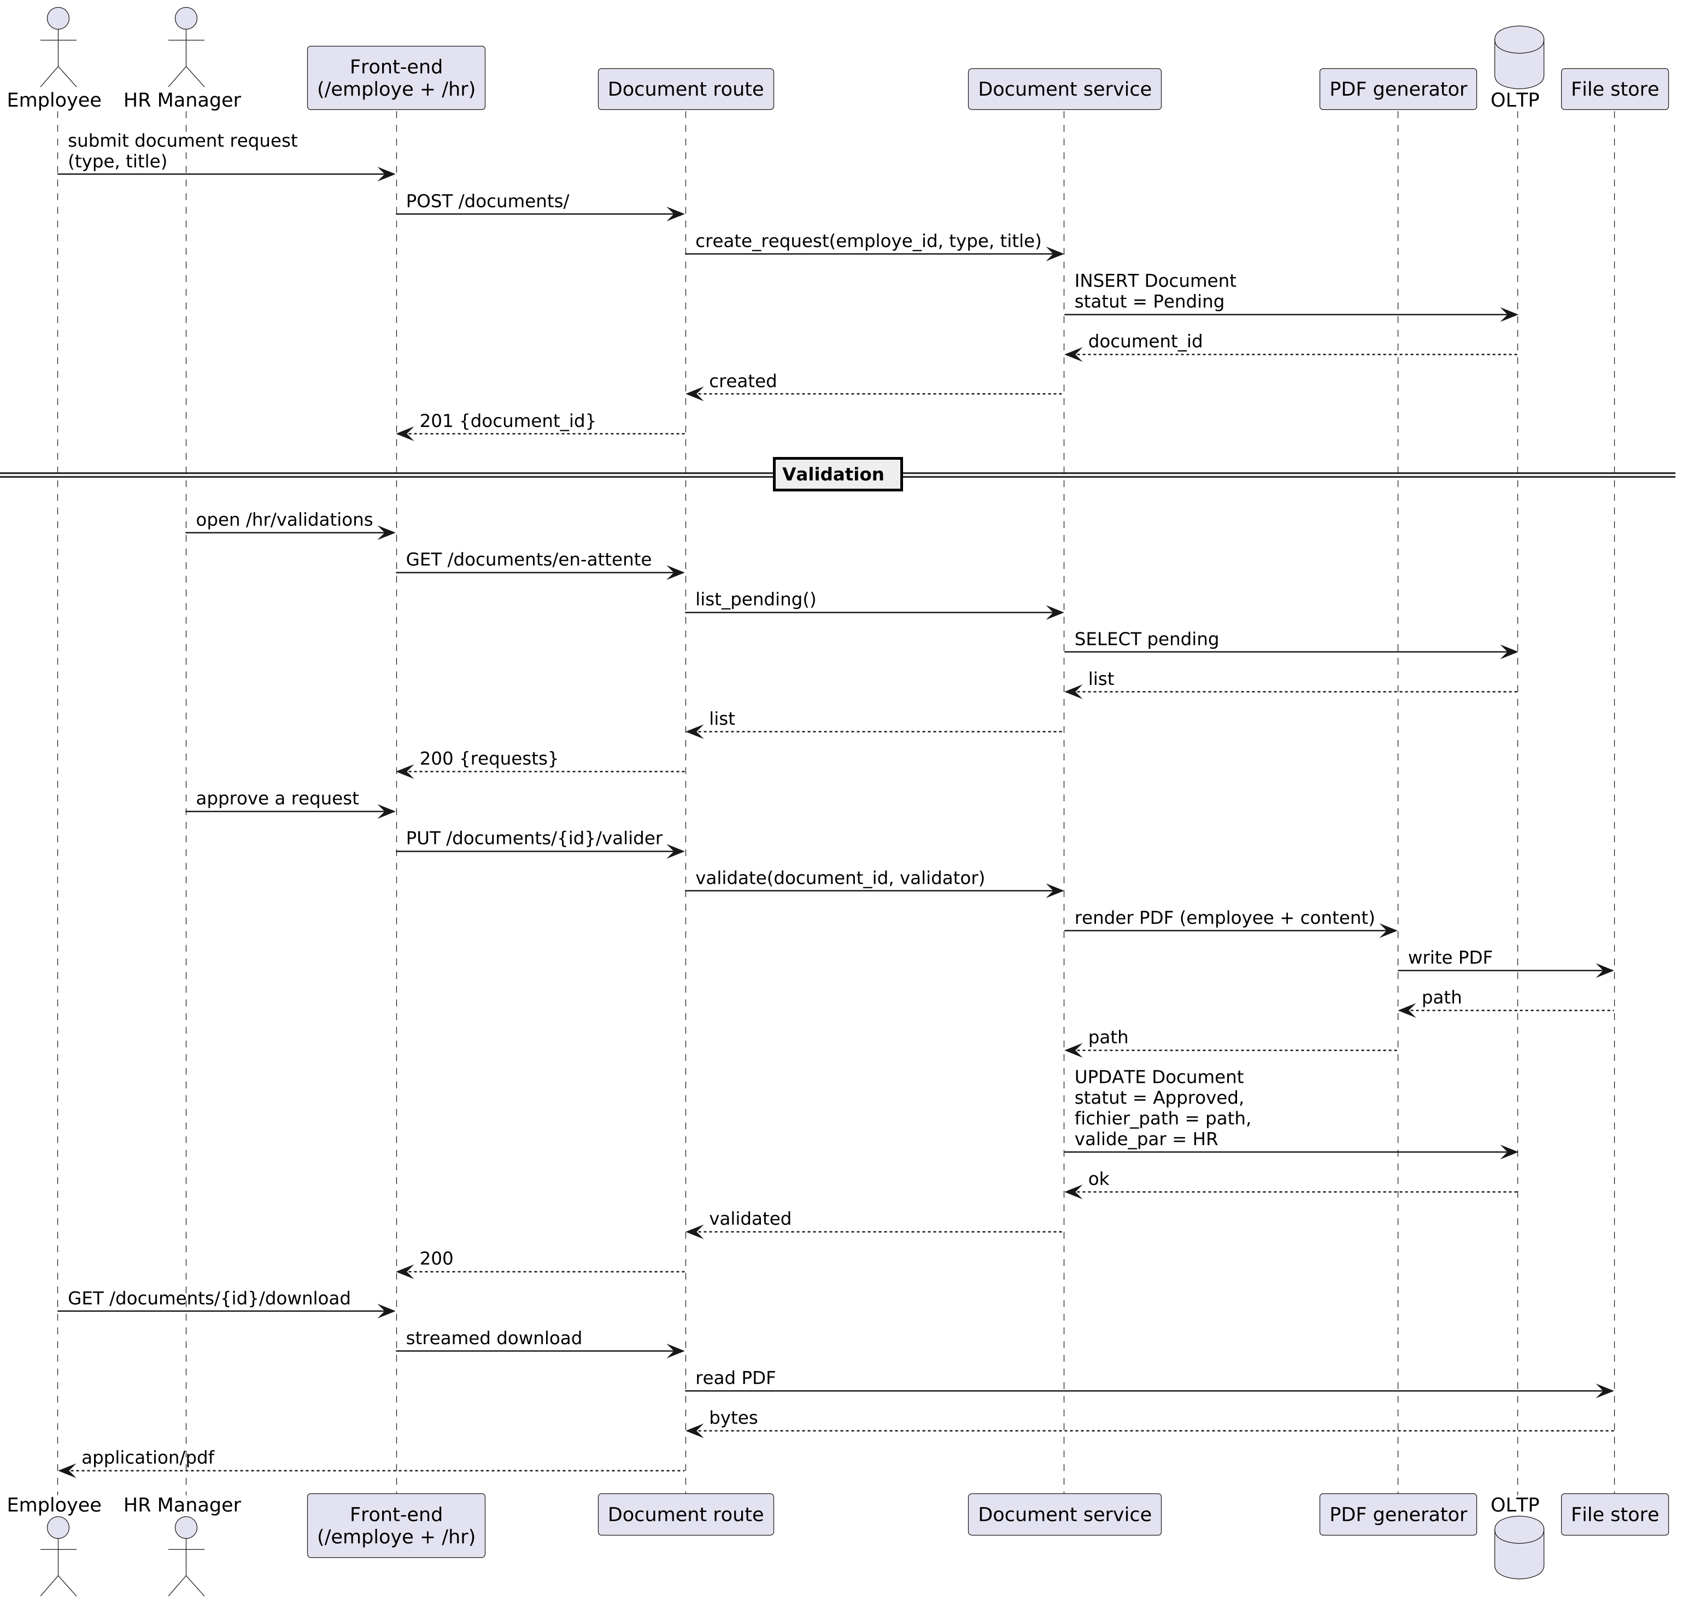
Figure 2.7 — Decision tree structure
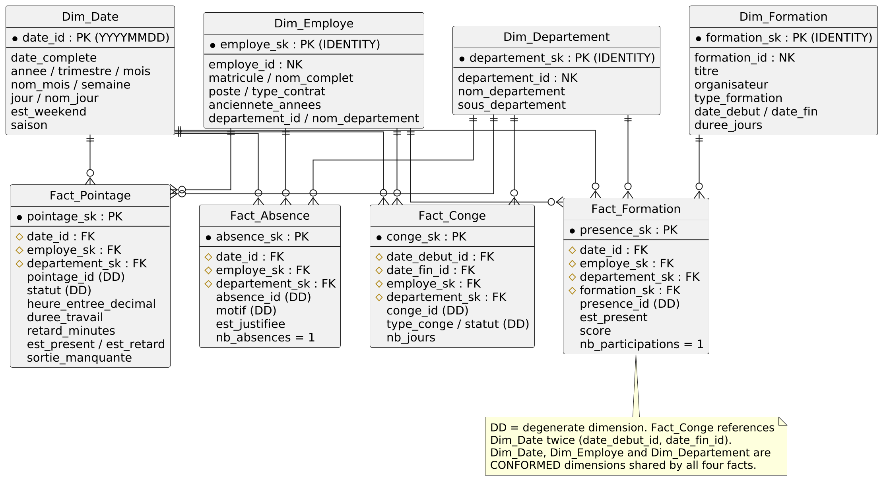
Figure 2.8 — Random Forest ensemble
Figure 2.9 — Isolation Forest anomaly detection
Figure 2.10 — Model evaluation metrics

2.1. Introduction
The solution proposed in this project rests on a chain of well-established disciplines: human-resources management provides the domain and the questions, Business Intelligence provides the way to answer them, data warehousing and the ETL process provide the structure that makes analysis possible, machine learning provides the anticipation, and dashboard design provides the final interface with the manager. This chapter defines the concepts behind each of these layers. The objective is not to survey the literature exhaustively but to fix, with precision and with references, the notions that the rest of the report uses. Each concept is therefore reformulated in the specific context of the project rather than left abstract. On the Scrum side, this chapter was assembled at the end of Sprint 0 alongside the product backlog: every concept presented below was introduced because at least one user story in §3.5 depends on it (the data-warehouse vocabulary supports US-08 / US-11, the machine-learning vocabulary supports US-09, and the dashboard design principles support US-11 / US-12). The chapter therefore documents the theoretical sprint backlog of the project.

2.2. Human-resources management and absenteeism
Concepts framed in Sprint 0 as the basis of the user-story wording in §3.5.
Human-resources management covers all the practices through which an organisation administers and develops its workforce. Among these practices, the monitoring of working time — presence, lateness, absence, and leave — is one of the most operational, because it produces a continuous stream of data and has a direct effect on both productivity and payroll.
Absenteeism is generally understood as the repeated or prolonged non-presence of an employee during scheduled working time, excluding authorised leave. It is distinguished from leave (an absence that is planned and approved in advance) and from lateness (a presence that begins after the expected time). The distinction matters for analysis: leave is a normal, plannable phenomenon, whereas unjustified absence and chronic lateness are the signals an HR manager actually needs to watch.
Absenteeism is costly and, more importantly for this work, partly predictable: past behaviour is a recognised indicator of future behaviour, which is exactly what justifies a predictive approach (Marler and Boudreau, 2017). The field that studies the use of workforce data to support such decisions is usually called HR analytics; Marler and Boudreau (2017) describe it as the application of analytical methods to HR data in order to improve organisational decisions, and note that its value depends less on the sophistication of the model than on whether the resulting indicators are actually used by managers. This observation guided the present project: the predictive layer was kept interpretable and was always coupled with a decision dashboard.
In HR practice, several indices summarise attendance behaviour. The Bradford Factor, for instance, is a widely used industry measure that deliberately weights frequent short absences more heavily than rare long ones, on the empirical assumption that fragmented absence is more disruptive. The present project does not reuse the Bradford Factor as such, but it follows the same logic: the model's features count frequency (number of absences, number of late arrivals) and not only volume. While I was implementing the feature pipeline, this distinction came back at every step — two employees who miss the same number of working days are not equivalent if one disappears for a single week and the other for nine isolated days, and the predictive layer has to see that difference.

2.3. Human-resources key performance indicators
Indicators specified in Sprint 0 and implemented as the KPI service in Sprint 2.
A Key Performance Indicator (KPI) is a quantified measure that expresses, in a single comparable number, the state of a process relative to an objective. For attendance management, four KPIs are sufficient to give an HR manager an immediate reading of the workforce, and they are the ones computed by this project's ETL layer.
Attendance (presence) rate — the share of expected working occurrences for which the employee was actually present:
Absenteeism rate — the share of expected working occurrences lost to absence:
Lateness rate — the share of present occurrences that were late:
Average worked hours per day — the mean of the daily worked duration over the period:
These formulas are deliberately the exact expressions implemented in the transformation step of the pipeline (Chapter 6), so that the indicator the manager reads on the dashboard and the indicator the model consumes as a feature are, by construction, the same.

2.4. Business Intelligence
Vocabulary fixed in Sprint 0; reused in Sprint 3 as the basis of the BI-layer design.
Business Intelligence (BI) designates the set of techniques and tools that transform raw operational data into information usable for decision-making. Negash (2004) characterises BI as systems that combine data collection, storage, and analysis to provide decision-makers with timely and actionable information; Chaudhuri, Dayal and Narasayya (2011) give a more technical reading, presenting BI as the chain that goes from operational data sources, through a data warehouse populated by an ETL process, to analytical and reporting tools.
That chain — sources → ETL → data warehouse → analysis and reporting → decision — is the backbone of this project. Its value is not in any single component but in the continuity of the whole: the same attendance event that is recorded by the operational system eventually becomes a point on a trend line and a feature in a risk model. The purpose of BI, in this sense, is to shorten the distance between an event happening in the organisation and a decision being taken about it.
Howson (2014) makes a useful distinction between BI that is built and BI that is used, and warns that the second is much harder than the first. A successful BI deployment is the one a manager actually opens every morning; a beautiful warehouse that no one reads is a failure even if the technical work is perfect. This observation also guided the project, in two ways: each chart on the decision dashboards was designed to answer one and only one question a manager would have, and the predictive layer was kept simple enough to be explained in a sentence ("this employee is in the top quartile of absence risk because of these three indicators") rather than presented as a black box.
A useful way to describe what BI delivers is by the type of question it answers. Descriptive analysis answers what happened (the absenteeism rate last month), diagnostic analysis answers why (which department drove it), and predictive analysis answers what is likely to happen (which employees are at risk). The present project covers all three levels: the dashboards are descriptive and diagnostic, and the machine-learning layer is predictive.

2.5. Data warehousing
Star-schema vocabulary anchored in Sprint 0; the schema itself was built during Sprint 3.

2.5.1. OLTP versus OLAP
Operational databases are optimised for Online Transaction Processing (OLTP): many small, concurrent read-and-write operations, a normalised schema to avoid redundancy, and a focus on the current state. Analysis has the opposite profile — Online Analytical Processing (OLAP) — with few but heavy read queries that aggregate large volumes across long periods. Chaudhuri and Dayal (1997) explain that running analytical queries directly on an OLTP database is inefficient and degrades the operational system, which is the classic justification for a separate data warehouse. In this project, the operational tables (attendance, absences, leave) keep their normalised OLTP form, while a dedicated warehouse stores the same facts in a form designed for aggregation.

2.5.2. The Kimball approach and the star schema
Two reference approaches structure data-warehouse design. Inmon (2005) advocates a normalised, enterprise-wide warehouse from which dependent data marts are derived. Kimball and Ross (2013) propose the opposite, bottom-up logic: model the warehouse directly around business processes using dimensional modelling, whose canonical form is the star schema.
A star schema separates two kinds of tables. Fact tables store the measurable events of a process at a defined grain (the precise meaning of one row). Dimension tables store the descriptive context by which those facts are filtered and grouped — time, employee, department. Each fact row references its dimensions through surrogate keys, that is, technical identifiers generated by the warehouse rather than the natural keys of the source system; Kimball and Ross (2013) recommend surrogate keys because they decouple the warehouse from operational identifiers and make historical handling explicit. When the descriptive attributes of a dimension change over time, the warehouse applies a Slowly Changing Dimension (SCD) policy; the simplest, type 1, overwrites the old value with the latest one.
This project follows the Kimball approach. The grain of the attendance fact is one row per employee per working day; the absence fact is one row per absence event; the leave fact is one row per leave request. Three conformed dimensions — date, employee, department — are shared by the three facts, and surrogate keys link them. The detailed design is given in Chapter 3; what matters here is the rationale: the star schema was chosen because the questions an HR manager asks (absenteeism by department, by month, by season) are exactly "measure-by-dimension" questions, which dimensional modelling answers naturally and quickly.

2.5.3. Slowly Changing Dimensions
A practical question that comes up as soon as a dimension is loaded for a second time is what to do with attribute changes — an employee moves to another department, a department is renamed, a contract type is updated. Kimball and Ross (2013) classify the answers into Slowly Changing Dimension (SCD) types. Type 1 simply overwrites the old value with the latest one: history is lost, but the dimension stays compact and every report reads the current truth. Type 2 creates a new dimension row at each change, keeps the old one with an end_date, and uses a fresh surrogate key, which allows queries to attribute facts to the structure that was in place at the time. Type 3 keeps the previous value in a parallel column ("previous department"), which is useful for one-step comparisons but does not scale to long histories.
The current warehouse uses type 1 on all three dimensions: at every ETL run the dimension is rebuilt from the operational source, so that the latest organisational picture is always the one the report sees. This choice was deliberate and is acknowledged as a limitation: it gives a clean, low-maintenance dimension at the cost of historical traceability of organisational changes. Section 5.5 and the general conclusion return to it as a perspective — promoting Dim_Employe to type 2 once the warehouse is deployed on real data.

2.6. The ETL process
Theoretical ETL vocabulary defined in Sprint 0; the actual pipeline was coded in Sprint 3.
The bridge between the operational source and the data warehouse is the Extract–Transform–Load (ETL) process. Vassiliadis (2009) describes ETL as the most resource-intensive part of a data-warehouse project and decomposes it into three responsibilities. Extraction reads the relevant data from the operational sources. Transformation cleans, conforms, and computes: it handles missing or inconsistent values, derives the analytical measures, and aligns the data with the target schema. Loading writes the result into the warehouse, either by full refresh or by incremental update.
Two ETL qualities matter for this project. The first is data quality: an indicator is only as trustworthy as the transformation that produced it, so the transformation step here recomputes every KPI from raw events rather than trusting pre-aggregated values. The second is idempotence: because the pipeline runs every night automatically, re-running it must not duplicate or corrupt data; the star-schema loader was therefore designed as a safe, repeatable full refresh.

2.7. Machine learning for HR analytics
Validation methodology agreed in Sprint 0; applied during Sprint 4 to the absenteeism model.

2.7.1. Supervised and unsupervised learning
Machine learning builds models that infer patterns from data instead of being programmed with explicit rules. In supervised learning the model is trained on labelled examples and learns to predict the label of new cases; classification is the supervised task where the label is a category. In unsupervised learning there are no labels, and the model is asked to find structure on its own; anomaly detection is an unsupervised task that isolates observations that differ from the norm (Han, Kamber and Pei, 2011). This project uses both: a supervised classifier to predict absenteeism risk, and an unsupervised detector to flag abnormal attendance behaviour.

2.7.2. Decision trees and the Random Forest
A decision tree splits the data through a sequence of conditions on the features until it reaches a class decision. Single trees are interpretable but unstable. Breiman (2001) introduced the Random Forest, an ensemble that trains many trees on bootstrapped samples with random feature subsets and combines their votes. The aggregation reduces variance and overfitting while preserving a useful by-product: a feature-importance score that quantifies how much each input contributes to the prediction. The Random Forest was chosen for the absenteeism model precisely for this combination — robustness on tabular HR data and an importance ranking that makes the prediction explainable to an HR manager rather than opaque.

2.7.3. Isolation Forest
For the unsupervised task, the project uses the Isolation Forest proposed by Liu, Ting and Zhou (2008). Instead of modelling what is normal and measuring distance from it, the Isolation Forest isolates points by random partitioning and exploits the fact that anomalies, being few and different, are separated in fewer splits than normal points. It is efficient on large tabular data and does not require labelled anomalies, which suits attendance data where "abnormal behaviour" is not pre-labelled.

2.7.4. Model evaluation
Evaluating a classifier on accuracy alone is misleading when the classes are imbalanced, which is the case here since at-risk employees are a minority. The project therefore reports precision (of the employees flagged at risk, how many really are), recall (of the truly at-risk employees, how many were caught), and their harmonic mean, the F1 score, all read from the confusion matrix (Han, Kamber and Pei, 2011).
A single train/test split can still give a lucky or unlucky result. k-fold cross-validation mitigates this by partitioning the data into k folds, training on k−1 and testing on the remaining one, and averaging the scores; the mean and the standard deviation together describe both the level and the stability of the performance (Hastie, Tibshirani and Friedman, 2009).
A further precaution is specific to this project. Because the labels and the features are both derived from behavioural data, a naive split risks letting the model simply restate the data it was trained on. Bergmeir and Benítez (2012) show that, when data has a temporal order, evaluation should respect that order rather than shuffle across it. The model therefore uses a temporal split — features computed from an earlier period, labels taken from a later one — so that good performance means genuine anticipation, not memorisation. Finally, the model is compared against a rule-based baseline (flagging everyone above a simple absence-rate threshold): a learned model is only worth its complexity if it beats the trivial rule it is meant to replace.

2.7.5. Overfitting and the cost of model complexity
The temptation, on a small training set, is to grow a complex model until the training error vanishes. Provost and Fawcett (2013) warn that this almost always leads to overfitting: the model memorises noise specific to the training sample and fails on new data. The classical signal of overfitting is a wide gap between the training and the validation performance, but on imbalanced data even this is misleading — the model can look excellent on accuracy while predicting the majority class for everyone. Two precautions were therefore taken in the present project: the Random Forest was deliberately kept small (one hundred trees, maximum depth four, minimum three samples per leaf), and the validation reads precision, recall, and F1 rather than accuracy alone. The training-set numbers are not reported in isolation; only the cross-validation mean and standard deviation, together with the baseline F1, are.

2.8. Data visualisation and dashboards
Dashboard principles agreed in Sprint 0; the web and Power BI dashboards built incrementally in Sprints 1 to 3.
The last link of the BI chain is the interface between the analysis and the manager. Few (2006) defines a dashboard as a visual display of the most important information needed to achieve one or more objectives, consolidated on a single screen so that it can be monitored at a glance. He stresses that a dashboard is not a report: its value lies in immediacy and selection, not in exhaustiveness, and that adding visual decoration that does not carry information actively harms comprehension. In a later work, Few (2013) extends the same logic from a single screen to a visual sensemaking practice: the goal of a chart is not to be looked at, it is to be read, and the analyst's job is to remove everything that competes with the signal. These principles directly shaped the dashboards built in this project — a small number of KPI cards, trends over time, and a departmental breakdown, with no ornamentation that does not encode a value.
Eckerson (2010) gives a complementary, organisational reading of the same idea. He defines a performance dashboard as a management system — not only a screen — that connects an objective to the indicators that measure it and to the action that follows when an indicator drifts. In the present project this was the rule of thumb for selecting the KPIs: each one was kept only if a clear HR action followed from a clear drift in its value. The absenteeism-rate card, for instance, is on the dashboard because a sustained rise in it triggers a documented HR response; a presence-by-quarter chart that has no associated action was removed.
Power BI [2] is the analytical and visualisation platform used for the decision report. It connects to the SQL Server [3] warehouse, lets relationships be defined between the dimensional views, and expresses indicators through the DAX formula language. It was selected because it integrates natively with the SQL Server [3] stack already used by the project and because it lets the HR manager explore the indicators interactively rather than receiving a static document.

2.9. Conclusion
This chapter has defined the theoretical chain the project relies on: the HR concepts and KPIs that frame the questions, Business Intelligence as the way to answer them, the Kimball data warehouse and the ETL process as the structure that makes analysis possible, the Random Forest and Isolation Forest as the predictive layer, the evaluation precautions that keep that layer honest, and the dashboard principles that decide how the result reaches the manager. Each notion has been stated in the specific terms the project uses, so that the following chapters can refer to them directly. The next chapter turns from concepts to the system itself, beginning with the analysis of requirements and the design of the database and the data warehouse.

CHAPTER 3 : SPRINT 0: REQUIREMENTS AND SPECIFICATION

3.1. Introduction
Sprint 0 is the framing sprint of the project: no line of production code is delivered, only the complete specification of the system to be built. Its sole purpose is to converge — with both the academic supervisor and the company supervisor — on the actors, the requirements, the backlog, the four structural diagrams, and the development environment that will govern every subsequent sprint. All artefacts produced here were formally reviewed and validated at the end of Sprint 0, before Sprint 1 was allowed to start.

3.2. Scrum Team and Roles
The project was organised as a single-developer Scrum team in which the conventional roles were distributed between the company and the academic side. The Product Owner — Mr. Omar Abbes, Project Manager at INET — owned the backlog and the business priorities; the Scrum Master — Mr. Thameur Dhieb, academic supervisor at ISB Sfax — ensured the methodology and removed impediments; and the development effort was carried out by the student.
Table 3.1 — Scrum team and roles
Role | Holder | Affiliation
Product Owner | Mr. Omar Abbes | INET — Informatique.Net (Project Manager)
Scrum Master | Mr. Thameur Dhieb | ISB Sfax (academic supervisor)
Developer | Hachem Zenati | ISB Sfax — student in Business Intelligence

3.3. Identification of actors
The system distinguishes three human actors and one non-human actor. The separation is not cosmetic: it drives the access-control model implemented later (role-based access control).
- Administrator. The technical and organisational owner of the platform. The administrator manages user accounts and roles, manages departments, configures the system parameters (AI thresholds, HR rules, scheduler, email), consults the platform statistics and the system logs, and can trigger a model retraining.
- HR Manager. The main beneficiary of the decision layer. The HR manager manages employees, supervises daily attendance, processes absences, validates leave and mission requests, handles document requests, consults the KPI dashboards and the Power BI [2] report, and reads the AI alerts and absenteeism-risk predictions.
- Employee. The end user who feeds the operational data. The employee records attendance, requests leave and documents, consults personal attendance history and leave balance, and follows personal training.
- System (scheduler). A non-human actor that acts autonomously on a time basis. It simulates the daily attendance flow, runs the ETL pipeline, sends the daily digest email, and retrains the predictive model. It is modelled as an actor because it initiates use cases without any human trigger.
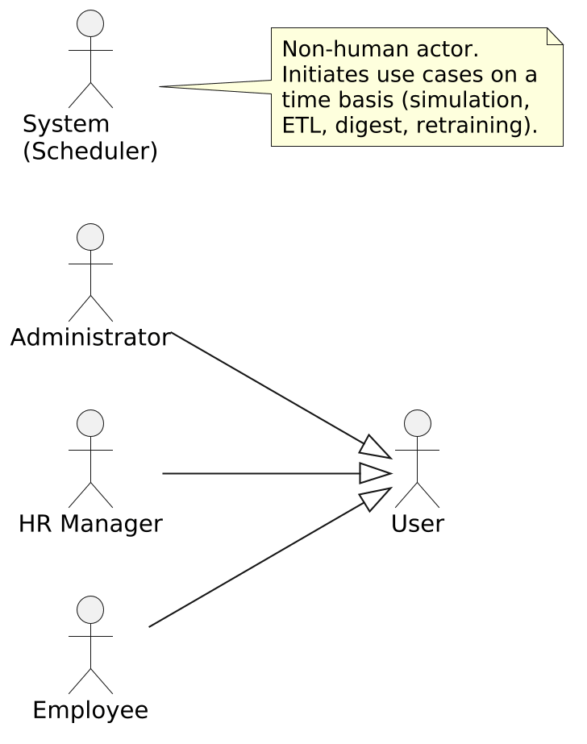
Figure 3.1 — Actors of the system

3.4. Identification of requirements

3.4.1. Functional requirements
The functional requirements describe what the system must do. They are grouped by functional area; this grouping is reused as the structure of the product backlog and of the implementation chapter.
Authentication and access control.
- Authenticate a user by username and password and return a signed session token.
- Restrict every protected operation according to the user's role (employee, HR, administrator).
Employee and organisation management.
- Create, consult, update, and deactivate employees.
- Manage departments (create, update, delete, list).
- Manage user accounts: change role, enable or disable an account, reset a password.
Attendance management.
- Record an entry/exit event (pointage) for an employee.
- Consult the day's attendance for the whole workforce.
- Consult an employee's attendance history and presence rate.
- Compute global and per-department attendance KPIs and the multi-year evolution.
Absence management.
- Record and list absences, justified or not.
- Distinguish unjustified absences for risk analysis.
Leave management.
- Submit a leave request and compute the working days it spans.
- Consult the personal leave balance.
- Approve or reject a pending request (HR), and cancel a request.
Documents, missions, training.
- Request a document and generate the corresponding PDF after validation.
- Declare and validate a business mission.
- Manage training sessions and record attendance and scores.
Predictive analytics and alerts.
- Predict, for every active employee, an absenteeism-risk score and a risk level.
- Detect abnormal attendance behaviour (unjustified absences, frequent lateness, abnormal punch patterns).
- Generate, list, and mark as read the AI alerts.
- Expose the model's metrics and feature importances.
Decision dashboards and reporting.
- Provide a role-specific web dashboard with the key HR indicators.
- Provide a Power BI [2] report connected to dedicated analytical views.
Automation.
- Run, without human intervention, the daily simulation, the nightly ETL, the daily digest email, and the weekly model retraining.

3.4.2. Non-functional requirements
The non-functional requirements describe how the system must behave.
- Security. Authentication must be based on a signed, expiring token; passwords must be stored only as cryptographic hashes; every endpoint must enforce the caller's role; cross-origin access must be restricted to the known front-end origin.
- Performance. Common read operations must remain responsive on a database holding around two hundred thousand attendance records; analytical questions must be answered from the warehouse, not from the operational tables.
- Reliability. The automated jobs must be idempotent — re-running the nightly ETL must not duplicate or corrupt data — and failures must be logged rather than silent.
- Maintainability. The back-end must keep a strict separation of responsibilities (routing, services, data access, models) so that a change in one layer does not propagate to the others.
- Scalability. The dimensional model must absorb the growth of history (more years, more employees) without a change of schema.
- Traceability. The system events (ETL runs, scheduler jobs, model retraining) must be logged and consultable.

3.5. Product backlog
The backlog was locked at the Sprint 0 planning meeting and only edited at the end of each sprint review.
The requirements were organised into a prioritised product backlog, written as user stories. Two distinct attributes are recorded for each story: a Priority (1 = Must-have, 2 = Should-have, 3 = Should-have / next, 4 = Could-have) expressing the business value of the story, and a Sprint (1 to 5) indicating when the story was actually delivered during the project. Priority and Sprint are not the same: priority is a backlog-level property assigned by the Product Owner; the sprint number is a planning artefact produced during sprint planning. The two usually align — a Priority-1 story tends to land in an early sprint — but they can differ. For example, US-11 — Decision dashboard carries Priority 3 yet was delivered in Sprint 3 alongside the BI layer rather than in the predictive sprint, because the dashboard needs the data warehouse to exist before it can be wired.
Table 3.2 — Product backlog (user stories)
ID | Functionality | User story | Priority | Sprint
US-01 | Authentication | As a user, I want to log in securely so that I can access my space according to my role. | 1 (Must) | 1
US-02 | Employee management | As an HR manager, I want to create, update, and deactivate employees so that the workforce data stays accurate. | 1 (Must) | 1
US-03 | Department & user management | As an administrator, I want to manage departments and user accounts so that the organisation and access rights stay correct. | 1 (Must) | 1
US-04 | Attendance recording | As an employee, I want to record my entry and exit so that my working time is tracked. | 1 (Must) | 1
US-05 | Attendance supervision | As an HR manager, I want to see the day's attendance and an employee's history so that I can monitor presence. | 2 (Should) | 2
US-06 | Absence management | As an HR manager, I want to record and qualify absences so that unjustified absence is identifiable. | 2 (Should) | 2
US-07 | Leave management | As an employee, I want to request leave and see my balance; as an HR manager, I want to validate requests. | 2 (Should) | 2
US-08 | HR KPIs | As an HR manager, I want global and per-department KPIs and their evolution so that I can read the workforce at a glance. | 2 (Should) | 2
US-09 | Absenteeism prediction | As an HR manager, I want each employee's absenteeism risk so that I can act before the absence happens. | 3 (Should) | 4
US-10 | Anomaly detection & alerts | As an HR manager, I want abnormal behaviour flagged automatically so that I do not have to find it manually. | 3 (Should) | 4
US-11 | Decision dashboard | As an HR manager, I want a single dashboard consolidating the indicators and the model results. | 3 (Should) | 3
US-12 | Power BI reporting | As an HR manager, I want an interactive Power BI report on the warehouse so that I can explore the data. | 3 (Should) | 3
US-13 | Documents / missions / training | As an employee, I want to request documents and follow training; as HR, I want to validate them. | 4 (Could) | 2
US-14 | Automation | As the system, I want to refresh the warehouse, the alerts, and the model automatically so that the analysis stays current. | 4 (Could) | 4

3.6. Global use-case diagram
Diagram drafted during Sprint 0 framing and revised at the Sprint 1 review when the auth + employee use cases were demonstrated.
The global use-case diagram synthesises the interaction between the four actors and the services of the system. The HR Manager and the Administrator share the authenticated, supervisory use cases; the Employee owns the data-feeding use cases; and the System actor owns the autonomous use cases. Authentication is an <<include>> of every protected use case, and alert notification is an <<extend>> of risk prediction and anomaly detection.
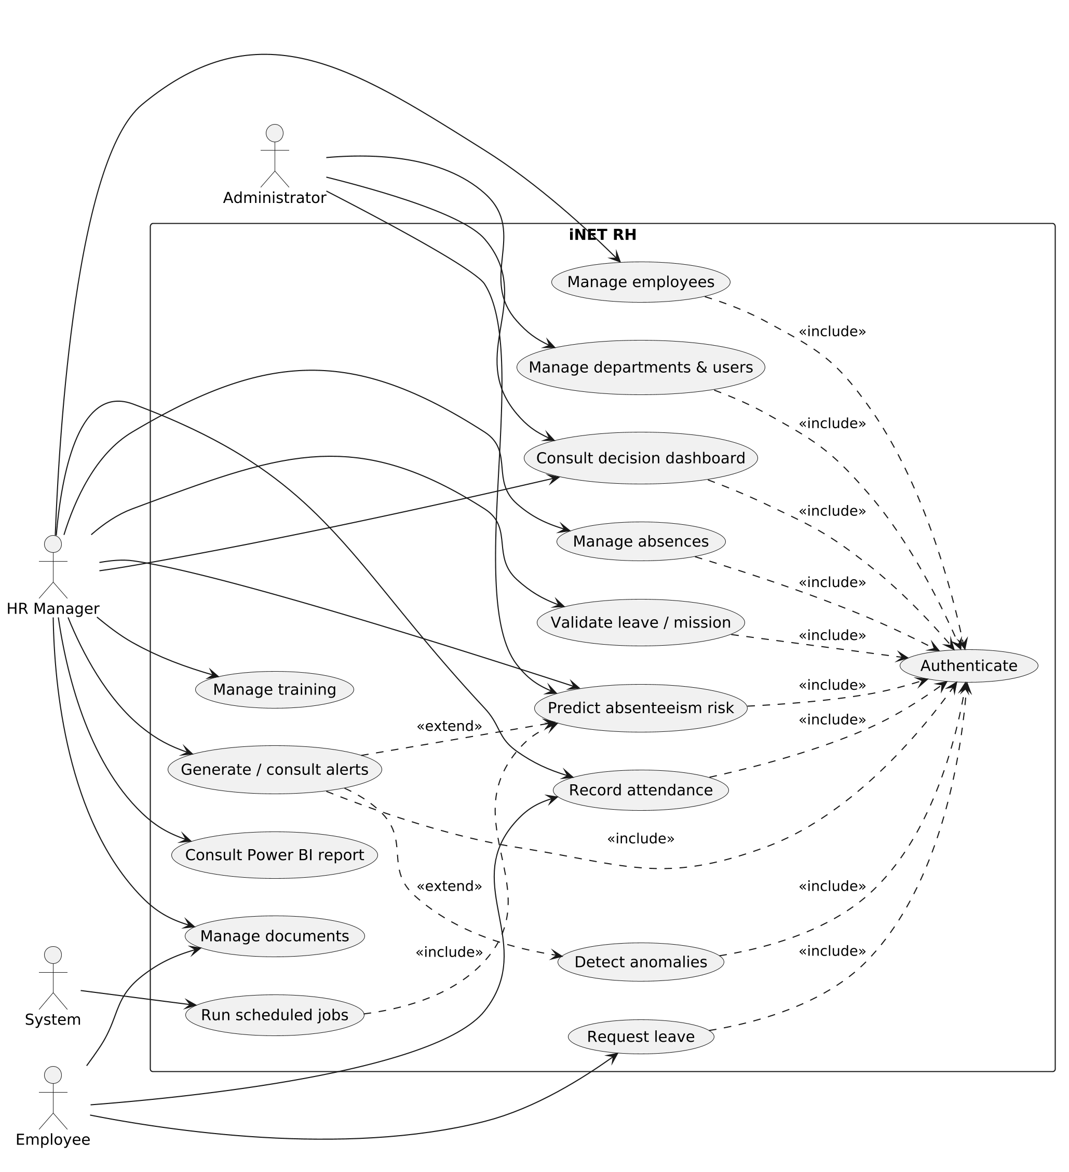
Figure 3.2 — Global use-case diagram of iNET RH
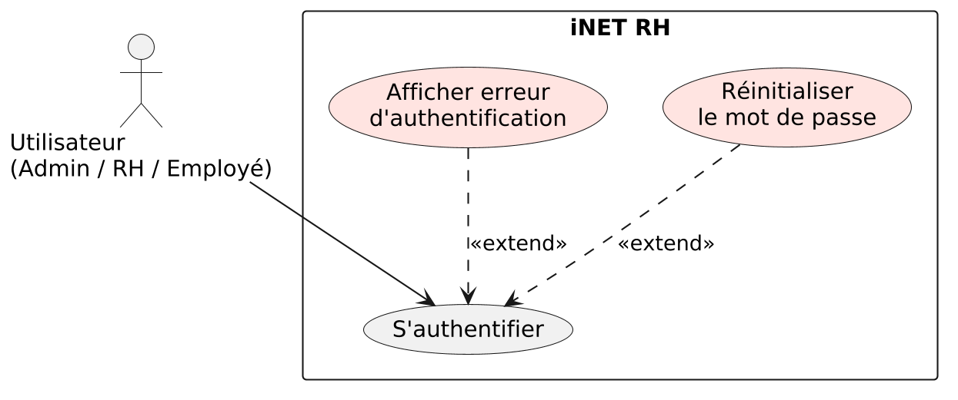
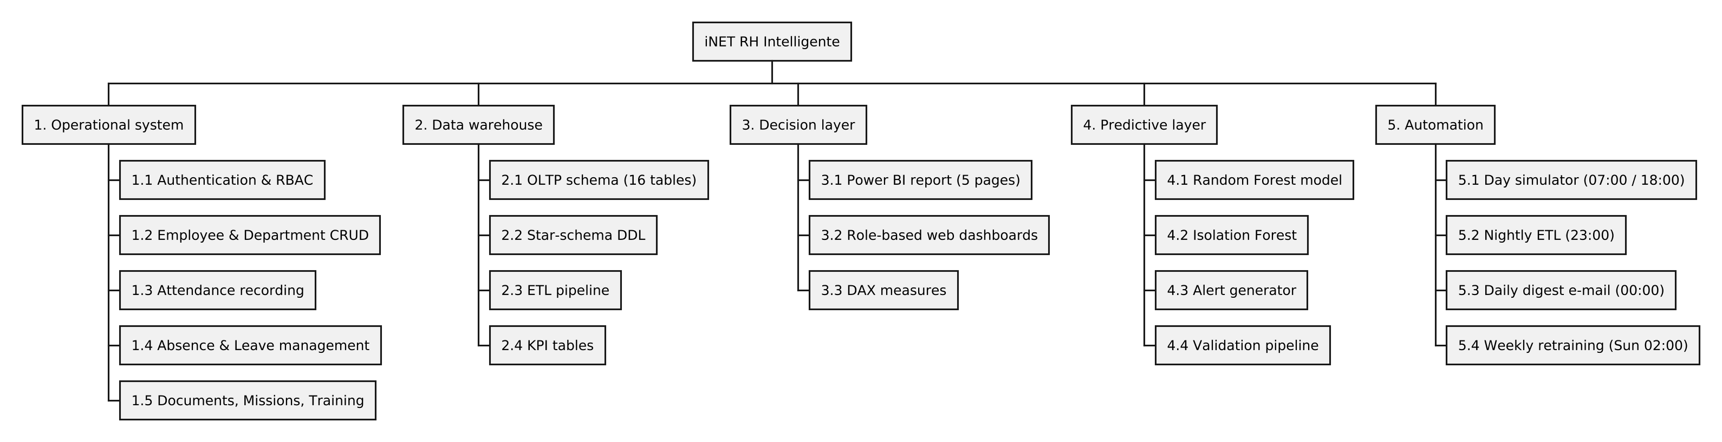
Figure 3.3 — Use case: authenticate
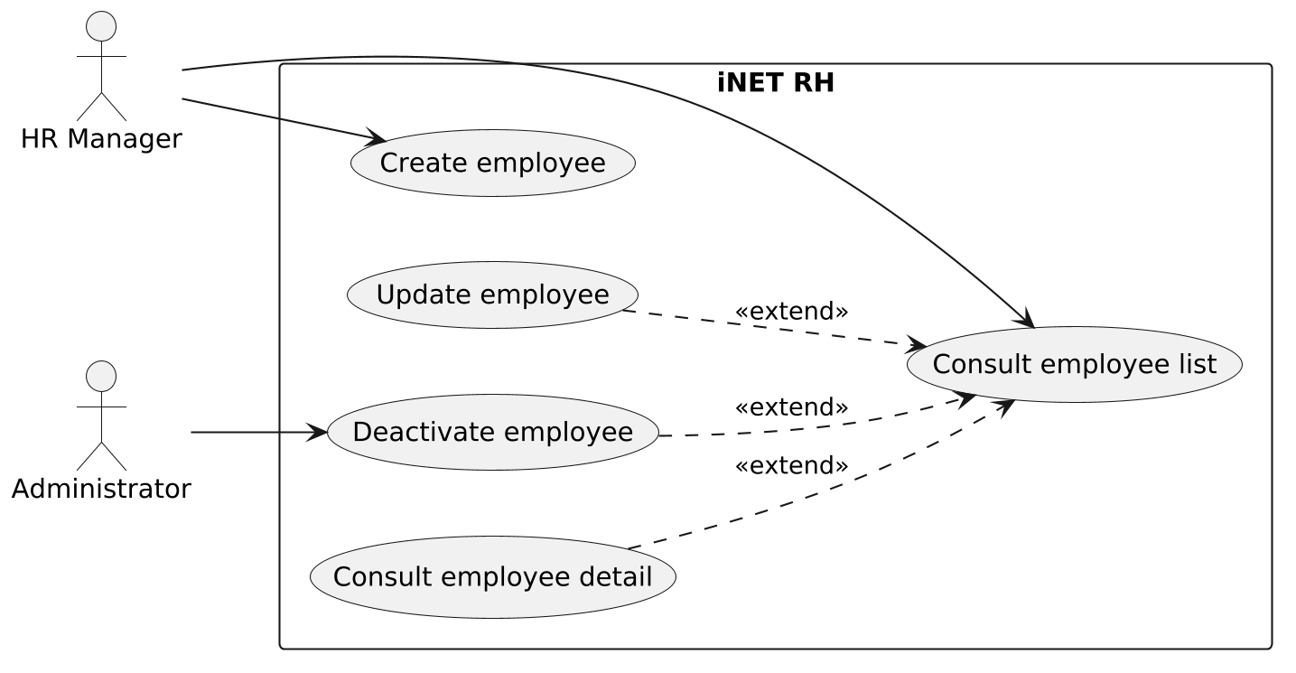
Figure 3.4 — Use case: manage employees
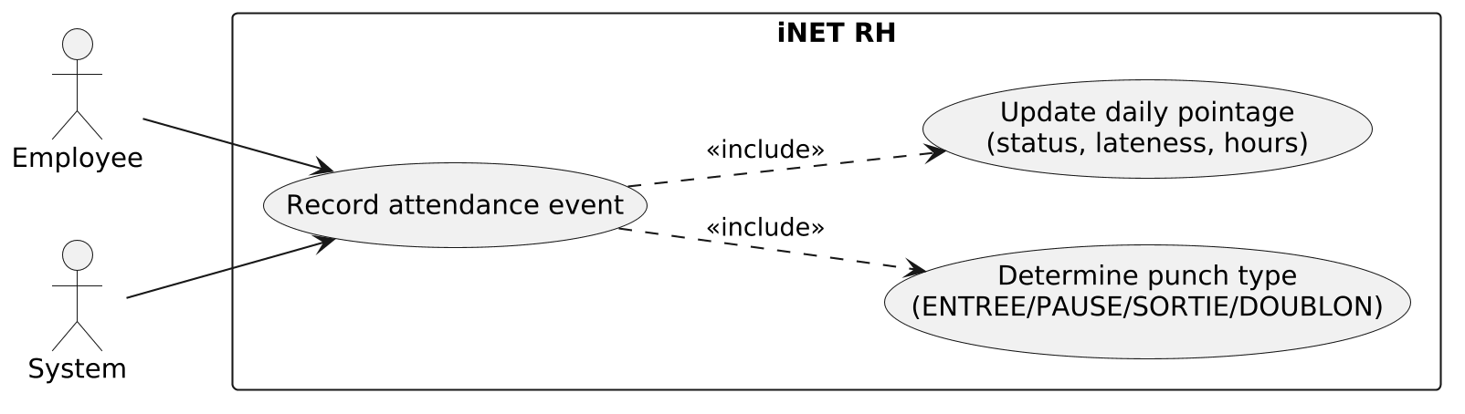
Figure 3.5 — Use case: record attendance
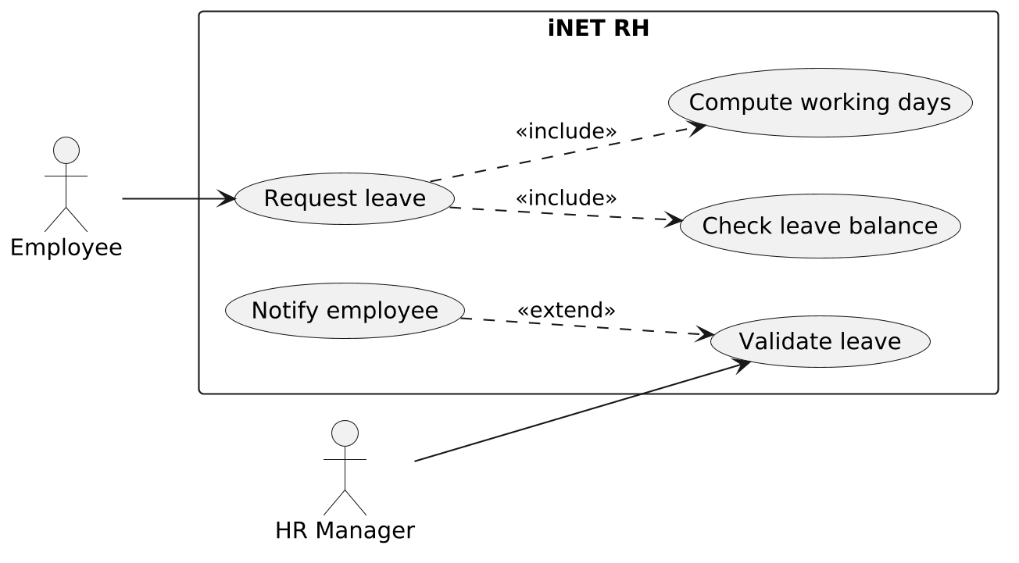
Figure 3.6 — Use case: leave

3.7. Class diagram
The static structure of the back-end mirrors the operational schema: each ORM model maps one table, the Employe class is the hub, and the service classes operate on these models through the repositories. The class diagram below shows the persistent entities, their main attributes, and their associations (1:1 between Employe and Utilisateur and SoldeConge; 1:N between Employe and Pointage, Absence, Conge, Mission, Document, AlerteIA; N:1 between Employe and Departement; the N:N between Employe and Formation resolved by PresenceFormation).
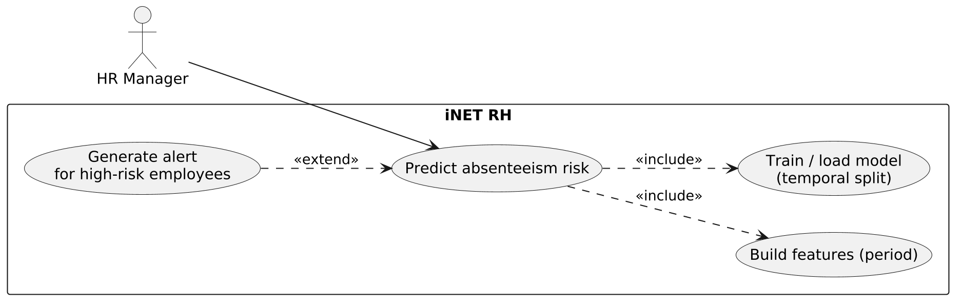
Figure 3.7 — Class diagram of iNET RH

3.8. Organigramme des tâches
The use cases above describe what the system does; the work-breakdown structure below describes how the project was decomposed into deliverable layers and packages. The hierarchy is intentionally aligned with the four-layer Business Intelligence chain (operational system, data warehouse, decision layer, predictive layer) plus the cross-cutting automation layer that orchestrates the rest, and the leaves of the tree map one-to-one onto the modules and cron jobs implemented in Chapter 4.
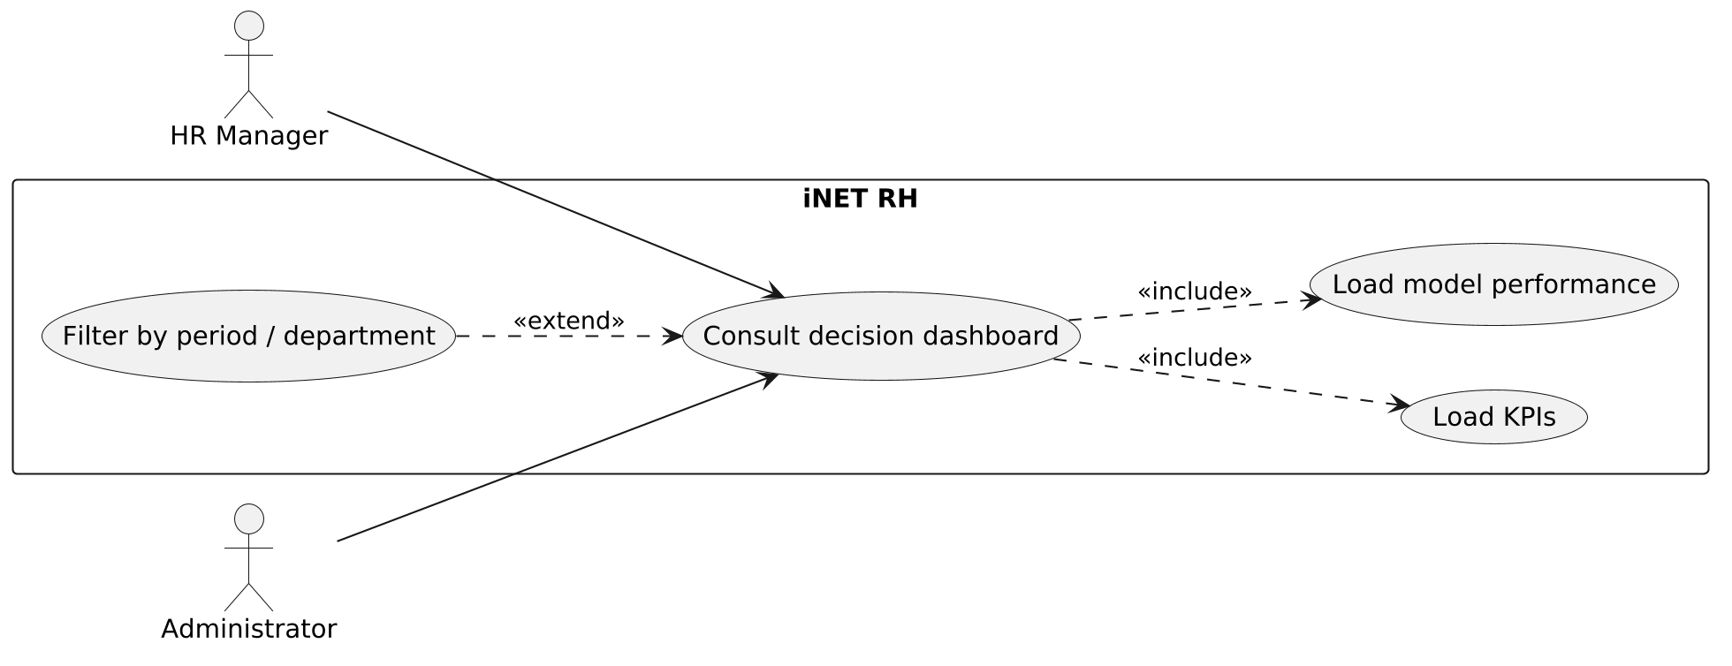
Figure 3.8 — Work-breakdown structure (organigramme des tâches) of iNET RH

3.9. Gestion de projet — Diagramme de Gantt
The internship period was distributed over the five sprints described above. The following Gantt-style planning summarises the sequencing: framing first, then the operational core, then the HR processes, then the Business Intelligence layer, and finally the predictive layer and the automation, with the report writing carried out in parallel during the second half of the period.
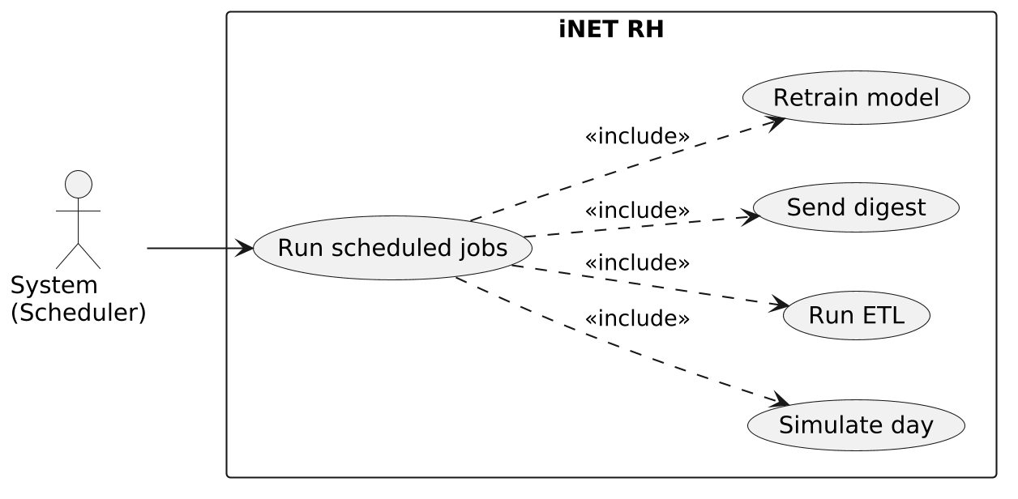
Figure 3.9 — Project planning (Gantt chart of the sprints)

3.10. Development environment
Environment set up during Sprint 0 (framing).

3.10.1. Hardware environment
The project was developed on a personal laptop with an Intel Core i7 processor, 16 GB of RAM, and an SSD. This configuration was sufficient because the database, the API, the scheduler, and the front-end all run locally during development, and because the machine-learning models used (Random Forest, Isolation Forest) are light enough to train in seconds on the volume involved.

3.10.2. Software environment
The software stack was chosen for coherence: a single language family on the back-end and analytics side (Python), a typed modern front-end, and a database that integrates natively with the analytics tool.
Table 3.3 — Software stack and justification
Tool | Role in the project | Reason for the choice
Python 3 | Back-end, ETL, machine learning | One language for the API, the pipeline, and the models
FastAPI + Uvicorn | REST API | Lightweight, typed, automatic validation and documentation
SQLAlchemy | ORM | Isolates the queries in the repository layer
SQL Server | OLTP + data warehouse | Native, efficient connection to Power BI through ODBC
pandas / numpy | Data preparation | Standard for the transformation and feature steps
scikit-learn [6] | Random Forest, Isolation Forest | Reference library for tabular machine learning (Pedregosa et al., 2011)
APScheduler [8] | Job scheduling | In-process cron, no external scheduler needed
Next.js / React / TypeScript | Web front-end | Role-based portals, type safety on the client
Power BI Desktop | Decision report | Interactive BI directly on the SQL Server warehouse
pytest | Unit testing | Fast, database-free regression tests
Visual Studio Code | IDE | Single editor for Python, TypeScript, and SQL

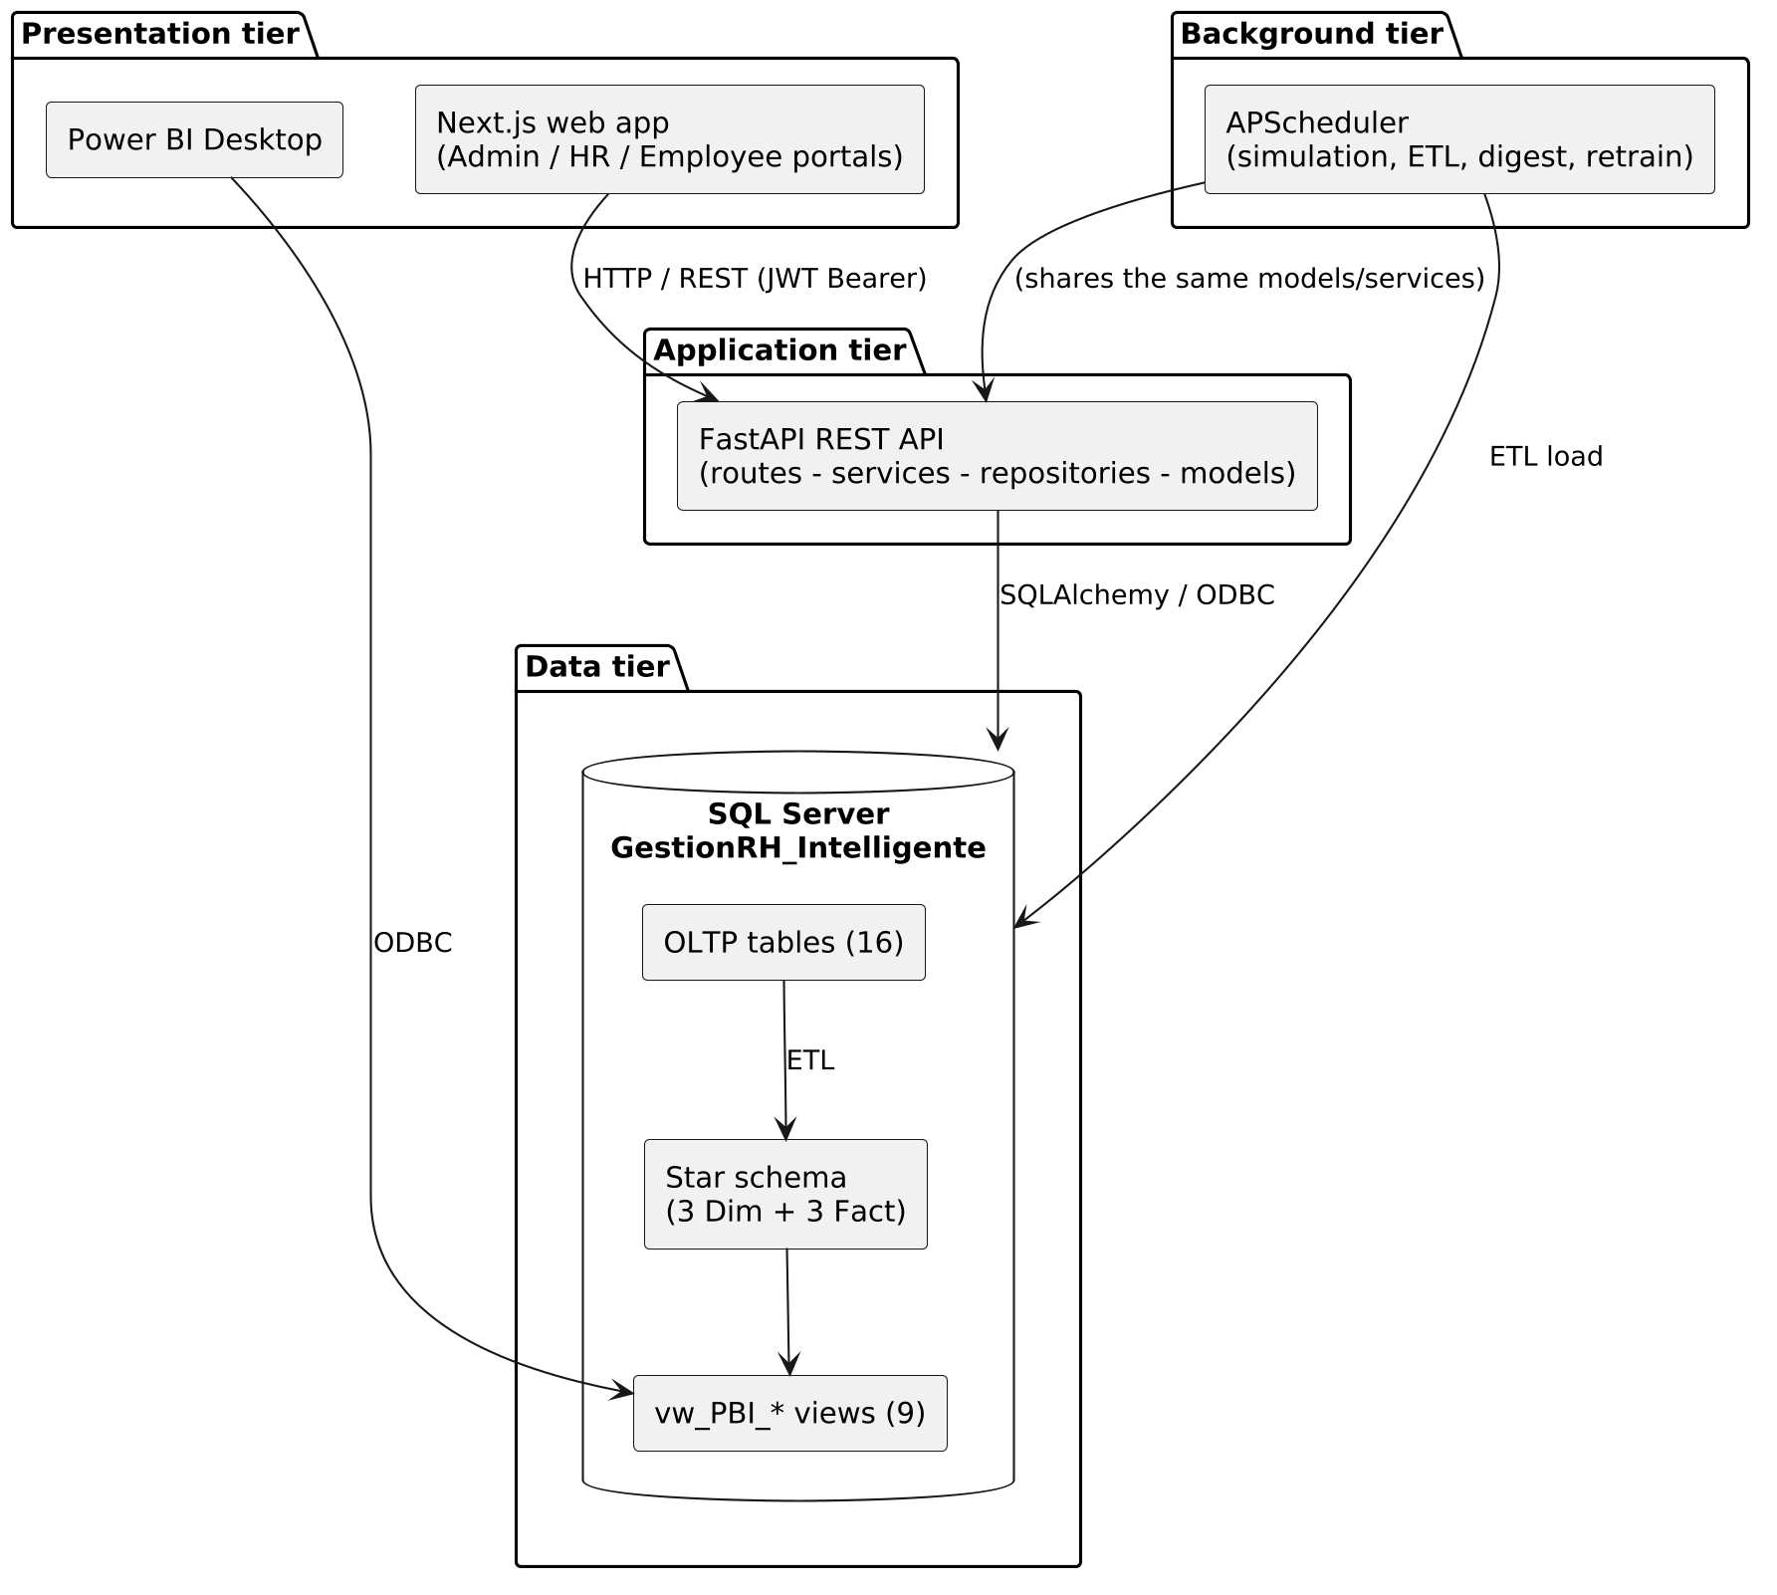
Figure 3.10 — Main tools of the development environment
Figure 3.11 — Deployment
Figure 3.12 — OLTP: er
Figure 3.13 — Star schema
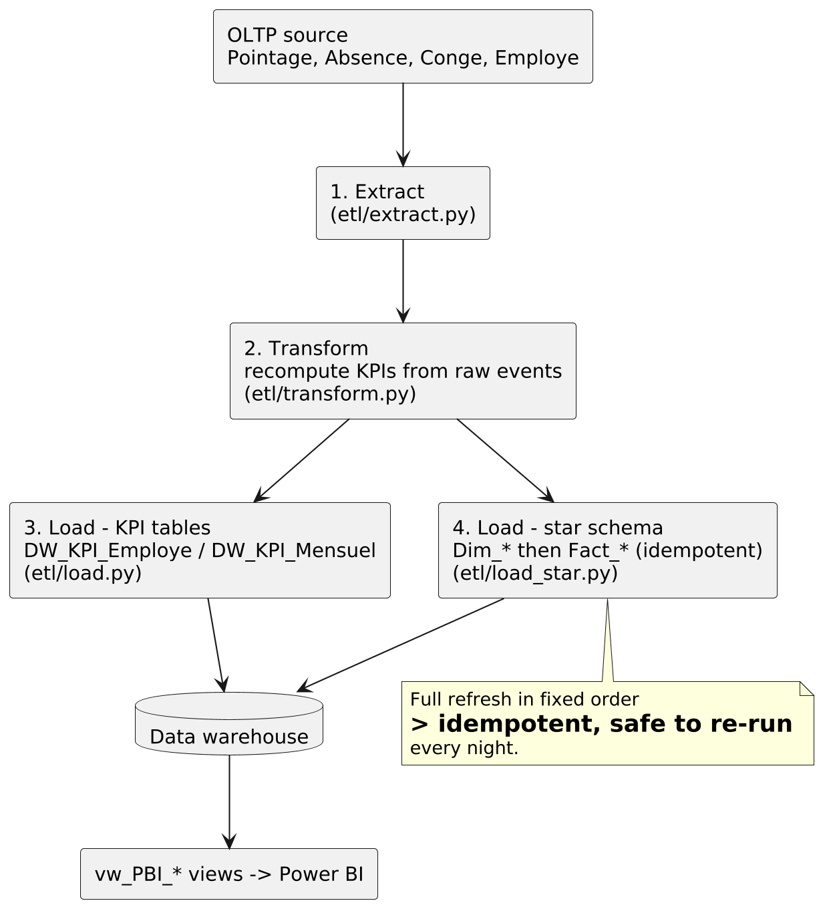
Figure 3.14 — ETL pipeline: flow
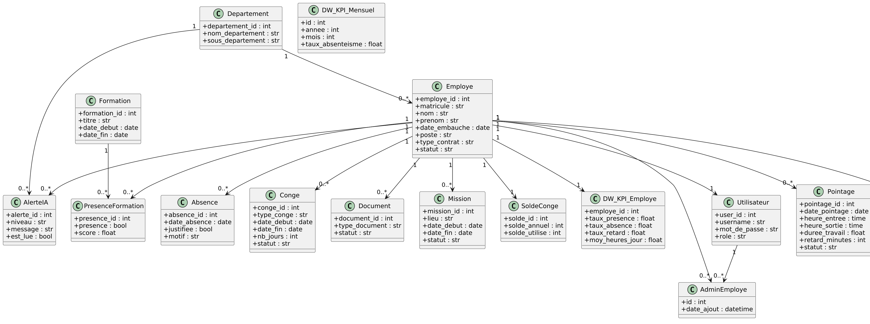
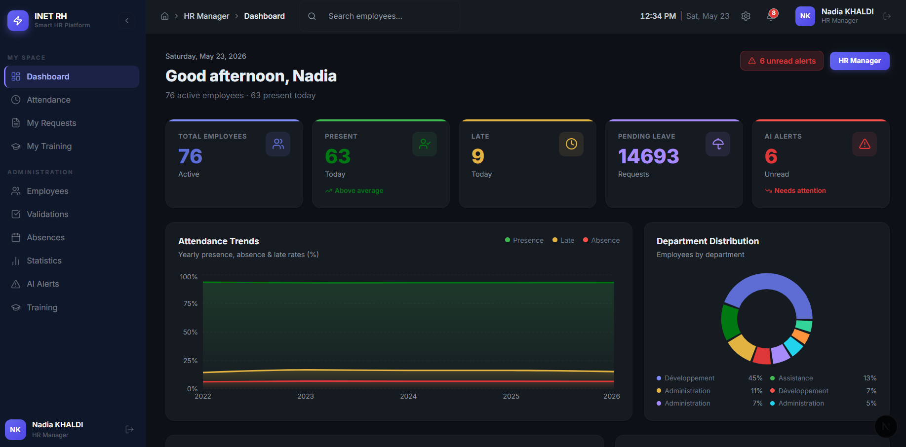
Figure 3.15 — Class diagram
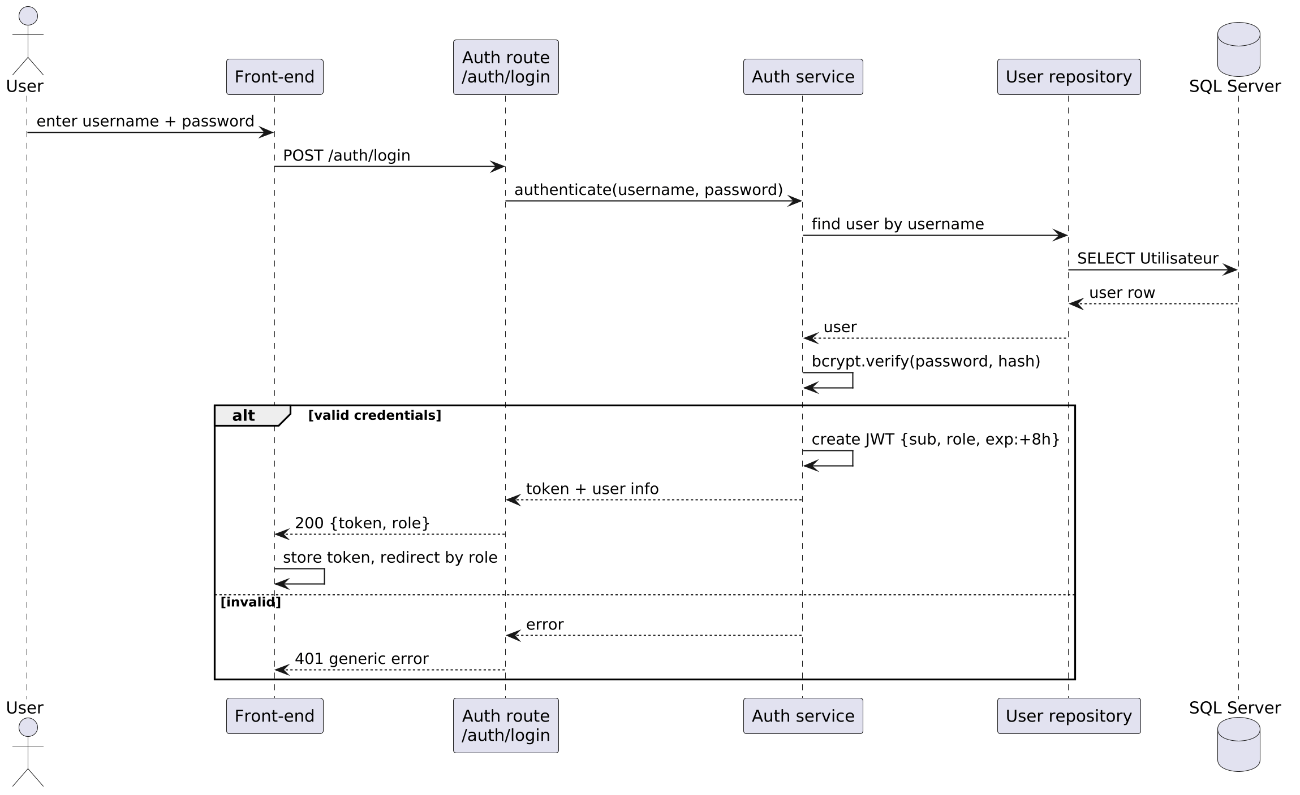
Figure 3.16 — Sequence diagram: auth
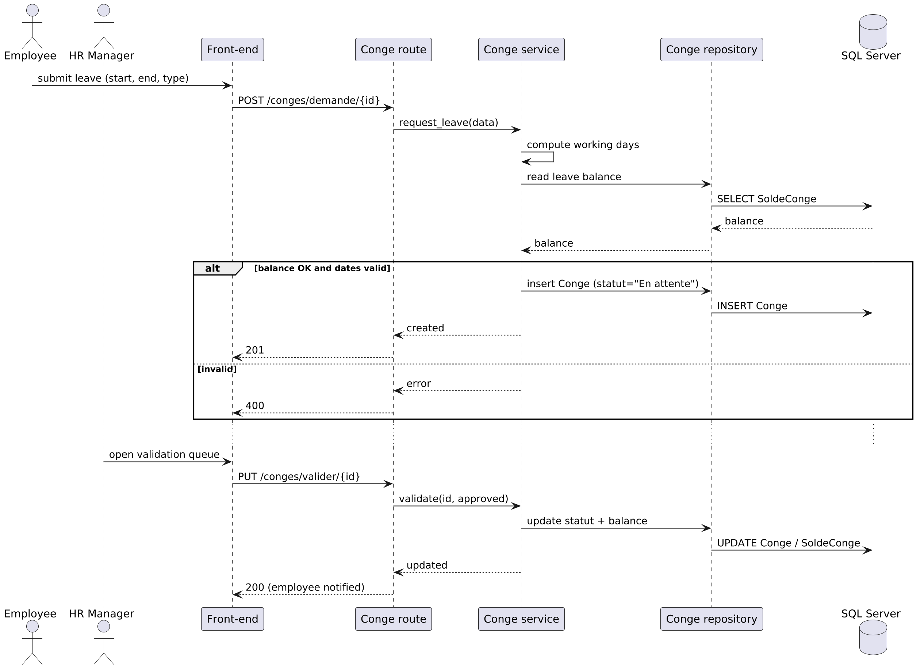
Figure 3.17 — Sequence diagram: leave
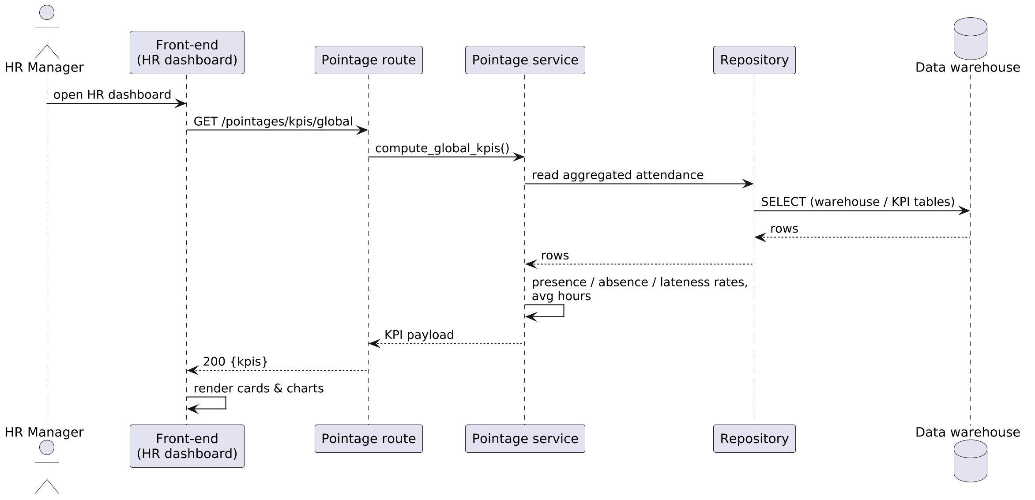
Figure 3.18 — Sequence diagram: kpi
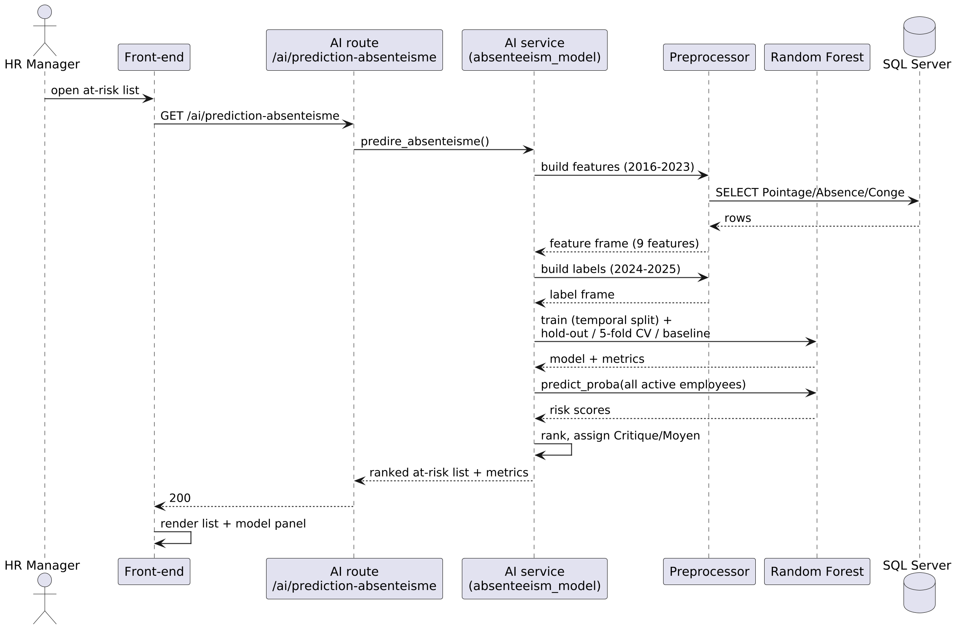
Figure 3.19 — Sequence diagram: prediction
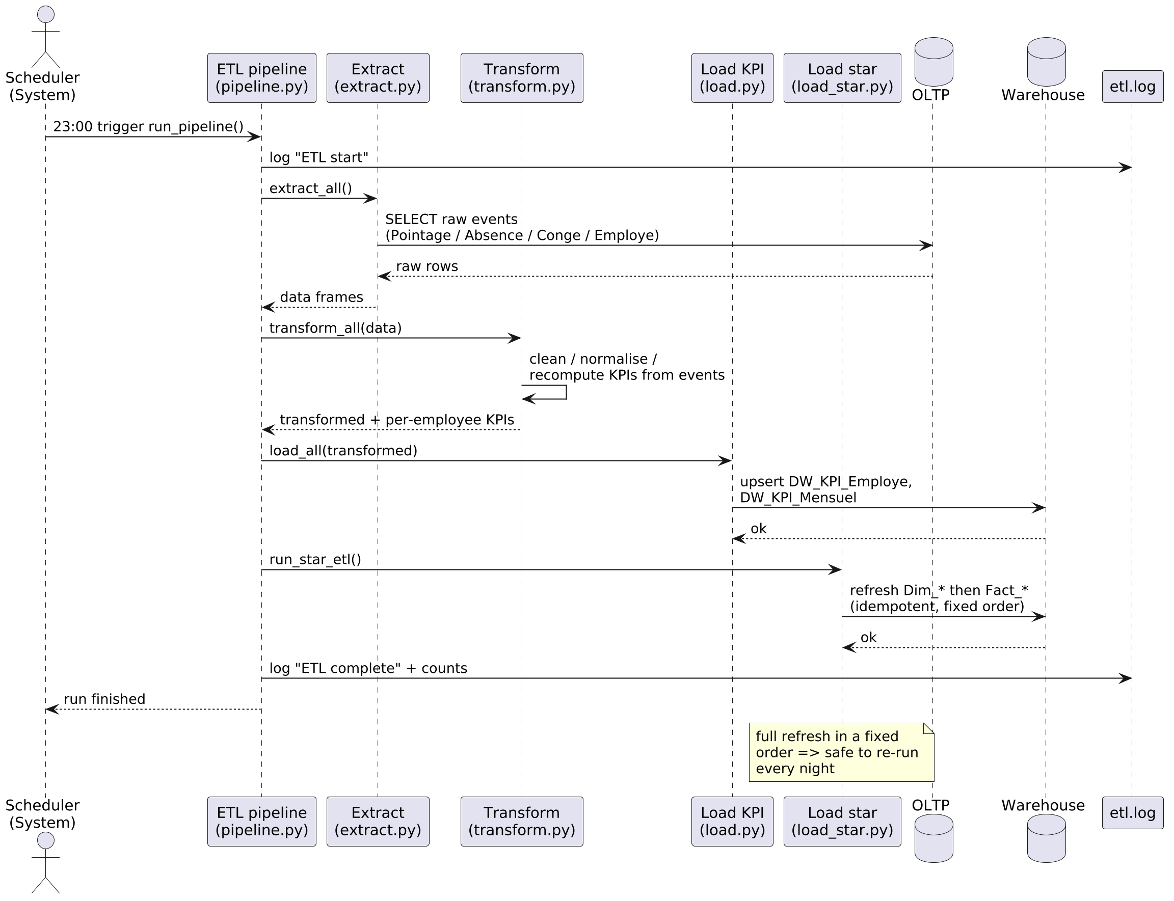
Figure 3.20 — Sequence diagram: etl pipeline
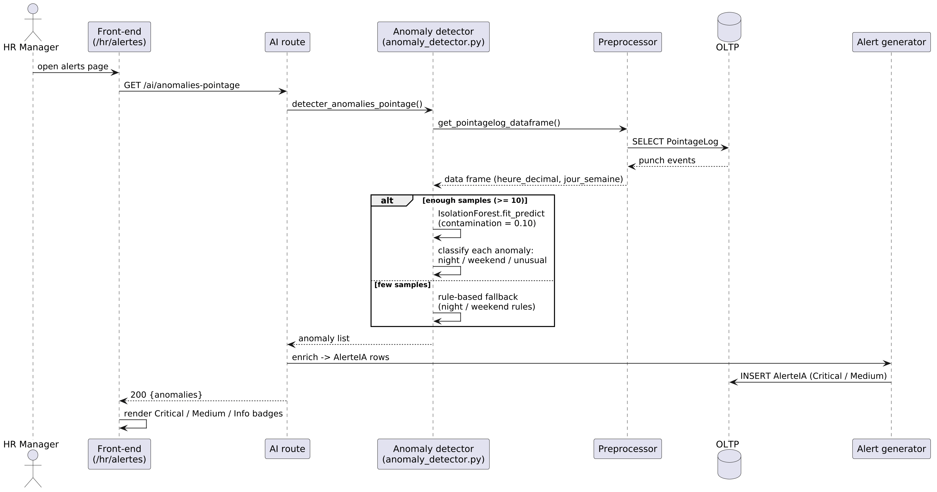
Figure 3.21 — Sequence diagram: anomaly
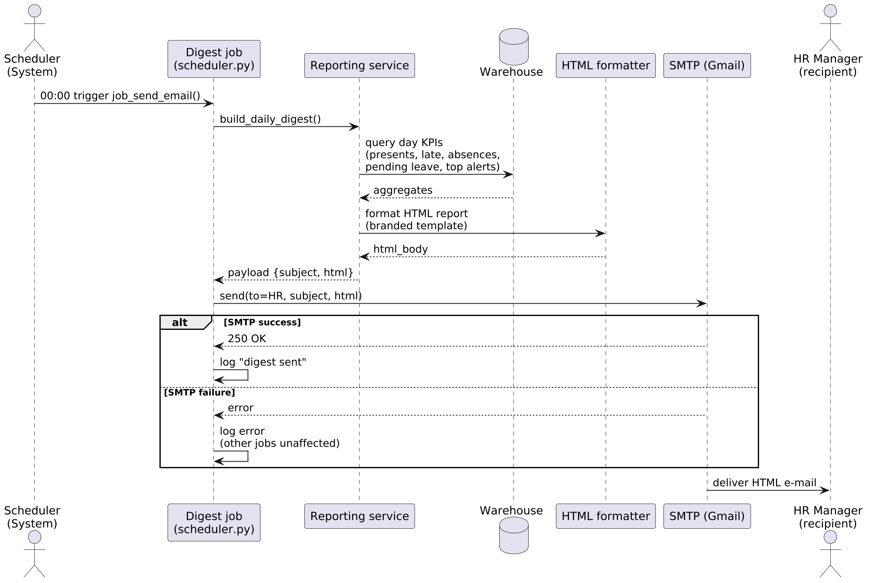
Figure 3.22 — Sequence diagram: digest
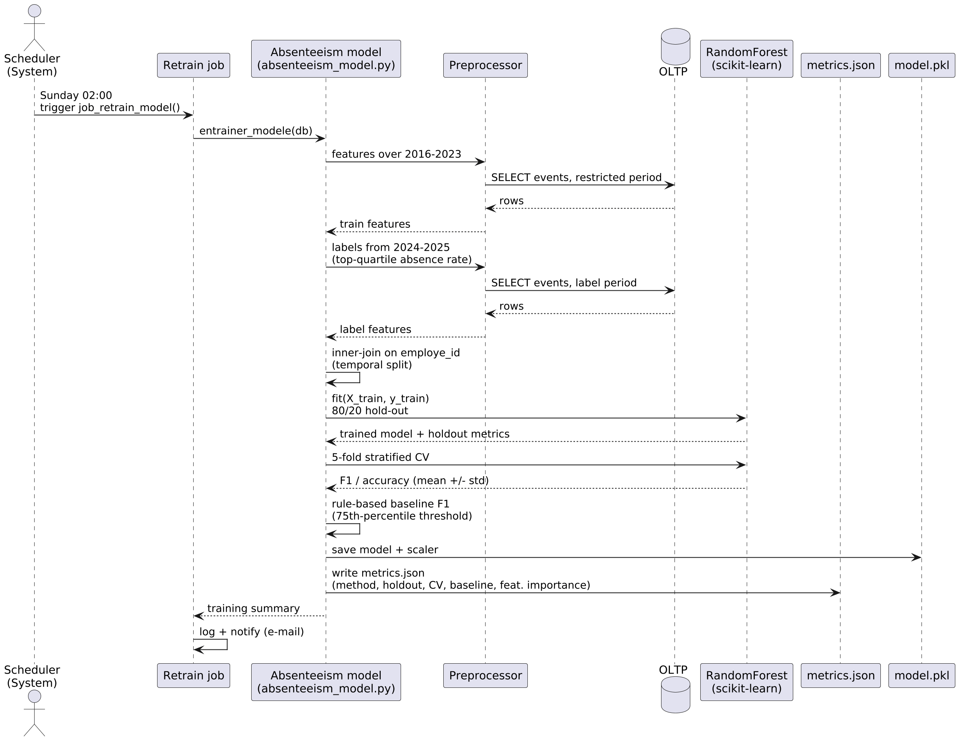
Figure 3.23 — Sequence diagram: retrain
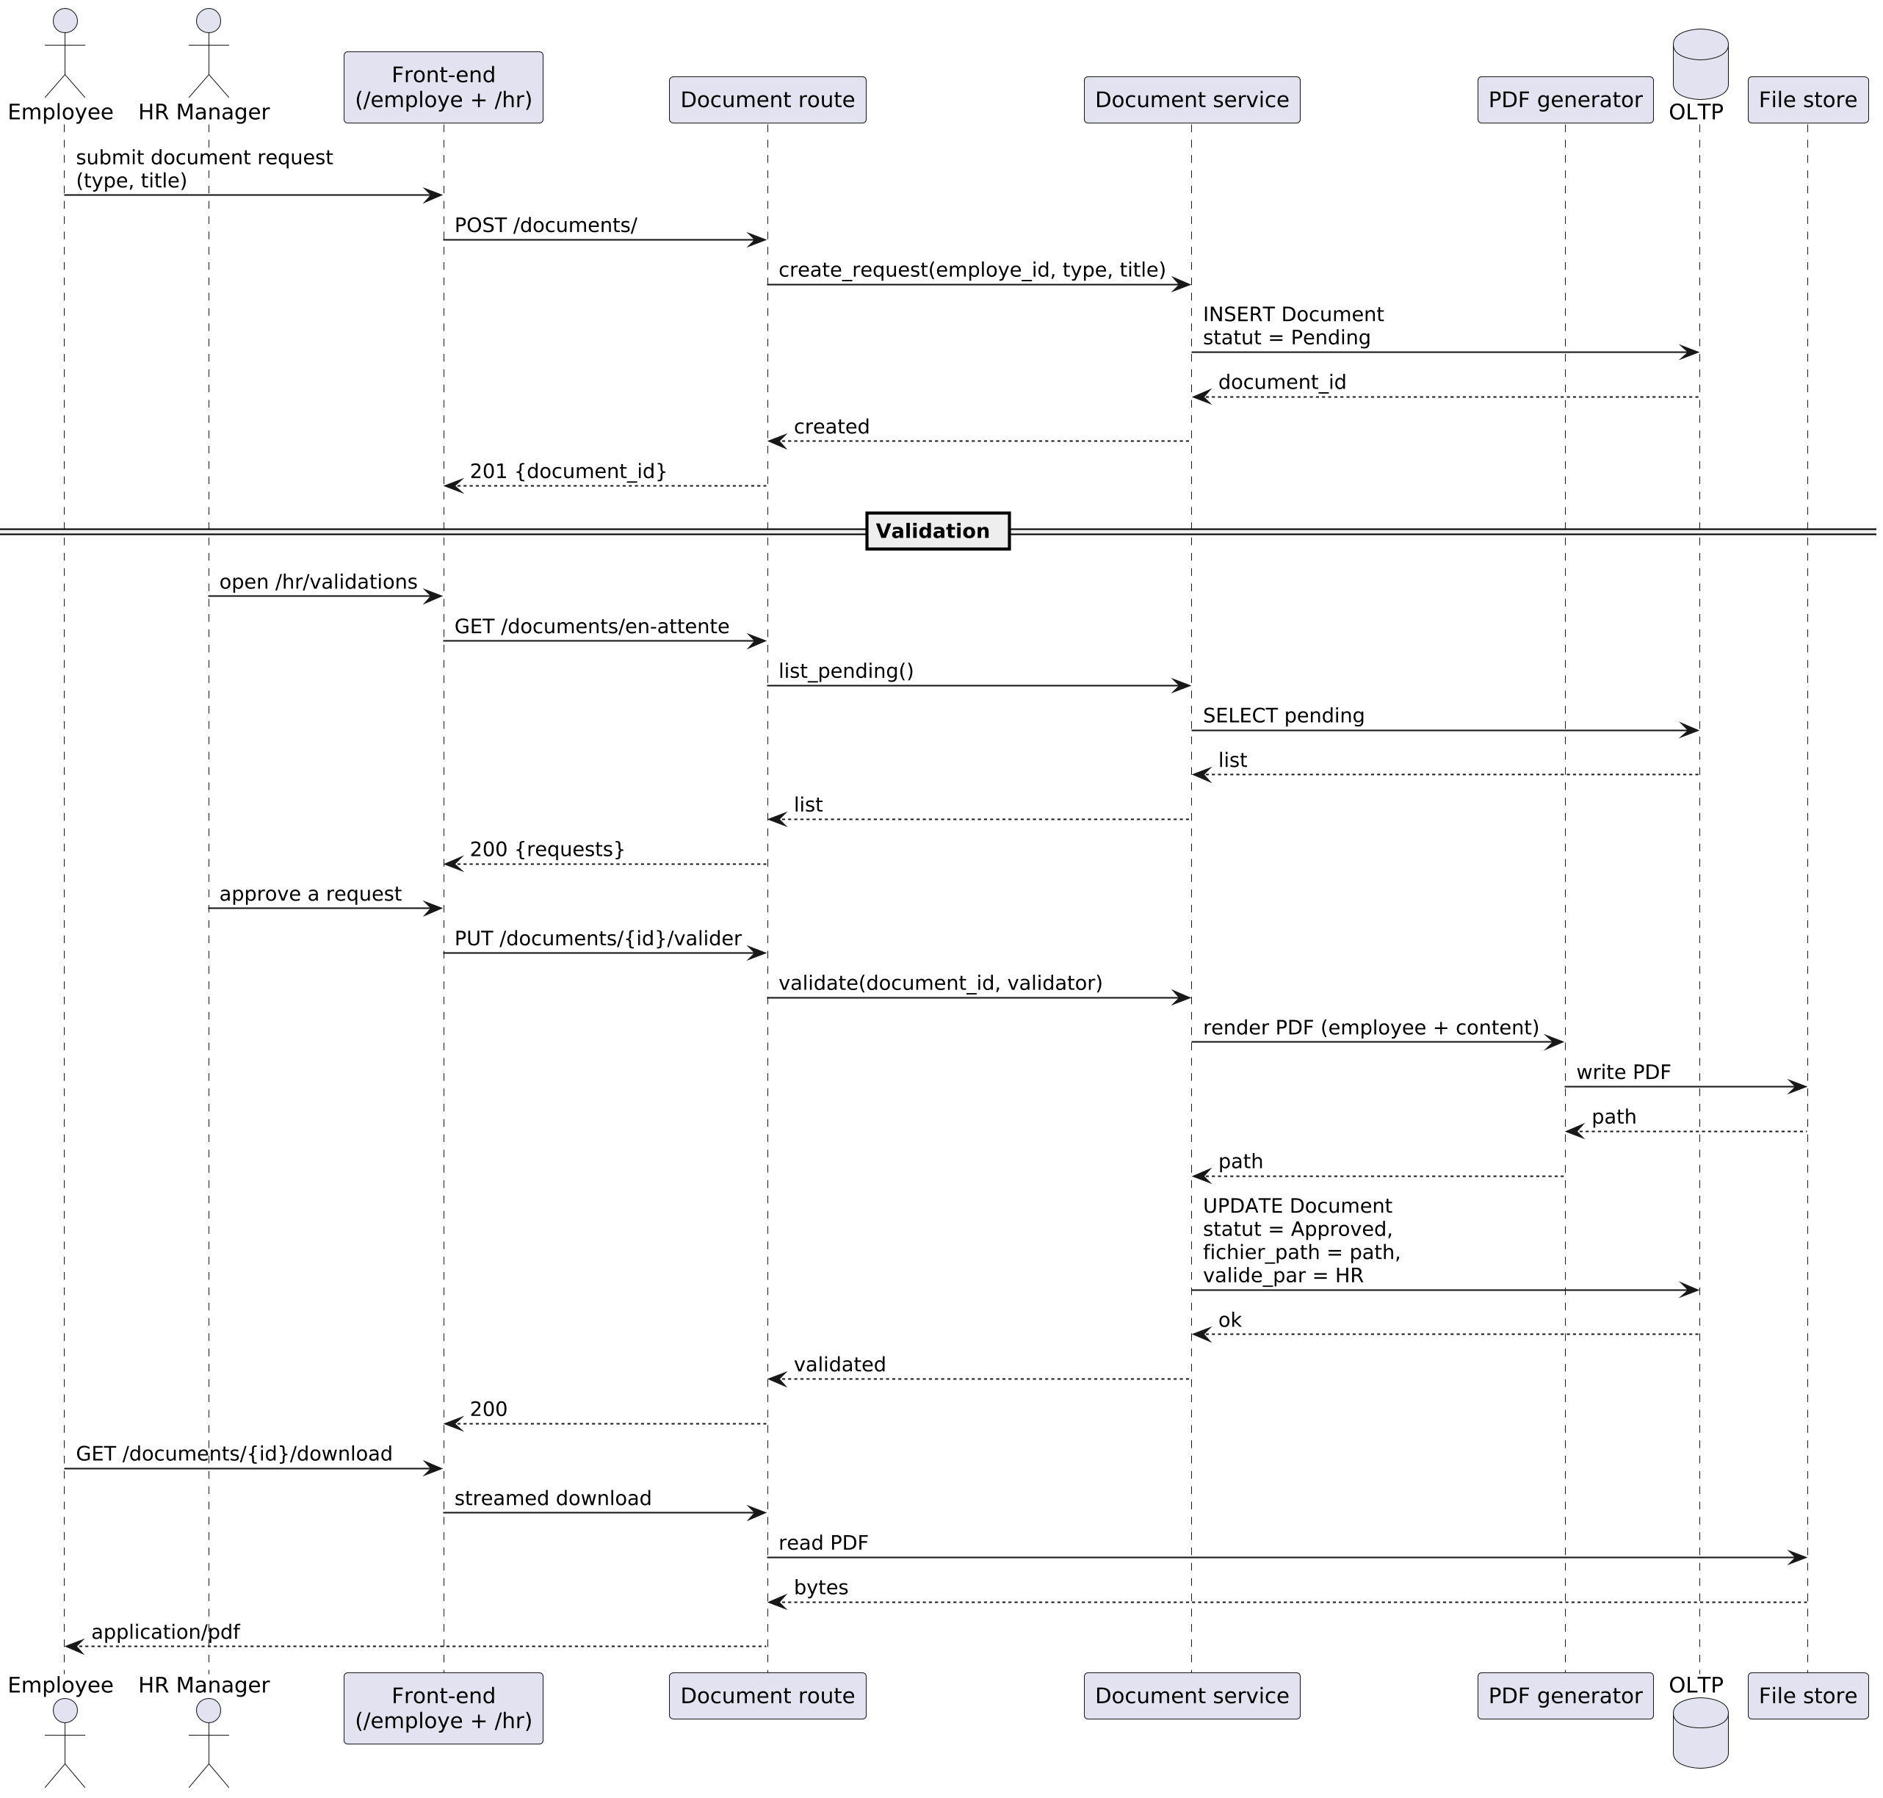
Figure 3.24 — Sequence diagram: document

3.11. Conclusion
Sprint 0 produced the complete specification on which the rest of the project rests: a clear cast of actors, an exhaustive list of functional and non-functional requirements, a prioritised product backlog of fourteen user stories, four complementary diagrams — the global use-case diagram, the global class diagram, the work-breakdown structure and the project Gantt chart — and a fully provisioned development environment. Every one of these artefacts was reviewed with both the academic supervisor and the company supervisor and validated before any code was written. With this foundation in place, the project entered Sprint 1 with no ambiguity left on what to build, who it is for, how the work is decomposed, or when each increment is due.

CHAPTER 4 : SPRINT 1: AUTHENTICATION AND OPERATIONAL CORE

Figure 4.1 — Technology stack logos
Figure 4.2 — Fact_Pointage data sample (SSMS)
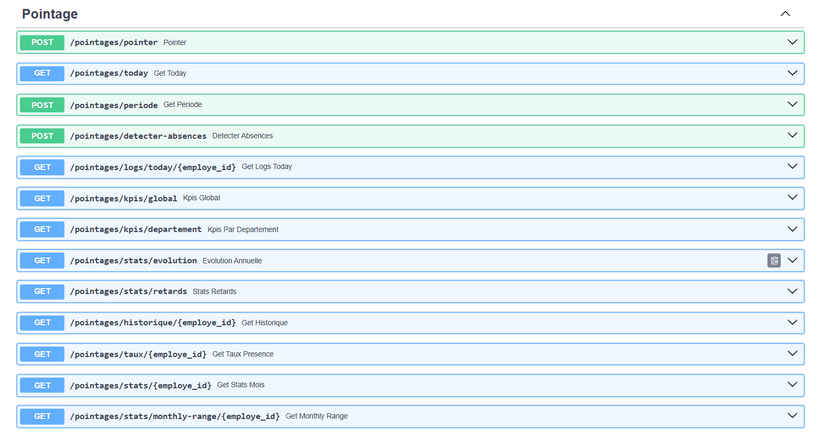
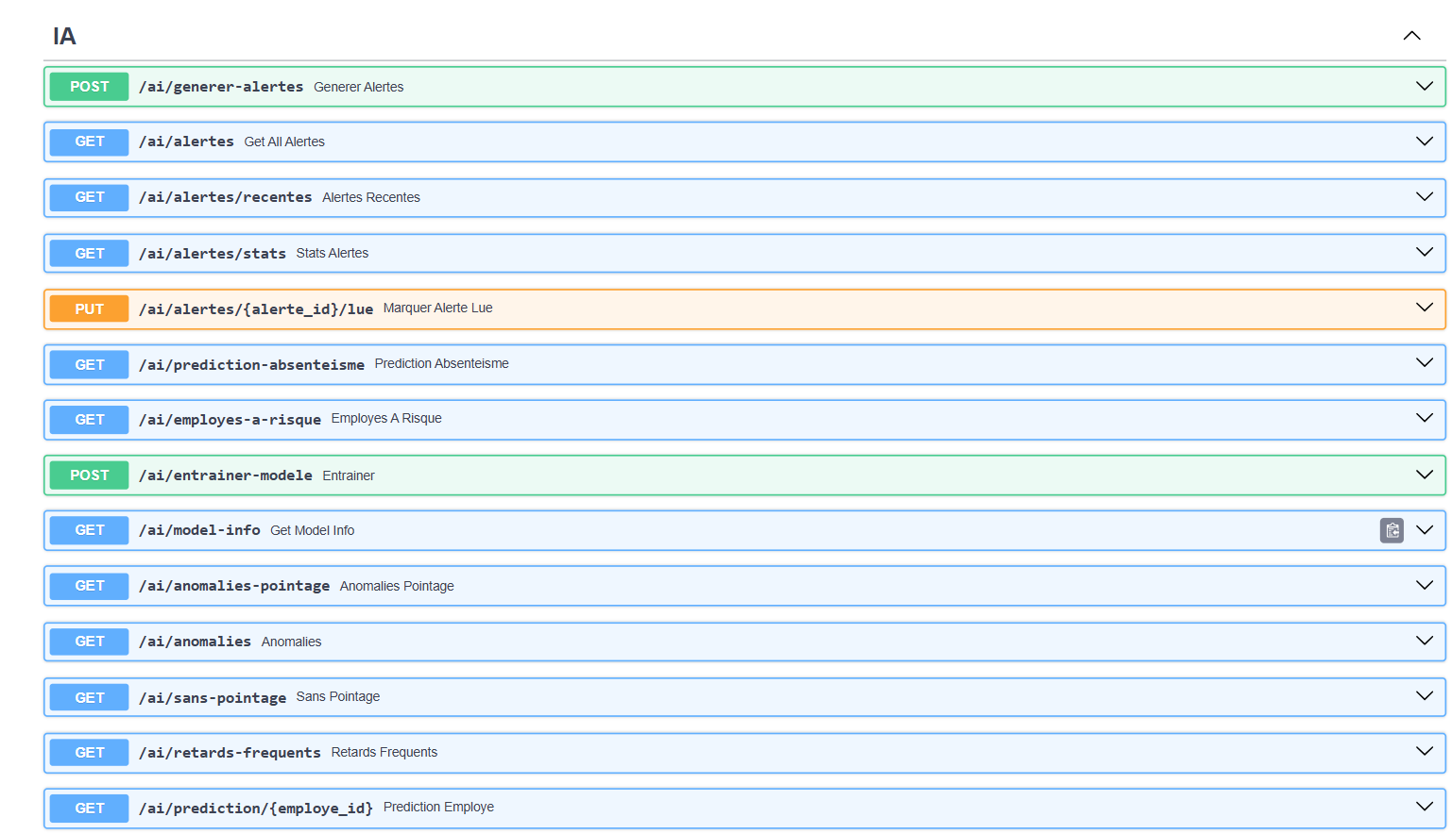
Figure 4.3 — FastAPI interactive documentation
Figure 4.4 — Employee table data sample (SSMS)
Figure 4.5 — Dimension table data sample (SSMS)
Figure 4.6 — Additional interface capture (1)
Figure 4.7 — Additional interface capture (2)
Figure 4.8 — Additional interface capture (3)
Figure 4.9 — Additional interface capture (4)

4.1. Introduction
Sprint 1 was the first delivery sprint of the project: it built the operational foundation on which every later sprint would depend. The scope was deliberately narrow — secure authentication, employee management, and attendance recording — but it covered four of the highest-priority user stories of the backlog, US-01 through US-04. By the end of the sprint, a real HR manager could log in, manage the workforce, and the system was already capturing the daily punch events that the analytical layer would later consume.

4.2. Sprint backlog
The four user stories pulled from the product backlog into Sprint 1 are the four "must-have" stories: they form the irreducible minimum of an HR information system.
Table 4.2 — Sprint 1 backlog
ID | Functionality | User story | Priority | Sprint
US-01 | Authentication | As a user, I want to log in securely so that I can access my space according to my role. | 1 (Must) | 1
US-02 | Employee management | As an HR manager, I want to create, update, and deactivate employees so that the workforce data stays accurate. | 1 (Must) | 1
US-03 | Department & user management | As an administrator, I want to manage departments and user accounts so that the organisation and access rights stay correct. | 1 (Must) | 1
US-04 | Attendance recording | As an employee, I want to record my entry and exit so that my working time is tracked. | 1 (Must) | 1

4.3. Sprint use-case diagram
The Sprint 1 use-case diagram restricts the global model of Chapter 2 to the four stories pulled into this sprint. It shows the three human actors of the operational core and the use cases through which they feed and read the operational data, with Authenticate as an <<include>> of every protected use case.
Figure 4.10 — Use-case diagram of Sprint 1

4.4. Sprint analysis — Use-case refinements

4.4.1. Refinement: "Authenticate"
Figure 4.11 — Refinement of the use case "Authenticate"
Table 4.3 — Explanatory table: "Authenticate"
Element | Actor | Functional description
Authenticate | User (Admin/HR/Employee) | Connect to the platform with a username and a password.
Verify credentials «include» | System | Look up the user and verify the password against the stored bcrypt hash.
Issue session token «include» | System | Create a signed JWT carrying the user identifier and role, with an 8-hour expiry.
Show authentication error «extend» | System | Display a generic error when the identifier or password is incorrect.

Table 4.4 — Alternative scenarios: "Authenticate"
ID | Scenario | Description
A1 | Wrong credentials | The system shows a generic "incorrect credentials" message without revealing which field failed.
A2 | Disabled account | The system refuses the connection and indicates that the account is disabled.
A3 | Expired token | On a later request, an expired token is rejected and the user is redirected to the login screen.

4.4.2. Refinement: "Manage employees"
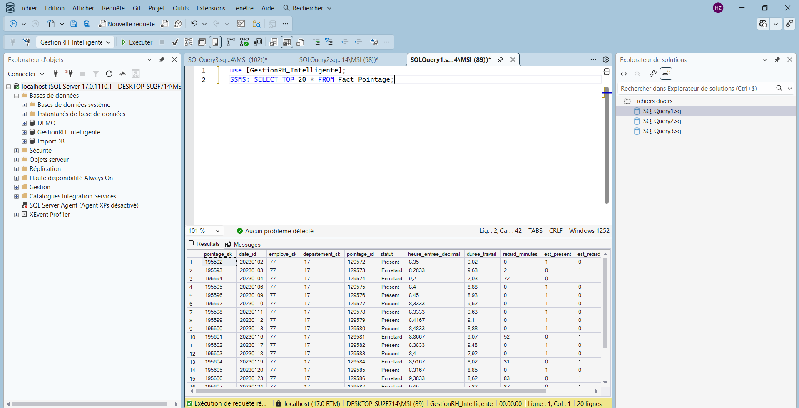
Figure 4.12 — Refinement of the use case "Manage employees"
Table 4.5 — Explanatory table: "Manage employees"
Element | Actor | Functional description
Consult employee list | HR Manager | Display the active workforce with search and filters.
Consult employee detail «extend» | HR Manager | Display the full record of a selected employee.
Create employee | HR Manager | Register a new employee and attach a user account.
Update employee «extend» | HR Manager | Modify an employee's data (post, contract, department, status).
Deactivate employee «extend» | Administrator | Set the employee to inactive (logical deletion preserves history).

Table 4.6 — Alternative scenarios: "Manage employees"
ID | Scenario | Description
A1 | Duplicate matricule | The system rejects creation if the matricule already exists.
A2 | Incomplete data | A required field missing blocks the save with a field-level message.
A3 | Employee not found | Acting on a removed employee returns a not-found message.

4.4.3. Refinement: "Record attendance"
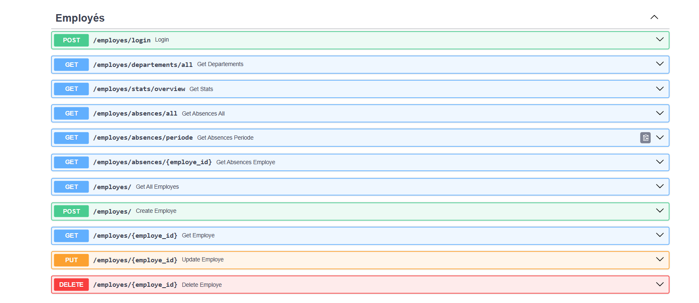
Figure 4.13 — Refinement of the use case "Record attendance"
Table 4.7 — Explanatory table: "Record attendance"
Element | Actor | Functional description
Record attendance event | Employee / System | Register a clock-in/out timestamp for an employee.
Determine punch type «include» | System | Classify the event as ENTREE, DEBUT_PAUSE, FIN_PAUSE, SORTIE, or DOUBLON from the existing logs of the day.
Update daily pointage «include» | System | Recompute the day's status, lateness minutes, and worked duration.

Table 4.8 — Alternative scenarios: "Record attendance"
ID | Scenario | Description
A1 | Duplicate punch | A second event within two minutes is classified DOUBLON and ignored.
A2 | Missing exit | A day with an entry but no exit is marked "Missing exit".
A3 | Late entry | An entry after the expected time produces a "Late" status and a positive lateness.

4.5. Sprint design

4.5.1. Static conception

4.5.1.1. Global architecture
The system follows a layered, client–server architecture organised in four tiers, which mirrors the Business Intelligence chain defined in Chapter 2.
- Presentation tier — the Next.js [4] web application (three role-based portals) and Power BI [2] Desktop. It captures user actions and renders the indicators; it holds no business logic.
- Application tier — the FastAPI [1] back-end. It authenticates requests, enforces roles, applies the business rules, and exposes a REST API.
- Data tier — a single SQL Server [3] database holding both the normalised OLTP tables and the dimensional warehouse, plus the analytical views consumed by Power BI [2].
- Background tier — the APScheduler [8] process that drives the autonomous jobs (simulation, ETL, digest, retraining).
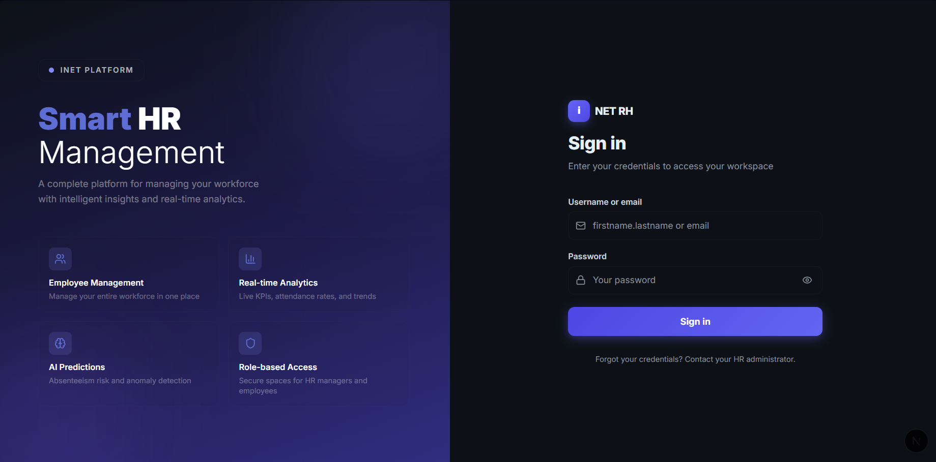
Figure 4.14 — Global four-tier architecture

4.5.1.2. Deployment diagram
The deployment diagram below shows the runtime nodes on which Sprint 1 ran, together with the communication protocols that link them. It anchors the layered architecture into concrete processes and network paths.
Figure 4.15 — Deployment diagram
Table 4.9 — Deployment nodes and communication protocols
Node | Type | Protocol | Description
Browser (Next.js portals) | Client device | HTTPS / REST + JWT | The three role-based web portals consumed by the human actors.
Power BI Desktop | Client device | ODBC | Reads the star schema directly from SQL Server for the analytical report.
FastAPI / Uvicorn | Application server (port 8000) | REST + JWT / ODBC | Hosts the layered API, enforces authentication, and serves the front-end.
APScheduler process | Background service | In-process / ODBC | Runs the five cron jobs (simulation, ETL, digest, retraining).
SQL Server (GestionRH_Intelligente) | Database server | ODBC / TCP | Stores the OLTP schema and the Kimball data warehouse.

4.5.2. Dynamic conception
The dynamic behaviour of Sprint 1 is illustrated by the authentication scenario, which carries the most logic of the sprint and exercises every architectural layer end to end.
Authentication. The front-end posts the credentials; the auth route calls the service, which fetches the user through the repository, verifies the bcrypt hash, and returns a signed JWT [5]; the front-end stores the token and redirects according to the role.
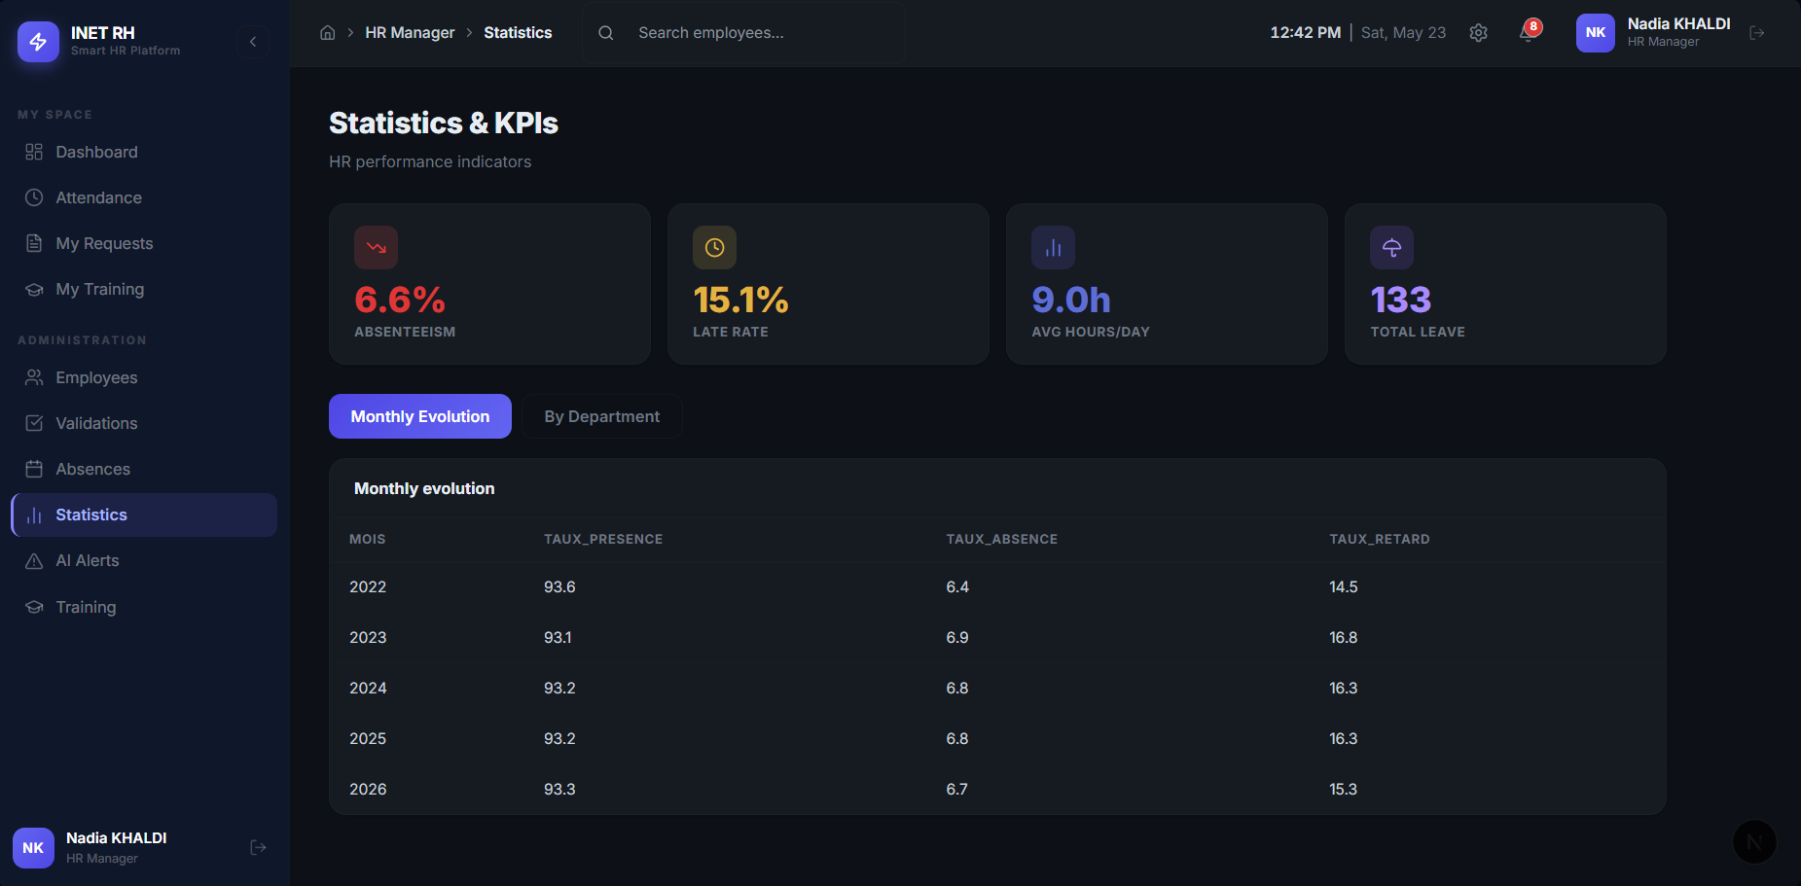
Figure 4.16 — Sequence diagram: authentication

4.6. Sprint realization

4.6.1. Database
Sprint 1 created the three operational tables on which the rest of the project rests: Employe holds the workforce master data, Utilisateur carries the account and the role attached to an employee, and Pointage stores the processed daily attendance.
Table 4.10 — Data dictionary: `Employe`
Column | Type | Description
employe_id | INT (PK) | Unique employee identifier
matricule | VARCHAR(20) | Unique payroll number
nom / prenom | VARCHAR(100) | Last / first name
date_naissance | DATE | Date of birth
sexe | VARCHAR(10) | Gender
adresse_mail | VARCHAR(150) | Unique e-mail
date_embauche | DATE | Hiring date (drives seniority)
poste | VARCHAR(100) | Job title
type_contrat | VARCHAR(50) | CDI / CDD / …
statut | VARCHAR(20) | Active / Inactive
departement_id | INT (FK) | → Departement

Table 4.11 — Data dictionary: `Utilisateur`
Column | Type | Description
user_id | INT (PK) | Unique account identifier
employe_id | INT (FK, unique) | → Employe (1:1)
username | VARCHAR(100) | Unique login
mot_de_passe | VARCHAR(255) | Bcrypt hash
role | VARCHAR(20) | employe / rh / admin

Table 4.12 — Data dictionary: `Pointage`
Column | Type | Description
pointage_id | INT (PK) | Unique record identifier
employe_id | INT (FK) | → Employe
date_pointage | DATE | Day of the record
heure_entree | TIME | Entry time
heure_debut_pause / heure_fin_pause | TIME | Break boundaries
heure_sortie | TIME | Exit time
duree_travail | FLOAT | Hours worked
retard_minutes | INT | Minutes late
statut | VARCHAR(30) | Present / Late / Missing exit

4.6.2. Graphical interfaces
The two screens delivered at the end of Sprint 1 are the login page — the single entry point of the application — and the HR employee-management screen, on which every later HR action depends.
Figure 4.17 — Login interface
Table 4.13 — Interface analysis: Login
Field | Content
Actors | Administrator, HR Manager, Employee
Interface | Single login form
Components | Username field, password field, sign-in button
Functionalities | Credential submission, token storage, role-based redirection
Objective | Open a secured session and route the user to the correct portal

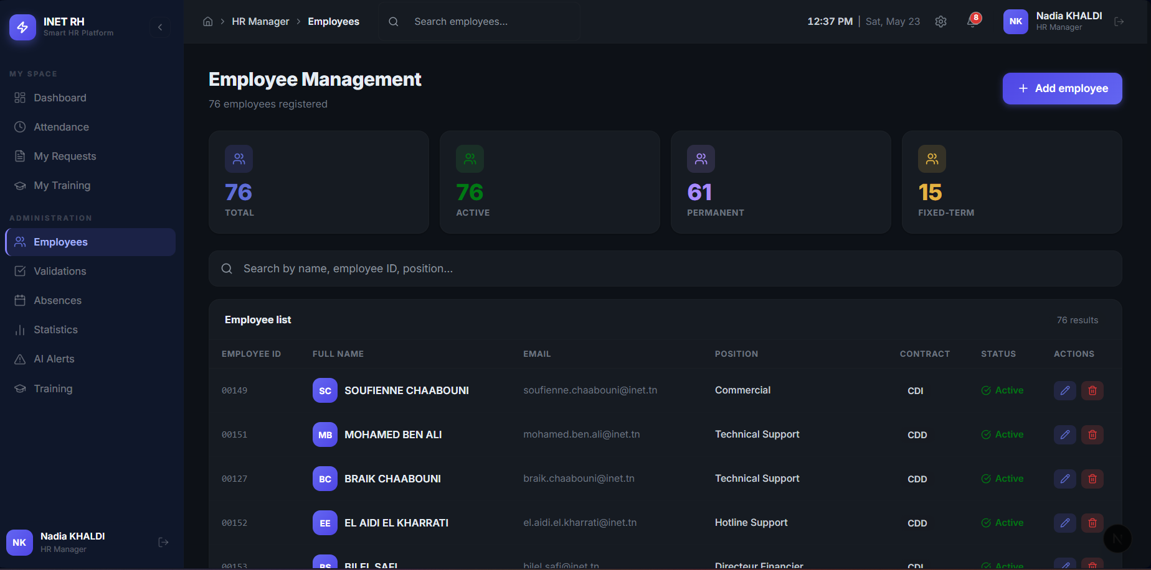
Figure 4.18 — Employee management
Figure 4.19 — Additional interface capture (5)
Table 4.14 — Interface analysis: Employee management
Field | Content
Actors | HR Manager
Interface | Searchable employee table with CRUD
Components | Search, filters, employee list, create/update forms
Functionalities | Create, consult, update, deactivate employees
Objective | Keep the workforce reference data accurate, since every indicator derives from it

4.7. Sprint review
The sprint review exercised every story of the sprint against the acceptance criteria agreed with the Product Owner. Each test case was executed manually in the live application, with the SQL Server logs cross-checked to confirm the database side of the behaviour.
Table 4.15 — Sprint 1 review
Test case | Steps | Expected result | Result
Login with valid credentials | Enter correct username and password | JWT token returned, redirect to role portal | Passed
Login with wrong password | Enter incorrect password | Generic error message, no field revealed | Passed
Expired token | Use a token older than 8 hours | Request rejected, redirect to login | Passed
Create employee | Fill form with valid data | Employee and user account created | Passed
Duplicate matricule | Create employee with existing matricule | Error returned, no duplicate created | Passed
Record entry punch | POST to /pointages | Event classified as ENTREE, daily record created | Passed
Duplicate punch | Send same punch within 2 minutes | Classified as DOUBLON, ignored | Passed

4.8. Sprint retrospective
Sprint 1 delivered the authentication and operational core on schedule. The role-based access control and the JWT token flow worked correctly from first implementation, and the layered architecture defended in §4.5 paid off immediately — every story was added by extending the corresponding routes / services / repositories triple without touching the layers above or below. The main technical challenge was the punch-classification logic — determining whether an event is ENTREE, DEBUT_PAUSE, FIN_PAUSE, SORTIE, or DOUBLON from the existing logs of the day — which required careful state-machine thinking and an extra day of testing before all edge cases (duplicate punches, missing exits, late entries) were covered.

4.9. Conclusion
Sprint 1 closed with a working operational core: a secure authentication flow, a complete employee-management screen, and an attendance pipeline already capturing the events on which the analytical layer will depend. With these three pillars in place, Sprint 2 could start with no infrastructure work left to do — only the HR processes themselves (absences, leaves, missions, training) to add on top.

CHAPTER 5 : SPRINT 2: HR PROCESSES

Figure 5.1 — Interface screenshot 1
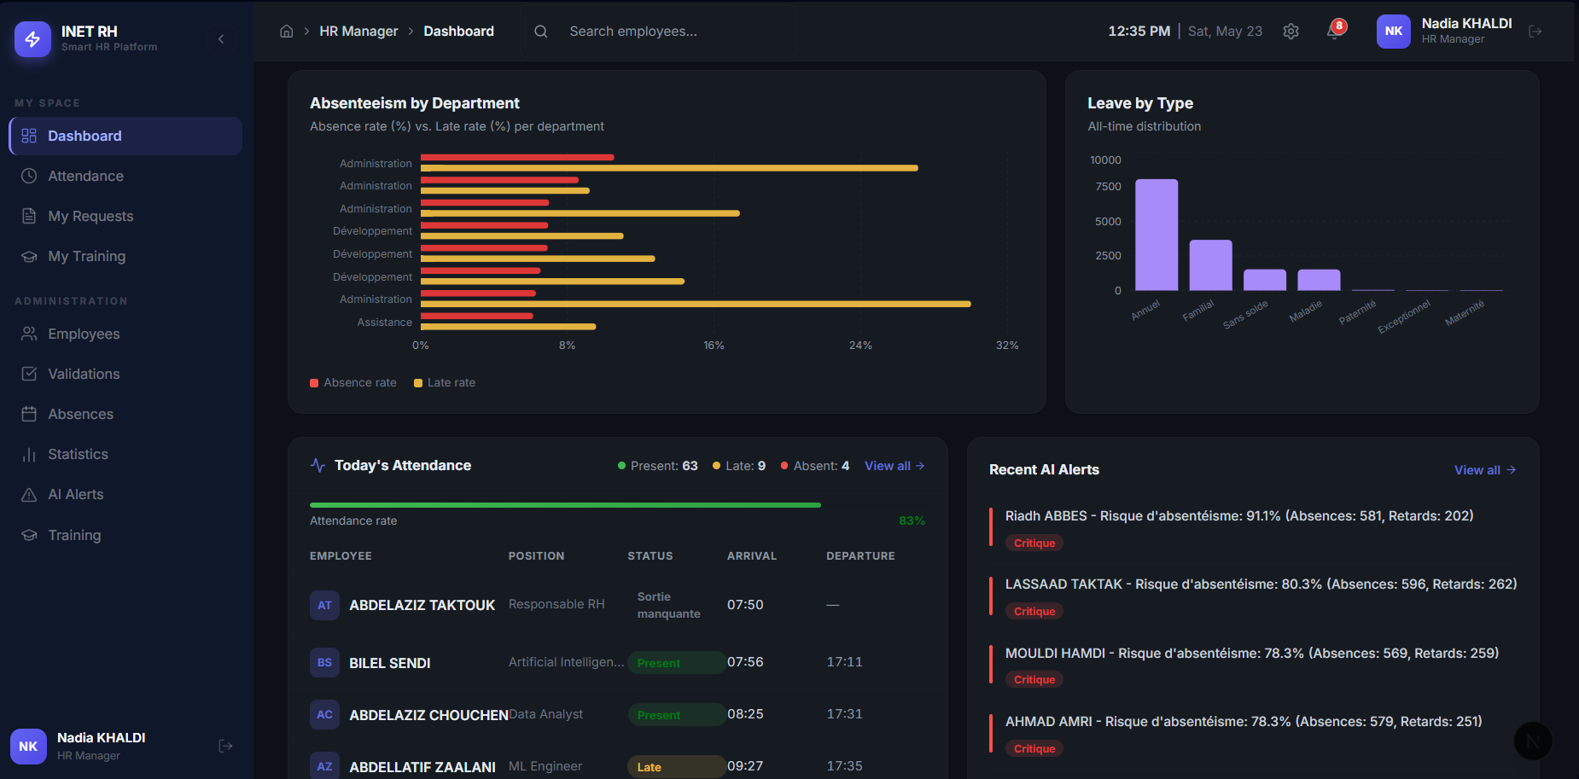
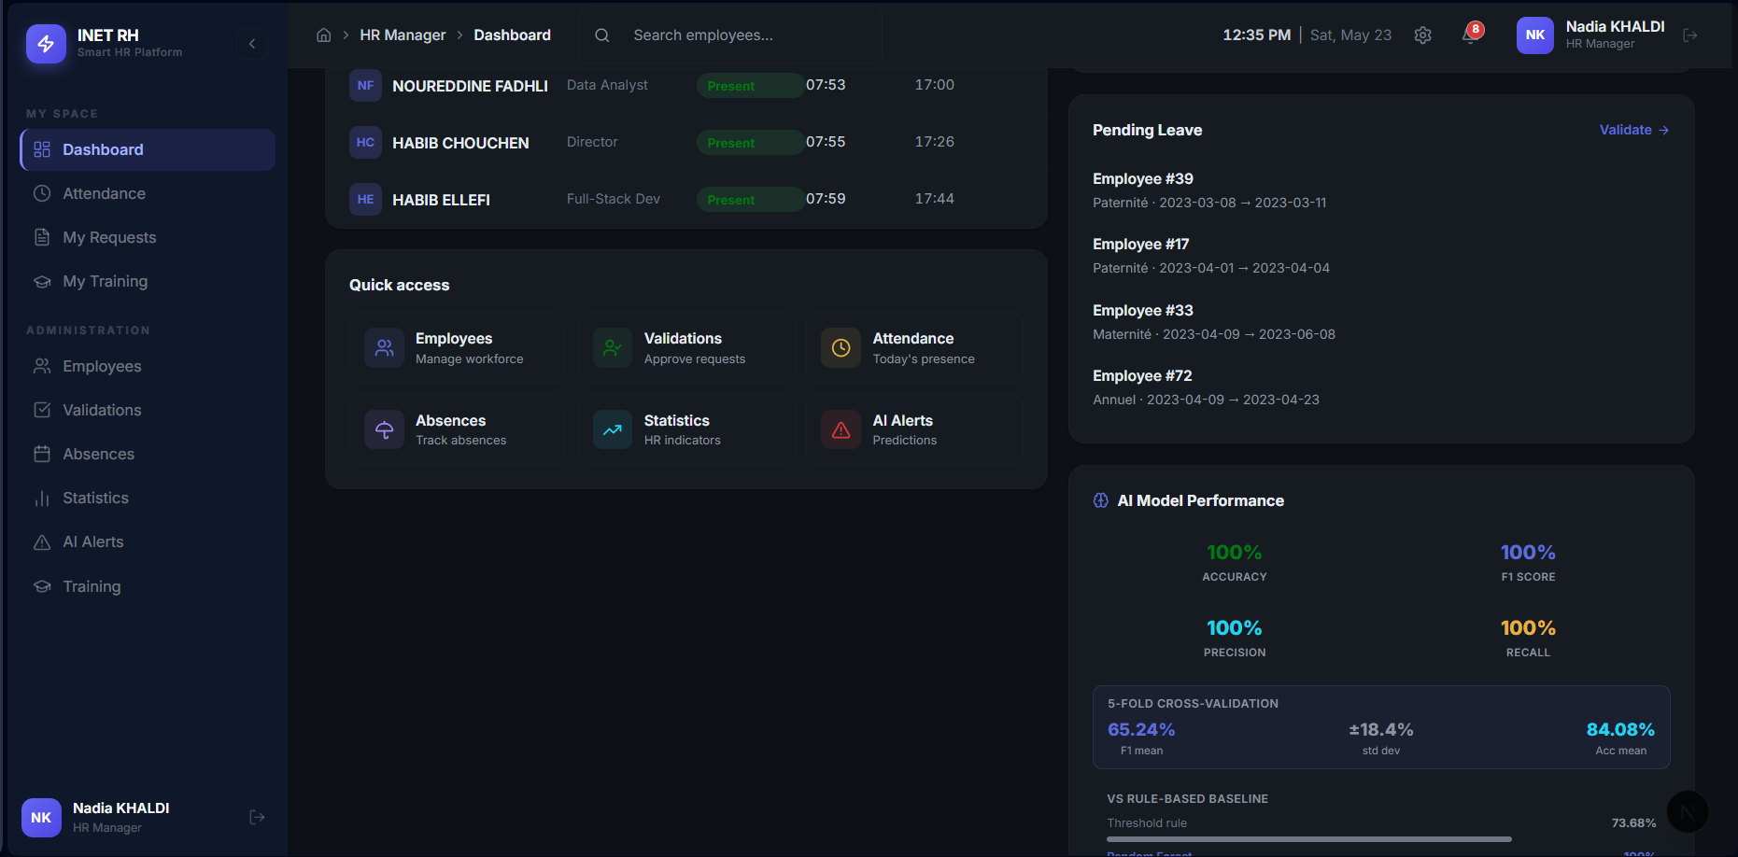
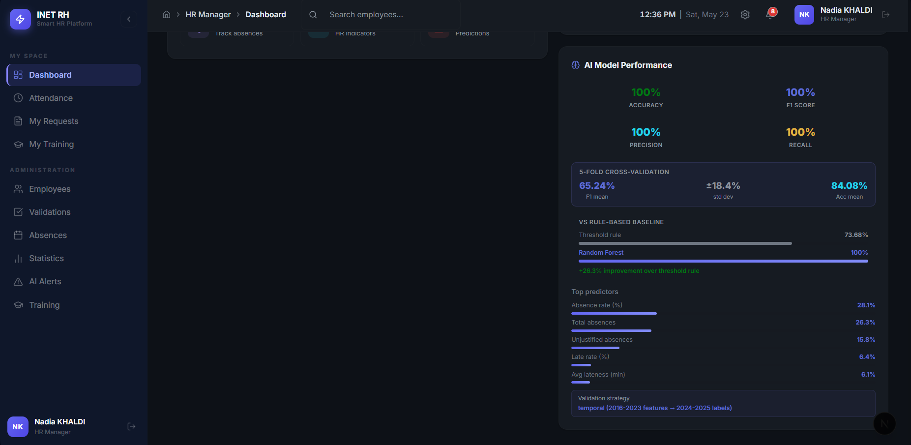
Figure 5.2 — Interface screenshot 2
Figure 5.3 — Interface screenshot 3
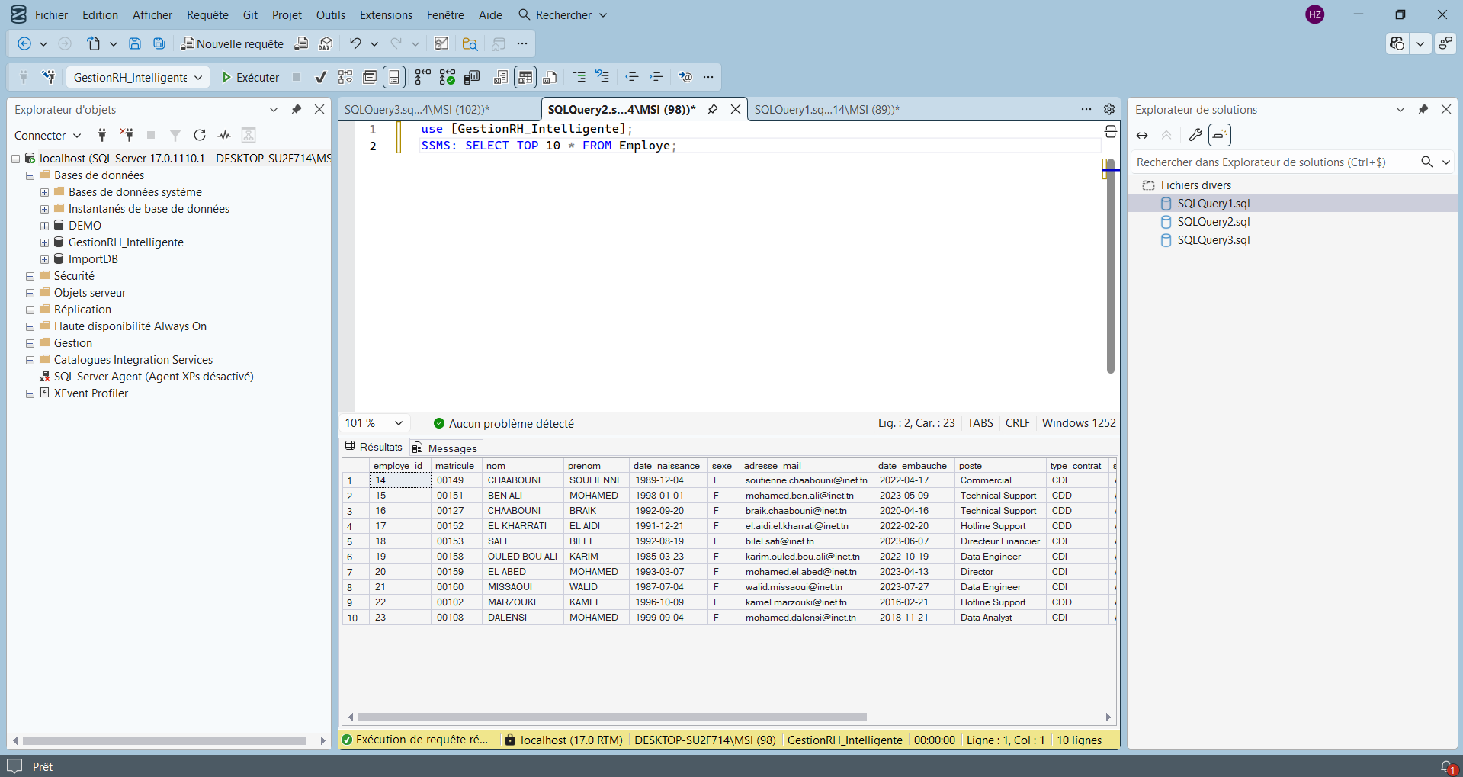
Figure 5.4 — Interface screenshot 4
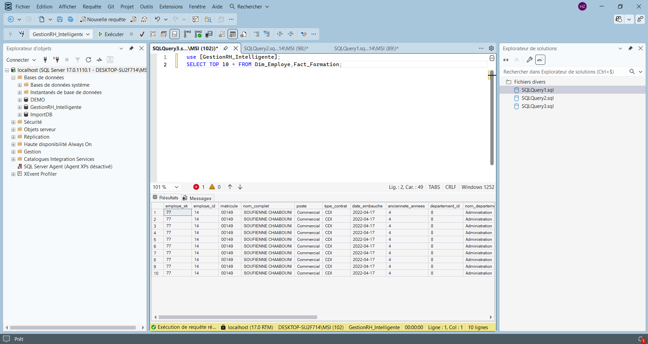
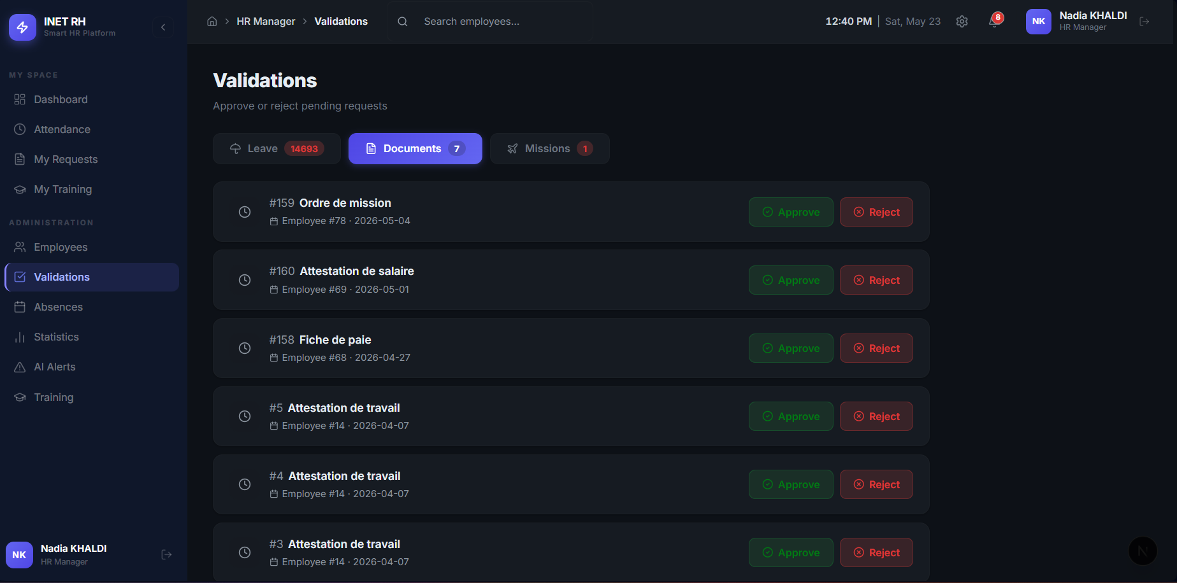
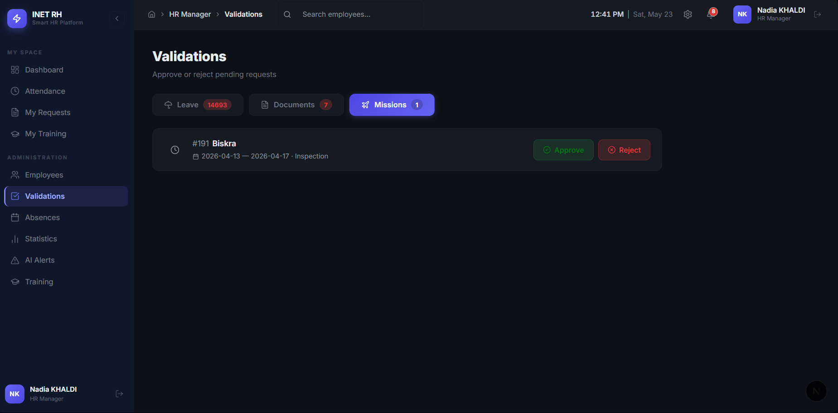
Figure 5.5 — Interface screenshot 5
Figure 5.6 — Interface screenshot 6
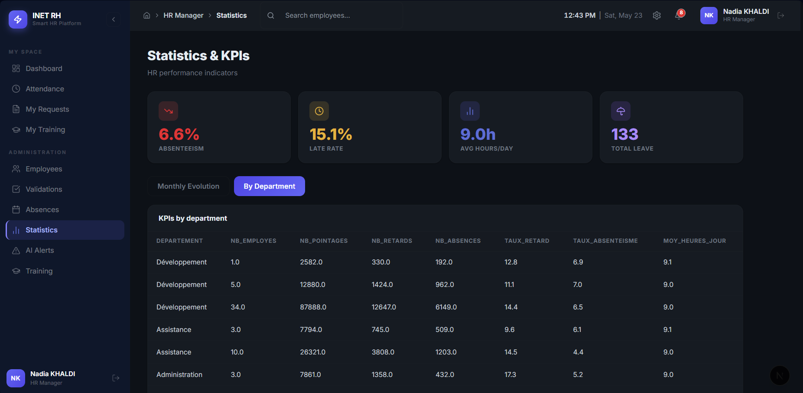
Figure 5.7 — Interface screenshot 7
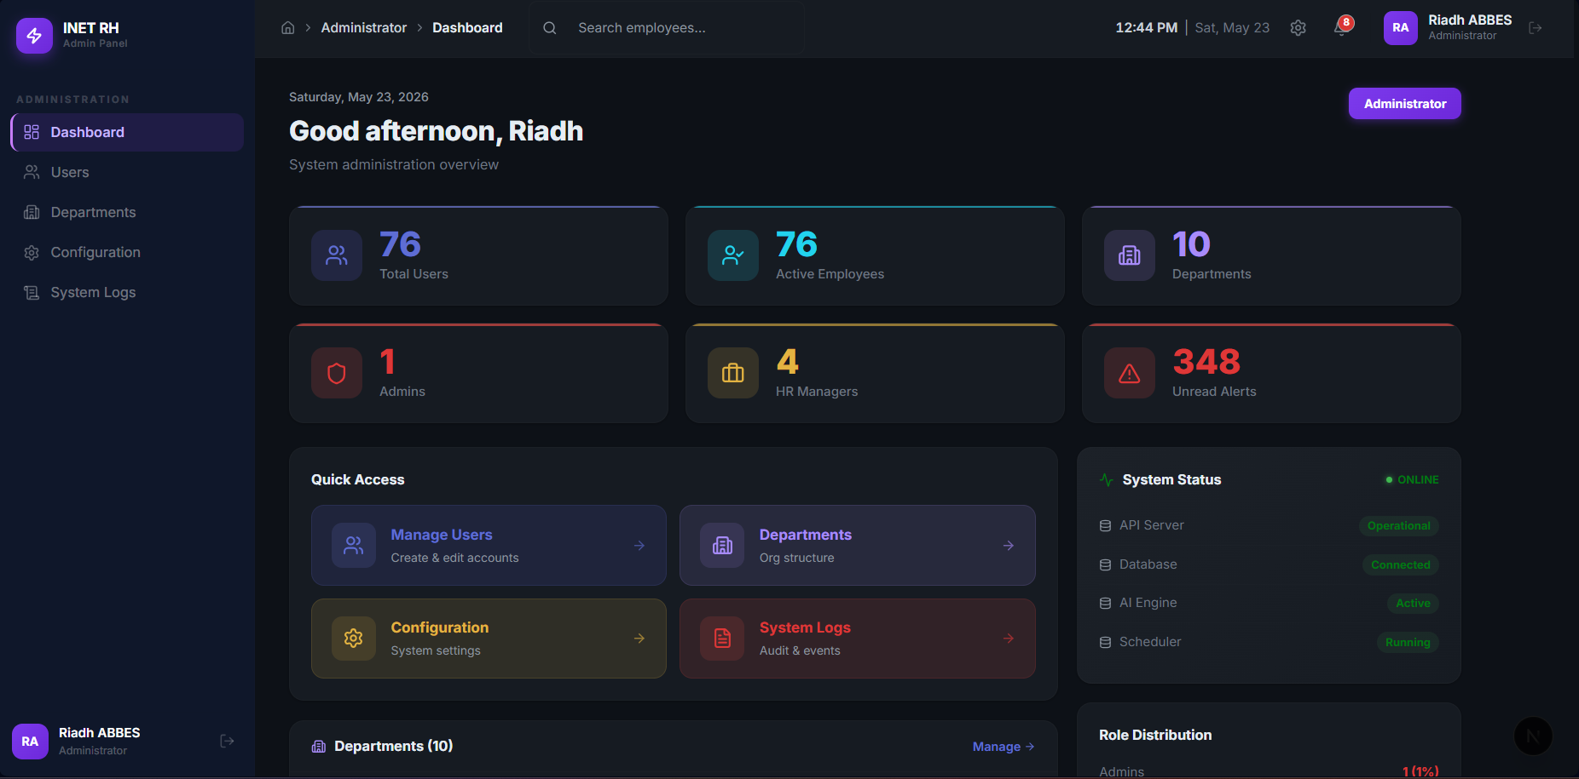
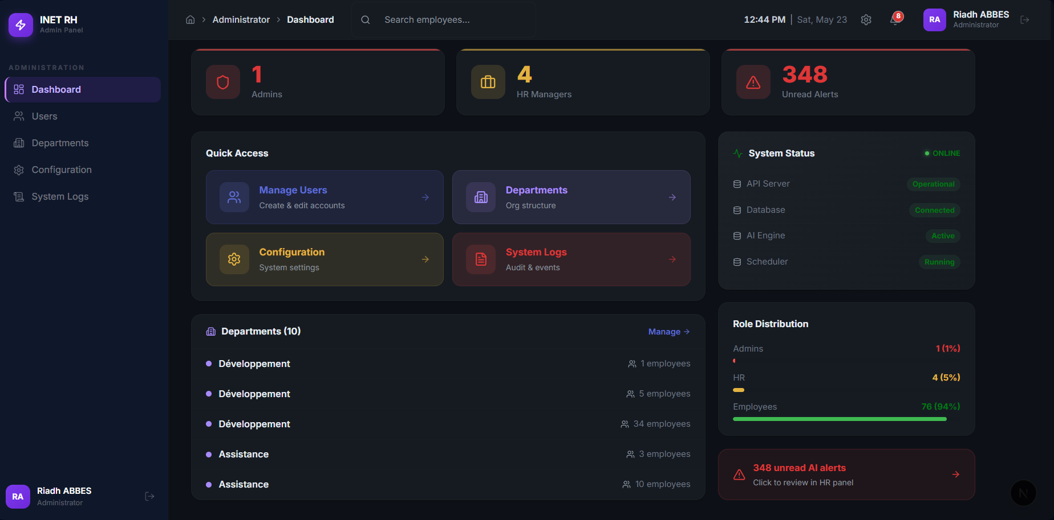
Figure 5.8 — Interface screenshot 8
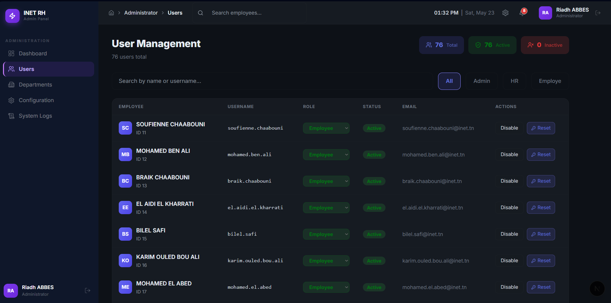
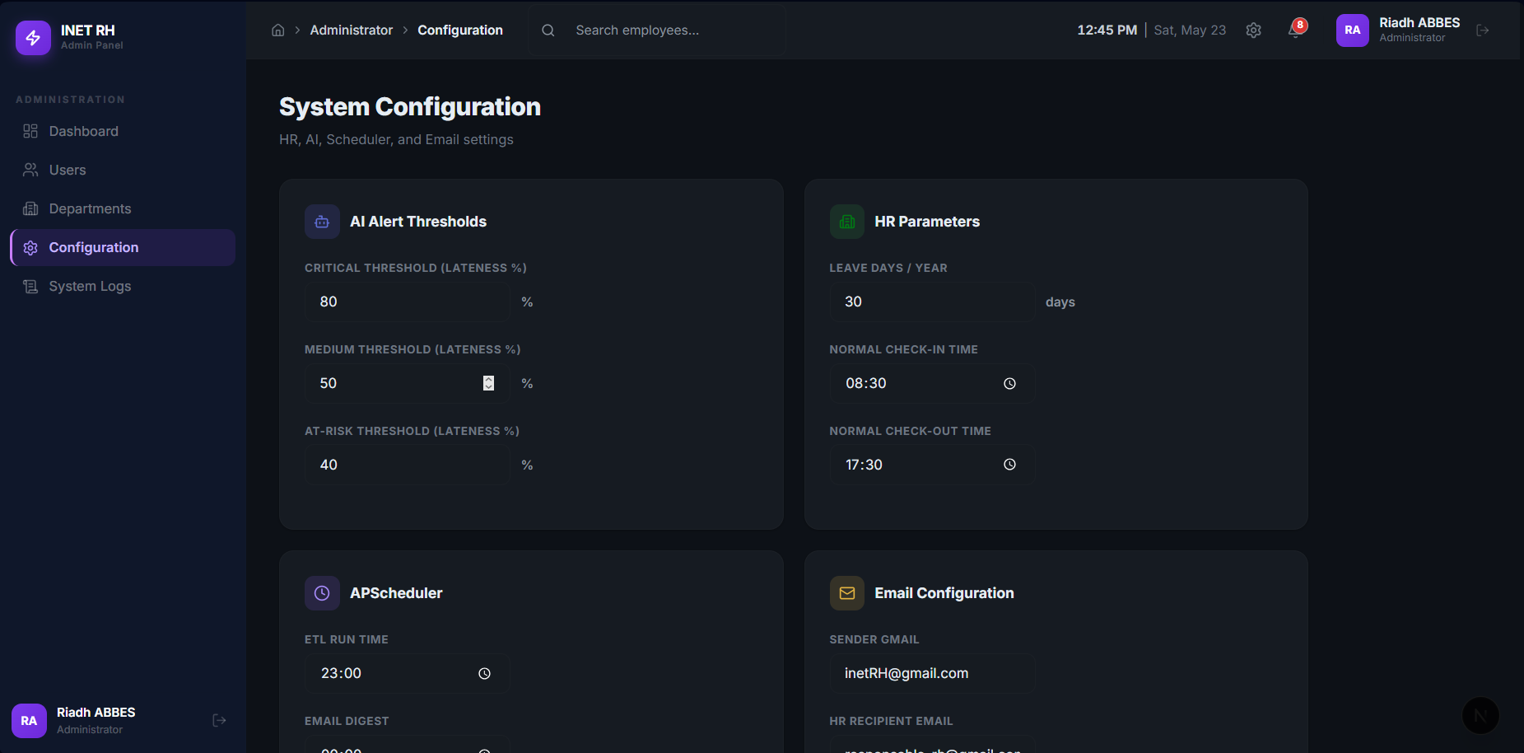
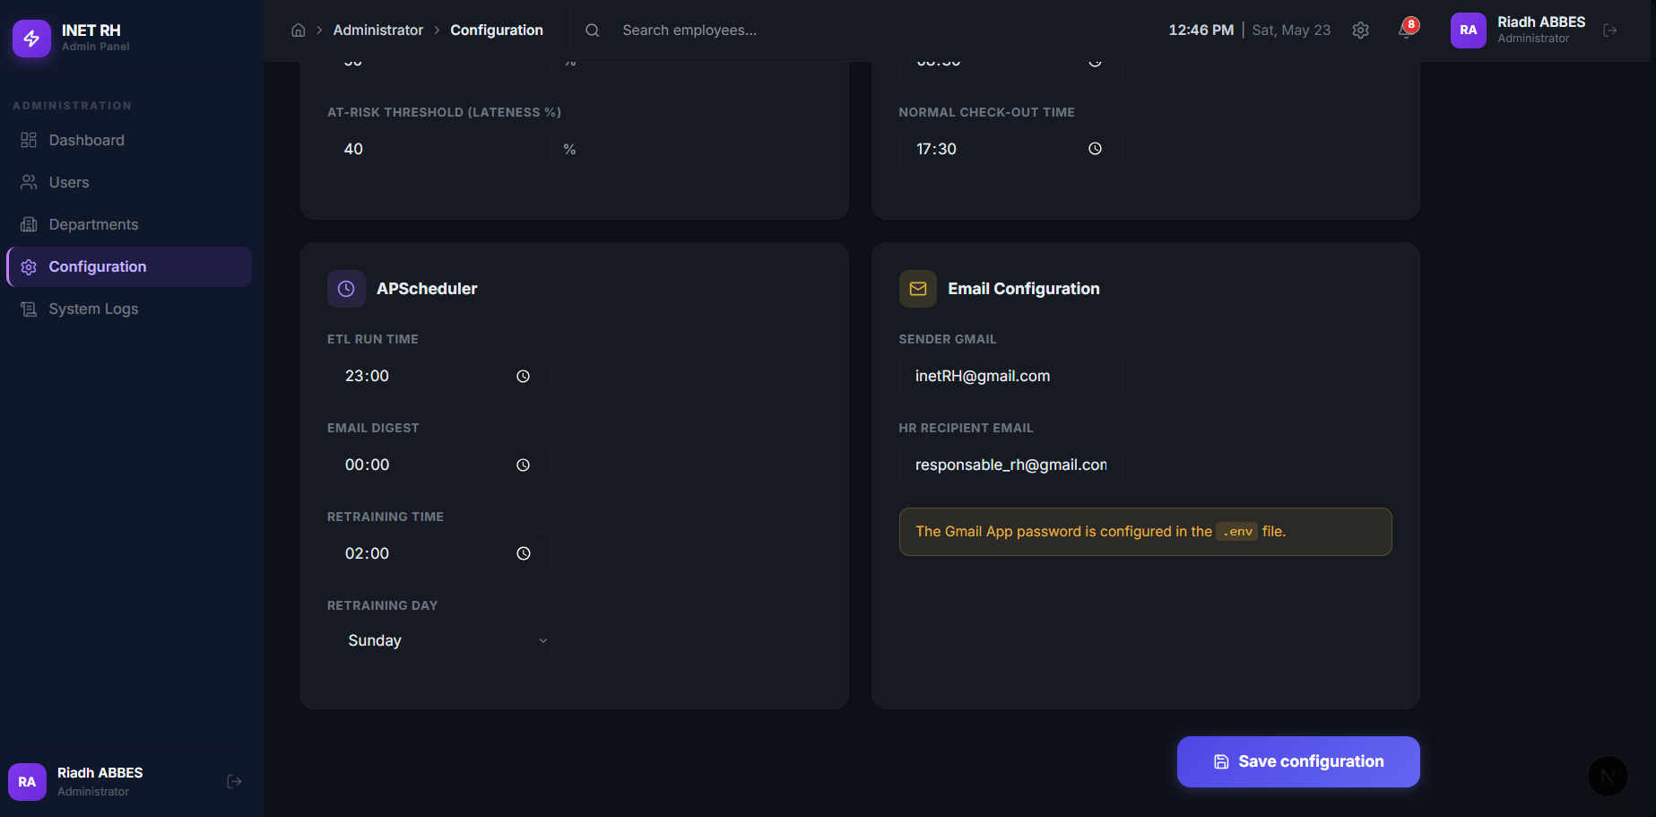
Figure 5.9 — Interface screenshot 9

5.1. Introduction
Sprint 2 built the HR process layer on top of the operational core delivered by Sprint 1. The scope covered attendance supervision, absence management, leave management with balance enforcement, the first generation of HR KPIs, and the supporting modules for documents, missions, and training. It corresponds to user stories US-05 through US-08 of the product backlog, plus US-13 for the document/mission/training extensions.

5.2. Sprint backlog
The stories pulled into Sprint 2 are the "should-have" HR processes that turn the operational core into a usable HR information system, plus the "could-have" supporting modules that round out the day-to-day HR workflow.
Table 5.2 — Sprint 2 backlog
ID | Functionality | User story | Priority | Sprint
US-05 | Attendance supervision | As an HR manager, I want to see the day's attendance and an employee's history so that I can monitor presence. | 2 (Should) | 2
US-06 | Absence management | As an HR manager, I want to record and qualify absences so that unjustified absence is identifiable. | 2 (Should) | 2
US-07 | Leave management | As an employee, I want to request leave and see my balance; as an HR manager, I want to validate requests. | 2 (Should) | 2
US-08 | HR KPIs | As an HR manager, I want global and per-department KPIs and their evolution so that I can read the workforce at a glance. | 2 (Should) | 2
US-13 | Documents / missions / training | As an employee, I want to request documents and follow training; as HR, I want to validate them. | 4 (Could) | 2

5.3. Sprint use-case diagram
The Sprint 2 use-case diagram extends the Sprint 1 model with the HR process use cases. The HR Manager gains the supervisory use cases (attendance supervision, KPIs) and the validation use cases (leaves, missions, document requests); the Employee gains the request-side use cases (leave, document, training participation).
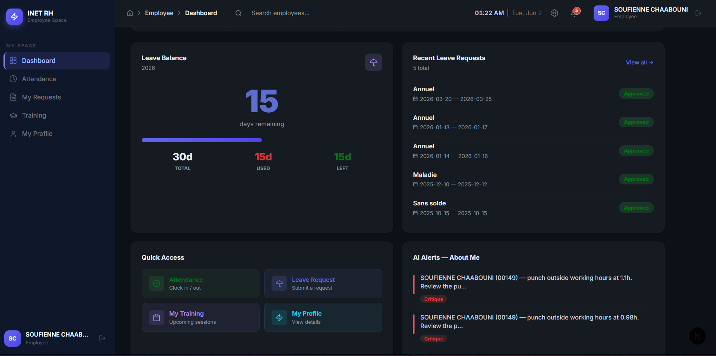
Figure 5.10 — Use-case diagram of Sprint 2

5.4. Sprint analysis — Use-case refinements

5.4.1. Refinement: "Request and validate leave"
Figure 5.11 — Refinement of the use case "Request and validate leave"
Table 5.3 — Explanatory table: "Request and validate leave"
Element | Actor | Functional description
Request leave | Employee | Submit a leave request for a date range and a type.
Compute working days «include» | System | Count the working days the request spans, excluding weekends.
Check leave balance «include» | System | Verify the requested duration against the remaining annual balance.
Validate leave | HR Manager | Approve or reject a pending request.
Notify employee «extend» | System | Inform the employee of the decision.

Table 5.4 — Alternative scenarios: "Request and validate leave"
ID | Scenario | Description
A1 | End before start | The system rejects a request whose end date precedes its start date.
A2 | Balance exceeded | The request is blocked if it exceeds the remaining balance.
A3 | Cancel pending request | The employee may cancel a request still in "Pending".

5.4.2. Refinement: "Manage absences"
Figure 5.12 — Refinement of the use case "Manage absences"
Table 5.5 — Explanatory table: "Manage absences"
Element | Actor | Functional description
Record absence | HR Manager | Register an absence event for a given employee and date.
Qualify absence «include» | HR Manager | Mark the absence as justified or unjustified and attach a reason.
Update absence statistics «extend» | System | Recompute the employee's absence rate and the unjustified-absence count.
List absences | HR Manager | Display the absence history with a filter on status and period.

Table 5.6 — Alternative scenarios: "Manage absences"
ID | Scenario | Description
A1 | Absence on a non-working day | The system warns that the date is a weekend or a public holiday.
A2 | Conflict with approved leave | The system flags an absence that overlaps an already-approved leave request.
A3 | Late justification | An unjustified absence can be re-qualified later once a justification is provided.

5.4.3. Refinement: "Supervise attendance and KPIs"
Figure 5.13 — Refinement of the use case "Supervise attendance and consult decision dashboard"
Table 5.7 — Explanatory table: "Supervise attendance and KPIs"
Element | Actor | Functional description
Consult daily attendance | HR Manager | Display the day's presence, lateness, and missing-exit events.
Consult dashboard | HR Manager / Administrator | Display the consolidated HR indicators on a single screen.
Load KPIs «include» | System | Read attendance, absenteeism, lateness, and average-hours indicators.
Filter by period/department «extend» | HR Manager | Restrict the indicators to a chosen period or department.

Table 5.8 — Alternative scenarios: "Supervise attendance and KPIs"
ID | Scenario | Description
A1 | No data for period | The system shows an empty-state message instead of a broken chart.
A2 | Department filter empty | A filter on an empty department returns zero values without an error.
A3 | Warehouse refresh in progress | If the ETL is running, the dashboard displays the previous consolidated snapshot.

5.5. Sprint design

5.5.1. Static conception — Class diagram (Sprint 2 entities)
Sprint 2 introduced the leave, absence, balance, mission, document, and training entities on top of the operational core. They are all attached to Employe by a foreign key, and the leave-balance entity is in a 1:1 relationship with Employe so that the balance enforcement is centralised on a single row per employee per year.
Table 5.9 — Data dictionary: `Conge`
Column | Type | Description
conge_id | INT (PK) | Unique leave identifier
employe_id | INT (FK) | → Employe (requester)
type_conge | VARCHAR(50) | Annuel / Maladie / …
date_debut / date_fin | DATE | Leave range
nb_jours | INT | Working days spanned
statut | VARCHAR(30) | Pending / Approved / Rejected
valide_par | INT (FK) | → Employe (validator)

Table 5.10 — Data dictionary: `Absence`
Column | Type | Description
absence_id | INT (PK) | Unique absence identifier
employe_id | INT (FK) | → Employe
date_absence | DATE | Day of absence
justifiee | BOOLEAN | Justified flag
motif | VARCHAR(255) | Reason
statut | VARCHAR(30) | Justified / Unjustified

Table 5.11 — Data dictionary: `SoldeConge`
Column | Type | Description
solde_id | INT (PK) | Unique balance identifier
employe_id | INT (FK, unique) | → Employe (1:1)
solde_annuel | INT | Annual entitlement (default 30)
solde_utilise | INT | Days already used
annee | INT | Reference year

5.5.2. Dynamic conception
The two scenarios that carry the most logic of Sprint 2 are the leave request/validation flow — which exercises both the employee side and the HR side of the system — and the KPI computation flow — which reads the warehouse and feeds the dashboard.
Leave request and validation. The employee submits a range; the service computes the working days, checks the balance, and persists the request as "Pending"; later the HR manager validates it, the status changes, and the employee is notified.
Figure 5.14 — Sequence diagram: leave request and validation
KPI computation. The dashboard requests the indicators; the pointage service aggregates presence, absence, lateness, and average hours from the warehouse and returns them shaped for the charts.
Figure 5.15 — Sequence diagram: KPI computation

5.6. Sprint realization

5.6.1. Database
Beyond the three core entities of Sprint 2 already described in §5.5.1, the sprint also delivered the supporting tables for documents, missions, and training that complete the day-to-day HR workflow.
Table 5.12 — Data dictionary: `Mission`
Column | Type | Description
mission_id | INT (PK) | Unique mission identifier
employe_id | INT (FK) | → Employe
lieu | VARCHAR(200) | Mission location
date_debut / date_fin | DATE | Mission range
role | VARCHAR(100) | Role during the mission
type_mission | VARCHAR(50) | Mission type
statut | VARCHAR(30) | Pending / Approved / Rejected
date_declaration | DATETIME | Declaration date
valide_par | INT (FK) | → Employe (validator)

Table 5.13 — Data dictionary: `Document`
Column | Type | Description
document_id | INT (PK) | Unique document identifier
employe_id | INT (FK) | → Employe (requester)
type_document | VARCHAR(100) | Document type (work certificate, payslip, …)
titre | VARCHAR(200) | Document title
date_demande | DATETIME | Request date
date_validation | DATETIME | Validation date
statut | VARCHAR(30) | Pending / Approved / Rejected
commentaire | VARCHAR(255) | Validator comment
valide_par | INT (FK) | → Employe (validator)
fichier_path | VARCHAR(255) | Path of the generated PDF

Table 5.14 — Data dictionary: `Formation`
Column | Type | Description
formation_id | INT (PK) | Unique training identifier
titre | VARCHAR(200) | Training title
date_debut / date_fin | DATE | Session range
organisateur | VARCHAR(100) | Organiser
type_formation | VARCHAR(50) | Training type
description | VARCHAR(500) | Training description
date_creation | DATETIME | Record creation timestamp

Table 5.15 — Data dictionary: `PresenceFormation`
Column | Type | Description
presence_id | INT (PK) | Unique participation identifier
formation_id | INT (FK) | → Formation
employe_id | INT (FK) | → Employe
presence | BOOLEAN | Attended flag
score | FLOAT | Evaluation score

5.6.2. Graphical interfaces
The HR-side screens delivered at the end of Sprint 2 turn the new entities into actionable workflows: the daily attendance view, the validation queue, the absence list, and the consolidated KPI dashboard.
Figure 5.16 — HR decision dashboard
Table 5.16 — Interface analysis: HR dashboard
Field | Content
Actors | HR Manager, Administrator
Interface | Consolidated decision dashboard
Components | KPI cards (headcount, present, late, pending leave, unread alerts), attendance-trend chart, absenteeism-by-department chart, leave-by-type chart
Functionalities | Read the key indicators at a glance, follow the multi-year trend, compare departments
Objective | Give the manager, on one screen, the state of the workforce

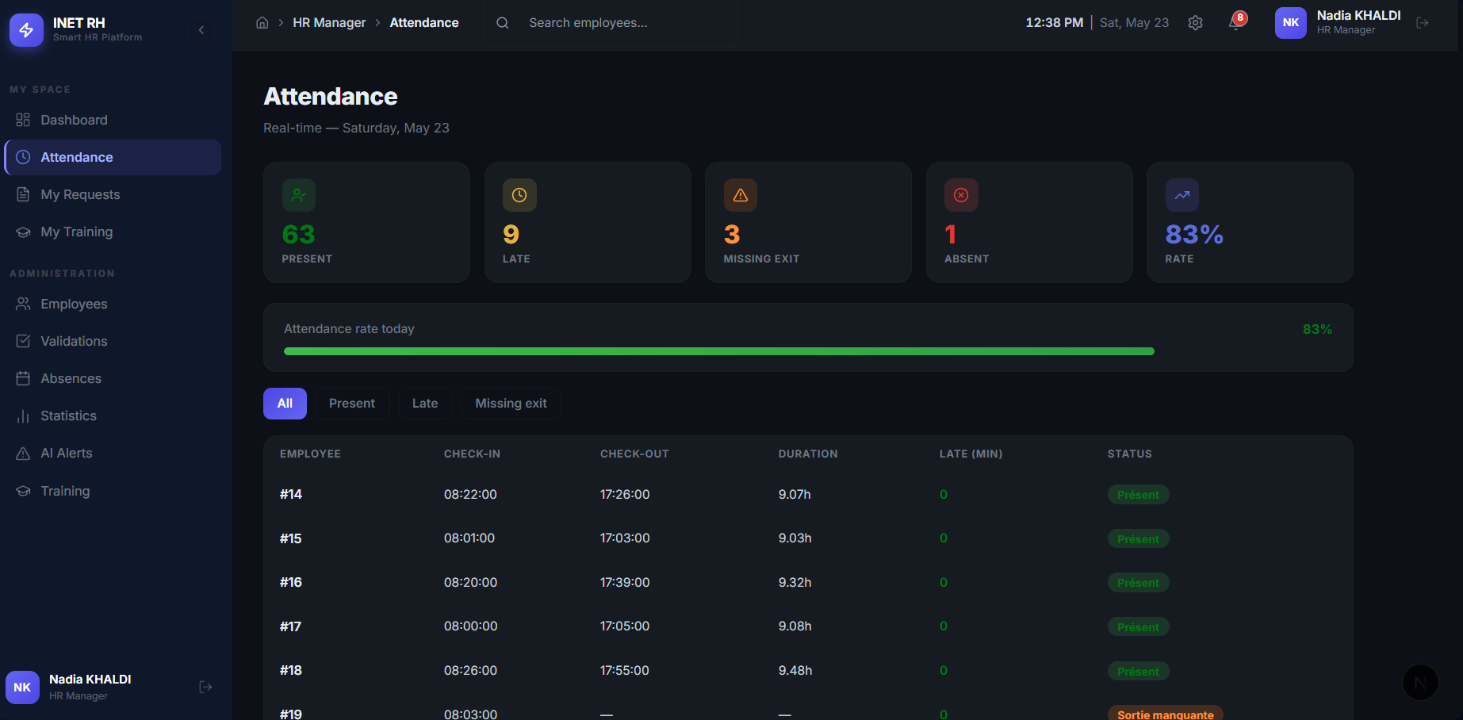
Figure 5.17 — Daily attendance
Table 5.17 — Interface analysis: Attendance supervision
Field | Content
Actors | HR Manager
Interface | Daily attendance table
Components | Day selector, attendance rows (entry, status, lateness), manual entry
Functionalities | Consult the day's presence, identify lateness and missing exits
Objective | Give an immediate operational reading of the day

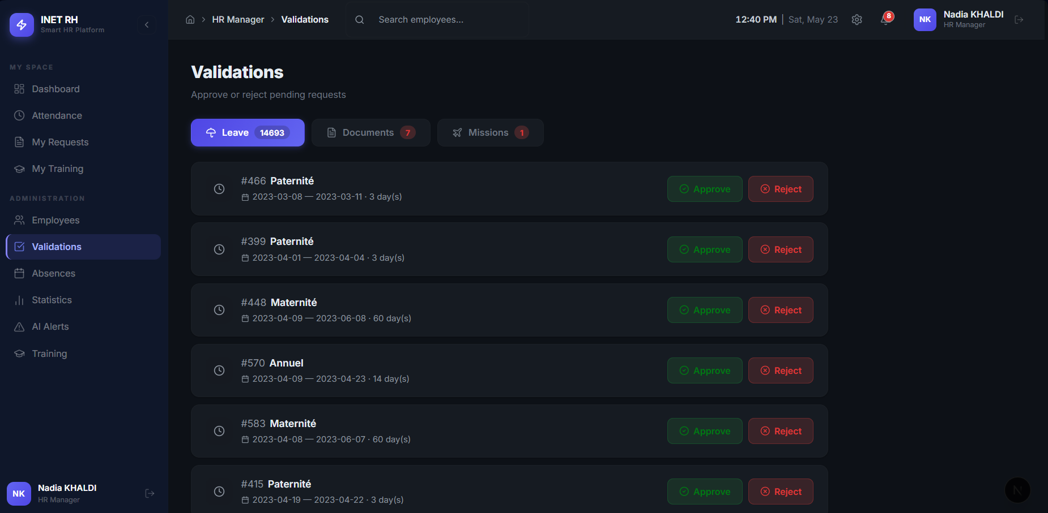
Figure 5.18 — Leave and mission validation
Table 5.18 — Interface analysis: Validations
Field | Content
Actors | HR Manager
Interface | Approval queue
Components | Pending leave and mission list, approve/reject actions
Functionalities | Validate or reject requests, update balances
Objective | Process HR requests in one place with a clear status trail

Figure 5.19 — HR statistics
Figure 5.20 — Interface screenshot 20
Figure 5.21 — Interface screenshot 21
Table 5.19 — Interface analysis: HR statistics
Field | Content
Actors | HR Manager
Interface | Analytical charts
Components | Evolution chart, department KPIs, lateness statistics
Functionalities | Explore the indicators over time and by department
Objective | Support diagnostic analysis ("why did the indicator move?")

5.7. Sprint review
The sprint review exercised every story of Sprint 2 against the acceptance criteria agreed with the Product Owner, with the KPI computations cross-checked against manually calculated reference values on a subset of the data.
Table 5.20 — Sprint 2 review
Test case | Steps | Expected result | Result
Submit leave request | Employee submits valid date range | Working days computed, balance checked, request saved | Passed
End date before start | Submit request with inverted dates | Request rejected with error | Passed
Balance exceeded | Request more days than remaining | Request blocked, error shown | Passed
HR approves leave | HR clicks approve on pending request | Status updated to approved | Passed
Record unjustified absence | HR records absence without justification | Absence saved, flagged for risk analysis | Passed
Compute KPIs | Run ETL pipeline | Attendance rate, absenteeism rate, lateness rate computed correctly | Passed
Department filter | Select department in KPI view | KPIs filtered to that department | Passed

5.8. Sprint retrospective
Sprint 2 completed the HR process layer on time. The leave-balance computation required careful handling of edge cases — overlapping requests, weekend and public-holiday exclusion, and the cancellation of a pending request that had already been counted against the balance. The KPI computation formulas (attendance rate, absenteeism rate, lateness rate, average daily worked hours) were validated against manually calculated reference values on a small subset of the data before being integrated into the dashboard, which avoided a class of subtle off-by-one errors that would otherwise have only surfaced once the warehouse was populated. The absence-management module's distinction between justified and unjustified absences — implemented at the model level as a justifiee boolean and surfaced in the UI as the statut field — proved essential in Sprint 4, where the predictive layer uses the unjustified-absence count as one of its strongest features.

5.9. Conclusion
Sprint 2 closed with a fully usable HR information system: the HR Manager can supervise attendance, qualify absences, validate leave and mission requests, and read the consolidated KPIs on a single dashboard, while the Employee can request leave, documents, and training and follow their personal status. The operational chain is now complete end to end, which lets Sprint 3 focus exclusively on the Business Intelligence layer — the data warehouse, the ETL pipeline, and the Power BI report — on top of the now-populated operational database.

CHAPTER 6 : SPRINT 3: DECISION LAYER

Figure 6.1 — Power BI report page 1
Figure 6.2 — Power BI report page 2
Figure 6.3 — Power BI report page 3
Figure 6.4 — Power BI report page 4
Figure 6.5 — Power BI report page 5
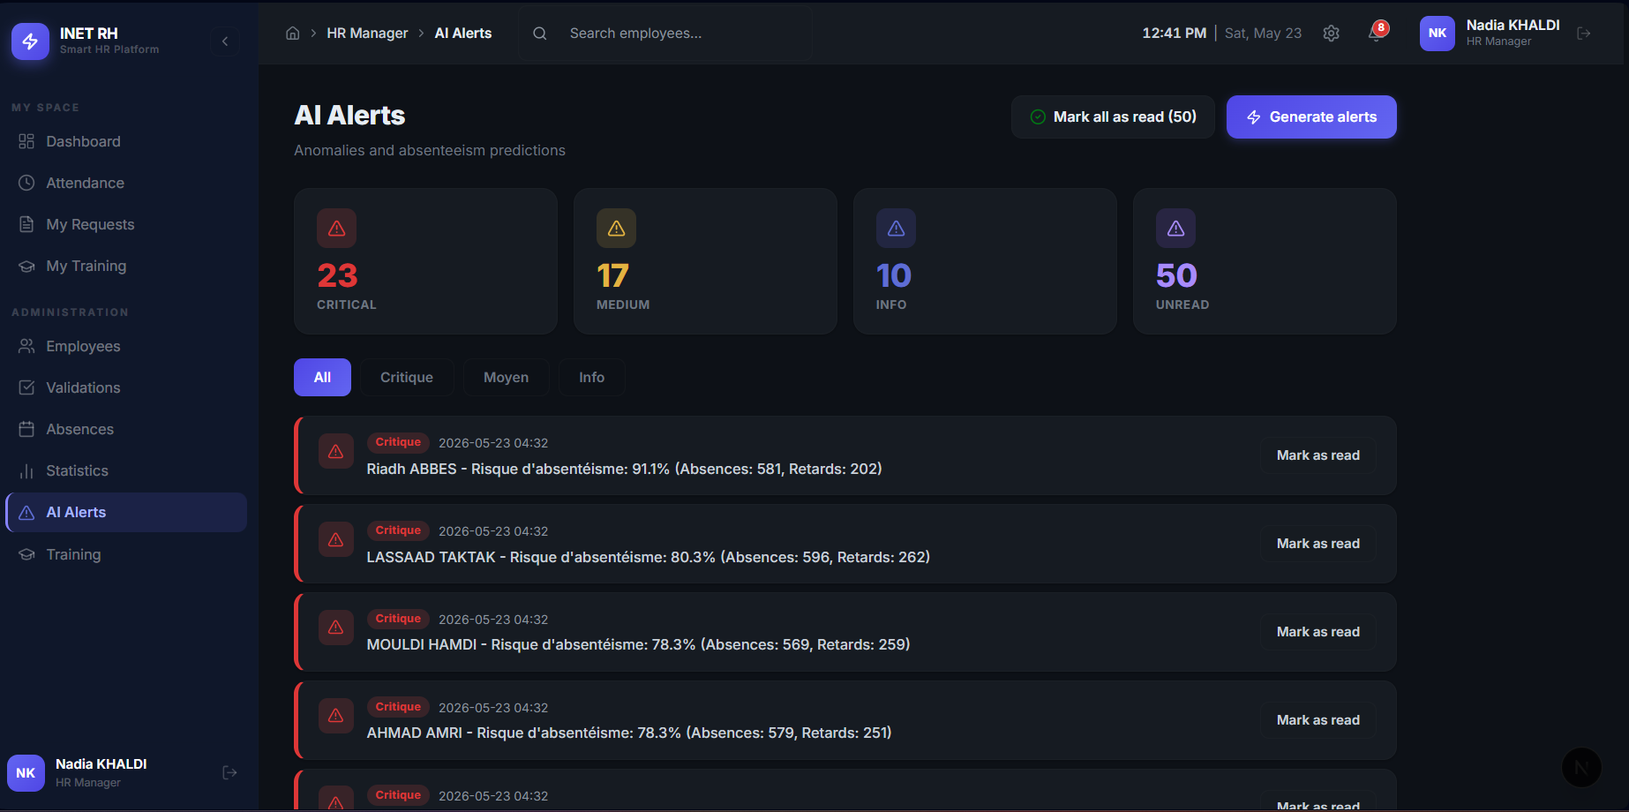
Figure 6.6 — Power BI report page 6
Figure 6.7 — Power BI report page 7
Figure 6.8 — Power BI report page 8
Figure 6.9 — Power BI report page 9

6.1. Introduction
Sprint 3 built the Business Intelligence layer on top of the operational system delivered in Sprints 1 and 2. The scope covered the Kimball data warehouse, the ETL pipeline that feeds it, the consolidated web dashboards consumed by the three role-based portals, and the Power BI report wired directly onto the warehouse. It corresponds to user stories US-11 (decision dashboard) and US-12 (Power BI reporting) of the product backlog.

6.2. Sprint backlog
The two stories pulled into Sprint 3 are the two "should-have" decision-layer stories. They depend on the warehouse existing, so they could only be scheduled once the operational data of Sprints 1 and 2 had been populated.
Table 6.2 — Sprint 3 backlog
ID | Functionality | User story | Priority | Sprint
US-11 | Decision dashboard | As an HR manager, I want a single dashboard consolidating the indicators and the model results. | 3 (Should) | 3
US-12 | Power BI reporting | As an HR manager, I want an interactive Power BI report on the warehouse so that I can explore the data. | 3 (Should) | 3

6.3. Sprint use-case diagram
The Sprint 3 use-case diagram restricts the global model of Chapter 2 to the two stories of this sprint. The HR Manager and the Administrator are the two human actors that drive the BI layer; both consult the dashboard and the Power BI report, while the System actor is responsible for keeping the warehouse current through the nightly ETL.
Figure 6.10 — Use-case diagram of Sprint 3

6.4. Sprint analysis — Use-case refinements

6.4.1. Refinement: "Consult decision dashboard"
Figure 6.11 — Refinement of the use case "Consult decision dashboard"
Table 6.3 — Explanatory table: "Consult decision dashboard"
Element | Actor | Functional description
Consult dashboard | HR Manager / Administrator | Display the consolidated HR indicators on a single screen.
Load KPIs «include» | System | Read attendance, absenteeism, lateness, and average-hours indicators.
Load model performance «include» | System | Read the model's accuracy, F1, cross-validation, and feature importances.
Filter by period/department «extend» | HR Manager | Restrict the indicators to a chosen period or department.

Table 6.4 — Alternative scenarios: "Consult decision dashboard"
ID | Scenario | Description
A1 | No data for period | The system shows an empty-state message instead of a broken chart.
A2 | Model not yet trained | The performance panel shows "no model trained yet".

6.5. Sprint design

6.5.1. Data warehouse design (Kimball star schema)
The analytical layer does not reuse the OLTP schema: analytical questions are "measure-by-dimension" questions and are answered far more efficiently by a dimensional model. We therefore designed a star schema with four fact tables and four dimensions, three of which are conformed across every fact.

Grain and dimensions
The grain of each fact was fixed first, because the grain decides everything else:
- Fact_Pointage — one row per employee per working day.
- Fact_Absence — one row per absence event.
- Fact_Conge — one row per leave request.
- Fact_Formation — one row per employee per training participation.
The four facts share three conformed dimensions — Dim_Date (the calendar), Dim_Employe (the workforce, with its department denormalised in), and Dim_Departement — which is the textbook Kimball strength: the same employee, the same day, and the same department are described identically wherever they appear, so cross-process questions ("how does training participation correlate with absenteeism by department?") are answered without any reconciliation. A fourth dimension, Dim_Formation, is used by Fact_Formation only. Each fact references the dimensions by surrogate keys (employe_sk, departement_sk, date_id, formation_sk), generated by the warehouse and independent of the operational identifiers, following the Kimball recommendation.
Table 6.5 — Data dictionary: `Dim_Date`
Column | Type | Description
date_id | INT (PK) | Calendar key in YYYYMMDD form
date_complete | DATE | Full date
annee / trimestre / mois | INT | Year / quarter / month
nom_mois | VARCHAR(20) | Month name
semaine | INT | ISO week
jour / nom_jour | INT / VARCHAR | Day number / day name
est_weekend | BIT | Weekend flag
saison | VARCHAR(20) | Winter / Spring / Summer / Autumn

Table 6.6 — Data dictionary: `Dim_Employe`
Column | Type | Description
employe_sk | INT (PK, IDENTITY) | Surrogate key
employe_id | INT | Natural key from OLTP
matricule | VARCHAR(20) | Payroll number
nom_complet | VARCHAR(200) | Full name
poste / type_contrat | VARCHAR | Job / contract
anciennete_annees | INT | Seniority in years
departement_id / nom_departement | INT / VARCHAR | Department context (denormalised)

Table 6.7 — Data dictionary: `Fact_Pointage`
Column | Type | Description
pointage_sk | INT (PK, IDENTITY) | Surrogate key
date_id | INT (FK) | → Dim_Date
employe_sk | INT (FK) | → Dim_Employe
departement_sk | INT (FK) | → Dim_Departement
statut | VARCHAR(30) | Degenerate dimension
heure_entree_decimal | FLOAT | Entry time as decimal (8.5 = 08h30)
duree_travail | FLOAT | Hours worked (measure)
retard_minutes | INT | Minutes late (measure)
est_present / est_retard / sortie_manquante | BIT | Pre-computed indicators

Table 6.8 — Data dictionary: `Fact_Absence`
Column | Type | Description
absence_sk | INT (PK, IDENTITY) | Surrogate key
date_id | INT (FK) | → Dim_Date
employe_sk | INT (FK) | → Dim_Employe
departement_sk | INT (FK) | → Dim_Departement
motif | VARCHAR(255) | Reason (degenerate)
est_justifiee | BIT | Justified flag
nb_absences | INT | Always 1, for SUM aggregation

Table 6.9 — Data dictionary: `Fact_Conge`
Column | Type | Description
conge_sk | INT (PK, IDENTITY) | Surrogate key
date_debut_id / date_fin_id | INT (FK) | → Dim_Date (start / end)
employe_sk | INT (FK) | → Dim_Employe
departement_sk | INT (FK) | → Dim_Departement
type_conge / statut | VARCHAR | Degenerate dimensions
nb_jours | INT | Days of leave (measure)

Figure 6.12 — Kimball star schema of the data warehouse

ETL design
The pipeline that feeds the warehouse is designed as four ordered steps. Extract reads the raw operational tables. Transform recomputes every KPI from the raw events. Load — KPI tables upserts the flat indicator tables (DW_KPI_Employe, DW_KPI_Mensuel). Load — star schema performs an idempotent full refresh of the dimensions and facts, joining each fact to the dimensions to obtain the surrogate keys. The full-refresh choice for the star schema was deliberate: it guarantees idempotence — a property required by the non-functional specification, since the pipeline runs unattended every night.
Figure 6.13 — ETL pipeline design

6.5.2. Dynamic conception
Two scenarios carry the analytical logic of the sprint: KPI computation, triggered every time the dashboard is opened, and the nightly ETL run that keeps the warehouse current.
KPI computation. The dashboard requests the indicators; the pointage service aggregates presence, absence, lateness, and average hours from the warehouse and returns them shaped for the charts.
Figure 6.14 — Sequence diagram: KPI computation
Nightly ETL run. At 23:00 the APScheduler process triggers run_pipeline(). Extraction reads the raw operational tables through the ORM, transformation recomputes every KPI from the raw events, the flat KPI tables are upserted, and the star-schema loader refreshes the dimensions and the four facts in a fixed order. The whole sequence is idempotent — re-running the nightly pipeline cannot duplicate or corrupt the warehouse — and every step writes a timestamped line to logs/etl.log.
Figure 6.15 — Sequence diagram: nightly ETL run

6.6. Sprint realization

6.6.1. ETL pipeline implementation
The pipeline is orchestrated by etl/pipeline.py, which runs four ordered steps — extraction, transformation, KPI load, and star-schema load — and writes a timestamped line to logs/etl.log at every step so that a failed nightly run can be diagnosed the next morning.
Extraction. Extraction reads the raw operational tables — Pointage, Absence, Conge, Employe, and the alert table — through the ORM into pandas data frames, with no aggregation at this stage. Reading through the ORM rather than with hand-written SQL means the extraction automatically follows any change made to the table mappings.
Transformation and data quality. Transformation is the step where raw events become trustworthy figures. Three kinds of cleaning are applied. First, missing values are made explicit: a null worked-duration becomes zero, a missing status becomes Unknown, an unflagged absence is treated as not justified. Second, textual fields are normalised so grouping is reliable — the attendance status is stripped of stray whitespace, because "Present " with a trailing space would otherwise be counted as a different category and corrupt every presence rate. Third, continuous values are bucketed into analytical categories with pandas.cut: seniority into five bands, age into five brackets, and lateness into five severity classes.
KPI computation. The indicators are recomputed from the raw events for every employee, which is what guarantees that the number on the dashboard and the number consumed by the model are the same number.
Table 6.10 — HR indicators computed by the ETL and their formulas
Indicator | Formula | Meaning
Presence rate | nb_presents / nb_pointages × 100 | Share of attendance records marked present
Absence rate | nb_absences / (nb_pointages + nb_absences) × 100 | Share of expected days lost to absence
Lateness rate | nb_retards / nb_pointages × 100 | Share of attendance records that were late
Average worked hours | total_heures / nb_pointages | Mean daily worked duration

Loading. The flat KPI tables DW_KPI_Employe and DW_KPI_Mensuel are loaded first; they back the operational dashboard. The star schema is then loaded by etl/load_star.py. Loading a fact is where the dimensional model is actually assembled: each fact query joins the operational table to Dim_Employe and Dim_Departement to resolve the surrogate keys. The loader was written to be idempotent — before reloading, it deletes the fact tables and dimensions in a fixed order so that foreign keys are never violated and re-running the nightly pipeline never duplicates or corrupts the warehouse.
Figure 6.16 — Sample of the loaded data warehouse (anonymised)

6.6.2. Graphical interfaces
The dashboards delivered at the end of Sprint 3 turn the warehouse into a one-screen reading of the workforce, with one portal per role.
Figure 6.17 — HR decision dashboard
Table 6.11 — Interface analysis: HR dashboard
Field | Content
Actors | HR Manager, Administrator
Interface | Consolidated decision dashboard
Components | KPI cards, attendance-trend chart, absenteeism-by-department chart, leave-by-type chart
Functionalities | Read the key indicators at a glance, follow the multi-year trend, compare departments
Objective | Give the manager, on one screen, the state of the workforce

Figure 6.18 — Administration dashboard
Table 6.12 — Interface analysis: Administration dashboard
Field | Content
Actors | Administrator
Interface | Platform overview and management
Components | User counts, role distribution, system health, quick links
Functionalities | Monitor the platform, reach user/department/configuration management
Objective | Keep the platform and its access rights under control

Figure 6.19 — Employee dashboard
Table 6.13 — Interface analysis: Employee dashboard
Field | Content
Actors | Employee
Interface | Personal portal
Components | Personal KPI cards, leave balance, request shortcuts, training list
Functionalities | Consult own attendance, request leave or documents, follow training
Objective | Give the employee a single self-service entry point

6.6.3. Power BI report
The decision report is built in Power BI Desktop, connected to the SQL Server warehouse through ODBC. It is built directly on the Kimball star schema — the four fact tables and their four dimensions — and not on the operational tables. The relationships go from each fact to the dimensions by surrogate key, exactly as designed in §6.5.1, which keeps the model a clean star and the queries fast. The indicators are expressed as DAX measures over the facts.
Table 6.14 — Power BI report pages
Page | Main visuals
Executive Overview | KPI cards (headcount, absenteeism %, lateness %, average hours), yearly trend line, absenteeism by department, contract-type donut
Attendance & Lateness | Presence-rate area chart, month × year lateness heatmap, lateness by department, lateness by season
Absences Analysis | Justified vs unjustified stacked column, absence trend, absences by department and season, top-absentees table
Leave Analysis | Leave-type donut, leave by status, leave days by month, season, and department
Training Analytics | Participation rate, average score, training by type, training trend by year, score scatter, by department

Figure 6.20 — Power BI: Executive Overview
Figure 6.21 — Power BI: Attendance and Lateness
Table 6.15 — DAX measures: headcount, attendance, and absence
Measure | DAX formula | Interpretation
Total Employes | DISTINCTCOUNT(Dim_Employe[employe_id]) | Active headcount in the current filter context.
Nb Pointages | COUNTROWS(Fact_Pointage) | Volume of attendance records.
Nb Presents | CALCULATE(COUNTROWS(Fact_Pointage), Fact_Pointage[est_present]=1) | Records flagged present.
Nb Retards | CALCULATE(COUNTROWS(Fact_Pointage), Fact_Pointage[est_retard]=1) | Records flagged late.
Nb Absences | SUM(Fact_Absence[nb_absences]) | Volume of absence events.
Nb Absences Non Justifiees | CALCULATE(SUM(Fact_Absence[nb_absences]), Fact_Absence[est_justifiee]=0) | Unjustified absences.
Taux Presence % | DIVIDE([Nb Presents], [Nb Pointages], 0) * 100 | Presence rate.
Taux Retard % | DIVIDE([Nb Retards], [Nb Pointages], 0) * 100 | Lateness rate.
Taux Absenteisme % | DIVIDE([Nb Absences], [Nb Pointages] + [Nb Absences], 0) * 100 | Absenteeism rate.
Moy Heures Jour | AVERAGEX(FILTER(Fact_Pointage, Fact_Pointage[duree_travail] > 0), Fact_Pointage[duree_travail]) | Mean daily worked hours, excluding zero-duration records.

Table 6.16 — DAX measures: leave, training, and year-over-year
Measure | DAX formula | Interpretation
Total Jours Conge | SUM(Fact_Conge[nb_jours]) | Total leave days.
Nb Inscriptions | SUM(Fact_Formation[nb_participations]) | Total enrolments.
Taux Participation Formation % | DIVIDE([Nb Participants Presents], [Nb Inscriptions], 0) * 100 | Participation rate.
Score Moyen Formation | CALCULATE(AVERAGE(Fact_Formation[score]), Fact_Formation[est_present]=1) | Average evaluation score, attendance-weighted.
Absenteisme Annee Prec % | CALCULATE([Taux Absenteisme %], DATEADD(Dim_Date[date_complete], -1, YEAR)) | Same-period absenteeism rate one year earlier.
Variation Absenteisme YoY (pts) | [Taux Absenteisme %] - [Absenteisme Annee Prec %] | Year-over-year change in percentage points.

6.7. Sprint review
The sprint review exercised the dashboards and the Power BI report against the acceptance criteria agreed with the Product Owner, with the warehouse refreshed by the nightly ETL the morning of the review.
Table 6.17 — Sprint 3 review
Test case | Steps | Expected result | Result
HR dashboard loads | Login as HR, open dashboard | All KPIs render with current data | Passed
Period filter | Change period in dashboard | Charts update to selected period | Passed
Department breakdown | Select department filter | KPIs filtered correctly | Passed
Power BI connects to warehouse | Open .pbix with live SQL Server connection | All visuals load with warehouse data | Passed
ETL idempotency | Run ETL twice on same day | No duplicate rows in warehouse | Passed
Role restriction | Employee tries to access HR dashboard | Access denied, redirect to own portal | Passed

6.8. Sprint retrospective
Sprint 3 delivered the full Business Intelligence layer on time. The Kimball star schema design required careful grain definition — one row per employee per working day for Fact_Pointage, one row per event for Fact_Absence and Fact_Conge — to support both the dashboard aggregations and, downstream, the machine-learning features of Sprint 4. Connecting Power BI directly to the SQL Server analytical views, rather than going through a separate data export step, avoided an entire class of synchronisation problems and meant the report always reflected the live warehouse. The main challenge was designing the DAX measure layer so that the HR manager's questions could be answered at a glance without any per-page configuration, which required pre-computing the boolean indicators (est_present, est_retard, sortie_manquante) during the fact-table load rather than at query time.

6.9. Conclusion
Sprint 3 closed with a working decision layer: a populated star-schema warehouse, an idempotent nightly ETL, three role-based web dashboards, and a five-page Power BI report exposed to the HR Manager. The descriptive and diagnostic levels of analysis defined in Chapter 2 are now both covered, which lets Sprint 4 turn from describing the past to anticipating the future with the predictive layer.

CHAPTER 7 : SPRINT 4: PREDICTIVE LAYER AND AUTOMATION

7.1. Introduction
Sprint 4 added the predictive and automated layer on top of the BI foundation delivered by Sprint 3. The scope covered absenteeism-risk prediction (Random Forest), anomaly detection (Isolation Forest), AI-generated alerts, and the five-job scheduled automation that keeps the whole chain current without human intervention. It corresponds to user stories US-09, US-10, and US-14 of the product backlog.

7.2. Sprint backlog
The three stories pulled into Sprint 4 are the predictive and automation stories that turn the descriptive system of Sprints 1 to 3 into an anticipatory one.
Table 7.2 — Sprint 4 backlog
ID | Functionality | User story | Priority | Sprint
US-09 | Absenteeism prediction | As an HR manager, I want each employee's absenteeism risk so that I can act before the absence happens. | 3 (Should) | 4
US-10 | Anomaly detection & alerts | As an HR manager, I want abnormal behaviour flagged automatically so that I do not have to find it manually. | 3 (Should) | 4
US-14 | Automation | As the system, I want to refresh the warehouse, the alerts, and the model automatically so that the analysis stays current. | 4 (Could) | 4

7.3. Sprint use-case diagram
The Sprint 4 use-case diagram introduces the HR Manager's predictive use cases and the System actor's autonomous use cases. The HR Manager consults the risk list and the alerts; the System actor runs the four scheduled jobs (simulation, ETL, digest, retraining) on a fixed time basis.
Figure 7.10 — Use-case diagram of Sprint 4

7.4. Sprint analysis — Use-case refinements

7.4.1. Refinement: "Predict absenteeism risk"
Figure 7.11 — Refinement of the use case "Predict absenteeism risk"
Table 7.3 — Explanatory table: "Predict absenteeism risk"
Element | Actor | Functional description
Predict absenteeism risk | HR Manager | Obtain, for every active employee, a risk probability and level.
Build features «include» | System | Compute the nine behavioural features over the analysis period.
Train / load model «include» | System | Train the Random Forest on the temporal split, or load the saved model.
Generate alert «extend» | System | Create a "Critical" or "Medium" alert for employees above the risk threshold.

Table 7.4 — Alternative scenarios: "Predict absenteeism risk"
ID | Scenario | Description
A1 | Insufficient history | If a training period lacks data, the system falls back to rule-based scoring.
A2 | Model unavailable | If the saved model cannot be loaded, the percentile fallback is used.
A3 | No employee at risk | The system returns an empty risk list and no alert is generated.

7.4.2. Refinement: "Run scheduled jobs"
Figure 7.12 — Refinement of the use case "Run scheduled jobs"
Table 7.5 — Explanatory table: "Run scheduled jobs"
Element | Actor | Functional description
Run scheduled jobs | System | Execute the time-triggered jobs without human action.
Simulate day «include» | System | Generate the day's entries, exits, and seasonal leave requests.
Run ETL «include» | System | Refresh the KPI tables and the star schema.
Send digest «include» | System | Build and send the daily HTML report.
Retrain model «include» | System | Retrain the Random Forest weekly and report its metrics.

Table 7.6 — Alternative scenarios: "Run scheduled jobs"
ID | Scenario | Description
A1 | ETL failure | The error is logged to etl.log and the job exits without partial corruption.
A2 | Email failure | The digest failure is logged; the other jobs are unaffected.

7.5. Sprint design

7.5.1. Dynamic conception
Five scenarios carry the predictive and autonomous logic of the sprint: absenteeism prediction, anomaly detection, the nightly ETL, the daily digest e-mail, and the weekly model retraining.
Absenteeism prediction. The dashboard requests the risk list; the AI service builds the features over the analysis period, trains or loads the Random Forest on the temporal split, scores every active employee, and returns the ranked at-risk list with the model metrics.
Figure 7.13 — Sequence diagram: absenteeism prediction
Nightly ETL run. At 23:00 the APScheduler process triggers run_pipeline(). Extraction reads the raw operational tables through the ORM, transformation recomputes every KPI from the raw events, the flat KPI tables are upserted, and the star-schema loader refreshes the dimensions and the four facts in a fixed order.
Figure 7.14 — Sequence diagram: nightly ETL run
Anomaly detection. When the HR manager opens the alerts page, the AI route calls the anomaly detector, which loads the raw punch logs as a data frame and applies an Isolation Forest (contamination 0.10) on the two punch features (decimal time of day, day of week). Each flagged event is then classified by a small rule set into a critical (night), medium (weekend), or info anomaly.
Figure 7.15 — Sequence diagram: anomaly detection
Daily digest e-mail. At 00:00 the digest job queries the warehouse for the day's KPIs, formats them in an HTML template, and posts the message to Gmail SMTP. The SMTP outcome is logged; an e-mail failure is recorded but does not stop the other scheduled jobs from running.
Figure 7.16 — Sequence diagram: daily digest e-mail
Weekly model retraining. On Sunday at 02:00 the retraining job calls entrainer_modele(db). The preprocessor builds the nine behavioural features over the training window 2016–2023, then the labels over the label window 2024–2025; only the employees present in both windows are kept, and labels are defined as the top quartile of absence rate in the label window. A Random Forest is fitted on the 80/20 hold-out and additionally evaluated by 5-fold stratified cross-validation.
Figure 7.17 — Sequence diagram: weekly model retraining

7.6. Sprint realization

7.6.1. Predictive analytics implementation
Feature engineering. The features are built in ai/preprocessor.py. For each active employee, nine behavioural features are computed from the raw attendance, absence, and leave history. They were chosen to describe how an employee attends work — not who they are — so that the model reasons about behaviour rather than about any personal attribute.
Table 7.7 — Features used by the absenteeism-risk model
Feature | Description
Seniority | Years since the hiring date
Total absences | Number of absence events
Unjustified absences | Absence events not flagged as justified
Late arrivals | Attendance records with status Late
Leave days taken | Number of approved leave requests
Average worked hours | Mean daily worked duration
Average lateness | Mean lateness in minutes per record
Absence rate | Absences over expected days
Lateness rate | Late records over total records

Two functions produce these features. The first computes them over an employee's whole history and is used at prediction time. The second computes the same nine features but restricted to a date range, and it is this function that makes temporal validation possible, because it lets the features be computed on one period and the labels on another. Employees with fewer than ten attendance-or-absence records in the period are excluded, as they carry too little signal to be scored fairly.
The absenteeism-risk model. The supervised model is a Random Forest classifier, configured deliberately small to resist overfitting on tabular data:
RandomForestClassifier(
n_estimators = 100,
max_depth = 4,
min_samples_leaf = 3,
random_state = 42,
)
The labelling strategy is the heart of the honesty of this layer. By default the model uses a temporal split: the features are computed over 2016–2023, and the label — is this employee in the top quartile of absence rate? — is computed over the later period 2024–2025. Only employees present in both periods are kept. The model is therefore trained to predict future risk from past behaviour, not to restate the present. If a period lacks data, the system falls back to an all-time heuristic label.
Validation. The training routine reports three independent signals so that the model cannot be judged on a single, possibly lucky number. First, a stratified 80/20 hold-out split gives accuracy, precision, recall, and F1. Second, a 5-fold stratified cross-validation gives the mean and the standard deviation of the F1 and the accuracy. Third, a rule-based baseline — flag everyone above the 75th absence-rate percentile — is evaluated on the same data; the Random Forest is only considered worth its complexity if it beats this trivial rule. All results are written to ai/models/model_metrics.json and served by GET /ai/model-info.
From prediction to HR alert. After training, the forest produces a risk probability for every active employee; the employees in the top quartile of that probability are surfaced as at-risk, ranked from highest to lowest, and each is tagged Critical when the probability exceeds seventy percent and Medium otherwise. Each entry carries the figures that justify it — the employee's absence rate, absence count, and lateness count — so the manager sees not only who but why.
Anomaly detection. In parallel with the supervised model, an Isolation Forest (ai/anomaly_detector.py) flags abnormal attendance behaviour without requiring any labelled anomalies. It is trained on two features of each punch event, the decimal time of day and the day of the week, with a contamination rate of ten percent. Each flagged event is then classified by a small set of business rules into an interpretable type and severity: a punch in the middle of the night becomes a critical out-of-hours anomaly, a weekend punch a moyen one, and an otherwise unusual pattern an info item.

7.6.2. Scheduled automation
The whole chain is kept current without human intervention by an APScheduler process (notifications/scheduler.py) running on the Africa/Tunis timezone. Five jobs are registered.
Table 7.8 — Scheduled jobs
Time | Job | Effect
Mon–Fri 07:00 | Simulate entries | Generate the morning entries by employee profile
Mon–Fri 18:00 | Simulate exits | Generate exits and seasonal leave requests
Daily 23:00 | ETL | Refresh the KPI tables and the star schema
Daily 00:00 | Digest email | Build and send the daily HTML report
Sunday 02:00 | Retrain model | Retrain the Random Forest and send its metrics

Each job is independent and logged, so a failure in one (for example the email) is recorded without affecting the others — the traceability requirement of the specification. Every job can also be triggered manually for demonstration through command-line flags.

7.6.3. Machine learning results
The predictive layer is evaluated on the three independent signals implemented above. The training run used a temporal split, 76 employees present in both periods, of whom 19 were labelled at risk in 2024–2025.
Table 7.9 — Absenteeism model: measured performance
Metric | Value | Reading
Validation method | temporal (2016–2023 features → 2024–2025 labels) | Performance means anticipation, not memorisation
Hold-out accuracy | 100 % | On a test set of only 16 employees (12 / 4)
Hold-out precision / recall / F1 | 100 % / 100 % / 100 % | Perfect — but on a test set too small to trust
5-fold CV F1 (mean ± std) | 65.2 % ± 18.4 % | The trustworthy estimate of the F1
5-fold CV accuracy (mean ± std) | 84.1 % ± 6.9 % | The trustworthy estimate of the accuracy
Rule-based baseline F1 | 73.7 % | F1 of the trivial absence-rate threshold rule

This table must be read with honesty, and the reading is more instructive than a flattering number would have been. The hold-out split reports a perfect score, but the test set contained only sixteen employees; a perfect result on so few samples is an artefact of the split, not evidence of a perfect model. The reliable estimate is the 5-fold cross-validation: an F1 of about 65 % with a large standard deviation (±18 points) and an accuracy of about 84 % (±7 points). The comparison with the baseline is the most important and the most honest point. On cross-validation, the Random Forest's F1 (≈65 %) does not clearly beat the trivial rule "flag everyone above the 75th absence-rate percentile" (F1 ≈74 %). This does not mean the modelling was wrong; it means that, at this data size and with simulated behaviour, a learned model does not yet add measurable value over a simple threshold. Reporting this rather than hiding it is precisely the purpose of building the baseline and the cross-validation into the pipeline in the first place.
The feature-importance ranking nevertheless makes the model interpretable and behaviourally sensible: absence rate (28.1 %), total absences (26.3 %), and unjustified absences (15.8 %) account for roughly 70 % of the decision, followed by lateness and seniority. This ordering is exactly what HR domain knowledge would predict, which is reassuring — whatever its statistical limits at this scale, the model is not relying on a spurious signal, and its reasoning can be explained to a manager.
Figure 7.18 — Measured model performance and feature importance (from the live system)

7.6.4. Managerial recommendations
The value of the project is not the model in isolation but what an HR manager can do with it. Each output maps to a concrete action:
- A rising absenteeism rate on the trend chart, localised by the department chart, tells the manager where to look, not just that something is wrong.
- An employee appearing as Critical in the at-risk list, before any formal absence problem, is an invitation to a preventive conversation rather than a late sanction — which is the whole point of moving from reaction to anticipation.
- The anomaly alerts (unjustified absences, chronic lateness) surface cases that manual monitoring would likely miss in a workforce of this size.
- The leave-by-type and seasonal views let the manager anticipate staffing tension in the high-leave months instead of discovering it when it happens.
In short, the system answers the central question of the introduction: it turns raw attendance data into indicators and, through the predictive layer, into anticipation.

7.7. Sprint review
The sprint review exercised every story of Sprint 4 against the acceptance criteria agreed with the Product Owner. The five scheduled jobs were demonstrated on the running system either by waiting for their natural trigger time or by invoking them manually through the command-line flags.
Table 7.10 — Sprint 4 review
Test case | Steps | Expected result | Result
Predict risk for all employees | GET /ai/predict | Risk score and level returned per active employee | Passed
High-risk alert generated | Employee crosses risk threshold | Alert created in AlerteIA table | Passed
Anomaly: unjustified absences | Employee has 3+ unjustified absences | Anomaly alert generated automatically | Passed
Nightly ETL cron | Wait for 23:00 scheduler trigger | Warehouse refreshed, log written | Passed
Weekly model retrain | Wait for Sunday 02:00 | Model retrained, new metrics logged | Passed
ETL failure resilience | Simulate ETL error | Error logged, no partial corruption, other jobs unaffected | Passed
Model unavailable fallback | Remove saved model file | System falls back to rule-based scoring | Passed

7.8. Sprint retrospective
Sprint 4 completed the predictive layer on time. The Random Forest model achieved satisfactory performance on the temporal validation split — training on earlier months and validating on more recent ones to respect the time ordering of the data, which is what makes the score a real anticipation rather than a restatement of the present. The main technical challenge was the feature-engineering pipeline: ensuring the nine behavioural features were computed identically during training and during inference, so that the model score and the dashboard indicator reference the same underlying calculation. The anomaly-detection module was deliberately kept rule-based on top of the Isolation Forest output rather than fully model-based, which made it more transparent and easier to explain to the HR manager — a punch at 3 a.m. is "critical" because of an explicit rule, not because of an opaque score. Reporting honestly that the Random Forest does not clearly beat the rule-based baseline on cross-validation, rather than hiding it behind a flattering hold-out figure, was a deliberate choice taken with the academic supervisor at the Sprint 4 review.

7.9. Conclusion
Sprint 4 closed with a working predictive and autonomous layer: every active employee receives a risk score and a level, anomalies are flagged the moment they happen, alerts surface on the HR portal, and the five scheduled jobs keep the warehouse, the digest, and the model current without human intervention. With this layer in place, the full Business Intelligence chain defined in Chapter 2 — operational, decisional, and predictive — is now end-to-end operational, which lets Chapter 7 turn from building to evaluating the system.

GENERAL CONCLUSION AND PERSPECTIVES

Recall of the problem and central question
This project started from a simple but real observation made at INET: human-resources attendance data is collected every day and used almost only for payroll. Between two payrolls, an HR manager has no consolidated view of the workforce and no way to anticipate what is forming inside it. The international BI platforms that would technically solve the problem are out of reach for the kind of SME that INET serves, and the traditional payroll software those SMEs already own remains strictly transactional. The empty space — an accessible, HR-specific BI chain that goes from raw events to a prediction — is the space this project tried to fill.
The central question this work tried to answer can therefore be restated in a single sentence: can a complete Business Intelligence chain, built on the very HR attendance data an SME already produces, turn that data into actionable indicators and anticipate absenteeism rather than only record it? The chapters that precede this conclusion describe, layer by layer, how the answer was assembled; this conclusion reads it back as a whole.

Contributions of the project
The work answers the central question with a working system rather than a prototype, and the contributions are best read as the four layers that make up the chain.
The first contribution is an operational system — a FastAPI [1] back-end organised in models, repositories, services and routes, and three role-based portals (Administrator, HR Manager, Employee) built with Next.js [4] — that records the daily HR activity: attendance, lateness, absences, leave, training and document requests. Without that base layer there is no clean data to analyse, so a serious BI project on HR could not start from an aggregated extract; it had to start from the events themselves.
The second contribution is a Kimball star-schema data warehouse fed by an automated ETL pipeline. Three conformed dimensions (date, employee, department) and three fact tables (attendance, absence, leave) at well-defined grains turn the operational events into an analysis-ready structure, while a fourth pre-aggregated table (DW_KPI_Employe) holds the four HR KPIs precomputed for the Power BI [2] report.
The third contribution is a decision layer that exposes the indicators to the HR manager in two complementary forms: a Power BI [2] report organised into pages (KPI overview, departmental breakdown, multi-year trends, training, prediction) connected to dedicated SQL views, and web dashboards inside the HR portal that present the same indicators next to the operational screens where the manager already works.
The fourth contribution is a predictive layer: an absenteeism-risk Random Forest validated by a temporal split (2016-2023 features → 2024-2025 labels), a 5-fold stratified cross-validation, and a rule-based baseline; and an Isolation Forest that flags abnormal attendance behaviour without requiring labelled examples. The whole chain is kept current by an APScheduler [8] scheduler running five cron jobs (morning entries, evening exits, nightly ETL, midnight digest e-mail, Sunday model retraining).
The continuity is, in my view, the most important point: the same clock-in event that an employee produces in the morning becomes, the same night, a point on a trend, a row in a fact table, a feature in the risk model, and an entry in the HR digest that the manager reads the next morning. None of these components is original on its own; what is original is the fact that they are connected end to end on the same data.

Limitations
The work has limits, and stating them is part of the honesty the project tried to maintain throughout.
The first limit is the nature of the data. Real attendance and salary data is strictly confidential, and INET could not — rightly — give a direct extract of a client's database. The historical volume on which the predictive layer was trained therefore rests on a behavioural simulation, calibrated to reproduce realistic absenteeism, lateness and leave patterns over roughly ten years. The validation methodology (temporal split, cross-validation, baseline comparison) was specifically designed to remain meaningful under that constraint, but only a deployment on real records would prove that the model still anticipates correctly when faced with the noise of an actual workforce.
The second limit is the scale of deployment. The system was built and validated on a single company's structure (INET) and runs in a local environment. A multi-tenant deployment, on several SMEs sharing the same instance, would require multi-database isolation, row-level security in the warehouse and the dashboards, and a cost model that the present academic project did not address.
The third limit is dimensional historisation. As discussed in Chapter 2, the warehouse uses type-1 Slowly Changing Dimensions, which keeps only the latest organisational state. Questions about the past structure ("what was the absenteeism rate in the department this employee used to belong to?") cannot be answered today; the dimensional model would have to evolve to type-2 to support them.
The fourth limit is the scope of the alerts. The anomaly detection identifies abnormal behaviour but does not yet recommend an action; the HR manager still has to decide what to do. A future iteration could couple each alert to a documented HR action template, in the spirit of Eckerson's performance dashboards.
These limits do not invalidate the result, but they delimit it. They are the price of a project that prioritised end-to-end coverage over depth in any single layer.

Perspectives
Several perspectives follow naturally from the limits above.
The first is a deployment on real, anonymised data inside INET, in agreement with one of its existing clients. This would turn the methodological validation into an empirical one and would also exercise parts of the ETL — outlier handling, missing values, deduplication — that the simulation does not stress.
The second is to enrich the predictive layer. Three directions are open: adding behavioural features (clock-in time variability, weekend behaviour, sequence of unjustified absences), giving each individual prediction a local explanation (SHAP values on the Random Forest), and introducing a class-imbalance correction (class weights, threshold tuning) calibrated on the recall the HR business actually requires.
The third is to promote the dimensional model to type-2 SCD on the employee and department dimensions, so that the warehouse can answer historical questions about reorganisations and not only about the current structure. This goes together with a calendar of organisational events that the ETL can read to know when to close a dimension row.
The fourth, more ambitious, is to move the BI layer to the cloud (Azure SQL Database, Power BI [2] Service, a managed scheduler), and to broaden the analytical scope from attendance toward a wider HR-analytics perimeter — recruitment, training effectiveness, internal mobility. Each of these builds on the chain delivered here rather than replacing it, which is the best indication that the foundation laid by this project is solid.

Personal and skills assessment
Beyond the technical result, this project was a genuine professional immersion. It forced the confrontation of the BI concepts studied during the licence with the realities of a concrete project: modelling a dimensional warehouse against operational data, validating a model honestly instead of reporting a flattering number, and assembling a chain in which each layer must feed the next. On the technical side, I consolidated my command of the back-end (FastAPI [1], SQLAlchemy [7], JWT [5], layered services), the data layer (SQL Server [3], ETL design, dimensional modelling), the analytics layer (scikit-learn [6], temporal validation, Power BI [2], DAX) and the front-end (Next.js [4], TypeScript, role-based UI).
The clearest lesson, however, was methodological: the difficulty in an HR-analytics project is rarely the algorithm. It is making the evaluation trustworthy and making the result usable by a non-technical manager. I leave this internship convinced that a small, well-validated, well-explained predictive layer is worth far more than a large, opaque one, and that this conviction will guide the next BI project I am asked to build.

BIBLIOGRAPHY

Books and scientific articles
Bergmeir, C. and Benítez, J. M. (2012). On the use of cross-validation for time series predictor evaluation. Information Sciences, vol. 191, pp. 192–213.
Breiman, L. (2001). Random Forests. Machine Learning, vol. 45, no. 1, pp. 5–32.
Chaudhuri, S. and Dayal, U. (1997). An overview of data warehousing and OLAP technology. ACM SIGMOD Record, vol. 26, no. 1, pp. 65–74.
Chaudhuri, S., Dayal, U. and Narasayya, V. (2011). An overview of business intelligence technology. Communications of the ACM, vol. 54, no. 8, pp. 88–98.
Eckerson, W. W. (2010). Performance Dashboards: Measuring, Monitoring, and Managing Your Business. Wiley, 2nd edition, 318 p.
Few, S. (2006). Information Dashboard Design: The Effective Visual Communication of Data. O'Reilly Media, 1st edition, 223 p.
Few, S. (2013). Now You See It: An Introduction to Visual Data Sensemaking. Analytics Press, 1st edition, 320 p.
Han, J., Kamber, M. and Pei, J. (2011). Data Mining: Concepts and Techniques. Morgan Kaufmann, 3rd edition, 744 p.
Hastie, T., Tibshirani, R. and Friedman, J. (2009). The Elements of Statistical Learning: Data Mining, Inference, and Prediction. Springer, 2nd edition, 745 p.
Howson, C. (2014). Successful Business Intelligence: Unlock the Value of BI and Big Data. McGraw-Hill Education, 2nd edition, 304 p.
Inmon, W. H. (2005). Building the Data Warehouse. Wiley, 4th edition, 576 p.
Kimball, R. and Ross, M. (2013). The Data Warehouse Toolkit: The Definitive Guide to Dimensional Modeling. Wiley, 3rd edition, 600 p.
Liu, F. T., Ting, K. M. and Zhou, Z.-H. (2008). Isolation Forest. Proceedings of the 8th IEEE International Conference on Data Mining (ICDM), pp. 413–422.
Marler, J. H. and Boudreau, J. W. (2017). An evidence-based review of HR Analytics. The International Journal of Human Resource Management, vol. 28, no. 1, pp. 3–26.
Negash, S. (2004). Business Intelligence. Communications of the Association for Information Systems, vol. 13, pp. 177–195.
Pedregosa, F. et al. (2011). Scikit-learn: Machine Learning in Python. Journal of Machine Learning Research, vol. 12, pp. 2825–2830.
Provost, F. and Fawcett, T. (2013). Data Science for Business: What You Need to Know about Data Mining and Data-Analytic Thinking. O'Reilly Media, 1st edition, 414 p.
Schwaber, K. and Sutherland, J. (2020). The Scrum Guide: The Definitive Guide to Scrum — The Rules of the Game. Scrum.org, November 2020 edition, 14 p.
Vassiliadis, P. (2009). A survey of Extract–Transform–Load technology. International Journal of Data Warehousing and Mining, vol. 5, no. 3, pp. 1–27.

WEBOGRAPHY
[1] FastAPI. FastAPI documentation. https://fastapi.tiangolo.com/ — accessed 14 October 2025.
[2] Microsoft. Power BI documentation. https://learn.microsoft.com/power-bi/ — accessed 22 January 2026.
[3] Microsoft. SQL Server documentation. https://learn.microsoft.com/sql/ — accessed 03 November 2025.
[4] Next.js. Next.js documentation. https://nextjs.org/docs — accessed 19 December 2025.
[5] OWASP Foundation. JSON Web Token Cheat Sheet for Java. https://cheatsheetseries.owasp.org/cheatsheets/JSON_Web_Token_for_Java_Cheat_Sheet.html — accessed 28 February 2026.
[6] scikit-learn. scikit-learn user guide. https://scikit-learn.org/stable/user_guide.html — accessed 09 December 2025.
[7] SQLAlchemy. SQLAlchemy documentation. https://docs.sqlalchemy.org/ — accessed 17 September 2025.
[8] APScheduler. Advanced Python Scheduler — User guide. https://apscheduler.readthedocs.io/ — accessed 11 March 2026.

APPENDICES

Annexe A — Star-schema DDL
The CREATE TABLE statements below are the actual powerbi/star_schema.sql script executed against the warehouse database GestionRH_Intelligente. They evidence the dimensional design described in §3.11 (three conformed dimensions, three fact tables at well-defined grains) and explain the surrogate-key convention <table>_sk versus the natural key <table>_id that runs through the warehouse.
-- ─── Dimension: Dim_Date ─── calendar dimension, populated by the ETL (2015-2027)
CREATE TABLE Dim_Date (
date_id INT NOT NULL PRIMARY KEY, -- YYYYMMDD
date_complete DATE NOT NULL,
annee INT NOT NULL,
trimestre INT NOT NULL, -- 1-4
mois INT NOT NULL, -- 1-12
nom_mois VARCHAR(20) NOT NULL,
semaine INT NOT NULL, -- ISO week
jour INT NOT NULL, -- 1-31
nom_jour VARCHAR(20) NOT NULL,
jour_semaine_num INT NOT NULL, -- 0=Mon … 6=Sun
est_weekend BIT NOT NULL DEFAULT 0,
saison VARCHAR(20) NOT NULL -- Hiver/Printemps/Été/Automne
);

-- ─── Dimension: Dim_Departement (type 1 SCD) ───
CREATE TABLE Dim_Departement (
departement_sk INT IDENTITY(1,1) PRIMARY KEY,
departement_id INT NOT NULL, -- NK from OLTP
nom_departement VARCHAR(100) NOT NULL,
sous_departement VARCHAR(100),
date_chargement DATETIME NOT NULL DEFAULT GETDATE()
);

-- ─── Dimension: Dim_Employe (type 1 SCD — latest state wins) ───
CREATE TABLE Dim_Employe (
employe_sk INT IDENTITY(1,1) PRIMARY KEY,
employe_id INT NOT NULL, -- NK from OLTP
matricule VARCHAR(20) NOT NULL,
nom_complet VARCHAR(200) NOT NULL,
poste VARCHAR(100),
type_contrat VARCHAR(50),
date_embauche DATE,
anciennete_annees INT,
departement_id INT,
nom_departement VARCHAR(100),
sous_departement VARCHAR(100),
date_chargement DATETIME NOT NULL DEFAULT GETDATE()
);

-- ─── Fact: Fact_Pointage — grain = 1 attendance record per employee per working day ───
CREATE TABLE Fact_Pointage (
pointage_sk INT IDENTITY(1,1) PRIMARY KEY,
date_id INT NOT NULL REFERENCES Dim_Date(date_id),
employe_sk INT NOT NULL REFERENCES Dim_Employe(employe_sk),
departement_sk INT NOT NULL REFERENCES Dim_Departement(departement_sk),
pointage_id INT, -- natural key
statut VARCHAR(30), -- degenerate dimension
heure_entree_decimal FLOAT, -- ex: 8.5 = 08h30
duree_travail FLOAT, -- hours worked
retard_minutes INT,
est_present BIT NOT NULL DEFAULT 0,
est_retard BIT NOT NULL DEFAULT 0,
sortie_manquante BIT NOT NULL DEFAULT 0
);

-- ─── Fact: Fact_Absence — grain = 1 row per absence event ───
CREATE TABLE Fact_Absence (
absence_sk INT IDENTITY(1,1) PRIMARY KEY,
date_id INT NOT NULL REFERENCES Dim_Date(date_id),
employe_sk INT NOT NULL REFERENCES Dim_Employe(employe_sk),
departement_sk INT NOT NULL REFERENCES Dim_Departement(departement_sk),
absence_id INT,
motif VARCHAR(255), -- degenerate dimension
est_justifiee BIT NOT NULL DEFAULT 0,
nb_absences INT NOT NULL DEFAULT 1 -- additive measure
);

-- ─── Fact: Fact_Conge — grain = 1 row per leave request ───
CREATE TABLE Fact_Conge (
conge_sk INT IDENTITY(1,1) PRIMARY KEY,
date_debut_id INT NOT NULL REFERENCES Dim_Date(date_id),
date_fin_id INT NOT NULL REFERENCES Dim_Date(date_id),
employe_sk INT NOT NULL REFERENCES Dim_Employe(employe_sk),
departement_sk INT NOT NULL REFERENCES Dim_Departement(departement_sk),
conge_id INT,
type_conge VARCHAR(50),
statut VARCHAR(30),
nb_jours INT -- additive measure
);
The full script (including Dim_Formation and Fact_Formation for the training subject area) is reproduced verbatim from the project repository at powerbi/star_schema.sql.

Annexe B — Predictive-layer code excerpts
The two excerpts below are the core of the absenteeism-risk implementation discussed in §6.5. They evidence three design decisions: the deliberately small Random Forest configuration (one hundred trees, depth four, three samples per leaf), the temporal labelling that splits the training period from the labelling period, and the rule-based baseline that prevents an inflated F1 from going unchallenged.
# ─── ai/absenteeism_model.py — Random Forest configuration ──────────────────
RandomForestClassifier(
n_estimators = 100,
max_depth = 4,
min_samples_leaf = 3,
random_state = 42,
)

# ─── _fit_and_evaluate: holdout + 5-fold CV + rule-based baseline ────────────
def _fit_and_evaluate(X, y):
scaler = StandardScaler()
X_scaled = scaler.fit_transform(X)
baseline_f1 = _rule_based_f1(X, y) # ← flag employees above 75th-percentile absence rate

X_train, X_test, y_train, y_test = train_test_split(
X_scaled, y, test_size=0.2, random_state=42, stratify=y if y.sum() > 1 else None
)
model = RandomForestClassifier(n_estimators=100, max_depth=4,
min_samples_leaf=3, random_state=42)
model.fit(X_train, y_train)
y_pred = model.predict(X_test)

metrics = {
"accuracy" : round(model.score(X_test, y_test) * 100, 2),
"precision" : round(precision_score(y_test, y_pred, zero_division=0) * 100, 2),
"recall" : round(recall_score(y_test, y_pred, zero_division=0) * 100, 2),
"f1" : round(f1_score(y_test, y_pred, zero_division=0) * 100, 2),
"baseline_f1": baseline_f1,
}

# 5-fold stratified cross-validation (only when enough samples per class)
if len(X) >= 25 and y.sum() >= 5 and (1 - y).sum() >= 5:
cv = StratifiedKFold(n_splits=5, shuffle=True, random_state=42)
rf2 = RandomForestClassifier(n_estimators=100, max_depth=4,
min_samples_leaf=3, random_state=42)
cv_f1 = cross_val_score(rf2, X_scaled, y, cv=cv, scoring="f1", n_jobs=1)
cv_acc = cross_val_score(rf2, X_scaled, y, cv=cv, scoring="accuracy", n_jobs=1)
metrics.update({
"cv_f1_mean" : round(cv_f1.mean() * 100, 2),
"cv_f1_std" : round(cv_f1.std() * 100, 2),
"cv_acc_mean": round(cv_acc.mean() * 100, 2),
"cv_acc_std" : round(cv_acc.std() * 100, 2),
})
return model, scaler, metrics

# ─── entrainer_modele: temporal labelling — features 2016-2023, labels 2024-2025 ─
def entrainer_modele(db):
df_train = get_employe_features_periode(db, date(2016, 1, 1), date(2023, 12, 31))
df_label = get_employe_features_periode(db, date(2024, 1, 1), date(2025, 12, 31))

if not df_train.empty and not df_label.empty and len(df_train) >= 10 and len(df_label) >= 10:
p75 = df_label["taux_absence"].quantile(0.75)
df_labels = df_label[["employe_id"]].copy()
df_labels["a_risque"] = (df_label["taux_absence"] >= p75).astype(int)
df = df_train.merge(df_labels, on="employe_id") # only employees present in both periods
validation_method = "temporal (2016-2023 features → 2024-2025 labels)"
else:
df = _heuristic_labels(get_employe_features(db))
validation_method = "heuristic (all-time data, fallback)"

X = df[FEATURES].fillna(0)
y = df["a_risque"]
model, scaler, metrics = _fit_and_evaluate(X, y)
# ... pickle the model + scaler, dump metrics.json ...

Annexe C — Scheduler configuration (APScheduler cron jobs)
The five cron jobs below — extracted from notifications/scheduler.py — keep the chain alive without human intervention. They evidence §6.6 (Automation) and §3.13.2 (sequence diagram of the weekly retraining).
# notifications/scheduler.py
from apscheduler.schedulers.blocking import BlockingScheduler
from apscheduler.triggers.cron import CronTrigger

scheduler = BlockingScheduler(timezone="Africa/Tunis")

# JOB 1 — 07:00 morning entries (simulated clock-in events)
scheduler.add_job(job_simulate_entrees,
trigger = CronTrigger(hour=7, minute=0),
id="simulate_entrees", name="Simulation Entrées",
replace_existing=True)

# JOB 2 — 18:00 end-of-day exits and leave processing
scheduler.add_job(job_simulate_sorties,
trigger = CronTrigger(hour=18, minute=0),
id="simulate_sorties", name="Simulation Sorties + Congés",
replace_existing=True)

# JOB 3 — 23:00 ETL pipeline (warehouse refresh + KPI rebuild)
scheduler.add_job(job_run_etl,
trigger = CronTrigger(hour=23, minute=0),
id="etl_pipeline", name="ETL Pipeline",
replace_existing=True)

# JOB 4 — Sunday 02:00 absenteeism model retraining
scheduler.add_job(job_retrain_model,
trigger = CronTrigger(day_of_week="sun", hour=2, minute=0),
id="auto_retrain", name="Auto Retraining Modèle IA",
replace_existing=True)

# JOB 5 — 00:00 daily HR digest e-mail (KPIs, alerts, top-risk employees)
scheduler.add_job(job_send_email,
trigger = CronTrigger(hour=0, minute=0),
id="daily_digest", name="Email Digest",
replace_existing=True)
The cadence is deliberately ordered so that the morning of day D + 1 opens on a fully refreshed warehouse and a freshly retrained model (on Mondays).

Annexe D — Model metrics file
The JSON below is a verbatim extract of the ai/models/model_metrics.json file produced by the last training run. It is the primary evidence behind the figures and tables of §7.4 and shows, line by line, the three independent signals discussed in Chapter 6 (hold-out metrics, 5-fold CV, rule-based baseline) together with the feature-importance ranking that grounds the interpretation of the model.
{
"trained_at" : "2026-05-23T04:31:59",
"validation_method": "temporal (2016-2023 features → 2024-2025 labels)",
"nb_employes" : 76,
"nb_a_risque" : 19,
"accuracy" : 100.0,
"precision" : 100.0,
"recall" : 100.0,
"f1" : 100.0,
"cv_f1_mean" : 65.24,
"cv_f1_std" : 18.40,
"cv_acc_mean" : 84.08,
"cv_acc_std" : 6.91,
"baseline_f1" : 73.68,
"feature_importance": [
{ "feature": "Absence rate (%)", "importance": 28.1 },
{ "feature": "Total absences", "importance": 26.3 },
{ "feature": "Unjustified absences", "importance": 15.8 },
{ "feature": "Late rate (%)", "importance": 6.4 },
{ "feature": "Avg lateness (min)", "importance": 6.1 },
{ "feature": "Avg hours/day", "importance": 5.5 }
]
}
The contrast is what matters: the 80/20 hold-out reports 1.00 because the 19 positive employees are well separated on the absence-rate axis, but the 5-fold cross-validation gives a more honest F1 = 65.24 ± 18.40, and the rule-based baseline gives F1 = 73.68. Read together, these three numbers say two things — first, the absence-rate threshold alone already captures most of the signal, and second, the Random Forest is currently competitive with rather than clearly above that baseline. The discussion of that gap is in §7.4 and the corresponding perspective ("enrich the feature set, retrain on real data") in the general conclusion.

Annexe E — Additional interface captures
Screens not shown in Chapter 7 but useful as evidence (anonymised): /admin/depts, /admin/logs, /hr/absences, /hr/formations, /hr/demandes, /employe/pointage, /employe/demandes, /employe/formations, /employe/profil. They complement the per-screen interface analyses of §7.2.

Annexe F — UML source diagrams
Full-resolution exports of the diagrams referenced in Chapter 3 (use-case, class, sequence, architecture, deployment, star schema) at a readable size, in case the in-text versions had to be reduced. The PlantUML sources are kept under rapport-pfe/diagrams/.

Résumé. Ce projet de fin d'études, réalisé chez INET (Informatique.Net, Sfax), porte sur la conception et la réalisation d'un tableau de bord décisionnel intelligent destiné aux gestionnaires RH, fondé sur une chaîne complète de Business Intelligence : un système opérationnel enregistre les présences, les absences et les congés ; un pipeline ETL alimente un entrepôt en schéma en étoile (Kimball) ; des rapports Power BI et des tableaux de bord web restituent les indicateurs ; un Random Forest prédit le risque d'absentéisme et un Isolation Forest détecte les comportements anormaux. La solution fait passer le suivi RH d'une réaction manuelle à une anticipation fondée sur les données. Mots-clés : Business Intelligence, Entrepôt de données, ETL, Tableau de bord RH, Apprentissage automatique, Prédiction de l'absentéisme, Power BI.
Abstract. This final-year project, carried out at INET (Informatique.Net, Sfax), concerns the design and implementation of an intelligent decision-support dashboard for HR managers, built on a complete Business Intelligence chain: an operational system records attendance, absences and leave; an ETL pipeline feeds a Kimball star-schema data warehouse; Power BI reports and role-based dashboards expose the indicators; a Random Forest predicts absenteeism risk and an Isolation Forest detects abnormal behaviour. The solution moves HR follow-up from manual reaction to data-driven anticipation. Keywords: Business Intelligence, Data Warehouse, ETL, HR Dashboard, Machine Learning, Absenteeism Prediction, Power BI.
الملخص. أُنجز مشروع التخرّج هذا بشركة iNET (Informatique.Net) بصفاقس، ويتمثّل في تصميم وإنجاز لوحة قيادة ذكية لمساعدة مسؤولي الموارد البشرية على اتّخاذ القرار، مبنيّة على سلسلة كاملة لذكاء الأعمال : نظام تشغيليّ يسجّل الحضور والغيابات والعُطل، وقناة ETL تُغذّي مستودع بيانات وفق نموذج النجمة (Kimball)، وتقارير Power BI ولوحات قيادة حسب الدور، إضافةً إلى الغابة العشوائية للتنبّؤ بخطر التغيّب وIsolation Forest لكشف السلوكيات الشاذّة. يهدف النظام إلى الانتقال بمتابعة الموارد البشرية من ردّ الفعل اليدويّ إلى الاستباق المبنيّ على البيانات. الكلمات المفاتيح : ذكاء الأعمال، مستودع البيانات، ETL، لوحة قيادة الموارد البشرية، التعلّم الآلي، التنبّؤ بالتغيّب، Power BI.

