Cairo University  
Faculty of Computers and Information



**CS251**

**Software Engineering I**

**WEG**

Software Design

Month & Year

Contents

Instructions [To be removed] 3

Team 3

Document Purpose and Audience 3

System Models 3

I. Class diagrams3

Important Algorithm 5

II. Sequence diagrams 5

Class - Sequence Usage Table 7

Ownership Report 8

Policy Regarding Plagiarism: 8

References 8

Authors 8

# 

# Cs251-TA-omar khalid –leader-id-20140063

**SSD-and-class Diagrams Decoment**

# TEAM Names

|  |  |  |  |
| --- | --- | --- | --- |
| **ID** | **Name** | **Email** | **Mobile** |
| 20140063 | Ismail Ismail abd Elfattah | [Ismailkhadr80@yahoo.com](mailto:Ismailkhadr80@yahoo.com) | 01119086341 |
| 20140312 | Walid gomaa elbehery | [Ledoledo750@gmail.com](mailto:Ledoledo750@gmail.com) | 01201817260 |
| 20130378 | Ahmed abd Elbasset abd Elmonem | ahmedabdelgawwad953@yahoo.com | 01112030188 |
| 20140123 | Ramdan nagger shazly | [Ramdanalex863@gmail.com](mailto:Ramdanalex863@gmail.com) | 01142361475 |

# Document Purpose and Audience

**This Decoment give us what is the objects that exist in our project and how this objects interact with each other (SSD). The expected audience is doctors and TA and other students.**

**Class diagram**

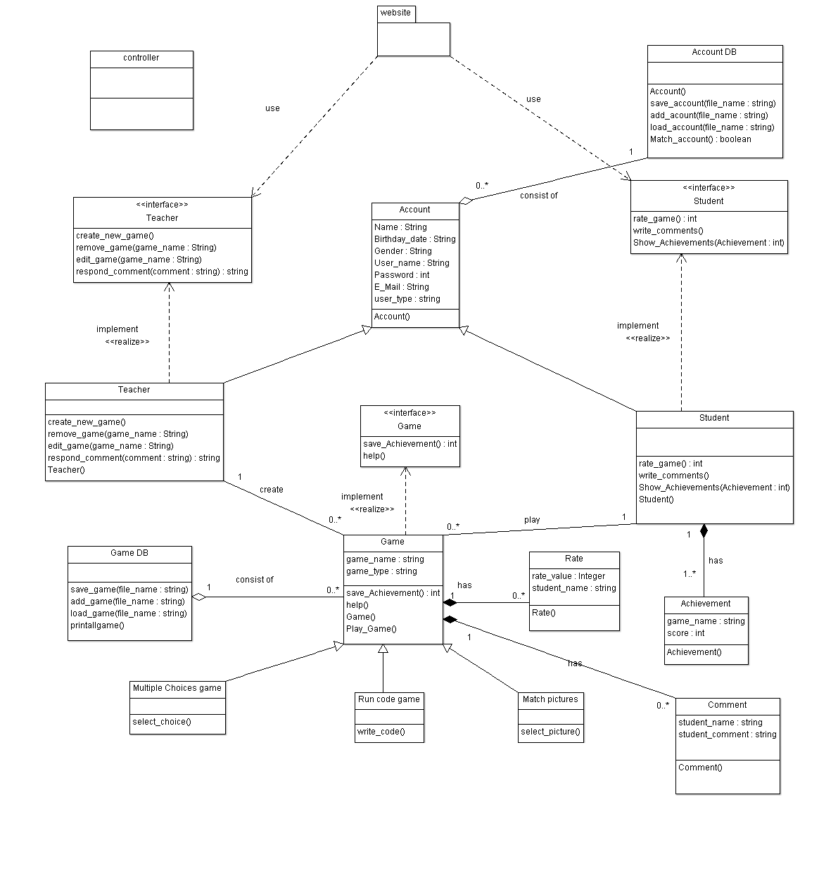

| **Class ID** | **Class Name** | **Description & Responsibility** |
| --- | --- | --- |
| 1 | Account | Class represent what user can do with web site and has user data like name ,gender and age and there is two classes inherited from it student and teacher |
| 2 | Game | Describe game properties and its function like help and play and it has three type or gatogry(multi choice ,match picture and run code) |
| 3 | Achievement | Represent the score of each student in each game |
| 4 | database | This class used for saving data of each game and account information of student and teacher also the achievement of student's score |
| 5 | Controller -GUI | This make the system more usable and easy to use by student and teacher by providing a good interface |

### 

### Important Algorithm

* **If any method in a class is implementing an algorithm (complex enough), then you should describe it here.**

## II. Sequence diagrams

1) register

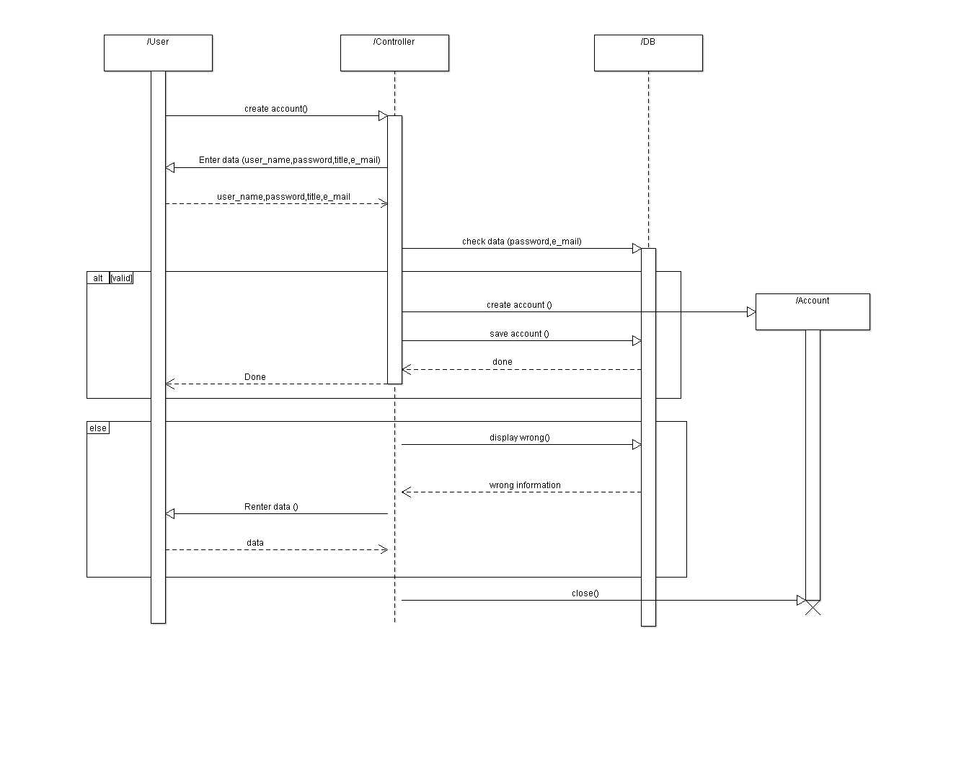

2) play Game

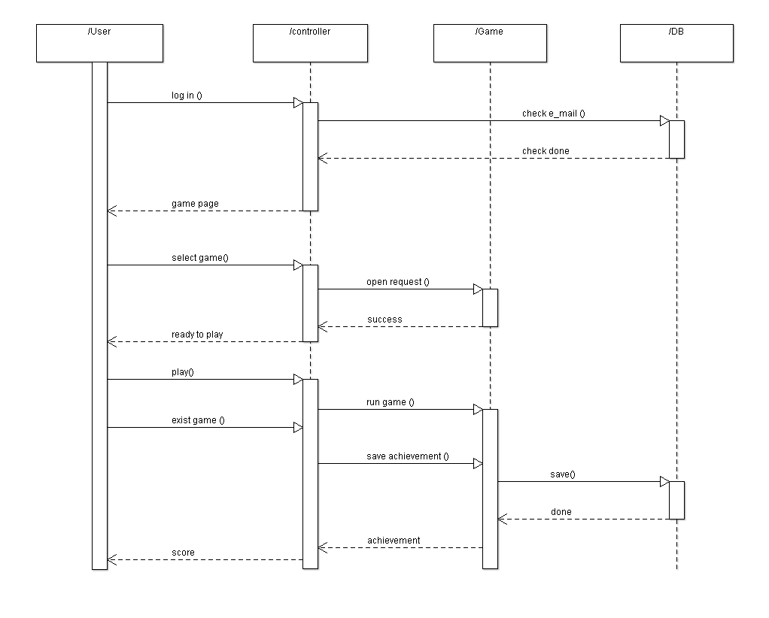

### 

3) create game

### 

### Class - Sequence Usage Table

| **Class Name** | **Sequence Diagrams** | **Overall used methods** |
| --- | --- | --- |
| Teacher | 1 ,3 | Create game() ,create acount() |
| Student | 1,2 | Create account() ,play game() |
| Game | 2,3 | Save achievement(),play gam(),create game() |
| accounted | 1 | Create account() ,set name ,set password |
| database | 1,2,3 | Add game() ,add account() ,save achievement () |
| achievement | 2 | Save student achievement () |

# Ownership Report

|  |  |
| --- | --- |
| **Item** | **Owners** |
| Class diagram | *Ramadan & Ahmed* |
| Sequence diagrams | *Ismail & walid* |