**NSCDC/NHQ/LC/IC/07/14/** **13140**

**26TH February, 2020**

**${personnel_name}**

Ufs: The Command General,

Nigeria Security and Civil Defence Corps,

${state_command},

${state}.

.

**LETTER OF UPGRADING/CONVERSION**

I am pleased to inform you that having met the necessary requirements, the management of Nigeria Security and Civil Defence Corps (NSCDC) by the recommendations of the Junior Staff Committee on Promotion, approved your ${type} from the Rank of **${old_rank_full} (${old_rank_short})** on **(CONPASS ${gl})** to the rank of **${promotion_rank_full} (${promotion_rank_short})** on **(CONPASS ${gl})** with effect from **${effective_date}**.

2. Notice of the Conversion will be published in the Official Gazette soon.

3. Congratulations.

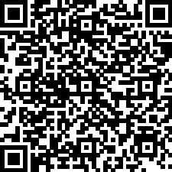

**ADAMU SALIHU**

Commandant Administration

For: Commandant General