AI Coder v3 - System Architecture
High-Level Design (C4 L1+L2), Key Flows, ADRs, NFRs, Risks
AI Coder v3 project
2026-08-30
Table of Contents

Document Control
Field | Value
Document | System Architecture - AI Coder v3 (package v2.0.0)
Version | 1.0
Status | Draft (markdown source of truth; renders from make all)
Date | 2026-08-30
Owner | AI Coder v3 maintainers
Reviewers | -
Approver | -
Sources | main.py, aicoder/core/*, pyproject.toml, README.md, AGENTS.md
Toolchain | pandoc + weasyprint + graphviz + mscgen + gnuplot (docs-as-code)
Component names and line counts in this document were verified against the codebase on 2026-08-30. ADR statuses are inferred from the implementation; no authoritative ADR files exist in the repo yet (see section 7).

1. Executive Summary
AI Coder v3 is a terminal-based, single-process AI coding assistant that runs entirely on Python 3.12+ standard library (zero external runtime dependencies, verified in pyproject.toml).
Key numbers:
- 0 runtime dependencies; Apache-2.0 licensed; console script aicoder-v3 = main:main.
- 1 process hosts the whole system: ~15 core modules orchestrated by AICoder (504 lines) with a static Config class (1,142 lines) driving behavior from environment variables.
- 2 interchangeable LLM provider clients behind one generator interface (StreamingClient for OpenAI-compatible endpoints, AnthropicClient for the Anthropic-compatible endpoint; selected by API_PROVIDER=enviro).
- 6 built-in tools (read_file, write_file, edit_file, run_shell_command, grep, list_directory) plus plugin-provided tools (bg_jobs, ask_user, web_search, get_url_content, read_image).
- ~50 plugins loaded from a 3-tier directory priority system; 30+ slash commands; hook-based extension points.
- 1 Unix-domain-socket IPC server (token-authenticated, mpv-inspired) for external control, inject, and status.
- 1 compaction engine: sliding-window conversation pruning with AI summarization (default context 128,000 tokens, auto-compact at 95%).
Design intent: keep the interactive loop fast on resource-constrained hosts (Raspberry Pi 3-class hardware), keep the tool surface auditable (approval gating, allow/deny filters, sandboxed shell), and keep every behavior configurable from the environment without a config file format of its own.

2. Scope & Goals

In scope
- Structural architecture: entry point, orchestrator, session pipeline, tool system, plugin system, IPC, compaction, provider abstraction.
- Key flows: interactive prompt, piped/YOLO mode, socket control, compaction.
- Non-functional requirements and known risks for the current implementation.

Out of scope
- Per-plugin internal design (covered by plugin source + memory notes).
- Line-by-line API documentation (see docs/SOCKET_API.md, docs in docs/).
- Deployment/ops runbooks; VM/container packaging.

Goals
- Zero-dependency: stdlib-only, trivially runnable via uv venv + pip.
- Extensible: plugins, hooks, and commands without core changes.
- Safe: approvals, allow/deny filters, sandboxed shell execution.
- Self-aware: compaction, caching (cache-hit tracking), cost tracking, stats logging.
- Controllable: external IPC for editors/scripts/tmux automation.

3. System Context (C4 L1)
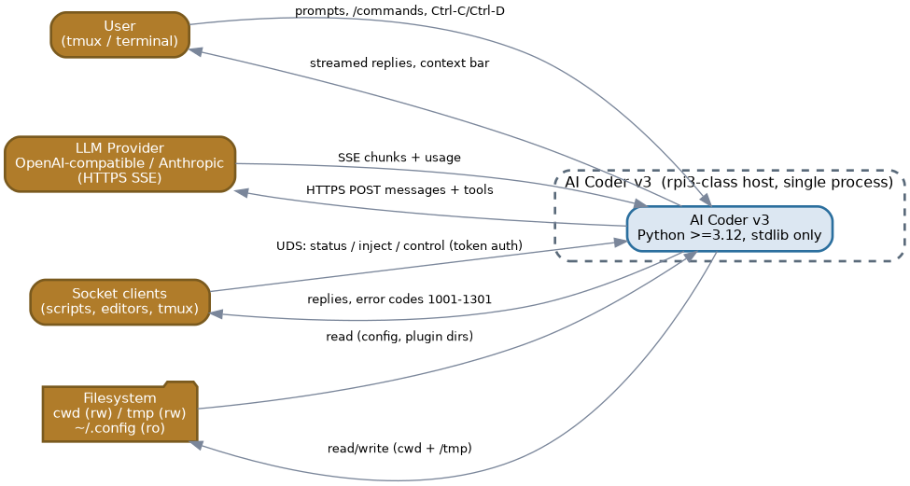
System Context
Element | Role
User | Human in tmux/terminal, drives interactive prompts and slash commands
AI Coder v3 | The system under analysis (single process on the rpi3-class host)
LLM provider | OpenAI-compatible or Anthropic-compatible HTTPS API (streaming SSE)
Socket clients | Scripts, editors, tmux automation talking over the Unix socket
Filesystem | Project cwd (writable), /tmp (writable), ~/.config (read-only), plugin dirs, session/stats logs
External interactions:
- User -> system: typed prompts, /commands, Ctrl-C/Ctrl-D, tmux control.
- System -> LLM provider: HTTPS POST with messages + tool definitions; streamed SSE responses with usage; exponential-backoff retry loops.
- Socket clients -> system: token-authenticated UDS commands (status, inject, control; 10 MiB inject cap).
- System -> filesystem: reads/writes under cwd and /tmp; sandboxed shell spawns have HTTPS-only egress (nftables allowlist).

4. Container View (C4 L2)
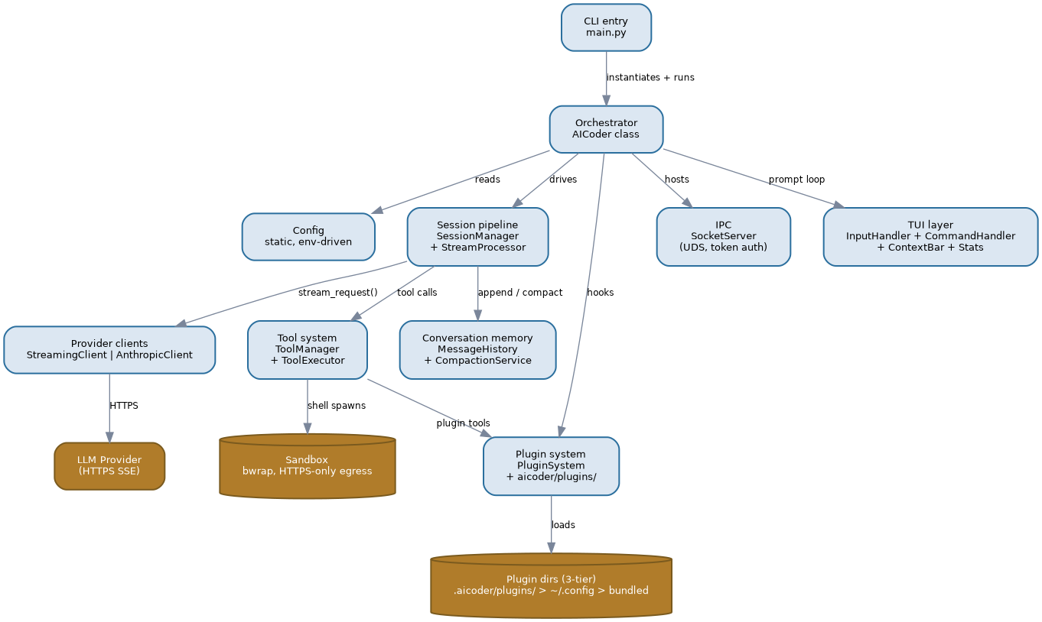
Container View
The AICoder process decomposes into these containers:
Container | Module(s) | Responsibility
CLI entry | main.py | Sets AICODER_START_TIME, instantiates AICoder(), starts the loop
Orchestrator | aicoder/core/aicoder.py | Wires all components; interactive/piped/socket-only modes; signal handling (SIGTERM/SIGHUP); auto-save
Config | aicoder/core/config.py | Static class; all behavior from env vars (YOLO_MODE, SANDBOX, THINKING, REASONING_EFFORT, retries/backoff, context size, thresholds)
Session pipeline | session_manager.py, stream_processor.py | process_with_ai: prepare -> stream -> validate tool calls -> post-process; recursive tool-call loop; reasoning-field detection; cache-collapse; liveness spinner
Provider clients | streaming_client.py, anthropic_client.py | Uniform stream_request(...) generator; SSE + non-streaming; backoff retries; usage hooks
Tool system | tool_manager.py, tool_executor.py | Tool defs for the API; allow/deny filtering; approval + preview flow; guidance mode; post-result hooks
Plugin system | plugin_system.py + aicoder/plugins/ | 3-tier loading, duck-typed create_plugin(ctx), register_tool/command/hook/completer, allow/deny filters
Conversation memory | message_history.py, compaction_service.py | Message store; sliding-window AI summarization; auto-compact trigger; after_compaction hook
IPC | socket_server.py | UDS server; token auth; fixed path via AICODER_SOCKET_IPC_FILE; error codes 1001-1301
TUI layer | input_handler.py, command_handler.py, context_bar.py, stats.py | Prompt input, 30+ slash commands, context/cost bar, request stats
Key points:
- Provider swap is a module import, not an interface layer: aicoder.py picks AnthropicClient vs StreamingClient from API_PROVIDER; both expose the same generator. anthropic_client.py intentionally duplicates core logic (“core must stay stable” - source comment).
- Single source of truth for behavior is the environment: Config is static and env-driven; no config files, no TOML/YAML.
- Conversation memory is two-tier: MessageHistory stores; CompactionService summarizes; dedup/caching plugins (cache_compact, tools_compact) handle the bookkeeping mechanics.
- Extension surface is hooks, e.g. on_context_bar, after_usage_data, on_api_error, before_api_request, on_empty_ai_response, after_compaction, on_stats, on_stats_entry.
- Shell execution is sandboxed (/sec plugin spawns AI shell commands in nested bwrap with HTTPS-only egress allowlist).
- Plugins ship tools (bg_jobs, ask_user, web_search, get_url_content, read_image) and are filtered by TOOLS_ALLOW/TOOLS_DENY/PLUGINS_ALLOW/PLUGINS_DENY.

5. Key Flows

5.1 Interactive prompt with tool loop
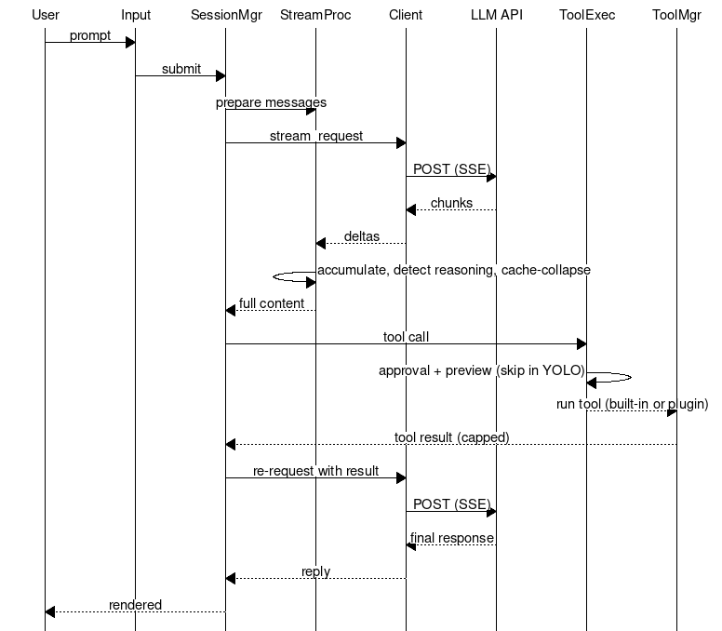
Interactive flow
# rendered from diagrams/key-flow-interactive.msc
Step | Actor | Action
1 | User | Types prompt in InputHandler
2 | SessionManager | _prepare_for_processing builds messages
3 | StreamingClient | POST to LLM provider (streaming, tools attached)
4 | StreamProcessor | Accumulates chunks; detects reasoning fields; collapses for cache; spinner
5 | SessionManager | _validate_and_process_tool_calls; on tool call -> exec
6 | ToolExecutor | Approval prompt + preview (skipped in YOLO mode or by allow-list)
7 | ToolManager | Runs built-in or plugin tool; result capped (MAX_TOOL_RESULT_SIZE=20000)
8 | SessionManager | Feeds tool result back into the loop; repeats until no tool calls
9 | User | Final response rendered

Failure modes (interactive)
Failure | Detection | Response
API error / 5xx / timeout | on_api_error hook | Exponential backoff retry (2^(attempt+1) capped at effective_max_backoff())
Empty AI response | empty content detected | on_empty_ai_response hook; empty-retry plugin re-injects (loop-guarded)
Tool validation error | _validate_and_process_tool_calls | Converted to a user message back to the model
Tool approval denied | ToolExecutor | Call skipped; model informed via result message
Provider returns non-SSE shape | StreamProcessor field detection | Falls back to non-streaming path
Ctrl-C / Ctrl-D | signal handlers, EOF | Graceful interrupt; session resumed

5.2 Piped / YOLO mode
- main.py reads stdin via read_stdin_as_string; non-interactive (piped) mode processes the piped input and exits.
- YOLO_MODE=1 bypasses tool-approval prompts (guidance mode); approvals skipped per allow-list.

5.3 Socket control
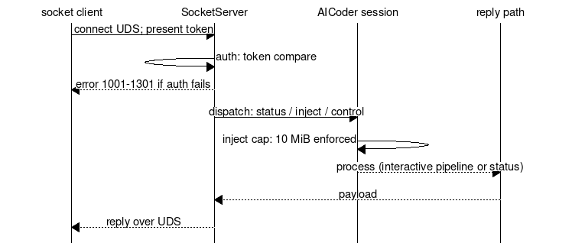
Socket flow
Step | Actor | Action
1 | Socket client | Connects to UDS path (AICODER_SOCKET_IPC_FILE); presents token
2 | SocketServer | Authenticates (token compare); dispatch (error codes 1001-1301)
3 | Session | Injects/controls/status; 10 MiB inject cap enforced
4 | SocketServer | Reply over UDS

Failure modes (socket)
Failure | Detection | Response
Bad/missing token | auth mismatch | Error code (1001 range)
Oversized inject | size check | Reject (10 MiB cap)
Busy session | in-processing flag | Busy status / queue (see memory: remote-busy-status)

5.4 Compaction
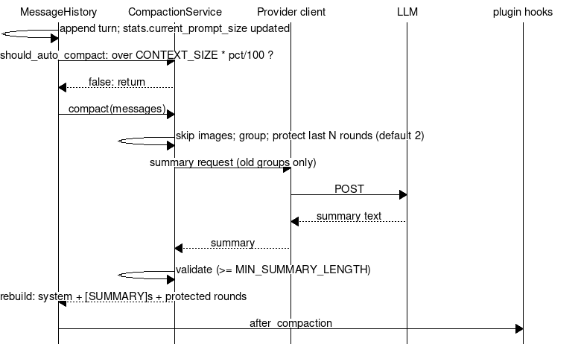
Compaction flow
Step | Actor | Action
1 | MessageHistory | Appends turn; should_auto_compact(): stats.current_prompt_size > CONTEXT_SIZE * CONTEXT_COMPACT_PERCENTAGE/100
2 | CompactionService | Groups messages; protects last COMPACT_PROTECT_ROUNDS (default 2) rounds
3 | CompactionService | Requests AI summary of old groups (_get_ai_summary)
4 | CompactionService | Validates summary (length >= MIN_SUMMARY_LENGTH=100); on failure skips compaction safely
5 | MessageHistory | Rebuilds: system + prior [SUMMARY]s + new summary + protected recent rounds
6 | - | after_compaction hook fires (plugins: cache_hit reset, ai_cost session stats)

Failure modes (compaction)
Failure | Detection | Response
Summary validation fails | summary is None / too short | Compaction skipped; conversation intact
Summary loss in rendering (historical) | memory: compaction-msg-loss | Summary must be visible reply text; whitespace-prefix convention; miss is safe (nudge re-injects)
Image-containing messages | _has_image_content | Excluded from compaction groups
Double-compact | cont_prompt guard + after_compaction hook | Refused + junk dropped (cache-compact mechanics)

6. Capacity & Growth
Single-user tool; the binding constraint is LLM context, not local hardware. Auto-compaction theoretically bounds prompt size at CONTEXT_SIZE * CONTEXT_COMPACT_PERCENTAGE = 128,000 * 95% = 121,600 tokens.
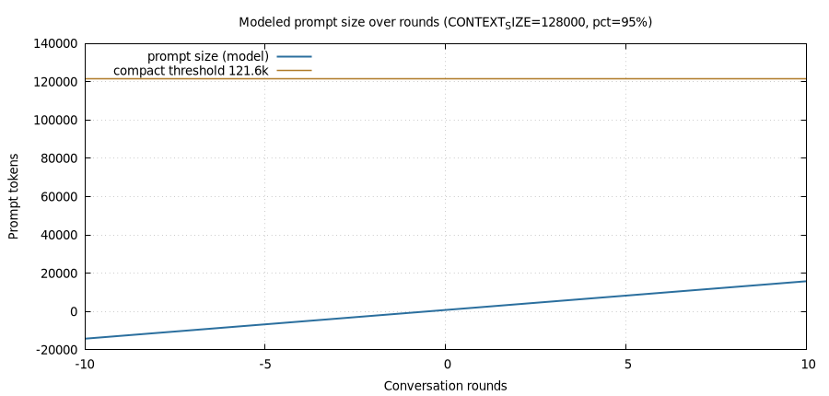
Token growth vs compaction
Modeled sawtooth (assumed ~1,500 tokens/turn, ~700-token summary; model only, not measured — see Risks R-2):
- Round 0-80: prompt grows to the 121.6k threshold.
- Round ~81: compaction collapses history to summary + 2 protected rounds (~3.6k), then growth resumes.
- Practical ceiling: 1 prompt + ~80 full turns per cycle on the default 128k context.
Sizing consequence: because compaction is prompt-size driven and the AI summary replaces the oldest groups wholesale, long sessions degrade into summary-only memory for everything older than 2 rounds — the “self-contained, actionable” summary prompt (compaction_service L317) is the quality bottleneck, not raw capacity.

7. ADR Summary
Inferred from implementation; statuses are observations, not decisions made in an ADR process.
ID | Decision | Rationale | Status
ADR-1 | Stdlib-only, zero runtime deps | Repo vetted; supply-chain and build risk none | Adopted (pyproject.toml)
ADR-2 | Unix-socket IPC (mpv-inspired) over HTTP | No port/exposed surface; local control only | Adopted (socket_server.py)
ADR-3 | Duck-typed create_plugin(ctx) over entry-point packages | Simplest load contract; 3-tier dirs | Adopted (plugin_system.py)
ADR-4 | Env-driven static Config (no config file) | Trivial deployment; tmux/env integration | Adopted (config.py)
ADR-5 | AI summarization compaction over truncation | Preserves context; sliding window + protect rounds | Adopted (compaction_service.py)
ADR-6 | Tool approval + preview gating with YOLO override | Auditability vs speed; user can opt out | Adopted (tool_executor.py)
ADR-7 | Two provider clients with duplicated core (no shared base) | “Core must stay stable”; avoids refactor risk of streaming_client | Adopted (anthropic_client.py header comment)
ADR-8 | Token auth on UDS + fixed socket file path | Local trust boundary; deterministic path for tooling | Adopted (socket_server.py)
ADR-9 | Multi-field reasoning detection + dedup | Providers differ in field names (reasoning_content/reasoning/reasoning_text) | Adopted (stream_processor.py; docs/REASONING_CAPTURE.md)

8. Non-Functional Requirements
ID | Requirement | Target
NFR-1 | Runtime dependencies | 0 (stdlib only)
NFR-2 | Interpreters | Python >= 3.12
NFR-3 | Startup | No network I/O at startup (local load only); interactive prompt in <2s on rpi3-class host (design intent, not measured — see R-2)
NFR-4 | Sandbox | AI-triggered shells in bwrap; HTTPS-only egress allowlist; writable = cwd + /tmp only
NFR-5 | Tool safety | Approval gating by default; TOOLS_ALLOW/TOOLS_DENY filters server-side
NFR-6 | Availability | Backoff retries on provider failure; compaction failures safe-skip; empty-response self-heal hooks
NFR-7 | Context bound | Prompt capped at CONTEXT_SIZE * percentage (default 121.6k)
NFR-8 | Compatibility | Two provider transports behind one generator interface
NFR-9 | Extensibility | Plugins/hooks/commands without core edits
NFR-10 | Observability | Stats log (per-request), central stats socket, cache-hit, session cost (plugins)

9. Risks & Mitigations
ID | Risk | Impact | Mitigation
R-1 | Provider SSE/field drift (reasoning fields, cache fields) | Broken/duplicated reasoning, wrong cost math | Multi-field detection + dedup; heuristic field-based anthropic detection (memory: ai_cost)
R-2 | Performance targets unverified on rpi3 | NFR-3 may not hold | Document as intent; measure on target hardware before claiming
R-3 | Compaction summary quality/loss (historical incidents) | Lost user messages, empty-retry loops | Visible-reply summary convention, whitespace-prefix tag, loop guard, after_compaction hook (memory: compaction-msg-loss, empty-retry-dedup)
R-4 | Plugin trust (arbitrary code via create_plugin) | Malicious plugin runs in-process | 3-tier priority, allow/deny filters, plugin dirs user-controlled; plugins audited (repo-internal)
R-5 | Sandbox escape via user-driven tooling (historical: git pager in cwd) | Host code execution | Seal = processes; .bashrc git wrapper; residual residual risk on make/pytest/npm by design (memory: sandbox-hardening)
R-6 | Central stats log pollution by tests/hooks | Fake cost/usage entries in shared log | Hermetic test rule: STATS_FALLBACK_FILE=0 + patched _write_to_central (memory: CENTRAL LOG POLLUTION INCIDENT)
R-7 | Config sprawl (1,142-line static class, env vars) | Undocumented knobs, drift | README env table; this doc; memory index
R-8 | ADR drift (no authoritative ADRs) | Decisions undocumented | This section; promote to real ADR files when feature set stabilizes

10. Glossary
Term | Meaning
UDS | Unix domain socket - local IPC endpoint (mpv-inspired)
SSE | Server-Sent Events - streaming HTTP response used by LLM providers
YOLO mode | YOLO_MODE=1 - bypass tool-approval prompts (guidance/allow-list)
Context bar | One-line session status (cache %, cost, stats) rendered by ContextBar + plugin hooks
Compaction | Sliding-window pruning of old messages replaced by an AI-generated [SUMMARY]
Protect rounds | COMPACT_PROTECT_ROUNDS (default 2) newest rounds never compacted
Allow/deny filter | Env-driven lists restricting tools/plugins (TOOLS_ALLOW, TOOLS_DENY, PLUGINS_ALLOW, PLUGINS_DENY)
bwrap | bubblewrap - sandbox used for AI-triggered shell commands
3-tier plugin priority | .aicoder/plugins/ > ~/.config/aicoder-v3/plugins/ > bundled aicoder/plugins/
Reasoning fields | Provider-specific stream fields for model “thinking” (reasoning_content, reasoning, reasoning_text)
nftables allowlist | HTTPS-only egress rule set for the sandbox network namespace

