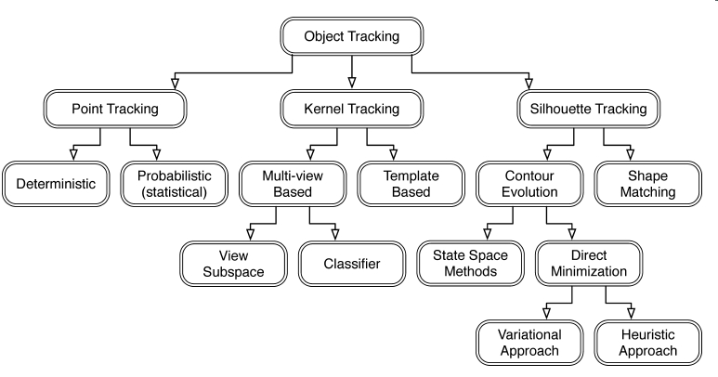detail: http://plaza.ufl.edu/lvtaoran/object_tracking.htm

Point Tracking: http://visual.ipan.sztaki.hu/psmweb/
Kernel Tracking: http://www.scribd.com/doc/11913854/Kernel-Tracking
Silhouette Tracking: http://www.bytegeistsoftware.com/various/SilhouetteTracking.pdf
Model-Based Silhouette Extraction for Accurate People Tracking: http://cvlab.epfl.ch/publications/publications/2002/PlankersF02.pdf

在《OpenCV教程》一书中也有关于跟踪的章节。

http://www.opencv.org.cn/

the simplest camshift tracking example:
http://www.opencv.org.cn/index.php/%E8%AE%BE%E5%AE%9A%E8%B7%9F%E8%B8%AA%E7%9B%AE%E6%A0%87%E5%9B%BE%E7%89%87%E7%9A%84%E6%94%B9%E8%BF%9Bcamshift%E4%BE%8B%E5%AD%90

Cv运动分析与对象跟踪:
http://www.opencv.org.cn/index.php/Cv%E8%BF%90%E5%8A%A8%E5%88%86%E6%9E%90%E4%B8%8E%E5%AF%B9%E8%B1%A1%E8%B7%9F%E8%B8%AA

u can contact me at MSN(riceballl@hotmail.com). any question r welcome.

