Verizon Innovative Learning Lab Middle School Program

Digital Product Innovations

Lesson Facilitator Guide:

Unit 1: Chapter 2

Lesson 4: Advanced Shapes and Colors

Era 1: The 1960’s

Lesson 4: Advanced Shapes and Colors

General Information

Overview
This lesson should take 1 class period, or about 50 minutes to complete.

During this lesson, students will learn how graphic designers make advanced designs using compound shapes and gradients. Then, students will apply their skills by designing a 60’s era band logo.

Lesson Objectives
Students Will Be Able To:
- Learn about color gradients and how to use them in Canva.
- Learn about compound shapes and how to create advanced designs in Canva.

Materials
To complete this lesson, students will need:
- Canva account
- A laptop/tablet
- Student Activity Worksheet

Standards
- ISTE Standards: 6a, 6b
- NCEE Standards: 1

Key Vocabulary
  - Color gradient: the smooth transition between two or more colors.
  - Compound Shapes: shapes combined to form a new shape.

Before you Begin
- Review the "Lesson 4: Advanced Colors and Shapes" presentation and/or lesson module.
- Review this lesson's activity video.
- Ensure students have access to Canva
- Optional: Digitally distribute the worksheet for this lesson: "Advanced Colors and Shapes". This worksheet includes links to videos and other sources, so if you print out hard copies for students, you may have to show each video to the class.

Lesson Procedure

Welcome and Introductions (5 Minutes)
- Welcome students to class. Use the included presentation, or direct students to the self-guided SCORM module if you choose to post it on your Learning Management System. Allow students 2-3 minutes to complete the warm-up on their own, then discuss as a class:
- Warm-up: In the late 1960s, artists and musicians began to experiment with patterns called color gradients. Both images below are examples of color gradients. Based on the images, what do you think a color gradient is?
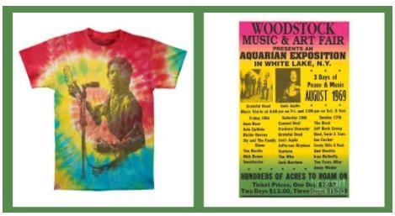
- Answer: A color gradient is a background made up of multiple colors gradually "fading" into each other.
- Next, review the lesson objectives and materials as a class.
- Alternatively, students can read these sections independently or with a partner in a self-guided manner

Color Gradients (5 Minutes)
In this section, students will read about color gradients and see examples of how color gradients are used.
- A color gradient is the smooth transition between two or more colors. You can use gradients in Canva to really make your designs "pop"!
- Check out the different types of gradients below!
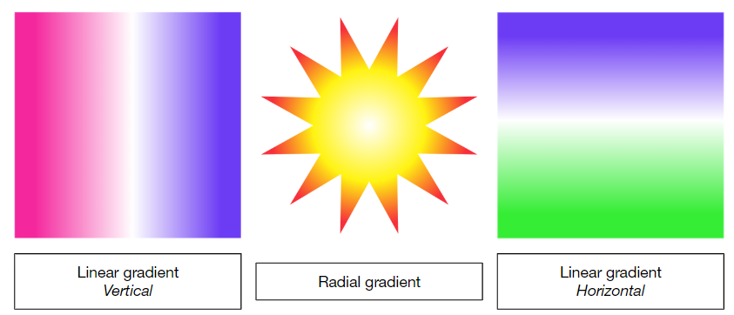

Compound Shapes (5 Minutes)
- Next, students will read about a Canva feature called the Grouping Tool. The Grouping Tool allows us to combine multiple layers into one layer. Check out the different examples of compound shapes below.
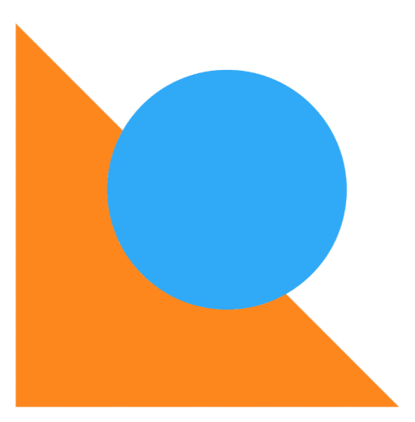

Activity Video: Advanced Shapes and Colors (35 Minutes)
- Students will watch this activity video and follow along in their Canva accounts. Students may also follow the video and guiding questions in the lesson worksheet. At the end of the video, students will complete an independent activity where they design a custom band logo. Their band logo should include:
  - The band name (Rainbow Music Collective)
  - At least one compound shape (union, subtract, difference, intersect)
  - At least one gradient (radial, linear, or angular)

You can use images, effects, clipping, and paths if you want!

- Students will export their logos as PNG files and submit them to their instructor
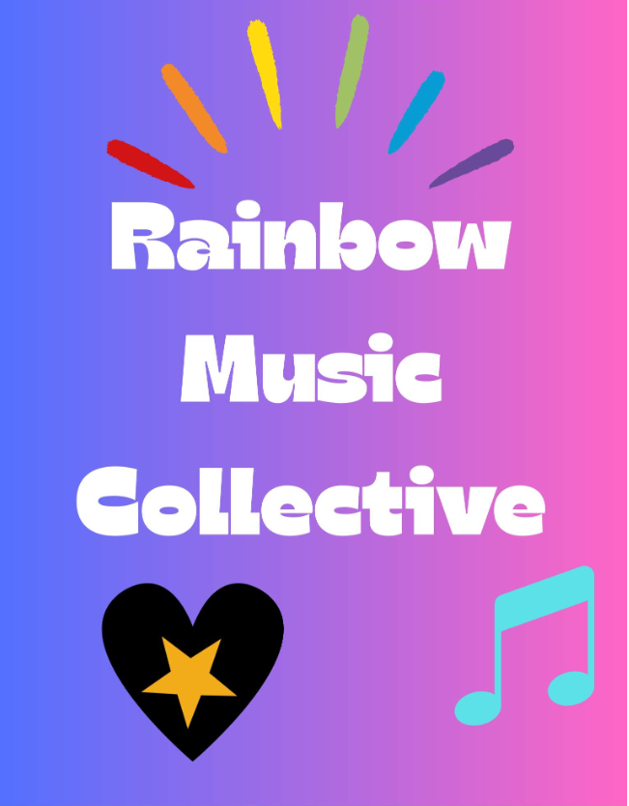

Optional Challenge
- For students that finish early or desire an added challenge: Try to recreate the image below in Canva! Export your design as a PNG and submit it along with the band logo design
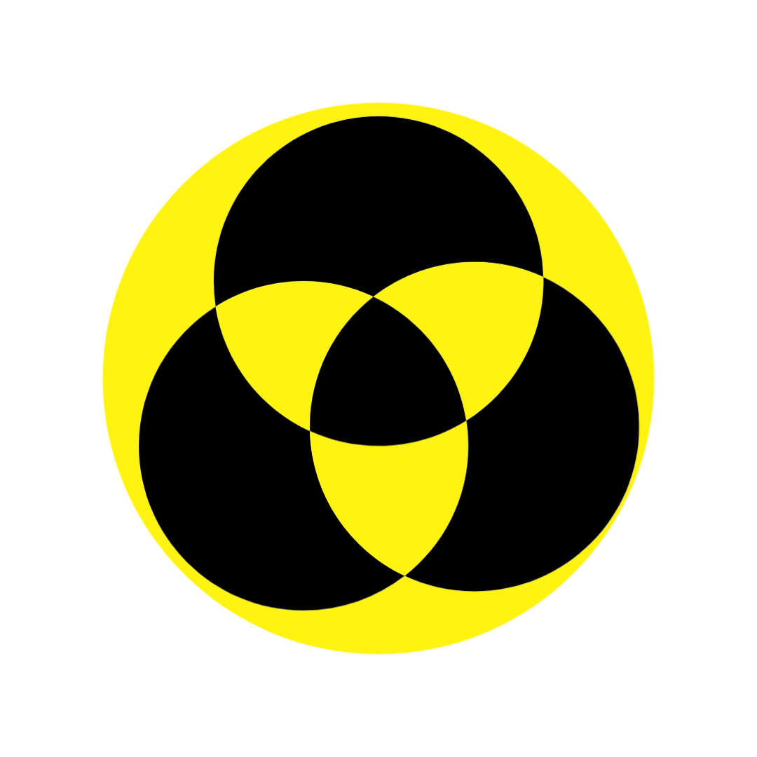

Wrap Up, Deliverable, and Assessment (10 Minutes)
- Wrap up: If time permits, encourage students to share their band logo designs with each other, then discuss the reflection questions as a class.
- Deliverable: Have students export their Surreal designs, save them as PNG files, and submit them to their instructor.
- Reflection Questions: Along with the PNG submission, students can submit answers to the following questions in complete sentences:
- What is something new you learned during this lesson?
- What are gradients and compound shapes?
- Is a sunset an example of a gradient? Can you think of other gradients in our world?
- Assessment: Students can complete "Student Checkpoint: Advanced Shapes and Colors" as an exit ticket. Alternatively, you can omit this checkpoint and grade each student’s activity as their formative assessment

Differentiation
- Additional support #1: Have students draw on paper first what they will then draw on Canva.
- Additional support #2: Group students into teams of 2-3 students and have them share ideas.
- Extension: Try to recreate the image below in Canva! Export your design as a PNG and submit it along with your band logo design.


Additional Resources
- Activity Video: Advanced Shapes and Colors

