Verizon Innovative Learning Lab Middle School Program

Digital Product Innovations

Lesson Facilitator Guide:

Unit 2: Chapter 2

Lesson 3: 3D Modeling Ancient Structures

Era 2: Part 2: Modeling with TinkerCAD
Lesson 3: 3D Modeling Ancient Structures

General Information

Overview
This lesson should take 1-2 class periods, or 50 to 100 minutes.

In Lesson 3’s activity, students will learn about architecture and scale, and they’ll 3D model and 3D print the Parthenon at 1:200 Scale using TinkerCAD and the Ultimaker 2+.

Lesson Objectives
Students Will Be Able To:
- Define the words architecture and scale by completing video activities.
- Follow along with a tutorial to recreate a scale model of the Parthenon in TinkerCAD.
- Customize the Parthenon with features of your choice!

Materials
To complete this lesson, students will need:
- A laptop/tablet
- A TinkerCAD account
- Optional: A 3D Printer

Standards
- ISTE Standards: 5B—Students collect data or identify relevant data sets, use digital tools
to analyze them, and represent data in various ways to facilitate problem-solving and decision-making.
- NCEE Standards: E.06—Compress or Alter files.

Key Vocabulary
- Architecture: is the process of designing and constructing buildings.
- Dimensions: usually Length, Width and Height of an object, and sometimes time (the 4th Dimension).
- Convert: To change a value or expression from one form to another.

Before you Begin
- Review the Student Guide Lesson 3: 3D Modeling Ancient Structures content and ensure it is published on Canvas.
- Provide your students with Link and Nicknames to sign on to TinkerCAD.com.
- Review procedures in Lesson 2 for taking STL files from TinkerCAD, uploading multiple designs to Cura for reviewing and Slicing, and loading the sliced files onto an SD card for the 3D Printer to print.

Lesson Procedure

Welcome and Introductions (5 Minutes)
Welcome students to class. Direct students to “Student Guide Lesson 3: 3D Modeling Ancient Structures.” Allow students 2-3 minutes to complete the warm-up on their own, then discuss as a class:

Architecture is the process of designing and constructing buildings. In the modern world, architects begin by sketching their building designs on paper, then use a computer to create 3D models and digital plans, or blueprints, of their designs.

Ancient Greece inspired many architectural ideas still used today! However, Ancient Greeks didn't have computers and 3D modeling, so what was it like?

Warm-up: One of the most famous buildings from Ancient Greece is the Parthenon. Look at all of the models of the Parthenon below. Which model would take the least amount of time to create?

Answer: Out of all of these modeling processes, 3D modeling the Parthenon on the computer is the fastest! What would the ancient Greeks say if they could have had this tool?
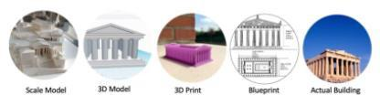

Review the lesson objectives and materials as a class.

Facilitation Tip: If your students need more support, project the lesson module on a screen and present it like a slideshow to the entire class. Alternatively, students can read these sections independently or with a partner in a self-guided manner.

Watch: Architecture in Ancient Greece (6 Minutes)
Watch this video as a class. Define Architecture. How did Ancient Greeks plan architecture without computer- aided design?

Knowledge Check: How did architects in Ancient Greece design buildings without computers?
Answer: (A) They created rough drawings (syngraphai) and models (paradigma) of the building. Then they worked out the calculations in real time through instinct and trial and error.
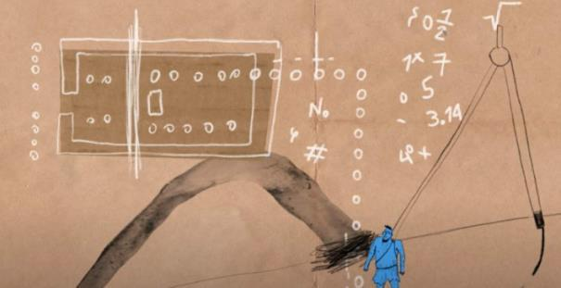

Architecture is the process of designing and constructing buildings. In the modern world, architects begin by sketching their building designs on paper, then use a computer to create 3D models and digital plans, or blueprints, of their designs.

Watch: Modern Architecture (5 minutes)
Watch this video as a class. Students learn how Computer-Aided Design and 3D Printing help modern architects design buildings in context.

A scale model is a smaller version of the real design. For example: if you were designing a 100 ft tall building, you might 3D print a 1:100 scale model to see how it looks! Your scale model would only be 1 foot tall.

Activity 1: Scale is a calculated re-sizing! (10 Minutes)
Today's Product: Today students will create a Miniature Parthenon!

- Design it as a 3D Model in TinkerCAD.
- Measure it to a 1 to 200 Scale (we also write this 1 : 200).
- If possible, teachers will 3D Print student creations.

Check out the dimensions (Length, Width and Height) of the Life-Size Parthenon by clicking on the image below. We will round to the nearest Meter (m).

Question: What does "1 to 200 Scale" mean?
Answer: Divide the Length of the Life-Size Parthenon by 200 to get the Length of the Miniature Parthenon.
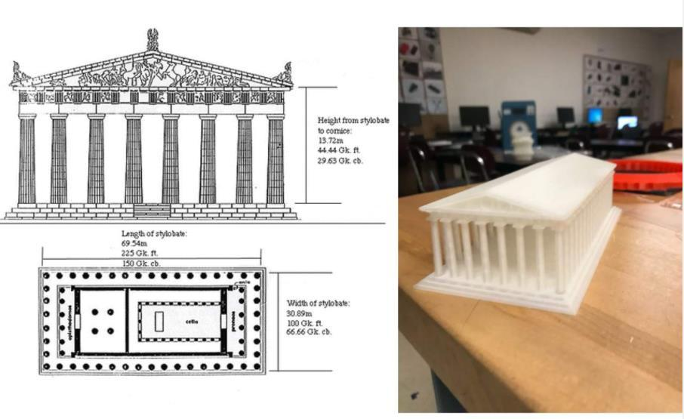
Students will investigate Dimensions of the original Parthenon:
- Stylobate = base.
- Height = 14 meters
- Width = 31 meters
- Length = 70 meters

Units: What are we measuring with? (5 Minutes)

How big is a meter? How big is a Millimeter
Did you notice the Parthenon was measured in Meters? In contrast, TinkerCAD measures in Millimeters(mm) by default. We must convert our measurements to Millimeters.

There are 1000 Millimeters in 1 Meter!

Think about it: How do we convert Meters to Millimeters?
Answer: Multiply by 1000.
Explanation: Since we are measuring the same length (70 meters) with a smaller unit (Millimeters), we will need MORE of these Millimeters! Therefore, we will multiply by 1000.

Calculate: What is the Length of a Miniature Parthenon? (5 Minutes)
To review, it takes two steps to find the Length of our Scale Model Parthenon:

- First we'll multiply to convert Meters to Millimeters (mm). There are 1000mm in one Meter.
- Second, we'll Divide to convert Life-Size to Miniature-size, using our Scale ratio, 1 : 200.
ANSWER: The Length of the Miniature Parthenon will be 350 Millimeters.

Now You Try: Calculate the Height and Width of your Parthenon. (5 Minutes)
From the calculations above, we know the Length of your 3D Model should be 350mm. Now we'll convert the Height and Width of the Life-size Parthenon to the expected Height and Width of your scale model.

Students will write down on paper the blanks in the table below. Multiply and divide, as the table says.

Challenge students to not use a calculator.

Life-Size Dimensions | Operation | Converted to Millimeters | Operation | Converted to 1:200 scale
70 Meters Long | Multiply by 1000 MM | 70,000mm Long | Divide by 200 | 350mm Long
14 Meters Height | Multiply by 1000 MM |  | Divide by 200
31 Meters Width | Multiply by 1000 MM |  | Divide by 200

Circle the final Length, Height and Width of your Parthenon 3D Model on your paper so you can create your product in TinkerCAD.

Check: Can a 3D Model with these measurements fit in a 3D Printer (about 12 inches long by 12 inches wide)?

Activity 2: Create a 3D Model Parthenon! (30 Minutes)
It's time to practice some advanced skills in TinkerCAD. In this activity, students will recreate a 1:200 scale model of the Parthenon in TinkerCAD by following a tutorial video. Then students will add their own custom features!

- Practice designing the Parthenon in TinkerCAD:
  - Log in to your TinkerCAD account
  - Follow the tutorial video below to recreate a 3D model of the Parthenon!
  - After the video, export the PNG image of your own design using the "Send To" button. You can then submit this image on canvas!
- Customize: Students choose at least two of the features below, then modify their 3D model of the Parthenon to include those features!
- A swimming pool
- A skylight (rooftop window)
- A playground/jungle gym
- A petting zoo
- A basketball court
- A garden
- A restaurant
- An ice cream parlor
- A skatepark
- A bowling alley

- Export: When the customized Parthenon is complete…
- First, students choose the "Send To" button to download a PNG (2D) screenshot of their design. Students will submit this on Canvas for a grade.
- Second, students use the "Export" button to download an STL file of your design. The teacher can review the STL file in Cura and slice it for 3D printing.

- Optional Challenge: Students can Build a Roman Dome with Columns.
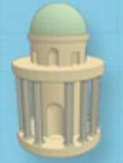
- Follow the steps in the project Build a Roman Dome with Columns
- Create your own custom structure using your new skills.
- If you have your teacher's approval: export, slice and 3D print your new design.

Wrap Up, Deliverable, and Assessment (5 Minutes)
Wrap up: If time permits, discuss the reflection questions as a class.
Deliverable: When the Customized Parthenon is complete, use the "Send To" button in TinkerCAD to download a PNG image of your design, and submit this on Canvas Era 2 Part 2 Lesson 3: 3D Modeling Ancient Structures.
Reflection Questions: In the "comments" of your Canvas submission, answer the following questions in complete sentences:
- What is something new you learned during this lesson?
- Why are scale models and 3D printing helpful tools for modern architects?
- If you could design your dream house in TinkerCAD, what would you include?
Assessment: Students can complete the quiz in Canvas labeled Student Checkpoint: Lesson 3: 3D Modeling Ancient Structures. Alternatively, the teacher can leave this Checkpoint unpublished in Canvas and grade each student’s activity as their formative assessment.

Differentiation
- Additional Support #1: students can use another medium to create a 3D object. Students should take multiple length, width, and height measurements.
- Additional Support #2: Group students into teams of 2-3 students.
- Extension #1: Students can Build a Roman Dome with Columns
  - Follow the steps in the project Build a Roman Dome with Columns

Additional Resources
- Student Guide Lesson 3: 3D Modeling Ancient Structures
- TinkerCAD Parthenon Tutorial Video
- A Day in the Life of an Ancient Greek Architect
- Modern Architects Using Scale 3D Models & 3D Printing
- Using a Ultimaker 2+
- Using a MakerBot Printer

