DAY 2 | MISSION 1 · DESIGN THE ROBOT  Start with a real job and a real constraint, not a gadget with no purpose.

TODAY'S GOAL Design a robot for one ocean-research job. | EVIDENCE One labeled design brief · 5 points

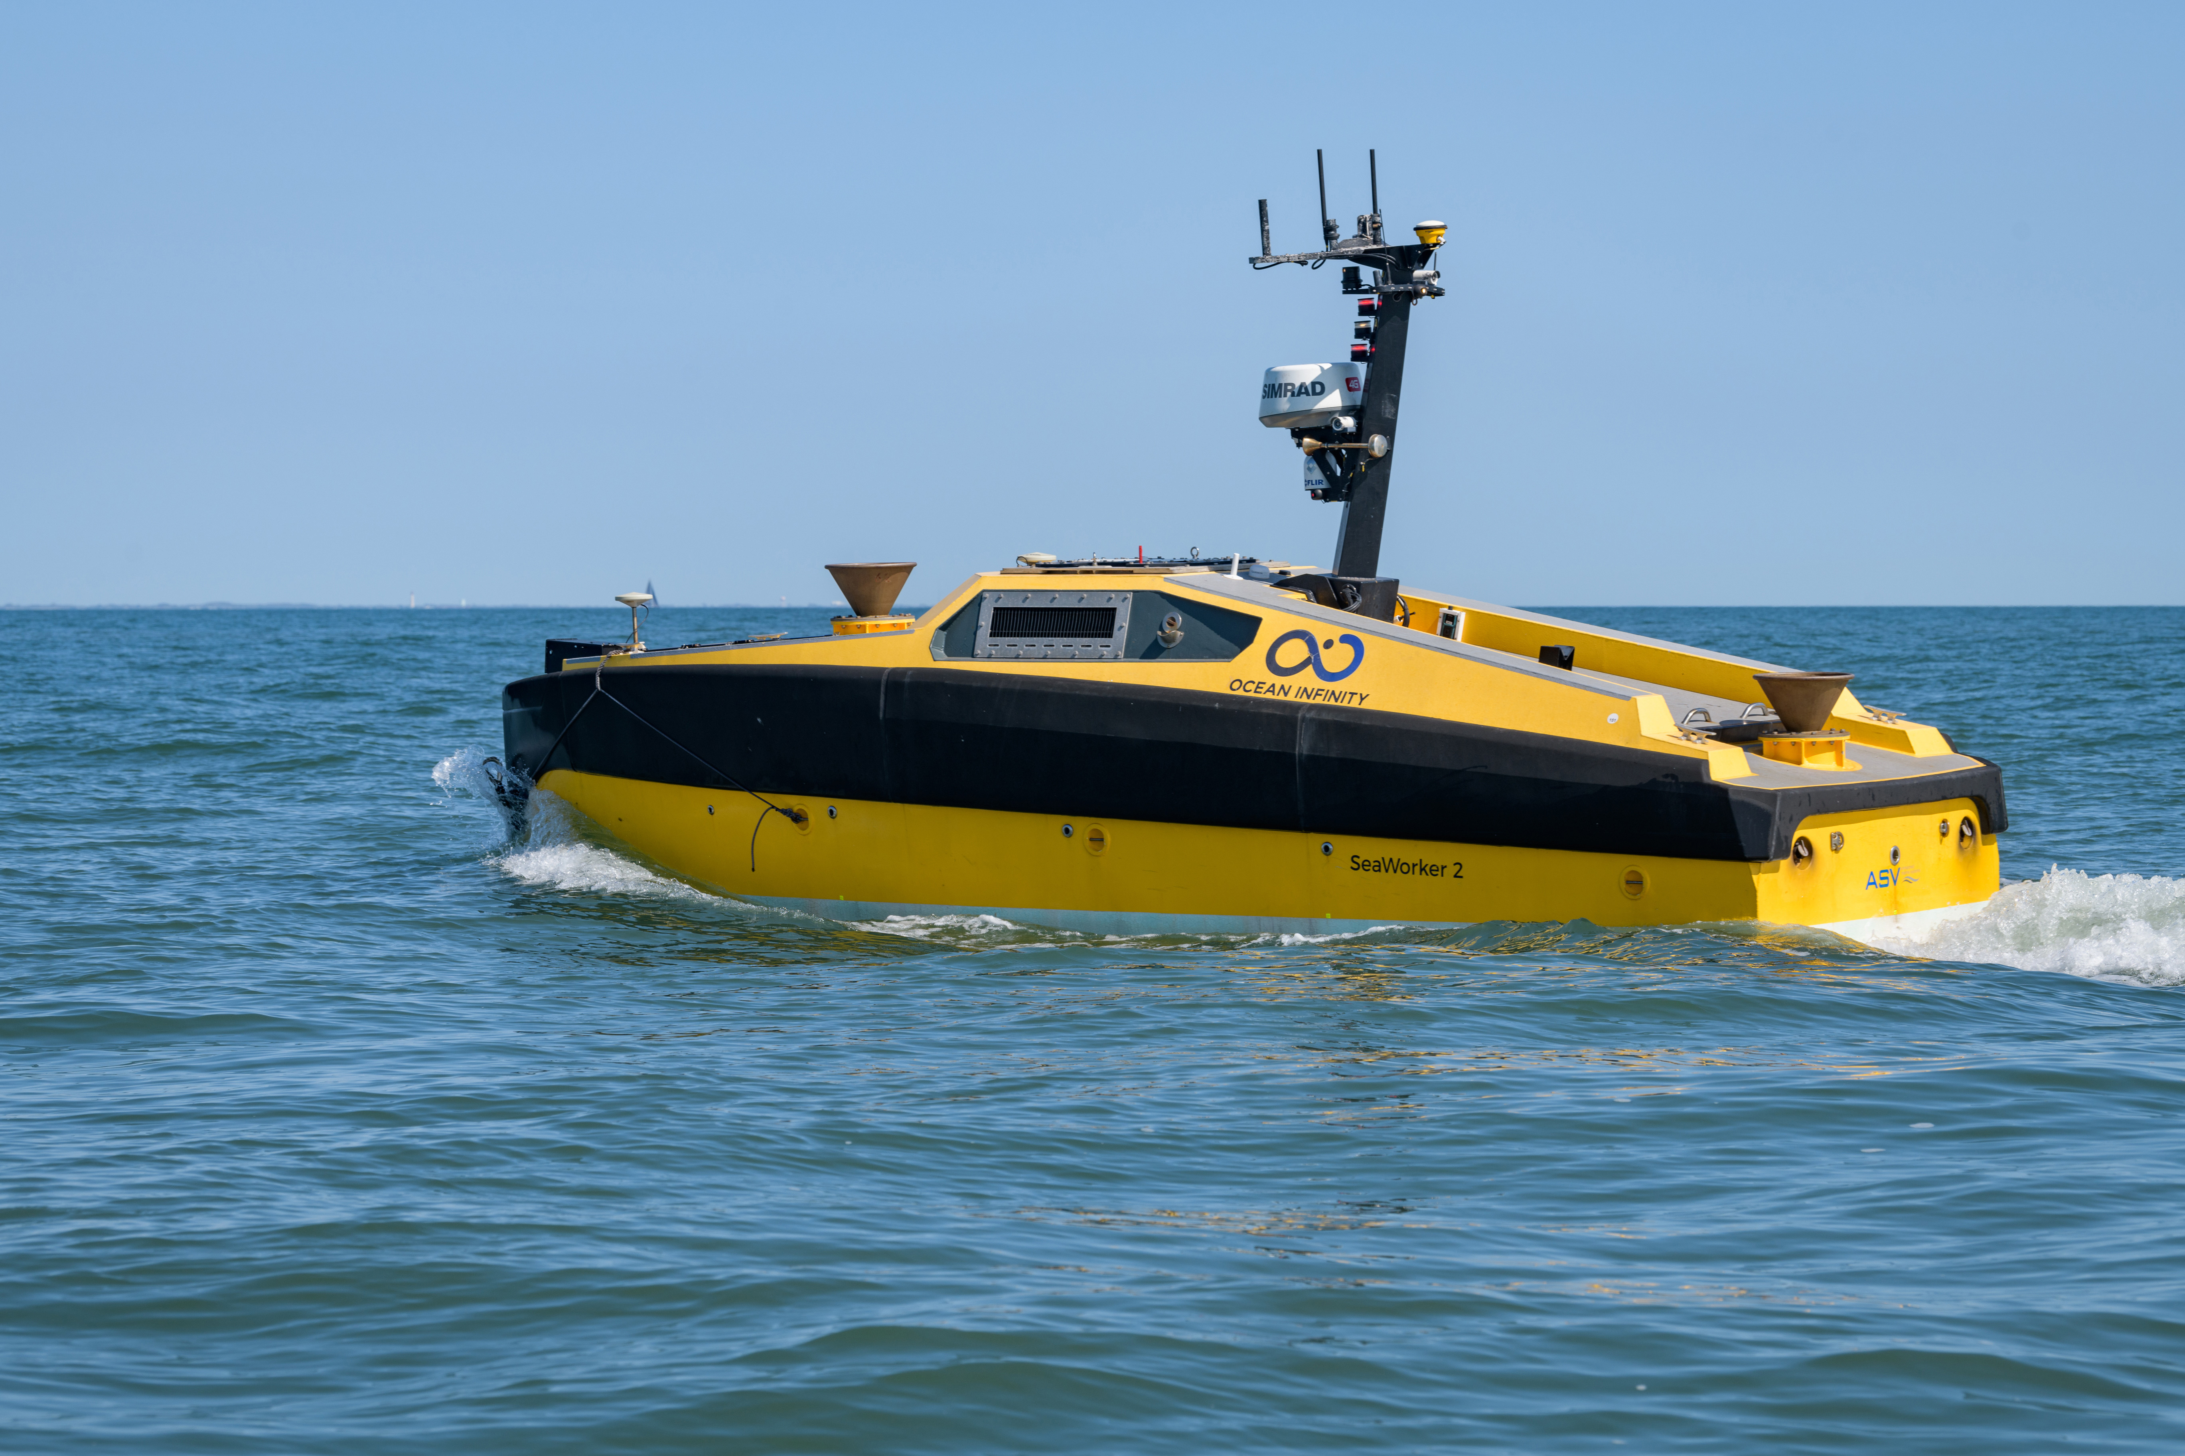  Autonomous surface vehicle used for lake mapping research.  Photo: Evan Krape, University of Delaware / NOAA Ocean Exploration. | CHOOSE ONE JOB Water Watch · Reef Scout · Trash Tracker · Signal Relay  USER Who needs the information or help?  ________________________________________________________________________________  NEED What must the robot help the user do?  ________________________________________________________________________________  CONSTRAINT What limit makes the design harder?  ________________________________________________________________________________

DESIGN BRIEF Sketch and label the system
DRAW LARGE. LABEL THE SENSOR, INPUT, PROCESS, AND OUTPUT.
MISSION | INPUT | PROCESS | OUTPUT | CONSTRAINT
job + user | what it senses | what it decides | what it does | limit it must handle

DAY 3 | MISSION 2 · WRITE, TRACE, REVISE  An algorithm is useful only when another person can follow it.

TODAY'S GOAL Write a testable algorithm for the robot. | EVIDENCE Steps + partner trace + revision · 10 points

ALGORITHM Write 6 to 10 ordered steps
WORD BANK move · scan · sense · record · compare · if · then · repeat · stop
# | ROBOT INSTRUCTION
1
2
3
4
5
6
7
8
9
10

LOGIC CHECK Add one decision and one stop or repeat rule
DECISION IF the robot detects ______, THEN it will ______.  ________________________________________________________________________________ | STOP / REPEAT The robot will STOP / REPEAT when ______.  ________________________________________________________________________________

TEST Partner trace
PARTNER READS  Where did the robot go?  ________________________________________________________________________________  ________________________________________________________________________________ | PARTNER FLAGS  What was unclear or missing?  ________________________________________________________________________________  ________________________________________________________________________________ | AUTHOR REVISES  What exact step did you change?  ________________________________________________________________________________  ________________________________________________________________________________
REVISION STEM I changed step ___ from ___ to ___ because the test showed ___.

DAY 4 | MISSION 3 · TRAIN, TEST, IMPROVE  A model learns patterns from examples. It does not understand the object.

TODAY'S GOAL Train two fair classes and test new examples. | EVIDENCE Evidence table + improvement · 10 points

COLLECT Plan two fair classes
CLASS A NAME ________________________  TRAINING PLAN Different angles, distances, positions, and people.  ________________________________________________________________________________  ________________________________________________________________________________ | CLASS B NAME ________________________  TRAINING PLAN Different angles, distances, positions, and people.  ________________________________________________________________________________  ________________________________________________________________________________
FAIR-TEST RULE Do not use the same example for training and testing.

EVIDENCE Record three tests
TEST EXAMPLE | PREDICTION | CONFIDENCE | CORRECT? | WHAT I NOTICE
New example 1
New example 2
New example 3

REVISE Improve the model using evidence
IMPROVEMENT What will you add, remove, or vary?  ________________________________________________________________________________  ________________________________________________________________________________  ________________________________________________________________________________ | HUMAN CHECK When should the robot ask a person instead of acting alone?  ________________________________________________________________________________  ________________________________________________________________________________  ________________________________________________________________________________
EVIDENCE STEM The model struggled when ___. We improved it by ___ because the test showed ___.

DAY 5 | FINAL SYSTEM BRIEF  Connect the physical robot, coded rules, learned model, and human judgment.

TODAY'S GOAL Explain one complete smart system. | EVIDENCE Final trace + peer check + DOL

SYSTEM BRIEF Build the six-part explanation
PART | YOUR EVIDENCE
1 · USER + NEED | Who needs what help?
2 · ROBOT DESIGN | What physical system will do the job?
3 · INPUT + OUTPUT | What does it sense and do?
4 · ALGORITHM | What ordered rules control it?
5 · MODEL | What pattern does it predict?
6 · HUMAN CHECK | When must a person decide?

GALLERY WALK Trace, check, revise
READ Find the user and need.  ________________________________________________________________________________  ________________________________________________________________________________ | TRACE Follow input → process → output.  ________________________________________________________________________________  ________________________________________________________________________________ | TEST Find one possible failure.  ________________________________________________________________________________  ________________________________________________________________________________
FEEDBACK STEM Your system is clear when ___. I still wonder what happens if ___.
REVISION After feedback, I changed ___ because ___.

EXIT Demonstration of learning
In our system, the robot ___, the algorithm ___, and the model ___. A human should step in when ___.
________________________________________________________________________________
________________________________________________________________________________
________________________________________________________________________________
WEEK EVIDENCE · 25 POINTS | Robot design 5 · Algorithm 10 · Model 10

