Name(s):_____________________________________________________________

Instructions
Follow each step below to learn how to wire the LED modules, use the expansion board, and program a traffic light!

1. Materials

For this activity, you will need the following materials:

-1 BBC micro:bit

-1 USB Cable

-1 micro:bit expansion board

-1 breadboard

-Several Wires

-3x LED’s

-3x 47 ohm Resistors
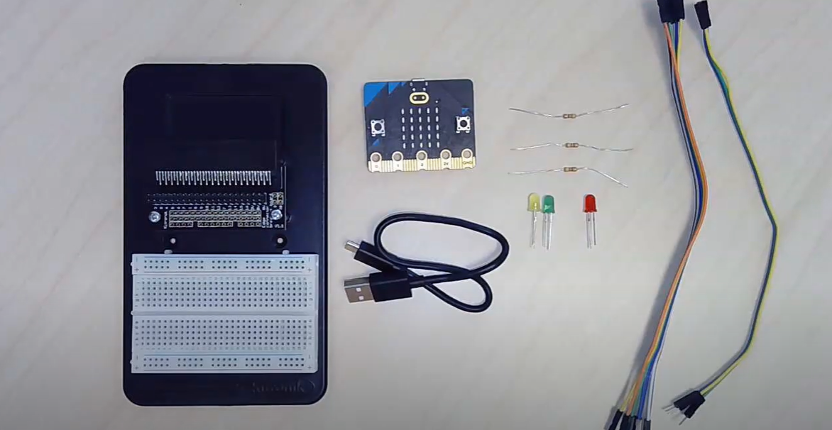

2. Video Tutorial: LED and Expansion Board
Follow along with the video tutorial below to learn how to wire the LED and use the micro:bit expansion board!
Link: https://www.youtube.com/watch?v=LbT3ztY0SiQ

3. Knowledge Check: Look at the image below, then choose the correct statement.

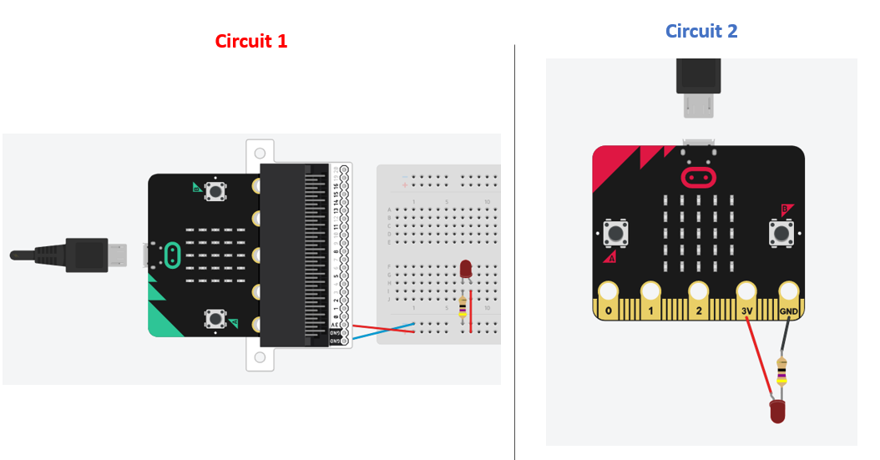
- These circuits are different. The LED in Circuit 1 will light up. The LED in Circuit 2 will not light up.
- These circuits are different. They are both wired incorrectly and the LED will not light up.
- Circuits 1 and 2 are the same. The LED will light up in both circuits.

4. Learn how to program the LED Module.
A. Wire your LED and expansion board like the image below. (The long side of the LED should go to pin P0, the "-" side should go to the resistor and GND)
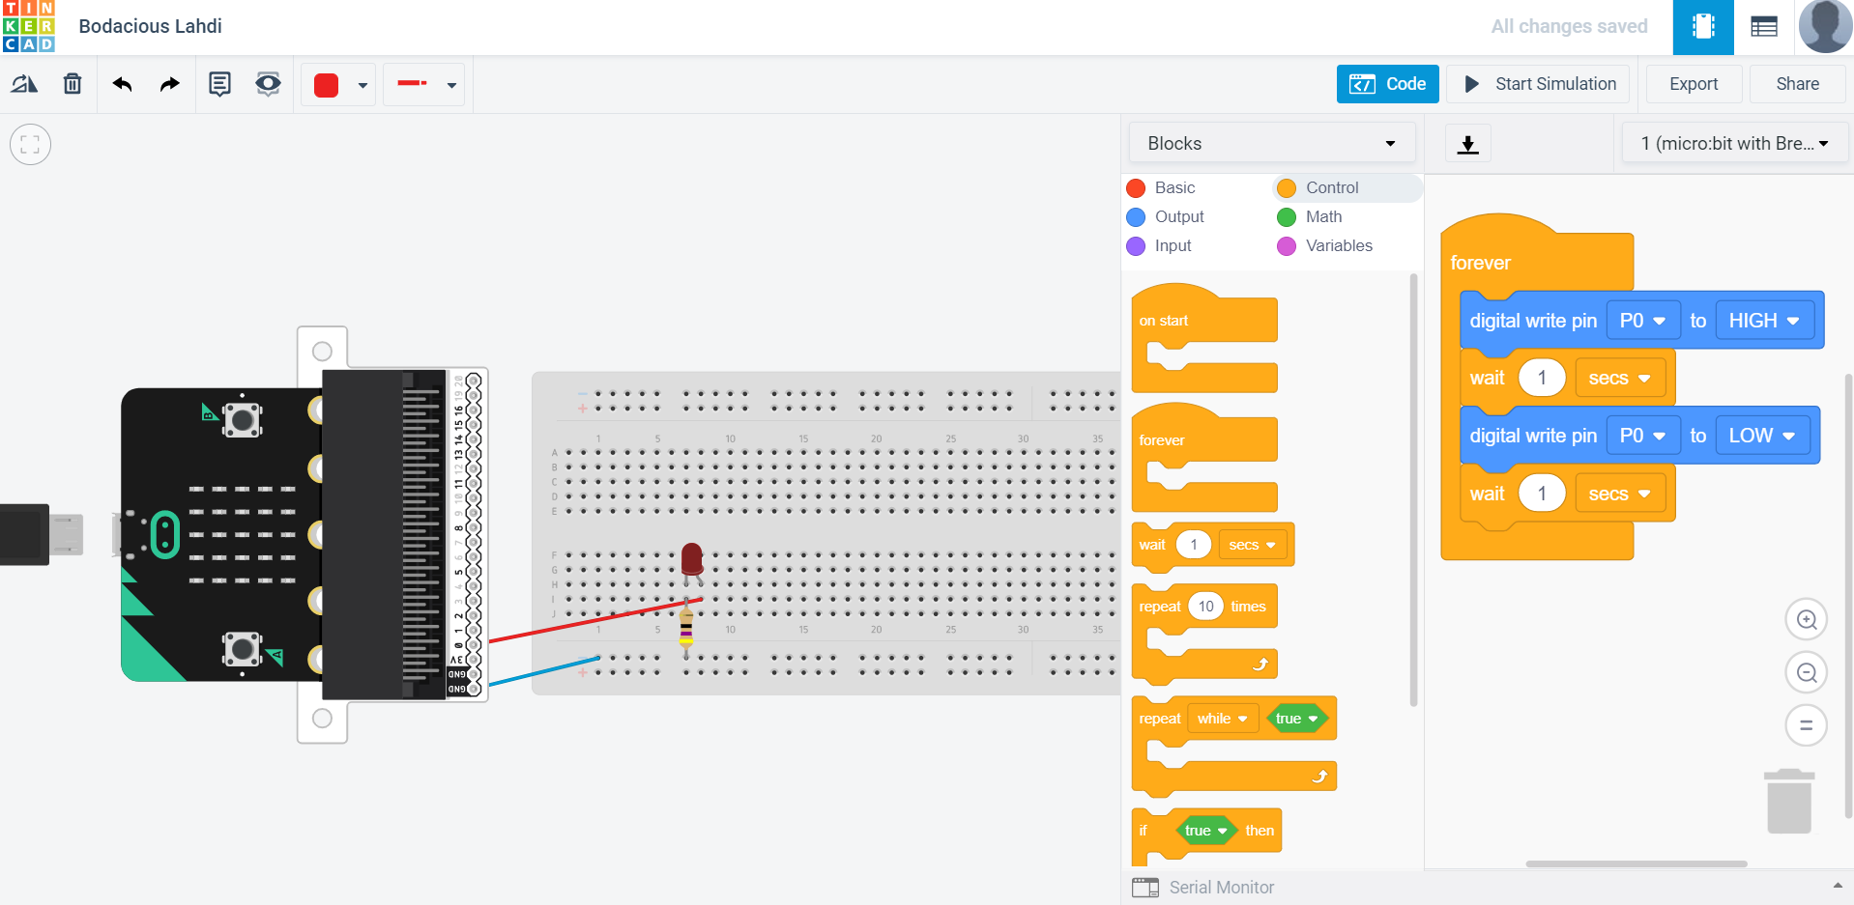

B. Go the MakeCode homepage [link: https://makecode.microbit.org/# ]. Start a new project. Create and upload the following code to your micro:bit (hint: the "digital write" command is under "pins" in the lefthand tool bar. You might have to click "advanced" to find it.)
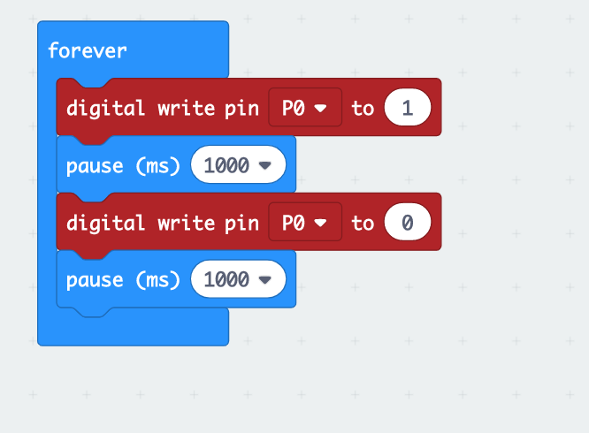

5. Knowledge Check: What happens when you upload the MakeCode from Step 4?

a. The LED turns on for one second, then off for one second, over and over again.
b. The LED turns on and stays on.
c. The LED turns on and off once, then stops.

6. Change your MakeCode program so that the "pause" time is 100 milliseconds. Upload this code to the micro:bit. What do you observe?

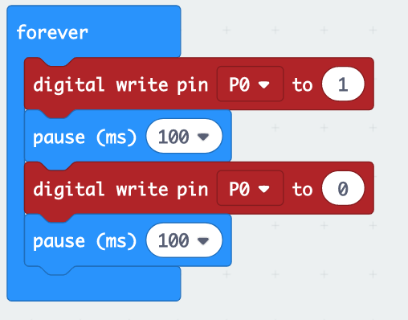

- The light is blinking slower than it was in Step 4.
- The light is blinking faster than it was in Step 4.
- The light is blinking at the same speed as Step 4.

7. The "digital write" command turns pins on and off. "1" means on, and "0" means off. What will the code below do? (Hint: write it yourself and test it on your micro:bit!)

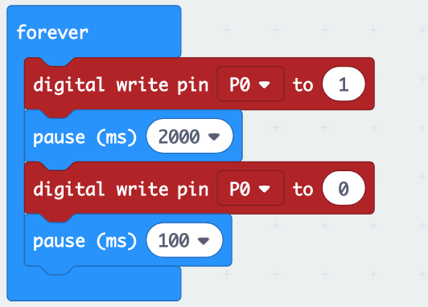

- Turn the light on, wait 100 milliseconds, turn the light off, wait 2000 milliseconds. Repeat.
- Turn the light on, wait 1 second, turn the light off, wait 1 second. Repeat.
- Turn the light on, wait 2000 milliseconds, turn the light off, wait 100 milliseconds. Repeat.

8. Control multiple lights!
A. Leave your Red LED connected to pin P0 and GND.
B. Connect the Green LED to the expansion board: "long leg" to pin P1, "short leg" to a resistor and GND (see image below).
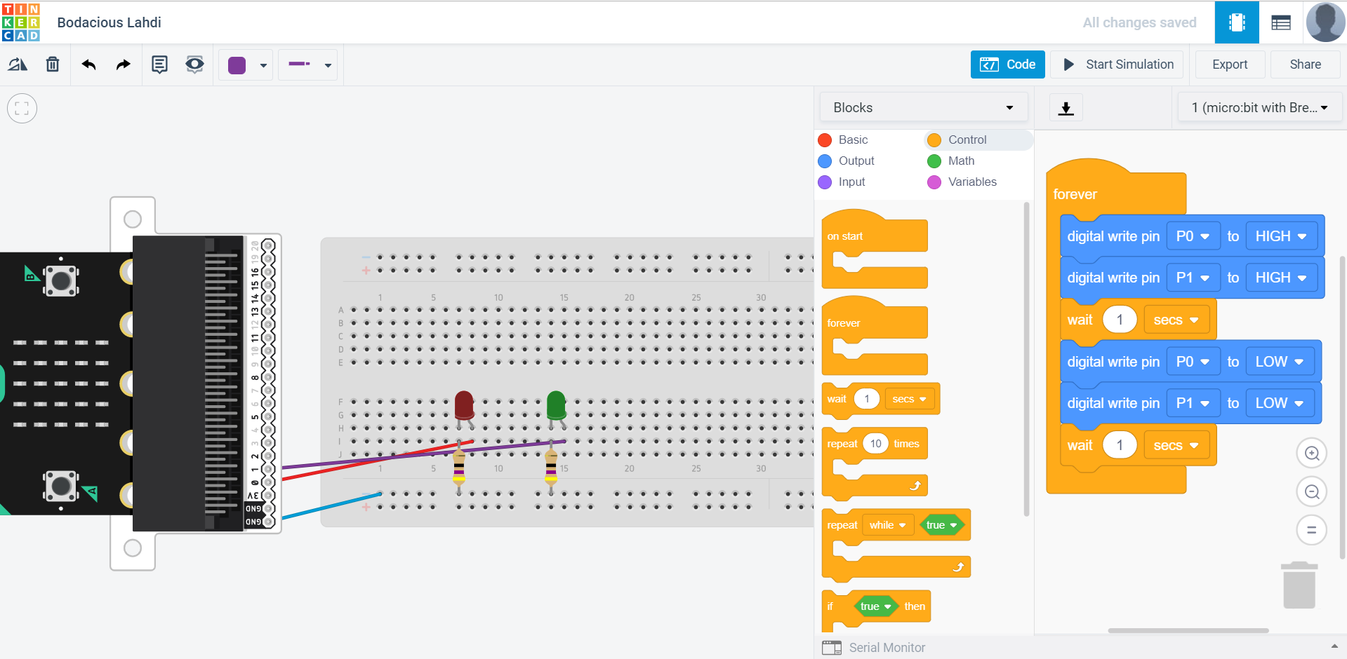

C. Write and upload the MakeCode below to your micro:bit. You should see both lights turn on at the same time, then turn off one at a time.
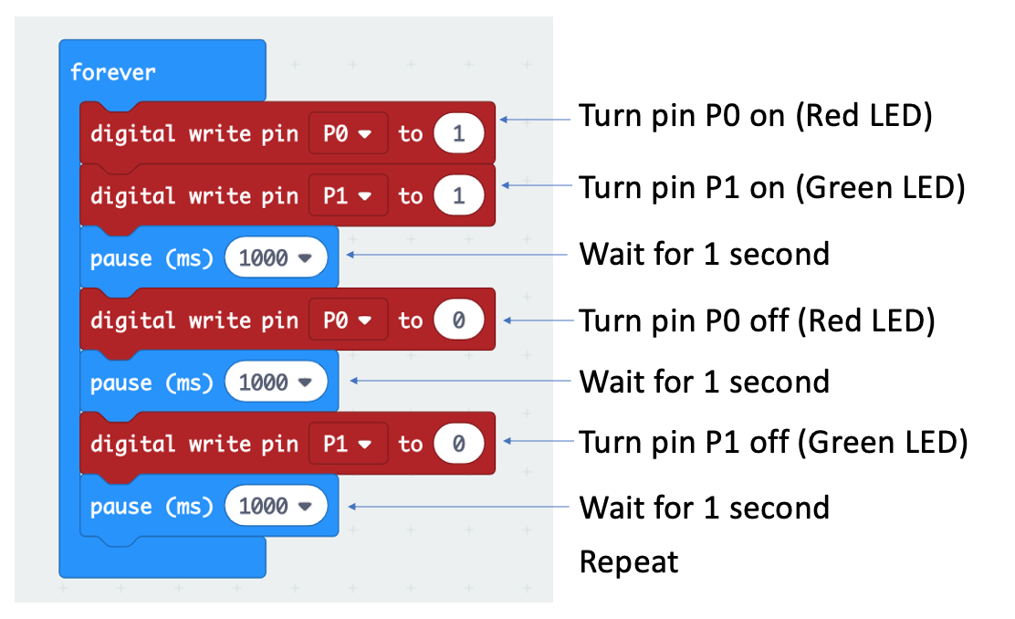

9. Tweak the Code!
Modify the code from Step 8 so:
-The Red LED turns on for 1 second, then off for 1 second.
-Then, the Green LED turns on for 1 second, then off for 1 seoncd.
-Next, both LEDs quickly blink on and off together.
-The code repeats
Share your MakeCode and paste the link in the space below.

________________________________________________________________________________________________________________________________________________________________________________________________________________________________________________________________________________________________________________________________

10. Optional Challenge: Traffic Light
VilBot's town needs a new traffic light, are you up to the task to wire and program it?
Here's what it needs:
-A Red, Green, and Yellow LED wired to the expansion board
Write your own MakeCode so that:
-The Green light turns on for 5 seconds
-The Green light turns off
-The Yellow light turns on for 2 seconds.
-The Yellow light turns off
-The Red light turns on for 5 seconds
-The Red light turns off
-Repeat
Copy and paste your shared MakeCode link in the space provided!

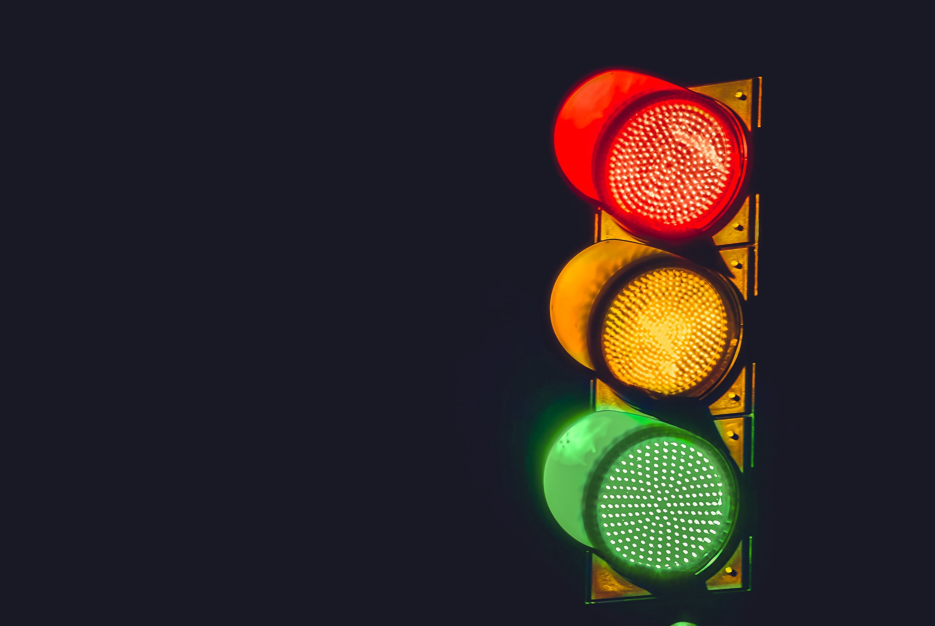

________________________________________________________________________________

Great work!

