LAB 1: COMPLETE PATH + MATERIAL TEST | DAYS 1-2

NAME: ____________________ | PARTNER: ____________________ | PERIOD / DATE: ____________________
OBJECTIVE  Trace a complete circuit and test one variable at a time. | DEMONSTRATION OF LEARNING  Label the path and support conductor/insulator claims with lamp evidence.

DAY 1 • FOLLOW THE PATH
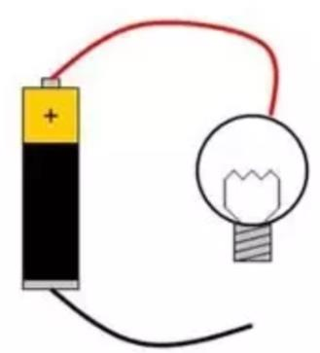
Concept diagram from the VILS/ASU circuit lesson. Your Snap Circuits build also needs a switch/control.
PART | JOB | OUR COMPONENT
Power source | Provides electrical energy
Path / conductor | Carries current
Control | Opens or closes the path
Load / output | Uses energy to do a job

Open / closed evidence
When the switch was closed, the lamp __________________ because ____________________________.
________________________________________________________________________________
________________________________________________________________________________
When we opened one connection, the lamp ______________ because ____________________________.
________________________________________________________________________________
________________________________________________________________________________
- ☐ Switch off before changing the build
- ☐ Never connect battery terminals directly
- ☐ Battery disconnected before return

DAY 2 • FAIR MATERIAL TEST
Keep the circuit, gap, and battery the same. Change one dry material at a time. Repeat a weak or flickering result.
MATERIAL | LAMP RESULT | CLAIM | EVIDENCE / NOTE
1. | On / Off / Flicker | Conductor / Insulator
2. | On / Off / Flicker | Conductor / Insulator
3. | On / Off / Flicker | Conductor / Insulator
4. | On / Off / Flicker | Conductor / Insulator
5. | On / Off / Flicker | Conductor / Insulator
6. | On / Off / Flicker | Conductor / Insulator

Troubleshooting record
- ☐ Power off
- ☐ Compared every connection to the diagram
- ☐ Checked every snap
- ☐ Checked component direction
- ☐ Asked for a second set of eyes
- ☐ Powered on and tested
The problem was ____________________. We changed ____________________. The result was ____________________.
________________________________________________________________________________
________________________________________________________________________________
________________________________________________________________________________
Claim: ____________________ is a conductor / insulator because the lamp ____________________.
________________________________________________________________________________
________________________________________________________________________________

