LAB 2: ONE PATH OR TWO? | DAYS 3-5

NAME: ____________________ | PARTNER: ____________________ | PERIOD / DATE: ____________________
OBJECTIVE  Compare series and parallel path structures using the same two lamps. | DEMONSTRATION OF LEARNING  Use a failure test to justify a reliability decision.

DAY 3 • SERIES: ONE PATH
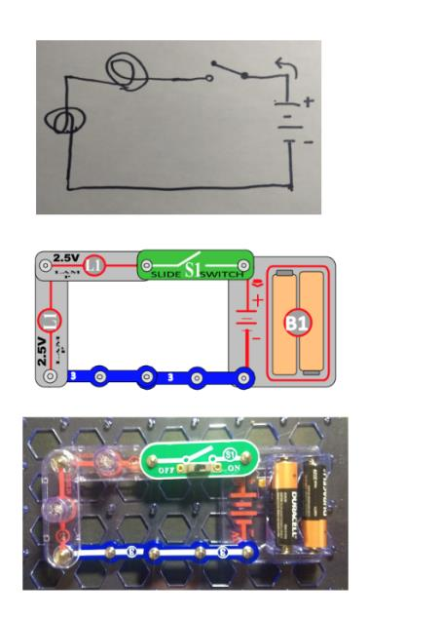
Series build: two lamps share one path. Diagram and classroom build from the VILS/ASU lesson.
Prediction: If one lamp is removed, ________________________________________________.
________________________________________________________________________________
________________________________________________________________________________
TEST | OBSERVATION | WHAT THE PATH EXPLAINS
Both lamps installed
Lamp 1 removed
One connection opened
In series, removing one lamp caused ____________________ because ______________________________.
________________________________________________________________________________
________________________________________________________________________________
________________________________________________________________________________

DAY 4 • PARALLEL: MORE THAN ONE PATH
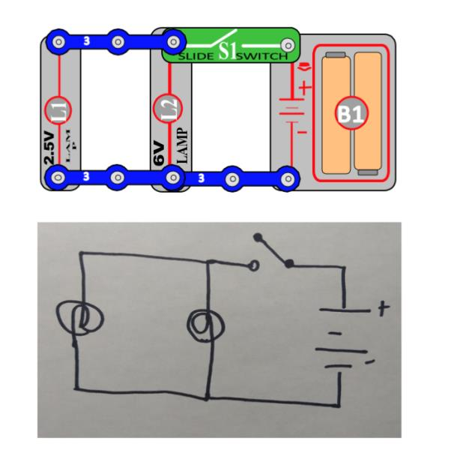
Parallel build: each lamp has a branch. Diagram from the VILS/ASU lesson.
TEST | OBSERVATION | WHAT THE BRANCH EXPLAINS
Both lamps installed
Lamp 1 removed
One branch opened

DAY 5 • RELIABILITY CHALLENGE
Design a two-light system where one lamp can be removed while the other stays on. Draw or photograph the final build, then let a partner trace it and run the failure test.
DRAW / ATTACH YOUR CIRCUIT | PARTNER FAILURE TEST  Removed: __________________  Other lamp: On / Off  Partner initials: __________  Evidence: __________________  ___________________________
I chose series / parallel because when we removed ____________________, ____________________________.
________________________________________________________________________________
________________________________________________________________________________
________________________________________________________________________________

