LAB 3: LIGHT, LIMIT + MOTION | DAYS 6-7

NAME: ____________________ | PARTNER: ____________________ | PERIOD / DATE: ____________________
OBJECTIVE  Use direction and resistance to control circuit behavior. | DEMONSTRATION OF LEARNING  Trace a user input through the path to a light or motion output.

DAY 6 • LED DIRECTION + RESISTANCE
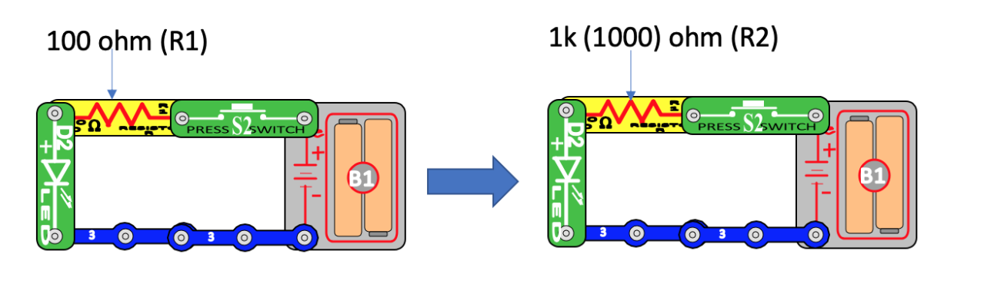
Same LED circuit, different resistor values. VILS/ASU Snap Circuits diagram.
TEST | LED RESULT | BRIGHTNESS | WHAT CHANGED?
100 ohm (R1) | On / Off | Bright / Dim
1k ohm (R2) | On / Off | Bright / Dim
LED reversed | On / Off | Bright / Dim
The LED did / did not light because ____________________. The __________ resistor made it __________ because ____________________.
________________________________________________________________________________
________________________________________________________________________________
________________________________________________________________________________
- ☐ LED direction checked
- ☐ A resistor used with the LED
- ☐ Power off before rebuilding

DAY 7 • MOTOR DIRECTION + STATUS
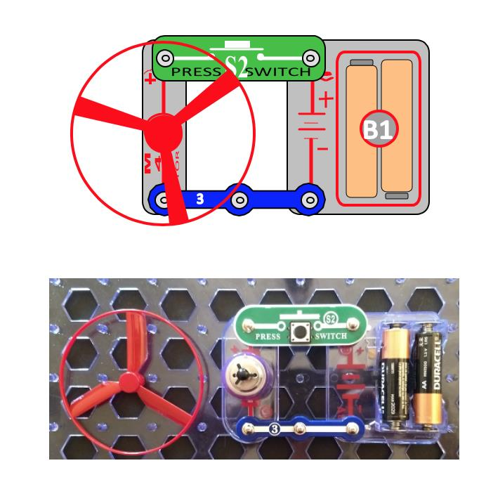
Press-switch motor build. Keep fingers, hair, faces, and loose objects clear of the fan.
MOTOR CONNECTION | DIRECTION / RESULT | EVIDENCE
First direction
Connections reversed

Status-and-motion system
Build or diagram the teacher-selected circuit. Show how one switch controls motion and how a light communicates system status.
USER INPUT | PATH | CONTROL / PROCESS | OUTPUT
When the user ____________________, the circuit ____________________, so the motor / LED ____________________.
________________________________________________________________________________
________________________________________________________________________________
________________________________________________________________________________

