SIGNAL LAB: CAN YOUR PARTNER DECODE IT? | DAYS 8-10

NAME: ____________________ | PARTNER: ____________________ | PERIOD / DATE: ____________________
OBJECTIVE  Use short and long electrical signals to communicate a message. | DEMONSTRATION OF LEARNING  Record a blind decode test, revise from evidence, and improve the final result.

DAY 8 • PLAN + BUILD
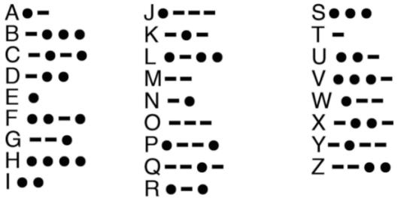 | MESSAGE BANK  GO OK YES NO  WAIT TURN OPEN CLOSE  My approved message: __________________  Letters: ______________________________  Morse code: ___________________________  _______________________________________
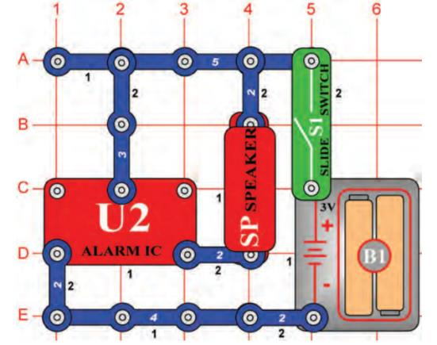
Approved alarm/speaker circuit diagram from the VILS/ASU lesson.
- ☐ Circuit matches the approved diagram
- ☐ Switch is off before power
- ☐ Sound works more than once
- ☐ Written Morse checked letter by letter

Rehearsal notes
Our counting rule for a dot, dash, and letter space: ____________________________________________
________________________________________________________________________________
________________________________________________________________________________
________________________________________________________________________________

DAYS 9-10 • BLIND TEST + REVISION
The partner may use the Morse key but may not see the written message. The sender may not speak, point, mouth the word, or give hints.
TEST | PARTNER'S EXACT DECODE | EVIDENCE / PROBLEM | RESULT
Practice
First blind test
Final blind test

Required revision
TIMING | SPACING | VOLUME | CONNECTION
☐ We changed this | ☐ We changed this | ☐ We changed this | ☐ We changed this
The first signal was hard / easy to decode because ____________________. We changed ____________________. The final result ____________________.
________________________________________________________________________________
________________________________________________________________________________
________________________________________________________________________________

100-point self-check
CRITERION | PTS | MY EVIDENCE
Safe, working circuit | 25
Code accuracy + signal timing | 25
Partner test + revision | 25
Evidence + explanation | 25
Circuit explanation: The switch ____________________, which caused ____________________, so the speaker ____________________.
________________________________________________________________________________
________________________________________________________________________________

