RVR Drawing Mission
OUTPUT: turn code into a visible path
Name(s): ____________________________________ RVR ID: __________ Date: __________
TOPIC  Robot drawing | OBJECTIVE  Use program types, heading, and movement to create a recognizable drawing. | EVIDENCE  A drawing run, program screenshot, and reflection.

1. Plan the drawing
Choose a vocabulary card or another teacher-approved word. Sketch a simple version that can be built from short lines, turns, and curves.
Word or symbol | What the robot must draw | Likely moves

Why will a robot understand this plan better than a detailed illustration?
________________________________________________________________________________
________________________________________________________________________________

2. Connect and choose a program type
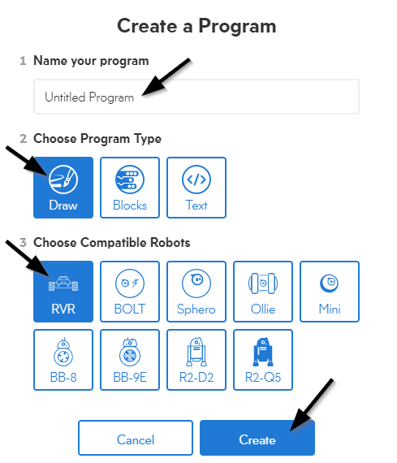
Use Draw for a quick path test. Use Blocks when you need exact headings, speed, duration, lights, or repeated actions.
☐ I connected to the correct RVR ID.
☐ I named the program.
☐ I chose RVR as the compatible robot.

3. Build, test, and revise
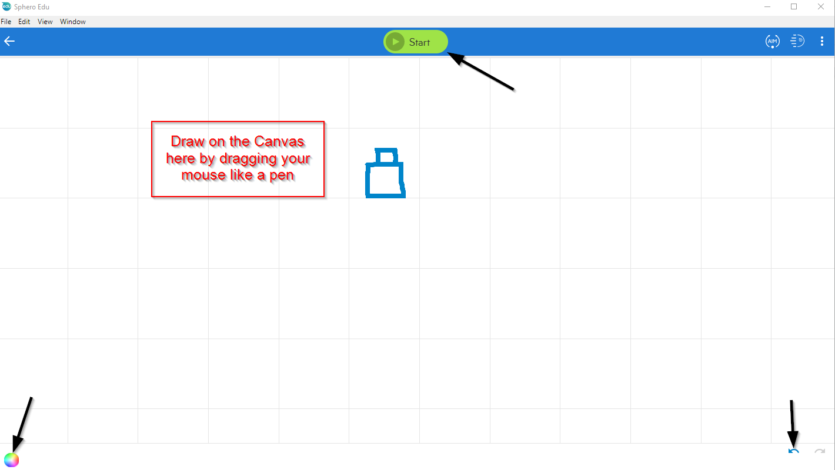
Test | What happened | One change | Result
1
2
3

Turn in
☐ Photo or screenshot of the final drawing
☐ Screenshot of the program
☐ Completed reflection below
The hardest move to control was _____ because _____.
________________________________________________________________________________
Our best revision was _____ because it changed _____.
________________________________________________________________________________

