RVR Color Sensor Mission
INPUT + DECISION + OUTPUT
Name(s): ____________________________________ RVR ID: __________ Date: __________
TOPIC  Color sensing | OBJECTIVE  Program RVR to travel across color tiles and make its LEDs match the color beneath it. | EVIDENCE  A working color route, code screenshot, test evidence, and systems explanation.

1. Build the test route
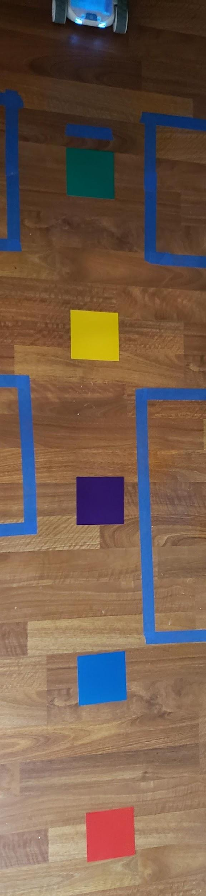
Arrange the tiles from green to red. Space them about 18 to 24 inches apart, tape them flat, and place RVR on green.

2. Program the stops
Test | Speed | Roll time | Did RVR stop on the next tile? | Next change
1 | 50 or less
2
3
Use roll and delay blocks. Stop on each tile for one second. Change one value at a time until the route works.

3. Make the LEDs match
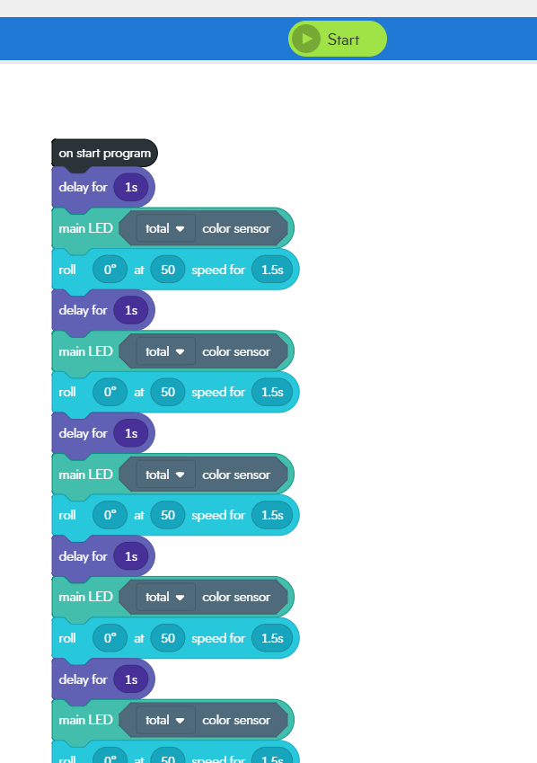
Add a one-second delay at the start so the sensor can load. Place the total color sensor block inside the color field of each main LED block. Put one main LED block after every stop.
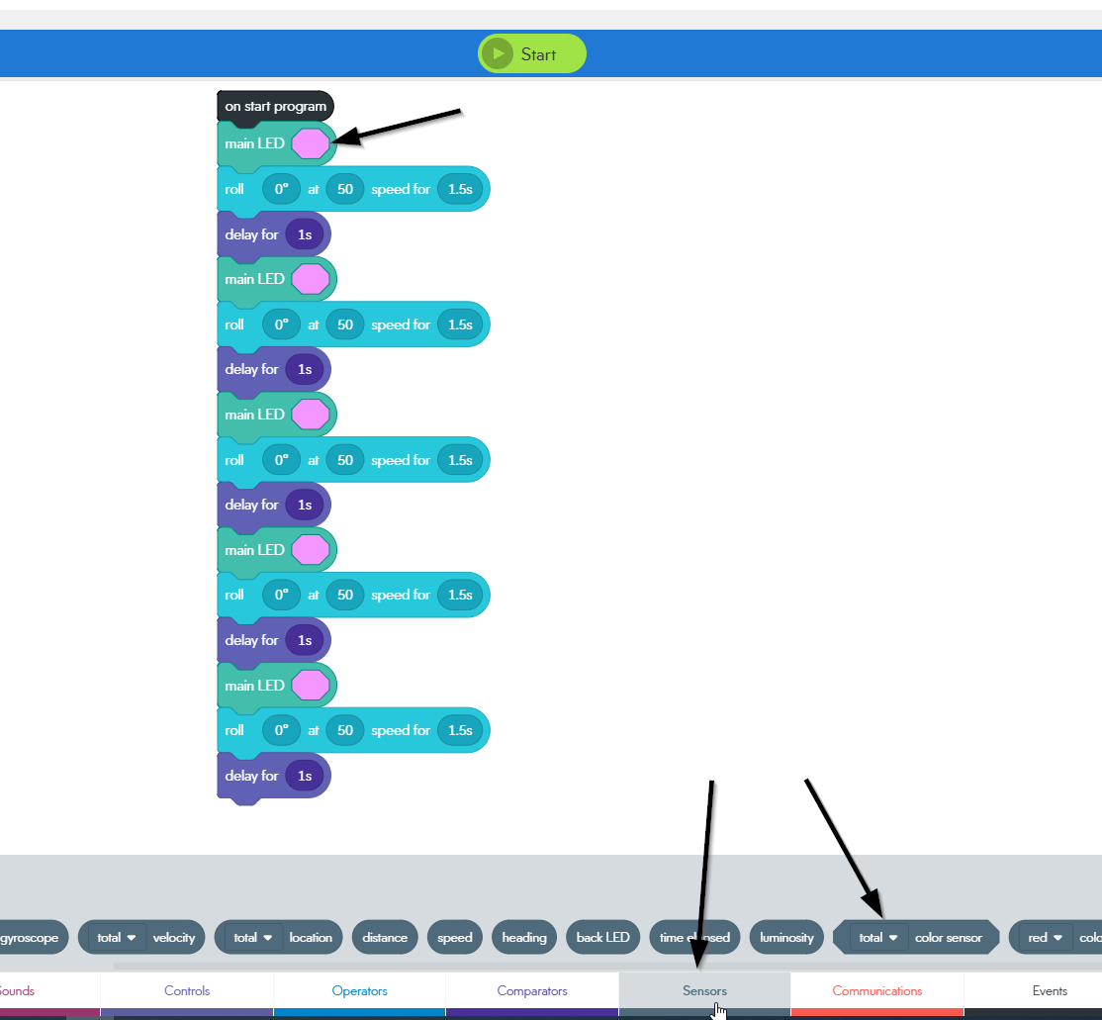

4. Test and debug
Color tile | Expected LED | Actual LED | Movement accurate? | Revision
The color sensor is the input because _____. The total color sensor value controls _____.
________________________________________________________________________________
________________________________________________________________________________

Optional extension
Continue with Sphero steps 4 through 7 to use on color events, build a red stopping sequence, navigate by color, or create a color boundary.

Turn in
☐ Photo or short video of the route
☐ Screenshot of final code
☐ Systems explanation completed

