The CANID starts from 0X00 to 0XFF

0X00 to 0X04 is reserved for E-Stop.

0X05 is reserved for DRIVE (speed and direction)

0X0A to 0X0C is reserved for SENSOR (actual speed and actual direction)

0X10 to 0X13 is reserved for Goal

0X20 is reserved for GPS

**\*\* In the code, be ware of the initial CAN-Bus baud rate. If you use MCP2515 module for testing, the baud rate needs to be set as twice as due CAN baud rate.**

**CAN Message Sample**

{ID} {Lower 4 bytes} {Higher 4 bytes}

eg. {0X00} {FFFFFFFF} {00000000}

**DRIVE (CANID 0X05)**

0X05 ComandedSpeed ComandedSteerAngle

ID 05 gives the command drive speed and angle.

ComandedSpeed: ComandedSpeed is an intege giving the speed for the rear wheel in centimeters per second.

The value is the speed, in centimeters / second.

ComandedSteerAngle: ComandedSteerAngle is a signed integer that specifies the steer angle (in degrees) of Elcano's front wheels. Negative value indicates left, positive value indicates right, 0 is straight.

eg. 05 256 -3 gives 05 00100000 FFFFFFFD

**SENSOR**

0X0A ActualSpeed ActualDeg

ID 0A gives the speed for the rear wheel in centimeters per second. And ActualDeg is angle of the front wheels, in degrees times.

0 degrees is straight ahead, small positive numbers are degrees to the right. Negative numbers (mod 360) are degrees to the left.

eg. 0A 100 0 gives 64000000 00000000

0X0B EPosMeters NPosMeters

0C Deg

Best estimate of vehicle position, fused from all sensors.

The East and North positions are relative to the origin.

Bearing tells which way the vehicle is pointing.

eg. 0B 200 200

0C 40

**Goal**

0X10 EPosMeters NPosMeters

0X11 Deg GoalCounter

0X13 Probability

0X15 SegSpeed

Goal gives the positions of the cones, which may be updated from visual information.

The localization processor passes messages 4, SENSOR and 5, GOAL to the vision processor. The vision processor then computes the expected position of the cone in the image. After processing the image, it will compute an updated cone position, including the probability that a cone is present in the image. It passes message 5a back to the vision processor.

Each segment represents the next goal to move. All segments are stored in a FIFO queue and pop out one by one. The speed on a segment is the recommended speed, taking account of conditions and turning radius.

**GPS**

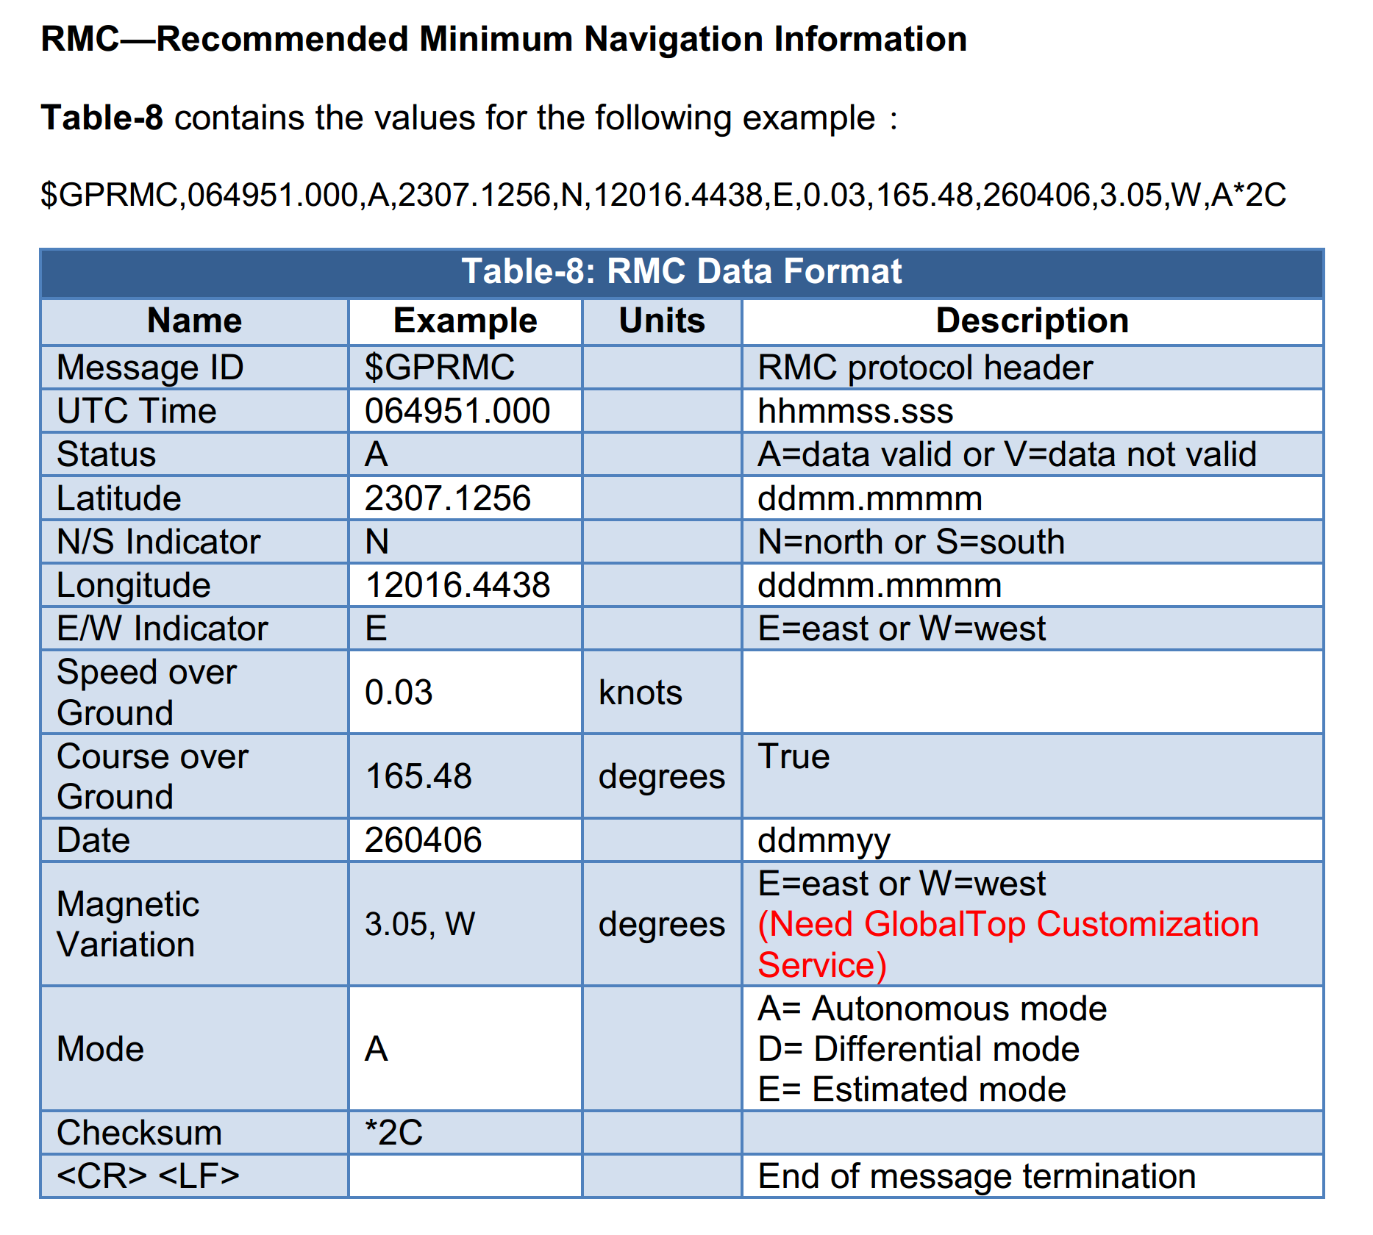

0X20 N/E (0/1) Latitude Longitude

0X20 (0/1) (w maximum value