# UWB

struct junction Nodes[MAP_POINTS] = {

-183969, 380865, 1 , 2 , END, END, 1, 1, 1, 1, // 0

-73039, 380865, 0 , 3 , 7 , END, 1, 1, 1, 1, // 1

-182101, 338388, 0 , 3 , 4 , 5 , 1, 1, 1, 1, // 2

-117516, 328381, 1 , 2 , 5 , 6 , 1, 1, 1, 1, // 3

-117840, 296690, 2 , 5 , 10, END, 1, 1, 1, 1, // 4

-143753, 300471, 2 , 3 , 4 , 8 , 1, 1, 1, 1, // 5

-66386, 118667, 3 , 13, 7 , END, 1, 1, 1, 1, // 6

71903, 154917, 1 , 6 , 14, END, 1, 1, 1, 1, // 7

-21087, 51950, 5 , 9 , 11, END, 1, 1, 1, 1, // 8

-61901, 14366, 8 , 10, 11, END, 1, 1, 1, 1, // 9

-192267, -70253, 4 , 9 , 12, END, 1, 1, 1, 1, // 10

-13687, -65027, 8 , 9 , 12, END, 1, 1, 1, 1, // 11

-6885, -97607, 10 , 11, 13, END, 1, 1, 1, 1, // 12

33855, -98274, 6 , 12, 15, 16, 1, 1, 1, 1, // 13

95599, -113397, 7 , 15, 17, END, 1, 1, 1, 1, // 14

84237, -137192, 13 , 16, END, END, 1, 1, 1, 1 // 15

-4941, -226037, 13 , 15, END, END, 1, 1, 1, 1 // 16

115408, -294533, 14 , END, END, END, 1, 1, 1, 1 // 17

};

# UWB SOCCER

struct junction Nodes[MAP_POINTS] = {

0, 0, 1, 4, END, END, 1, 1, 1, 1, //0 47.760854,-122.190033

-9785, -29675, 0, 2, 6, END, 1, 1, 1, 1, //1 47.760766,-122.190430

17457, -38495, 1, 3, END, END, 1, 1, 1, 1, //2 47.761011,-122.190548

36583, 18761, 2, 4, END, END, 1, 1, 1, 1, //3 47.761183,-122.189782

8895, 30721, 0, 3, 5, END, 1, 1, 1, 1, //4 47.760934,-122.189622

-18569, 36701, 4, 6, END, END, 1, 1, 1, 1, //5 47.760687,-122.189542

-37695, -20630, 1, 5, END, END, 1, 1, 1, 1 //6 47.760515,-122.190309

};

//waypoints

//1) 47.760907, -122.190527

//2) 47.761150, -122.190190

//3) 47.761023, -122.189800

//4) 47.760812, -122.189531

//5) 47.760565, -122.189858

//6) 47.760681, -122.190255

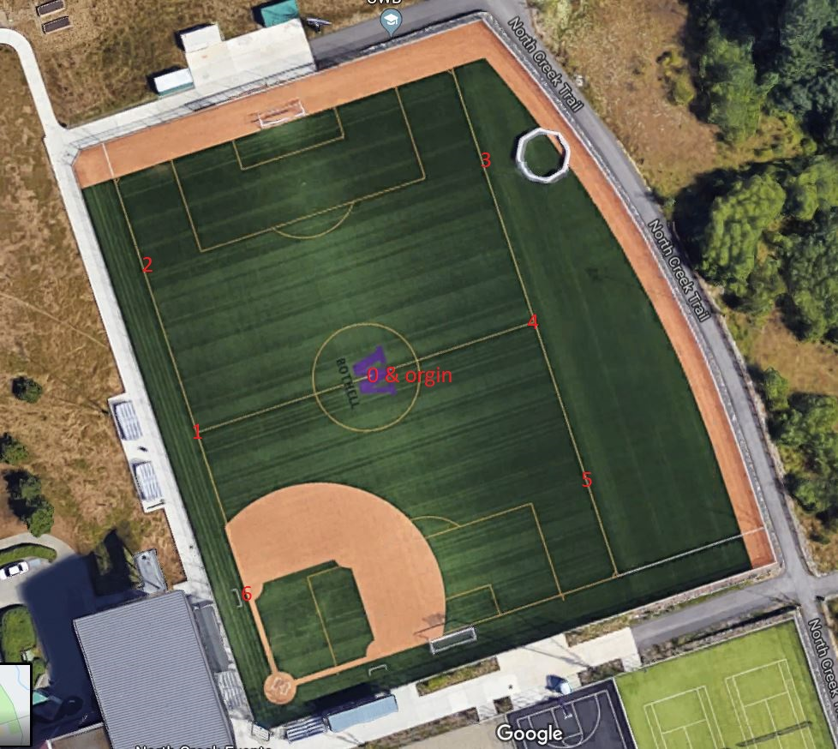

# Seattle Center

struct junction Nodes[MAP_POINTS] = {

-140828, 221434, 3 , 1 , END, END, 1, 1, 1, 1, // 0

-140986, 88800, 0 , 2 , 5 , END, 1, 1, 1, 1, // 1

-144313, -42065, 1 , 6 , END, END, 1, 1, 1, 1, // 2

-78568, 222090, 0 , 4 , END, END, 1, 1, 1, 1, // 3

-38276, 222290, 3 , 5 , END, END, 1, 1, 1, 1, // 4

-39558, 87844, 1 , 4 , 8 , 6 , 1, 1, 1, 1, // 5

-46528, -41631, 2 , 5 , 7 , 9 , 1, 1, 1, 1, // 6

-45764, -135413, 6 , 10, END, END, 1, 1, 1, 1, // 7

51834, 87232, 5 , 9 , 14, END, 1, 1, 1, 1, // 8

53041, -41220, 6 , 8 , 10, 13 , 1, 1, 1, 1, // 9

53438, -133901, 7 , 9 , 11, END, 1, 1, 1, 1, // 10

108750, -134590, 10 , 12 , END, END, 1, 1, 1, 1, // 11

130021, -143108, 11 , END, END, END, 1, 1, 1, 1, // 12

182559, -41031, 9 , END, END, END, 1, 1, 1, 1, // 13

177598, 86098, 8 , 15, END, END, 1, 1, 1, 1, // 14

170313, 69008, 14 , END, END, END, 1, 1, 1, 1 // 15

};

# Marymoor Park

struct junction Nodes[MAP_POINTS] = {

-775855, -78948, 1 , END, END, END, 1, 1, 1, 1, // 0

-598367, 16679, 0 , 2 , END, END, 1, 1, 1, 1, // 1

-426121, 137882, 3 , 17, 19, END, 1, 1, 1, 1, // 2

-345240, 149001, 4 , 18, END, END, 1, 1, 1, 1, // 3

-216431, 154561, 18, 15, END, END, 1, 1, 1, 1, // 4

-34449, 174576, 4 , 6 , 14, END, 1, 1, 1, 1, // 5

89118, 116792, 5 , 7 , 13, END, 1, 1, 1, 1, // 6

148281, 165680, 6 , 8 , 12, END, 1, 1, 1, 1, // 7

337751, -38918, 7 , 9 , 11, END, 1, 1, 1, 1, // 8

356474, -77836, 8 , 10, 22, END, 1, 1, 1, 1, // 9

703961, 147889, 9 , 11, END, END, 1, 1, 1, 1, // 10

353478, 163457, 8 , 10, END, END, 1, 1, 1, 1, // 11

352729, 161344, 7 , END, END, END, 1, 1, 1, 1, // 12

88370, 302450, 6 , END, END, END, 1, 1, 1, 1, // 13

21718, 64493, 5 , 15, END, END, 1, 1, 1, 1, // 14

-161761, 60045, 4 , 16, END, END, 1, 1, 1, 1, // 15

-187973, -287995, 15, END, END, END, 1, 1, 1, 1, // 16

-320527, -219054, 2 , END, END, END, 1, 1, 1, 1, // 17

-345240, 172353, 3 , 19, 20, END, 1, 1, 1, 1, // 18

-429117, 155673, 1 , 2 , 21, END, 1, 1, 1, 1, // 19

-346738, 216830, 18, 21, END, END, 1, 1, 1, 1, // 20

-438852, 210158, 19, 20, END, END, 1, 1, 1, 1, // 21

366958, -275763, 9 , END, END, END, 1, 1, 1, 1 // 22

};

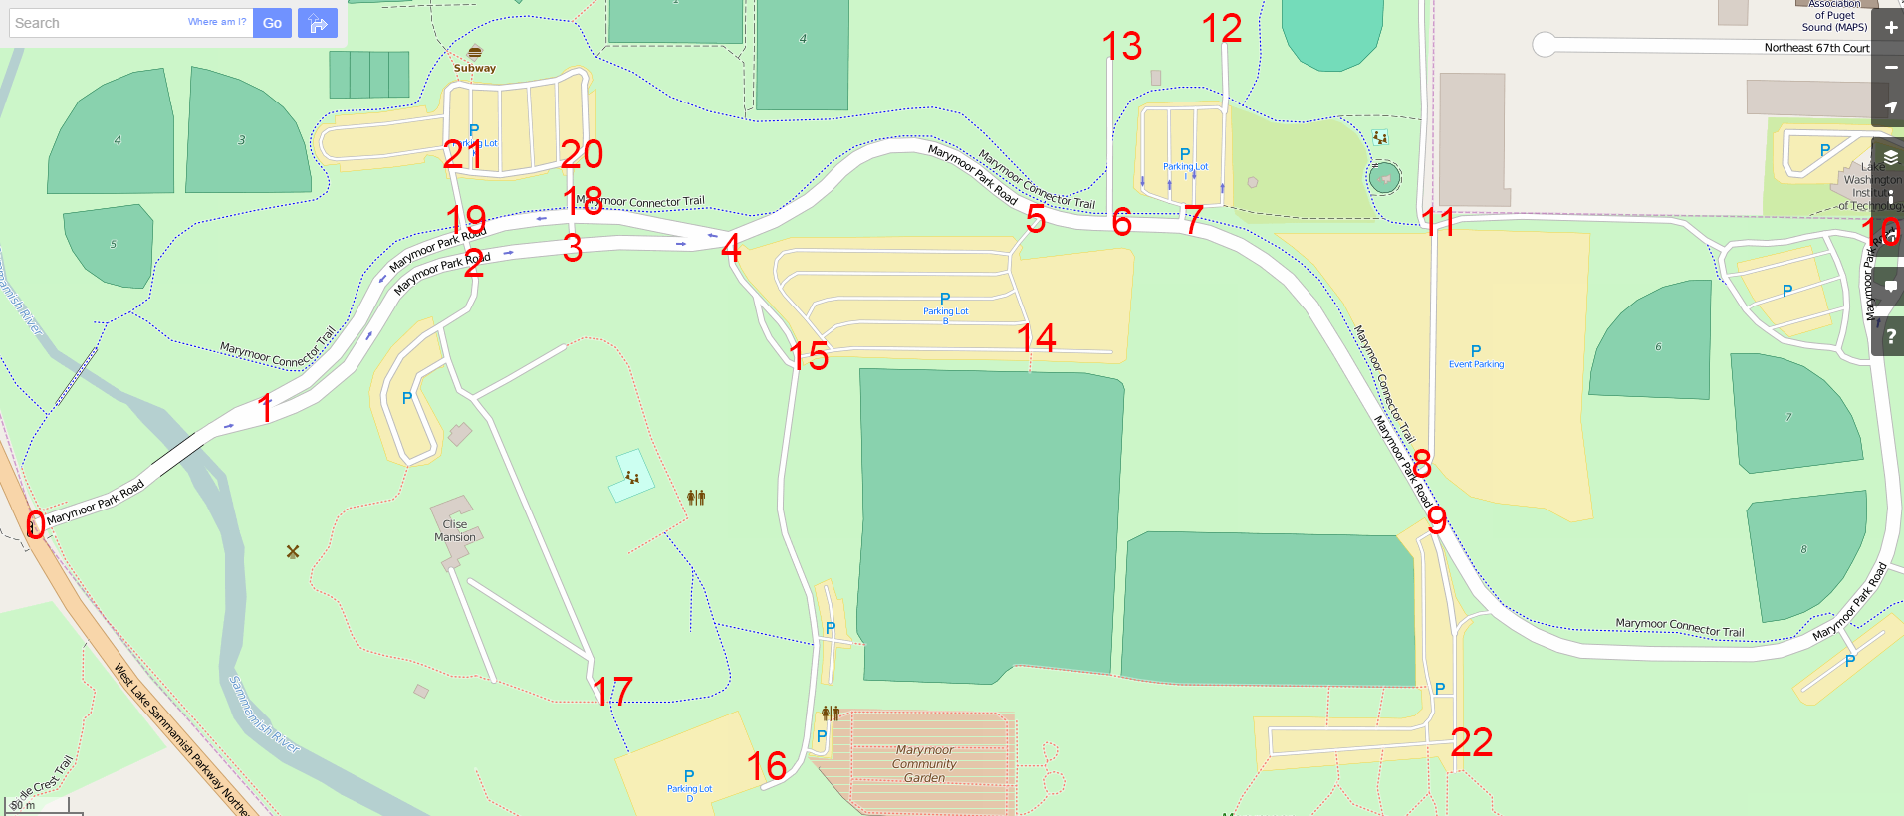

Bridle Trails State Park

struct junction Nodes[MAP_POINTS] = {

3594, -55041, 1 , 2 , END, END, 1, 1, 1, 1, // 0

-14454, -322576, 0 , 2 , 3 , END, 1, 1, 1, 1, // 1

379475, -450117, 0 , 1 , END, END, 1, 1, 1, 1, // 2

225798, -582105, 1 , 4 , 6 , END, 1, 1, 1, 1, // 3

154501, -655049, 3 , 5 , 6 , END, 1, 1, 1, 1, // 4

511884, -494150, 4 , 10 , END, END, 1, 1, 1, 1, // 5

761947, -427210, 3 , 4 , 7, 9 , 1, 1, 1, 1, // 6

762546, -496485, 6 , 8 , END, END, 1, 1, 1, 1, // 7

753110, -619578, 7 , 9 , 18 , END, 1, 1, 1, 1, // 8

539144, -964504, 6 , 8 , 17 , END, 1, 1, 1, 1, // 9

505443, -1077701, 5 , 11 , 12 , END, 1, 1, 1, 1, // 10

743149, -1132853, 10 , 13 , 14 , END, 1, 1, 1, 1, // 11

360902, -1165656, 9 , 10 , 14 , 15 , 1, 1, 1, 1, // 12

749590, -1614327, 11 , END, END, END, 1, 1, 1, 1, // 13

913902, -1062578, 11 , 12 , 28 , END, 1, 1, 1, 1, // 14

981229, -901679, 12 , 16 , 25 , END, 1, 1, 1, 1, // 15

962581, -660386, 15 , 17 , 21 , END, 1, 1, 1, 1, // 16

1425187, -145998, 9 , 16 , 20 , END, 1, 1, 1, 1, // 17

1549507, -52150, 8 , 19 , 20 , END, 1, 1, 1, 1, // 18

1369318, -448893, 18 , 23 , END, END, 1, 1, 1, 1, // 19

1337039, -658051, 17 , 18 , 21 , END, 1, 1, 1, 1, // 20

1375009, -670283, 16 , 20 , 22 , END, 1, 1, 1, 1, // 21

1483303, -692633, 21 , 23 , 25 , END, 1, 1, 1, 1, // 22

1529286, -683181, 19 , 22 , 24 , END, 1, 1, 1, 1, // 23

1329400, -1273515, 23 , 26 , END, END, 1, 1, 1, 1, // 24

1480682, -1577522, 15 , 22 , 27 , END, 1, 1, 1, 1, // 25

1403768, -1634787, 27 , 24 , END, END, 1, 1, 1, 1, // 26

865073, -1618553, 25 , 26 , 28 , END, 1, 1, 1, 1 // 27

};

