Eleanor Cotton

BIOS 6623-Project Zero

**Introduction**

The goal of this project is to examine the effectiveness of a new gel treatment for gum disease. It was hypothesized that the new gel treatment would lower average pocket depth and attachment loss, both of which are associated better oral health, when compared to a placebo and control. The researchers also wanted to explore the most effective concentration of the gel treatment (low, medium, or high) if it was found to be beneficial.

Data was collected on 130 patients. Each patient was randomized into one of five treatment groups: control, placebo, low, medium, or high gel concentration. Patients were measured at baseline, and 1 year after using the gel twice daily. Attachment loss and pocket depth values were calculated by averaging all the measurements recorded from a number of sites tested in the mouth. Demographics were also collected on each patient (race, gender, age, and smoking status).

**Methods**

Several patients were missing outcome data for the post (1 year) measurement. It was necessary to exclude them from the analysis because of this. They were also excluded from the demographics tables, since they were no longer involved in the analysis. There was no pattern/demographics associated with the missing data.

Mean and standard deviation were calculated for continuous variables and percent was calculated for categorical variables in table one.

Linear modelling was performed, using a hybrid model. Two models were run, one with change in attachment loss as the primary outcome and one with change in pocket depth as the primary outcome. Treatment group was the primary covariate, with baseline measurements corresponding to the outcome being controlled for. Given that the study was randomized, no demographic covariates were included in the modelling.

**Results**

Table One contains demographic information of the 103 participants who had complete outcome data. The majority of patients were white females. Over 50% of each treatment group were smokers. The average attachment loss for the control group at baseline was 2.55 (sd = 0.65). The average pocket depth for the control group at baseline was 3.29 (sd = 0.49).

Table two contains the model output with change in attachment loss at the primary outcome. The placebo, low gel concentration group, and high gel concentration group did not differ significantly from the control group in change in attachment loss. The medium gel concentration group differed significantly from the control group (p = 0.0232). The medium gel concentration group average change in attachment loss was 0.1759 units higher (SE = 0.0762). A positive difference means that attachment loss was higher at year 1 than at baseline, which is a negative oral health outcome and the opposite effect of what was hypothesized. The baseline measurement of attachment loss was significantly associated with the change in attachment loss (p < 0.0001). A one unit increase in baseline attachment loss decreased the average change in attachment loss by 0.1290 units (SE = 0.0304).

Table three contains the model output with change in pocket depth at the primary outcome. None of the treatment groups (placebo, low, medium, or high) differed significantly from the control group in change in pocket depth. The baseline measurement of pocket depth was significantly associated with the change in pocket depth (p = 0.0461). A one unit increase in baseline pocket depth baseline decreased the average change in attachment loss by 0.1130 units (SE = 0.0559).

Graphs one and two visually represent the change in attachment loss and pocket depth respectively. It was hypothesized that attachment loss and pocket depth would be lower at year 1 compared to baseline, which would result in a negative difference. In graph 1, all of the treatment groups are around zero, demonstrating that there was not a larger difference between baseline and year 1 attachment loss values. In graph 2, the groups all have negative differences, demonstrating that year 1 pocket depth was generally lower than baseline, but do not different from one another.

**Conclusions**

Overall, there was not enough evidence to demonstrate that the proposed gel treatment has a positive effect on gum disease. None of the treatment groups differed from the control in change in pocket depth. The medium gel concentration group in fact had a poorer outcome than the control group in attachment loss. Based on these results, it is not recommended that this gel be used to aid in gum disease treatment.

The study was relatively small, with the missing data making it even smaller. A larger study would have allowed for more information and a better understanding of the relationship between the treatment and oral outcomes. Researchers should also investigate a way of estimating adherence to the study guidelines. It could be possible that participants did not apply the gel treatment twice daily for the year, which would produce unreliable data.

**Tables and Figures**

|  |  |  |  |  |  |
| --- | --- | --- | --- | --- | --- |
| **Table One: Demographics by Group** | | | | | |
|  | **Treatment Group** | | | | |
| **Variable** | **Control** | **Placebo** | **Low** | **Medium** | **High** |
| **Number** | 23 | 23 | 21 | 20 | 16 |
| **Sex** (%) |  |  |  |  |  |
| Male | 30.43 | 43.48 | 42.86 | 35 | 18.75 |
| Female | 69.57 | 56.52 | 57.14 | 65 | 81.25 |
| **Race** (%) |  |  |  |  |  |
| Native American | 4.35 | 0.00 | 4.76 | 0.00 | 6.25 |
| African American | 4.35 | 4.35 | 14.29 | 0.00 | 6.25 |
| Asian | 4.35 | 4.35 | 0.00 | 5.00 | 0.00 |
| White | 86.96 | 91.3 | 80.95 | 95.00 | 87.5 |
| **Smoker** (%) | 69.57 | 56.52 | 71.43 | 55.00 | 68.75 |
| **Sites** (mean ± sd) | 153.91 ± 11.24 | 159.65 ± 10.66 | 161.71 ± 8.16 | 153.5 ± 17.12 | 158.25 ± 8.73 |
| **Attachment-Baseline** (mean ± sd) | 2.55 ± 0.65 | 1.83 ± 0.66 | 2.10 ± 1.09 | 2.24 ± 0.67 | 2.31 ± 1.01 |
| **Attachment-1 year** (mean ± sd) | 2.33 ± 0.55 | 1.74 ± 0.54 | 2.08 ± 1.06 | 2.24 ± 0.65 | 2.15 ± 0.92 |
| **PD-Baseline**  (mean ± sd) | 3.29 ± 0.49 | 3.1 ± 0.39 | 3.22 ± 0.64 | 3.05 ± 0.42 | 3.18 ± 0.28 |
| **PD-1 year**  (mean ± sd) | 2.95 ± 0.46 | 2.75 ± 0.48 | 3.02 ± 0.58 | 2.84 ± 0.47 | 2.80 ± 0.42 |

|  |  |  |  |
| --- | --- | --- | --- |
| **Table Two: Model 1 (Attachment Loss) Outcomes** | | | |
|  | **Coefficients** | **SE** | **P-Value** |
| **Control** | 0.1071 | 0.0930 | 0.2527 |
| **Placebo-Control** | 0.0420 | 0.0762 | 0.5824 |
| **Low-Control** | 0.1460 | 0.0759 | 0.0573 |
| **Medium-Control** | 0.1759 | 0.0762 | 0.0232 |
| **High-Control** | 0.0266 | 0.0809 | 0.7425 |
| **Attachment Baseline** | -0.1290 | 0.0304 | <0.0001 |

|  |  |  |  |
| --- | --- | --- | --- |
| **Table Three: Model 2 (Pocket Depth) Outcomes** | | | |
|  | **Coefficients** | **SE** | **P-Value** |
| **Control** | 0.0334 | 0.1916 | 0.8618 |
| **Placebo** | -0.0329 | 0.0768 | 0.6700 |
| **Low** | 0.1248 | 0.0780 | 0.1127 |
| **Medium** | 0.1084 | 0.0801 | 0.1787 |
| **High** | -0.0562 | 0.0842 | 0.5061 |
| **Pocket Depth Baseline** | -0.1130 | 0.0559 | 0.0461 |

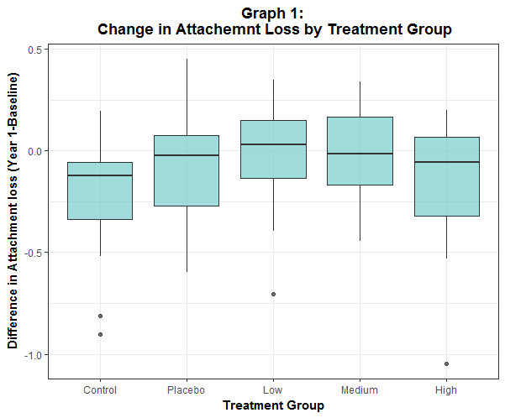

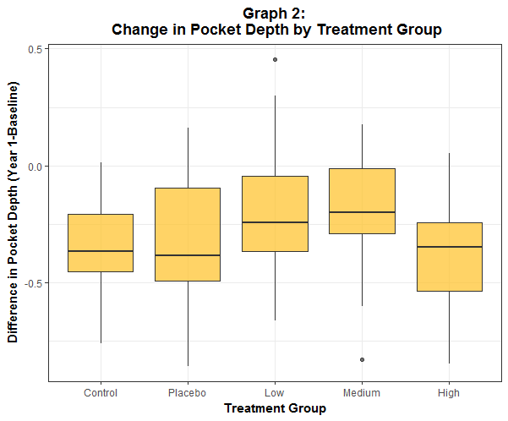

**Reproducible Research Information**

Code to generate the results in this report can be found at:

https://github.com/BIOS6623-UCD/bios6623-elcotton/tree/master/Project0