Eleanor Cotton

BIOS 6623-Project Two

**Introduction**

The primary aim of this research project is to calculate the predicted 30 day mortality rate (as well as a measure of variation in this estimate) of heart surgery patients at 44 different VA hospitals. The VA does a review of hospitals every six months in order to identify hospitals that have an unexpectedly high or low mortality rate for these patients. It is important to compare each hospital’s observed mortality rate to their predicted rate, which can account for the overall health of the population of patients.

Secondary aims of this project are to investigate the relationship between albumin and death rate, to see if it is a measurement that should be used in the estimation of predicted death rates.

The data used for analysis contains 26520 individuals who had either valve or CABG heart surgery from 44 different veterans’ hospitals. Data from the current six month time period (period 39) was available, as well as data from the past five six month periods. Comorbidities (BMI, ASA score, albumin levels) were recorded for each patient, along with their 30 day mortality.

**Methods**

RStudio version 3.4.2 was used for all statistical analysis

The initial dataset contained 26520 individuals. Two people in that cohort did not have the valve or CABG heart surgery, so they were removed from the study. For modeling purposes, only those individuals with complete cases (those with BMI, ASA, and Procedure Type recorded) could be used, which was a cohort of 21346. The predicted death rate for period 39 was calculated on the 3478 individuals from period 39 who had complete cases. Hospital 30 did not have any complete cases for period 39, which made it impossible to find an expected death rate.

Weight was measured in kilograms instead of pounds by hospitals 1 through 16 during period 39. These values were converted to pounds and BMI was recalculated for all individuals using the corrected weight values and height. Due to small sample sizes, ASA scores were recategorized into two groups: Low ASA (those with an original score of one, two, or three) and High ASA (those with an original score of four or five).

There was a missing data issue with albumin. It is missing due to ASA score. Those who were not missing albumin only had an ASA score of 4 or 5. Those who were missing albumin only had ASA scores of 1,2,3, or 4. Due to the large percentage of the study missing albumin (~62% of the population), it was not included in the primary analysis model.

Categorical data was presented using percents and group sizes. Numerical variables were presented using means and standard deviations.

Logistic regression was performed with 30 day mortality as the outcome, and BMI, ASA, and procedure type used as covariates. From this model, estimates of the expected death rate for each individual in period 39 were calculated. These estimates were then averaged across hospitals in order to get an expected death rate for each hospital. A secondary logistic regression model was ran, again using 30 day mortality as the outcome, with BMI, procedure type and albumin as the covariates. Every individual who had albumin score recorded had a high ASA score, so it could not be included in the model.

Bootstrapping was performed (sample = 10000) in order to get an estimate of the variation associated with each death rate.

**Results**

Table One contains summary statistics of the variables of interest for all individuals (all periods), individuals from the most recent six month period (current period), as well as for the last five six month periods (past periods). The CABG surgery was the most commonly performed heart surgery for all periods (75.90%). The majority of patients had high ASA scores (69.42%). The average BMI for all periods was 28.61. The average albumin for all periods was 3.89. The 30 day mortality was 3.27% for all periods.

The observed 30 day mortality rate for each hospital for period 39 is shown in table two. 1.15% of the patients from hospital one died during 30 days after their surgery. The predicted 30 day mortality for period 39 is also shown in table two. The predicted 30 day mortality rate for hospital one is 3.22%. The 95% CI for the predicted mortality rate for hospital one is 2.98 to 3.47. The ratio of observed mortality rate over predicted mortality rate demonstrates how closely the observed and predicted mortality rates are. A value close to 1 means that the observed and predicted rates are very similar. A value greater than 1 means that the hospital has a higher observed mortality rate than predicted. A value less than one means that the hospital has a lower observed mortality rate than predicted. The final column groups the ratio into 3 groupings: ≤ 0.80 (hospitals that should be investigated because they have a lower mortality than predicted), 0.8-1.2 (hospitals that have similar observed and predicted mortality rates), and ≥ 1.20 (hospitals that should be investigated because they have a higher mortality rate than predicted). Graph 1 plots the observed/predicted mortality ratios for each hospital.

Based on the current data, there is not a significant relationship between albumin and 30 day mortality (p = 0.193), when accounting for procedure type and BMI.

**Conclusions**

Overall, there are 16 hospitals that have a much higher observed mortality rate than predicted. Most notable, hospitals 7, 17, and 34 are of the most concern. These are the hospitals that should be investigated to see what they are doing that is worsening their mortality rates. There are 23 hospitals that have a much lower observed mortality rate than predicted. Most notable, hospital 19,32,33,42, and 44 have the lowest ratio of observation over predicted mortality rates. These are the hospitals that should be investigated to see how they are improving their mortality rates. There are only 4 hospitals that have very similar observed and predicted mortality rates.

Since 40 of the 44 hospitals would be investigated with the given cut offs, the VA could consider changing the cutoff for investigating hospitals that are doing well. If it was reduced to 70% from 80%, this would reduce the number of hospitals that need to be investigated from 40 to 30. This would require less work on the VA’s part.

Based on the current data, the VA should not continue to collect albumin, since it does not have a significant relationship with 30 day mortality.

The study has several limitations. First, the observed mortality rate for each hospital is based on every patient in the study during period 39. The predicted mortality rate for each hospital is based on only patients in the study during period 39 who were complete cases. The complete cases cohort had a slightly higher mortality rate than the not compete cases cohort. This could create a small bias in our predicted mortality rate by overestimating it. Second, albumin was missing at random, it was based on the ASA score. Third, Hospital 30 had no complete cases during period 39, so it’s predicted mortality rate could not be calculated.

**Tables and Graphs**

|  |  |  |  |
| --- | --- | --- | --- |
| **Table One: Comorbidities** | | | |
| **Variable** | **All Periods** | **Current Period** | **Past Periods** |
| **N** | 26518 | 4424 | 22094 |
| **Procedure**\* |  |  |  |
| Valve Surgery | 18.42 (4884) | 17.90 (792) | 18.52 (4092) |
| CABG Surgery | 75.90 (20126) | 76.40 (3380) | 75.79 (16746) |
| Missing | 5.69 (1508) | 5.70 (252) | 5.68 (1256) |
| **ASA**\* |  |  |  |
| Low (1,2,3) | 22.44 (5950) | 22.81 (1009) | 22.36 (4941) |
| High (4 or 5) | 69.42 (18408) | 69.60 (3079) | 69.38 (15329) |
| Missing | 8.15 (2160) | 7.59 (336) | 8.26 (1824) |
| **Weight**+ | 174.84 ± 26.91 (Missing = 1855) | 174.86 ± 27.37 (Missing = 418) | 174.84 ± 26.83 (Missing = 1437) |
| **Height**+ | 65.49 ± 2.56 (Missing = 1855) | 65.52 ± 2.61 (Missing = 418) | 65.48 ± 2.54 (Missing = 1437) |
| **BMI**+ | 28.61 ± 3.8 (Missing = 1855) | 28.58 ± 3.83 (Missing = 418) | 28.62 ± 3.79 (Missing = 1437) |
| **Albumin**+ | 3.89 ± 0.5 (Missing = 16496) | 3.89 ± 0.50 (Missing = 2695) | 3.9 ± 0.49 (Missing = 13801) |
| **30 day mortality**\* | 3.27 (868) | 3.28 (145) | 3.27 (723) |

*Variables are described using % (n)

+Variables are described using mean ± sd

|  |  |  |  |  |  |  |  |
| --- | --- | --- | --- | --- | --- | --- | --- |
| Table Two: Death Rates by Hospital | | | | | | | |
| Hospital | **Number**  **Died** | **Number**  **Seen** | **Observed**  **Death Rate** | **Predicted**  **Death Rate** | **95% CI of**  **Pre. Death Rate** | **Obs./Pre.**  **Death Rate** | **High or Low**  **Ratio?** |
| 1 | 1 | 87 | 1.15 | 3.22 | (2.98, 3.47) | 0.36 | ≤ 0.80 |
| 2 | 1 | 106 | 0.94 | 3.43 | (3.17, 3.7) | 0.27 | ≤ 0.80 |
| 3 | 4 | 100 | 4.00 | 3.34 | (3.1, 3.60) | 1.20 | ≥ 1.20 |
| 4 | 4 | 94 | 4.26 | 3.17 | (2.94, 3.41) | 1.34 | ≥ 1.20 |
| 5 | 1 | 115 | 0.87 | 3.35 | (3.11, 3.61) | 0.26 | ≤ 0.80 |
| 6 | 2 | 104 | 1.92 | 3.07 | (2.85, 3.30) | 0.63 | ≤ 0.80 |
| 7 | 7 | 105 | 6.67 | 3.12 | (2.89, 3.35) | 2.14 | ≥ 1.20 |
| 8 | 4 | 120 | 3.33 | 3.34 | (3.09, 3.59) | 1.00 | 0.8-1.2 |
| 9 | 0 | 105 | 0 | 3.17 | (2.94, 3.41) | 0 | ≤ 0.80 |
| 10 | 2 | 100 | 2.00 | 3.15 | (2.92, 3.39) | 0.63 | ≤ 0.80 |
| 11 | 1 | 90 | 1.11 | 3.04 | (2.81, 3.28) | 0.37 | ≤ 0.80 |
| 12 | 4 | 98 | 4.08 | 3.28 | (3.04, 3.53) | 1.24 | ≥ 1.20 |
| 13 | 4 | 84 | 4.76 | 3.28 | (3.04, 3.54) | 1.45 | ≥ 1.20 |
| 14 | 1 | 103 | 0.97 | 3.00 | (2.77, 3.23) | 0.32 | ≤ 0.80 |
| 15 | 3 | 105 | 2.86 | 3.17 | (2.94, 3.41) | 0.90 | 0.8-1.2 |
| 16 | 1 | 111 | 0.90 | 3.13 | (2.90, 3.38) | 0.29 | ≤ 0.80 |
| 17 | 13 | 93 | 13.98 | 3.48 | (3.22, 3.75) | 4.02 | ≥ 1.20 |
| 18 | 2 | 95 | 2.11 | 3.18 | (2.94, 3.42) | 0.66 | ≤ 0.80 |
| 19 | 0 | 113 | 0 | 3.13 | (2.89, 3.37) | 0 | ≤ 0.80 |
| 20 | 2 | 98 | 2.04 | 2.84 | (2.62, 3.06) | 0.72 | ≤ 0.80 |
| 21 | 5 | 92 | 5.43 | 3.20 | (2.96, 3.44) | 1.70 | ≥ 1.20 |
| 22 | 2 | 86 | 2.33 | 3.21 | (2.98, 3.45) | 0.73 | ≤ 0.80 |
| 23 | 6 | 97 | 6.19 | 3.05 | (2.83, 3.29) | 2.03 | ≥ 1.20 |
| 24 | 4 | 104 | 3.85 | 3.33 | (3.09, 3.59) | 1.16 | 0.8-1.2 |
| 25 | 3 | 95 | 3.16 | 3.16 | (2.93, 3.40) | 1.00 | 0.8-1.2 |
| 26 | 4 | 99 | 4.04 | 3.18 | (2.95, 3.42) | 1.27 | ≥ 1.20 |
| 27 | 2 | 99 | 2.02 | 3.26 | (3.02, 3.51) | 0.62 | ≤ 0.80 |
| 28 | 5 | 101 | 4.95 | 3.30 | (3.05, 3.55) | 1.50 | ≥ 1.20 |
| 29 | 2 | 105 | 1.90 | 3.16 | (2.92, 3.40) | 0.60 | ≤ 0.80 |
| 30 | 10 | 117 | 8.55 | NA | NA | NA | NA |
| 31 | 7 | 104 | 6.73 | 3.15 | (2.91, 3.39) | 2.14 | ≥ 1.20 |
| 32 | 0 | 93 | 0 | 3.19 | (2.96, 3.43) | 0 | ≤ 0.80 |
| 33 | 0 | 113 | 0 | 3.29 | (3.05, 3.54) | 0 | ≤ 0.80 |
| 34 | 14 | 99 | 14.14 | 3.17 | (2.93, 3.41) | 4.46 | ≥ 1.20 |
| 35 | 5 | 84 | 5.95 | 3.14 | (2.91, 3.38) | 1.89 | ≥ 1.20 |
| 36 | 1 | 99 | 1.01 | 2.98 | (2.74, 3.22) | 0.34 | ≤ 0.80 |
| 37 | 4 | 107 | 3.74 | 3.05 | (2.83, 3.29) | 1.23 | ≥ 1.20 |
| 38 | 1 | 113 | 0.88 | 3.02 | (2.79, 3.25) | 0.29 | ≤ 0.80 |
| 39 | 4 | 101 | 3.96 | 3.13 | (2.90, 3.37) | 1.27 | ≥ 1.20 |
| 40 | 2 | 86 | 2.33 | 3.12 | (2.89, 3.36) | 0.75 | ≤ 0.80 |
| 41 | 5 | 116 | 4.31 | 3.18 | (2.95, 3.43) | 1.36 | ≥ 1.20 |
| 42 | 0 | 107 | 0 | 2.97 | (2.74, 3.20) | 0 | ≤ 0.80 |
| 43 | 2 | 83 | 2.41 | 3.22 | (2.98, 3.46) | 0.75 | ≤ 0.80 |
| 44 | 0 | 98 | 0 | 3.20 | (2.97, 3.44) | 0 | ≤ 0.80 |

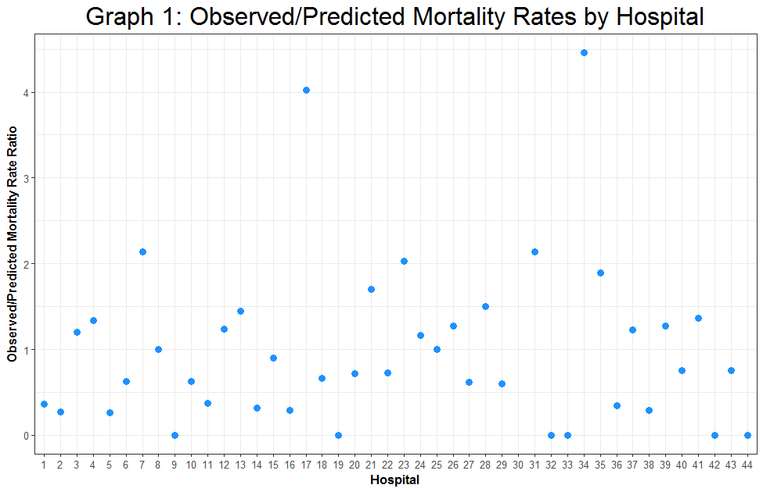

**GetHub Link**

Full Code to generate the above analysis can be found at:

https://github.com/BIOS6623-UCD/bios6623-elcotton

Check old report

Do powerpoint

Results from albumin model?

ADD how we found each predicted value

ADD who was used for observed value