Kinect resolves the geometry acquisition problem?

We study in the past, to use structured light we need a projector to obtain the geometry, in building mappings it is a disadvantage because the rent of projectors is expensive, so we look for a solution that involves use of the projector only in the show not in the design of it.

We study Kinect theory, without testing cases, now we are finishing our project and we can’t introduce new studies but we want remark that this tests could been futures works.

Kinect is a sensor based in Prieme Sence technology [<http://www.primesense.com/?p=514>]

It enables a computer to perceive the world in three-dimensions and to translate these perceptions into a synchronized depth image.

The depth image is based on Light Coding, first code pattern is projected in the scene using a infra red ray (IR projector is a Class 1 safe light source) ,

then a standard CMOS image sensor, receives the projected IR light and transfers the IR Light Coding image to the PS1080.

Finally the PS1080 processes the IR image and produces an accurate per-frame depth image of the scene.

Block Diagram

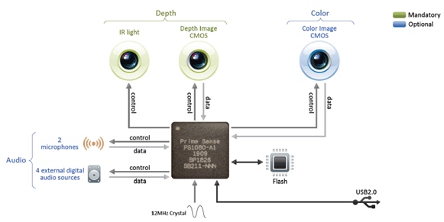Specification

|  |  |
| --- | --- |
| **Property** | **Spec** |
| Field of View (Horizontal, Vertical, Diagonal) | 58° H, 45° V, 70° D |
| Depth image size | VGA (640x480) |
| Spatial x/y resolution (@ 2m distance from sensor) | 3mm |
| Depth z resolution (@ 2m distance from sensor) | 1cm |
| Maximum image throughput (frame rate) | 60fps |
| Operation range | 0.8m - 3.5m |
| Color image size | UXGA (1600x1200) |
| Audio: built-in microphones | Two mics |
| Audio: digital inputs | Four inputs |
| Data interface | USB 2.0 |
| Power supply | USB 2.0 |
| Power consumption | 2.25W |
| Dimensions (Width x Height x Depth) | 14cm x 3.5cm x 5cm |
| Operation environment (every lighting condition) | Indoor |
| Operating temperature | 0°C - 40°C |

The specifications indicate that the distance to the sensor has a limit of 2 meters, it turns the kinect inappropriate for scanning buildings.