DOM Navigation

Everything in an HTML document is a node.

The DOM is a tree of nodes.

Nodes has the relationships:

* parent
* child
* sibling

# The DOM tree

* In a node tree, the top node is called the root (or root node)
* Every node has exactly one parent, except the root (which has no parent)
* A node can have a number of children
* Siblings (brothers or sisters) are nodes with the same parent

DOM Tree

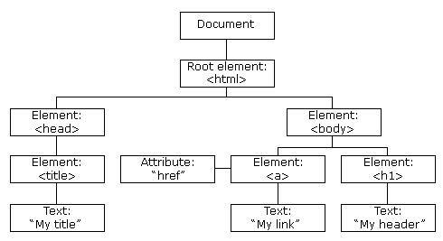

Tree Relations:

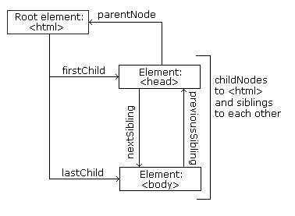

With the HTML DOM, all nodes in the node tree can be accessed by JavaScript.

New nodes can be created, and all nodes can be modified or deleted.

Navigation

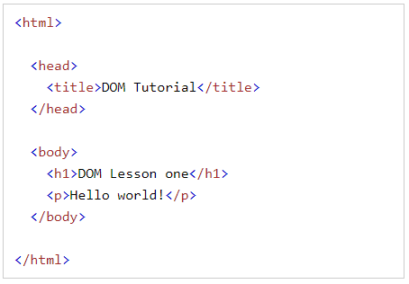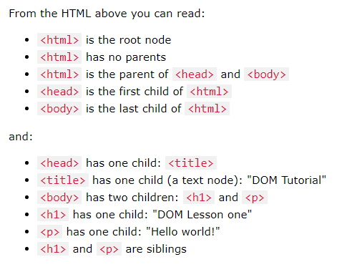

## Navigating Between Nodes

You can use the following node properties to navigate between nodes with JavaScript:

* parentNode
* childNodes[nodenumber]
* firstChild
* lastChild
* nextSibling
* previousSibling

a