classDiagram
class User {
<<abstract>>
-id: int
-name: string
-email: string
-password: string
+login()
+logout()
}

class Guest {
-phone: string
-preferences: string[]
+searchRooms()
+makeReservation()
+cancelReservation()
+writeReview()
}

class Staff {
-employeeId: string
-department: string
+checkInGuest()
+checkOutGuest()
+manageHousekeeping()
+processComplaint()
}

class Admin {
-permissionLevel: int
+addRoom()
+deleteRoom()
+updatePricing()
+generateReport()
+manageUsers()
}

class Room {
-roomId: int
-roomNumber: string
-type: string
-price: decimal
-capacity: int
-status: string
-amenities: string[]
+isAvailable()
+calculatePrice()
}

class Reservation {
-reservationId: int
-guestId: int
-roomId: int
-checkInDate: date
-checkOutDate: date
-status: string
-totalPrice: decimal
+calculateTotal()
+cancel()
+modify()
}

class Payment {
-paymentId: int
-reservationId: int
-amount: decimal
-method: string
-status: string
+processPayment()
+refund()
}

class Hotel {
-hotelId: int
-name: string
-location: string
-branches: Branch[]
+addBranch()
+getAllRooms()
}

class ChatBot {
-botId: int
+answerQuestion()
+escalateToStaff()
+learnFromInteraction()
}

User <|-- Guest
User <|-- Staff
User <|-- Admin

Guest "1" -- "*" Reservation : makes
Room "1" -- "*" Reservation : has
Reservation "1" -- "1" Payment : contains
Hotel "1" -- "*" Room : contains
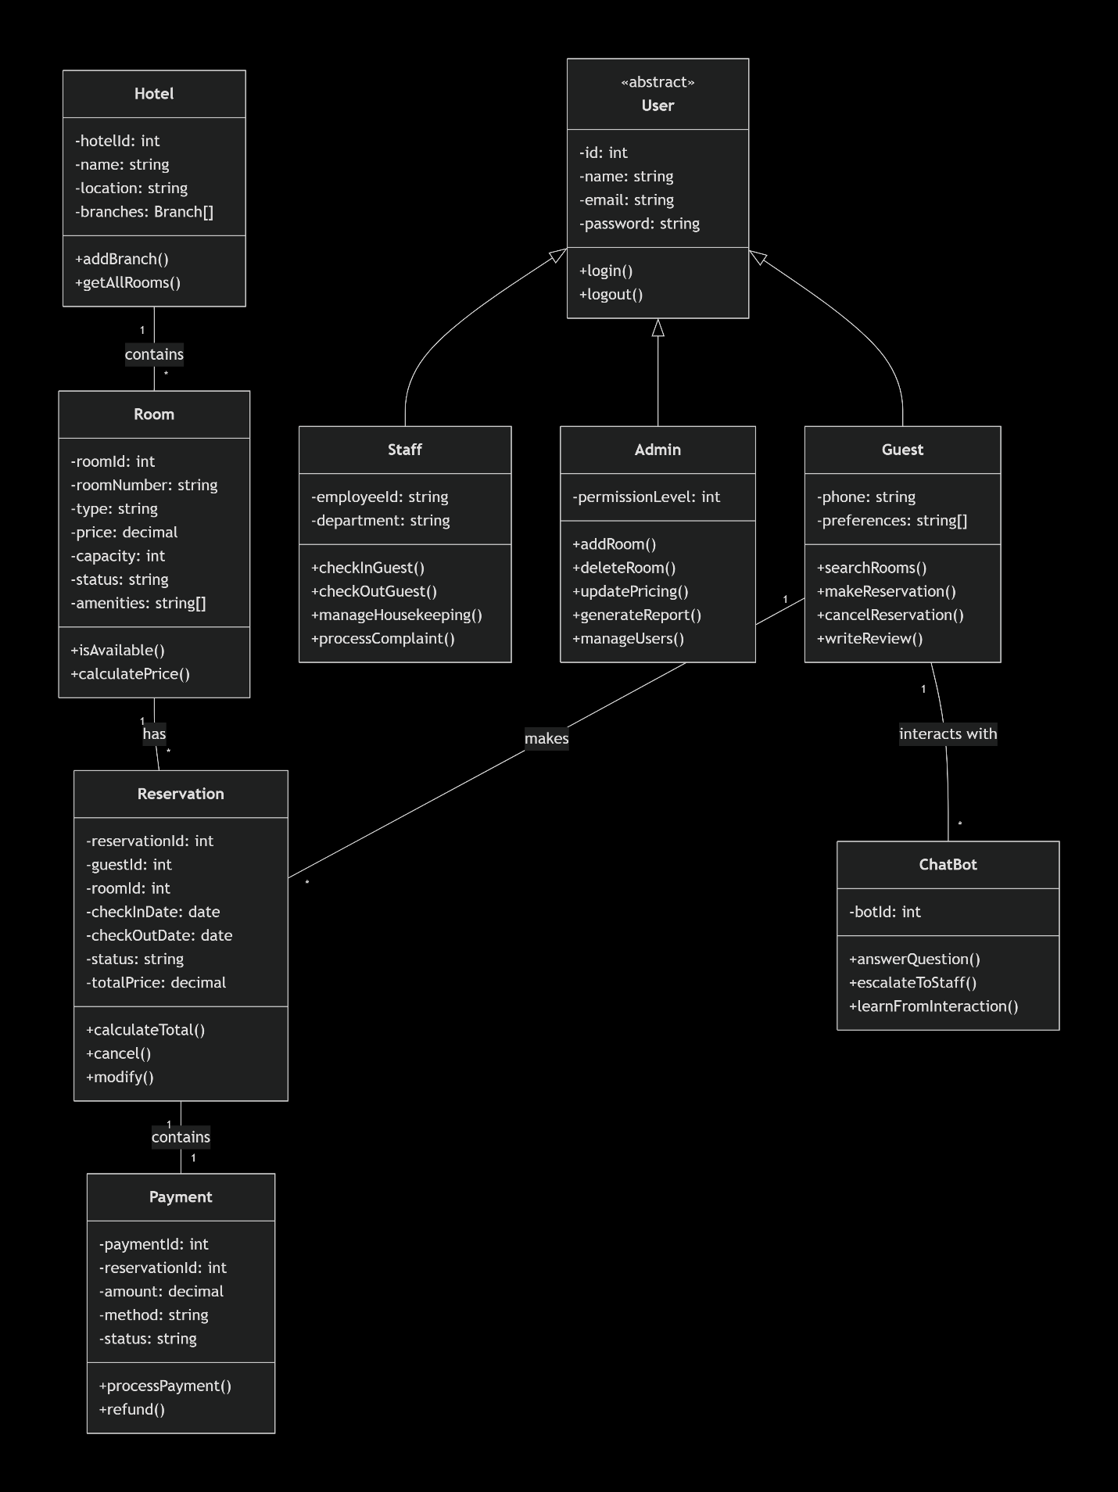
Guest "1" -- "*" ChatBot : interacts with

